From Copenhagen Airport, Kastrup:
The airport train station is in the main terminal, Terminal 3. You can buy tickets from a machine or by the counter. On platform 1 take any train going to Sweden. They all stop first in Malmö and then in Lund (most of them have different final destinations, such as Gothenburg, Kalmar, Helsingborg, Kristianstad). The trains go every 20 minutes (less frequent during the night) and the journey takes around 35 minutes to Lund Central Station.

From Lund Central Station:
- If you want to go by bus, you need either
- a local train/bus card (Jojo) with sufficient credit (around 16 SEK per trip). A Jojo card with 200 SEK credit can be purchased at the customer center (Kundcenter) of Skånetrafiken at the station;
- a train ticket that includes local buses - ask the train staff about your ticket.
Outside the north entrance of Lund Central Station at bus-stop K (see map), take bus no. 1 towards “Östra Torn” or bus no. 6 towards “Östra Linero”. They go every 15 minutes during the day and the journey takes around 6 minutes. Get off at bus-stop “Sparta”. From there, it’s 2 minutes walk to the gate. Call us from the gate, and we will let you in.
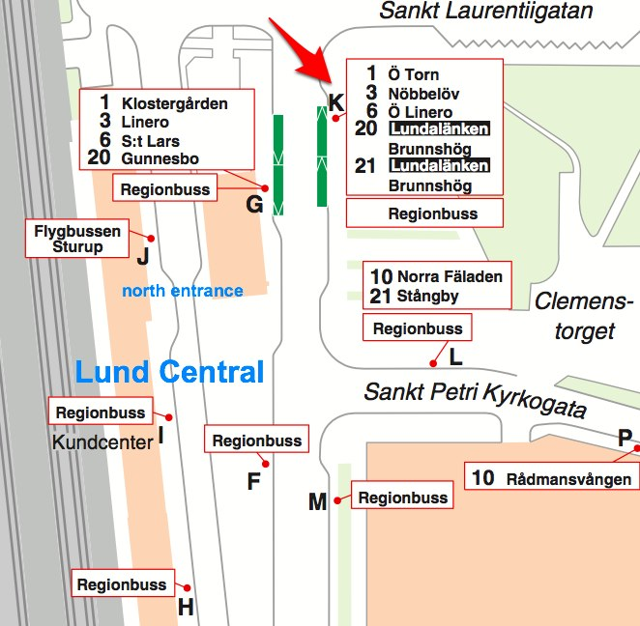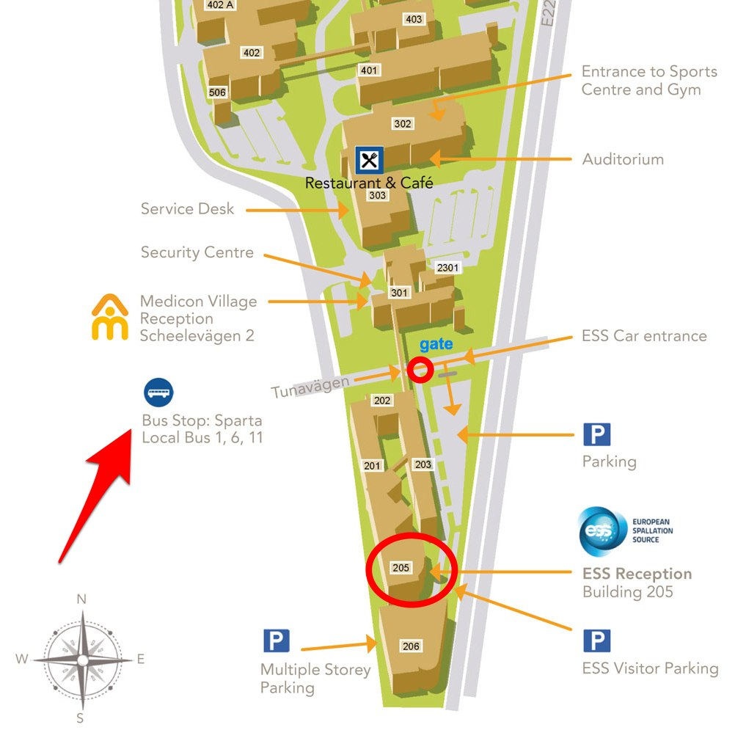

- If you want to go by taxi, look for Taxi Skåne outside the south entrance of Lund Central Station. Visitors to ESS get the agreed tariff of 105 SEK. The ride takes less than 10 minutes. The taxi can drive into the gate and go all the way to the door.
- If you want to walk, the distance is a bit over 2 km, so count around 25 to 30 min. Call us from the gate, and we will let you in.

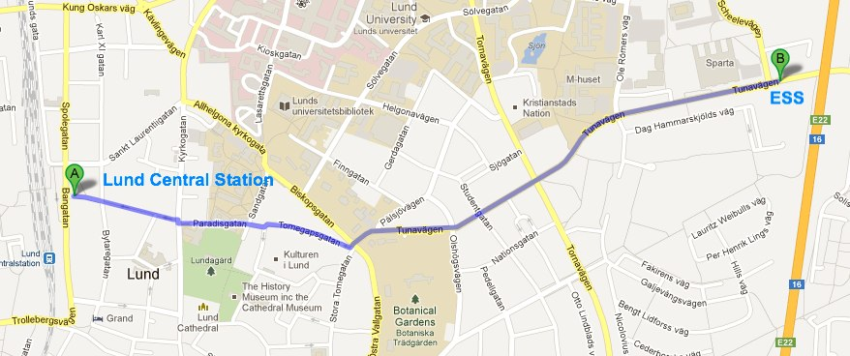
European Spallation Source ESS AB
Box 176 | Tunavägen 24
221 00 Lund | 223 63 Lund
Sweden

switchboard: +46 46 888 30 00

