
The sector of the ANTARES line to be deployed in the NEMO site
Davide Piombo for the ANTARES and NEMO collaborations*
^{aINFN}

Elsevier use only: Received date here; revised date here; accepted date here
Abstract
The NEWASTR project consists in the realization and deployment of an ANTARES mini string in the NEMO’s Capo Passero site together with the NEMO tower. This project has been proposed to make an on-site comparison between the two different layouts and to check how the bioluminescence phenomena can be affected by the detector geometry. In addition it will give a direct measurement of the bioluminescence activity immediately comparable to the ANTARES site data, since the detector is substantially the same. The technical specification of the NEWASTR string and the modifications to adapt line to the deeper site will be presented. The technical problems we encountered and the solutions we have used to make this project successfully work are also discussed.
. © 2008 Elsevier Science. All rights reserved
PACS: 95.55.Vj
Keywords: ANTARES ; NEMO ; Bioluminescence

- Introduction
The NEWASTR project has started at the end of 2005 when both the ANTARES [1] [5] and NEMO [2] collaborations gave their favorable opinion. In that period the first data from ANTARES showed a significant level of bioluminescence that negatively affected the global detector performances. The issue whether this phenomenon could also be present in the NEMO site, in spite of its larger depth, is very important.
It is clear now that this unexpected activity was only a temporary episode and that the level of the bioluminescence has decreased to an acceptable level.
However the direct comparison of the two sites using the same apparatus is still fundamental as well as the question whether the detector geometry can influence the bioluminescence and consequently the detector performance. The best method to answer these two questions is to have a direct measurement of the bioluminescence values using both ANTARES and NEMO architectures together in the NEMO site. This answer to the first question because it gives the ability to measure bioluminescence in the NEMO’s site using the same detector of ANTARES providing a direct comparison. Moreover this solution gives information on how the detector’s shape affects the bioluminescence phenomena since the ANTARES string will be deployed few hundreds meters far away from the NEMO’s phase 2 detector.
In the paper the Newastr string specification will be detailed and the activities to adapt the ANTARES detector to the new deeper and more distant site will be described.
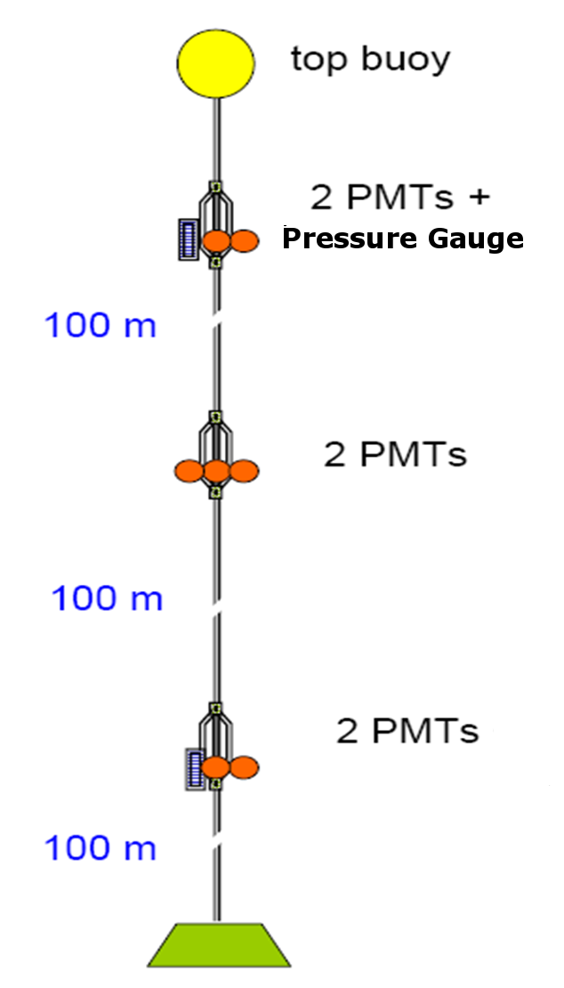
- The Newastr detector specifications
Figure 1: The ANTARES line schema
As discussed in the introduction the main goal of the detector is to continuously monitor the bioluminescence. In addition the movement of the line due to the currents in the sea and any oceanographic parameters that can affect the bio activity will be registered. In order to accomplish this task it is not necessary to use a complete string composed of 25 storeys, but a reduced implementation of the string like the ANTARES’ MILOM [3] suffices. The architecture that will be used will have only three storeys and each storey will be equipped with two PMTs and on the upper storey a pressure gauge will be inserted. For this new string a mix of spare and new production boards and electronic parts are used.
The distance between the string’s elements will be 100m and no acoustic position or led beacon will be used, since this equipment is necessary only if the data are used in muon track reconstruction. In Figure 1 a schematic of the Newastr string is presented.
The sea side of the detector is only half of it, on the shore in Capo Passero a small replica of the villa Pacha control room will be implemented by using a replica of the ANTARES’ clock station, a small DWDM crate and two Pentium-D based workstation for data acquisition.
The original ANTARES data acquisition and clock management software has been rebuilt on this system and it will be tested together with the string before deployment. Minor modification to the clock software has been done in order to avoid the use of the GPS signal that gives a timing precision not needed in this application.
- The string adaptation
In order to be sure that it is possible to use the string in the NEMO site at 3500m depth it is necessary to check out that all mechanical parts can resist the higher pressure and that power supply and data transmission are compatible with the new specifications.
From the mechanical viewpoint the titanium cylinders used in ANTARES are able to resist to the new pressure and all the cylinders used in the project have been tested in a hyperbaric chamber at 400 bar for a period of 24 hours and with 7 full cycles from 0 to 330 bar.
To avoid the penetrator a new penetrator from Seaproof Solutions has been used.
The new architecture uses a water blocking diaphragm that mechanically separates the internal atmospheric pressure in the cylinder from the external 400 bar pressure. This penetrator has been successfully tested up to 400 bar [4]
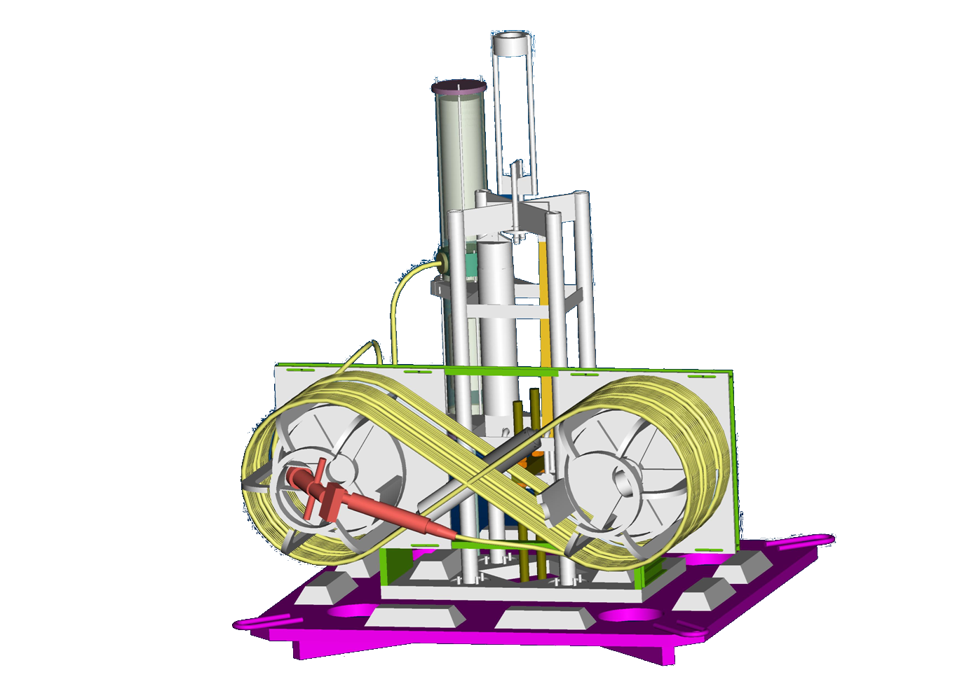
The BSS module, that is the anchor of the line, has been redesigned. The new model uses a different strategy for the interlink cable: in our case it is directly connected to the string by a penetrator while the cable and the under-water mateable connector are housed on a drum. After deployment the ROV rolls out the cable and connects it to the DC/DC converter (see below).
Figure 2: the new BSS drawing
In Figure 2 a drawing of the new BSS is presented.
In order to avoid that water penetration can affect the reliability of the NEMO DC/DC converter a fuse box, that limits the maximum current draw to 3A, is inserted in the interlink cable.
MLCM DWDM (top) to DWDM Mux
connections (only 3 storey)~ -0.1dB
300 m SMF28 string cable (EMC)~ -0.1dB
DWDM Mux~ -3.0dB
Splice DWDM Mux to fiber~ -0.2dB
Splice in SPM~ -0.1dB
200 m Cable from SCM to DC/DC
converter connector~ -0.3dB
Underwater connector on DC/DC
converter~ -3.0dB
Splice in DC/DC converter between
connector and 100Km fibre~ -0.3dB
100Km fibre~ -20dB
On Shore fibre splice~ -0.2dB
DWDM Demux~ -3.0dB
Splice DWDM Demux~ -0.2dB
Total Optical Losses~ -30.5dB

Nominal Laser Output Power CQF915/208~ +7dBm
Nominal APD sensitivity ERM577~ -32dBm
Total Optical Margin~ 39dB

Optical Margin~ 8.5dB

Table 1: Optical Margin Calculation
From the electric viewpoint the power supply in the NEMO site provides 380V DC directly on its output through the use of a DC/DC converter. The ANTARES line works at the same voltage so the original SPM module, that converts the ANTARES AC voltage supply in the 380 DC voltage is no more necessary and it will be substituted by a board, that simply manages the power distribution in the line and provides the 48V DC necessary to the SCM. This board is equipped with a microcontroller that implements the same protocols and functions as used originally in the SPM, so no changes are needed in the ANTARES control software in order to manage the string power.
Regarding the clock and data communications, that uses a fiber optic link, we have assumed that the data transmission can perfectly work in the new set up.
The new site is 100km from shore, compared with the 40 km distance in ANTARES. The optical fiber that is used in the NEMO cable has specifications that are better than the fibers in the ANTARES cable and specifically provides a lower chromatic dispersion and lower attenuation values.
The optical signal of the clock system in ANTARES is split, at the junction box, in 16 channels, one for each junction box output. In the NEMO site this split is not necessary and the attenuation induced by the larger distance is compensated by this fact.
Regarding the DWDM data transmission a new optical loss value has been computed and its details are reported in Table 1. The optical margin that will be available in the NEMO site is lower than the ANTARES’ one, but it is sufficient to allow for a correct data transmission. Using a high value optical attenuator some communication tests have been done in order to verify that the communication system can work in the new site.
The other factor that can affect optical fiber based transmission systems is the chromatic dispersion that introduces a jitter in the transmitted signals.
The value of this jitter can be critical in some situations so it is necessary that a correct characterization of this phenomenon is done in order to be sure that data transmissions are reliable.
The values of this parameter in the two fibers are respectively:
[0,21] ps nm/Km in ANTARES with a distance of 50Km
[-4.2,-1.6] ps nm/Km in NEMO over 100Km
The computed chromatic dispersion in the new fiber is less than the original ANTARES’ one so smaller signal jitter in the NEMO site is expected.
- Conclusions and final remarks
The Newastr project is currently in its end phase; as discussed above the adaptation to the new site is possible and we think that the solutions we implemented are valid and effective to make the string able to work in the deeper site.
In September the string integration will be done using the personnel and the facilities available at CPPM, that are the same as those used in the integration of all the other lines of the ANTARES neutrino detector.
Some other tests are programmed on the string and on the shore station in order to test the data acquisition in a dry environment before deployment.
In September some tests on the line power system are scheduled with the NEMO collaboration in order to be sure that string components are compatible with the Alcatel DC/DC converter that will feed power to the NEMO site.
The deployment of the line is expected at the beginning of 2009 after the deployment and the completion of underwater tests of the Alcatel apparatus.
Actually the bio activity in the ANTARES site is strongly decreased respect to the beginning period, but the initial target of this activity is still valid and we think that it can give some intriguing hints on the dependence of bio activity on detector geometry.
Acknowledgments
As conclusion of this paper I wish to say thank you to all people that helped this project during this years and which contribution is very important to the actual status of this project and to its conclusion.
A special thanks go to the whole ANTARES and NEMO collaborations that supported the project during this time.
References
- http://ANTARES.in2p3.fr
- http://nemoweb.lns.infn.it
- J.A. Aguilar et al. Nucl. Inst. And Meth. A555 (2005) 132
- ANTARES Technical Note 3-LIN-03-09-A (2006)
- VV.AA. Technical Design Report of the ANTARES 0,1 Km² project.

* Davide Piombo. Tel.: +39-010-353-6738; fax: +39-010-353-6452; e-mail: piombo@ge.infn.it.

