Some standards must be unique like the type of crates in the camera.

Below in the document:

[] defines the number of possibilities, for example [1] the choice must be unique.

In red color: obvious or preferred choices.

To understand correctly the different parts, the following picture depict a possible architecture for the MST camera.

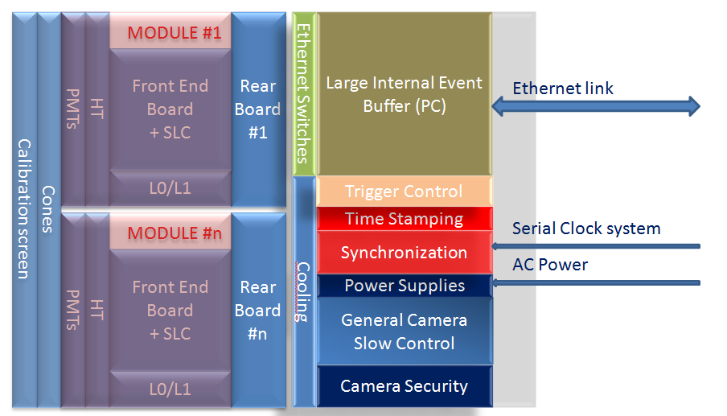

# Hardware section

## Crates in the camera [1]

* microTCA
* PXI
* cPCI

#### Parts involved

* Slow control
* Global synchronization
* Time stamping
* Camera security

## Processors [1]

* Motorola
* Intel

#### Parts involved

* Slow control
* Global synchronization
* Time stamping
* Camera security

## Large Event Buffer [1]

* PC
* CPU embedded in crate

#### Parts involved

* ACTL

## Protocols for slow control inside the camera to control different sensors or actuators (temp., motors, power supplies, etc…).

### Field Bus (to control global slow control systems) [ ]

* CANBus
* Profibus
* Ethernet

#### Parts involved

* Slow control
* Camera security

### Simple serial link for individual sensors (like temperature probes, relays, etc.) [ ]

* OneWire
* RS232/RS485

#### Parts involved

* Slow control
* Camera security

## Support for data inside the camera [1]

Ethernet

## Connectors

* Fieldbus
* Simple serial link
* Ethernet
* Powers
* Front end [Tyco 100-147-1]

# Software section

## General system processor software (must be compatible with ACTL) [1]

* Linux
* Distribution: (Fedora, Redhat, Ubuntu, etc…) [1]

#### Parts involved

* Slow control
* Camera security
* ACTL

## General programming software [ ]

* Java
* C
* C++

#### Parts involved

* Slow control
* Camera security
* ACTL

## Slow control

* OPC UA

## General exchange data protocol [1]

#### Parts involved

* Slow control
* Camera security
* ACTL
* Synchronization