MST Camera Components and Interfaces List

Author | Laboratory |  | Approved by | Laboratory
Integration Team | LLR, Palaiseau |  | Pending approval by  Stefan Schlenstedt  German Hermann

List of Abbreviations

History
0 | 26 April 2011 | Draft version

Reference Documents
1 | March 31, 2011 | CTA-TC-PR1-110331 | Level A: Preliminary CTA System Performance Requirements
2 | March 31, 2011 | CTA-TC-PR2-110331 | Level B: Preliminary CTA Sub-System Performance Requirements

Distribution | Private

- Table of Contents -

1. Introduction 4
2. The General Architectures 4
3. The Mechanical Body 6
3.1 Skeleton 6
3.2 Skin 7
3.3 Lids 7
4. The Common Components in the Front Part 7
4.1 Entrance window 7
4.2 Entrance window support 7
4.3 Funnel 8
4.4 Funnel support 8
4.5 Pointing calibration 8
4.6 Electronics calibration 9
5. The Cluster Architecture 9
5.1 General view 9
5.2 Core part 9
5.2.1 Mechanical cluster 9
5.2.2 Photomultiplier 10
5.2.3 Active Board 10
5.2.4 Front-End Board 10
5.2.5 Sandwich 11
5.2.6 Front-End Cooling 11
5.2.7 Backplane Board 11
5.2.8 L1 Fanout Board 12
5.2.9 L1 Digital Board 12
5.3 Rear part 12
5.3.1 Camera Central Trigger and Clock Distribution 12
6. The Rack Architecture 13
6.1 General view 13
6.2 Front part 13
6.2.1 Photomultiplier 13
6.2.2 Active Board 13
6.2.3 Back Plane Board 14
6.2.4 Sandwich 14
6.2.5 Front End Cooling 14
6.3 Rear part 15
6.3.1 FADC Board 15
6.3.2 Trigger Board 15
6.3.3 Clock Distribution Board 15
7. The Common Components in the Rear Part 16
7.1 DAQ 16
7.2 Racks 16
7.3 Rack Cooling 17
7.4 LV Power Supply 17
7.5 Environment Monitoring 17
7.6 Lid Control 18
7.7 Cooling Control 18
7.8 Safety Control 18
7.9 Dehumidifying system 19
8. Conclusions 19
9. Appendix 20
9.1 Sketch of interfaces for the Cluster architecture 20
9.2 Sketch of interfaces for the Rack architecture 21

Introduction

This document contains the list of mechanical, optical, electronic components of the MST camera. Their interfaces are also described with six types of interfaces: optical, mechanical, electronics, Ethernet/Optical fibre, energy, heat exchange. This paper does not contain a technical description of the components, such as their specifications and their technical parameters. So, for each component are given:
- its brief description
- its interfaces
- the names of team working on a possible design for an industrial production (this candidates list is non-exhaustive and it is wished to complete it if necessary)
This document gives also a description of possible architectures for MST camera based on the current knowledge.

One should notice already that they are missing components: the power distribution system from the telescope (220V or 380V), the lighting and EMI protection system, a possible pressured air distribution system (from the telescope) and a possible distribution system of a dehumidifying system (from the telescope). And it is missing also all the topics related to the virtual components like the software, mid-ware and data format.

The scope of this document is limited to a draft version of a working document allowing to create in the future design and integration documents of the MST camera. The listed information reflect the current knowledge at this date of the R&D studies made in the horizontal Work Packages ELEC, FPI and ATAC. As consequence and awaiting approval of their coordinators and of the Project Office, this document should not be distributed.

The General Architectures

Derived from the work of the Design Study and the beginning of the Preparatory Phase, one can derive the general architectures of the MST camera. They follow the preliminary requirements as defined in the references [1,2], ie sealed camera, and the recommendations of the FPI and ELEC Work Packages, ie the use of Photo-Multiplier Tubes as photo-detector, a modular front-end design (group of PMTs that can be removed for maintenance) and an embedded electronics. These generic architectures are using the known possible designs but they should not hide the fact that for each architecture they are several different designs of electronics (as illustrated in illustration 1) and designs of mechanical parts.

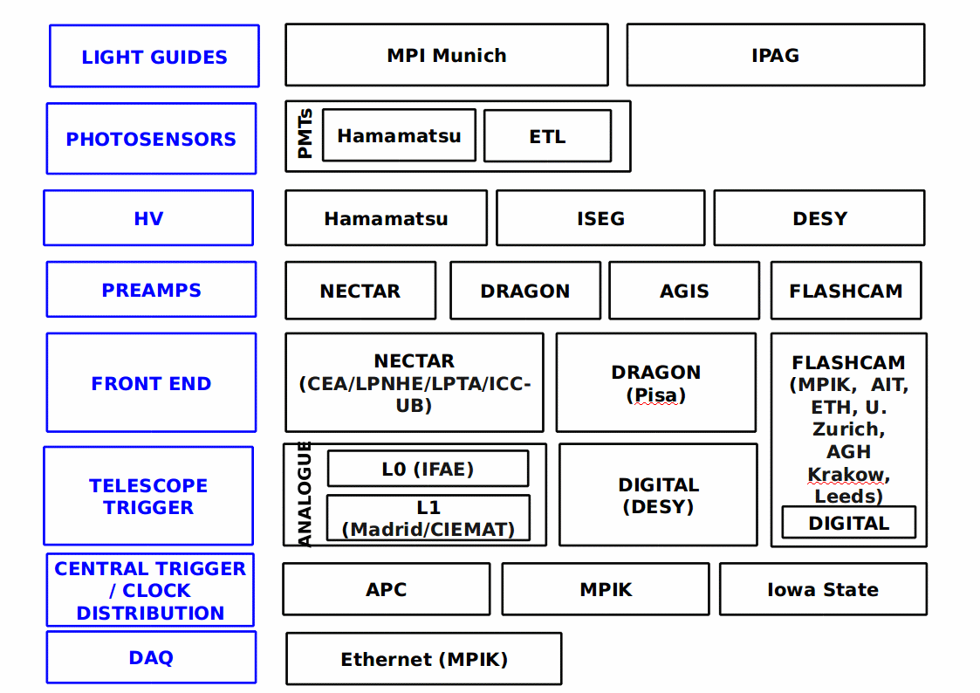Illustration 1: Sketch of possible electronics options (adapted from R. White)

Two different types of architecture have emerged, the “Cluster” architecture and the “Rack” architecture. More detailed descriptions are given below but one can easily identify common components. Thus the structure of this document is the following:
- The Mechanical Body, holding all camera elements and sealing the camera
- The Common Elements in the Front part of the camera (see the illustrations 2 and 3)
- The Cluster architecture
- The Rack architecture
- The Common Elements in the Rear part of the camera (see the illustrations 2 and 3)

The list of the common components is given in the chapters 3, 4 and 7. The two main architectures are illustrated below. For the Cluster architecture, most of the electronics is contained in the Front-End and is analogue. In contrary, for the Rack architecture, most of the electronic is contained in boards inserted in racks located at the rear of the camera and it is fully digital.

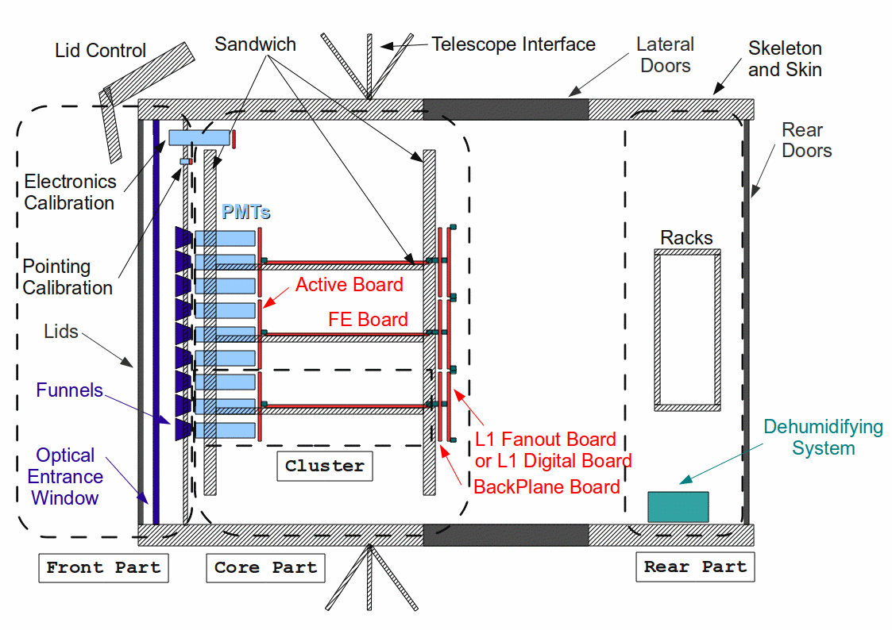Illustration 2: A possible Cluster architecture (not at scale)

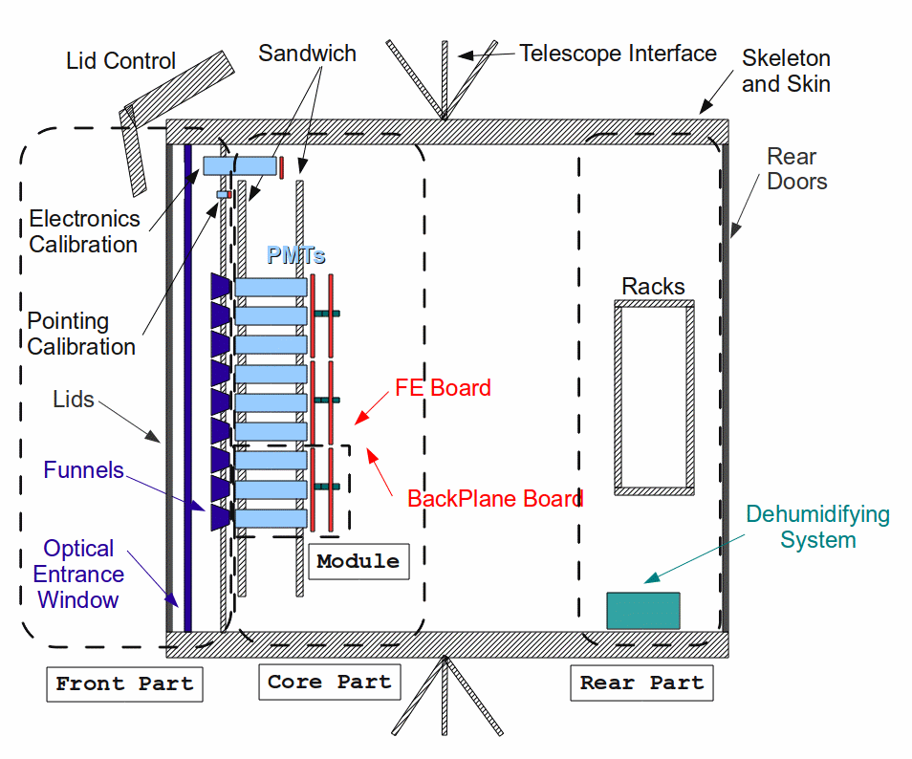Illustration 3: A possible Rack architecture (not at scale)

The Mechanical Body

Skeleton
Description
It consists on a rigid part of the camera on which all elements are mechanically fixed and thanks to which the camera is hold to the telescope structure.

Interfaces
- Skin: mechanical
- Sandwich: mechanical
- Entrance window support: mechanical
- Funnels support: mechanical
- Lids: mechanical
- Racks: mechanical
- Telescope: mechanical

Candidate
- LLR, Palaiseau, France

Skin
Description
It consists on the mechanical elements that seal the camera interior from the external environment. It contains also manual-opening doors to access to the camera interior. It allows to seal the camera and protect the instrumentation from the external environment.

Interfaces
- Skeleton: mechanical

Candidate
- LLR, Palaiseau, France

Lids
Description
It consists on the movable mechanical elements that seal the front part of the camera. They are automatised such that the DAQ can control them.

Interfaces
- Skeleton: mechanical
- Lid Control; electronic
- Pointing calibration: mechanical interface under study

Candidate
- LLR, Palaiseau, France

The Common Components in the Front Part

Entrance window
Description
This optical entrance window allows to seal the front part of the camera while minimising the optical loss of the Cherenkov light.

Interfaces
- Entrance Window Support: mechanical
- Funnel: optical

Candidates
- MPI, Munich, Germany

Entrance window support
Description
It holds the camera entrance window and avoids its too large gravitational bending.

Interfaces
- Entrance Window: mechanical
- Skeleton: mechanical

Candidates
- MPI, Munich, Germany

Funnel
Description
It consists on optical light concentrator allowing to reject Night Sky Background and albedo not coming from the dish and to increase to optical sensitive area of the focal plane.

Interfaces
- Funnel support: mechanical
- Entrance window: optical
- PMT: optical, mechanical under study

Candidates
- IPAG, Grenoble, France
- MPI, Munich, Germany

Funnel support
Description
It holds the funnels at the right position relative to the PMTs and allows an accurate positioning of the funnels between themselves.

Interfaces
- Funnels: mechanical
- Skeleton: mechanical
- Pointing calibration: mechanical

Candidates
- LLR, Palaiseau, France

Pointing calibration
Description
It consists on a set of instrumentation (LED flashers and their associated electronics, optics and mechanics) fixed to the funnel support allowing an accurate measurement of the pixels (entrance window of the funnels) position. It might be necessary to have an automatised system to open a space on the Lids surface to allow the light to pass through.
Interfaces
- Funnel support: mechanical
- Lids holes: optical, mechanical
- LV Power supply: energy
- Rack (Lid Control or Safety Control): electronic or Ethernet

Candidates
- None

Electronics calibration
Description
It consists on a set of instrumentation (PMT or other photo-sensor and its associated electronics and mechanics) fixed on the sandwich allowing to deliver an external trigger to the camera electronics chain for its calibration.

Interfaces
- Skeleton: mechanical
- LV Power supply: energy
- Rack: electronic or Ethernet

Candidates
- None

The Cluster Architecture

General view

This architecture is based on a pool of seven PMTs and its associated electronics into a so-called “cluster”. This cluster can be removed from the front of the focal plane facilitating the transportation, assembly and maintenance processes. The rear of the camera holds only the components of 'services', e.g. power supply, safety module, … The proposed designs of electronics are based on a analogue pipe-line of the signal processing using ASICs for the digitization. The possible candidates are the Dragon project, coordinated in Italy, and the Nectar project, coordinated in France. For the trigger solutions, both analogue and digital designs are under study.
A global sketch of interfaces can be found in section 9.1.

Core part

Mechanical cluster
Description
It consists on a set of mechanical pieces holding seven photo-sensors and its Front-End electronics. A full cluster should be removed from the camera front and the photo-sensor part (PMT and its associated electronics) can be easily separated from the Front-End electronics part.

Interfaces
- Sandwich: mechanical
- PMT: mechanical
- Active Board: mechanical
- Front End Board: mechanical
- Back Plane Board: electronic (connector fixed to the cluster making the connection between the Front End Board and the Back Plane Board)
- Front End Cooling: heat exchange under study
- Funnel: mechanical under study (a possible solution is to hold the funnels by this cluster)

Candidates
- LLR, Palaiseau, France
- Hamamatsu Company

Photomultiplier
Description
It is the photo-sensor type used for the MST camera.

Interfaces
- Mechanical Cluster; mechanical
- Funnel: optical
- Active Board: electronic and energy

Candidates
- Hamamatsu Company (R11920-100-01)

Active Board
Description
This electronic board hosts the HV distribution system and HV monitoring and slow control for the seven PMTs cluster. PMTs are welded on it. This board hosts also the pre-amplifier.

Interfaces
- PMTs: mechanical and electronic (welding)
- Mechanical cluster: mechanical
- Front End Board: electronic and mechanical (connector), energy
- Front End Cooling: heat exchange

Candidates
- Board: ISEG, contact Nectar project, coordinated in France
- Board: DESY, Hamburg, Germany
- Board: Hamamatsu Company
- Pre-amplifier: Uni Zurich, Switzerland
- Pre-amplifier: ICC-UB, Barcelona, Spain

Front-End Board
Description
This electronic board is the core of the MST camera electronics. It allows to produce the necessary information for the trigger, digitise the analogue signal of the PMTs once there is a trigger and send the data to the DAQ.

Interfaces
- Mechanical cluster: mechanical
- Active Board: electronic and mechanical (connector), energy
- Back Plane Board: mechanical and electronic (connector), energy
- Front End Cooling: heat exchange

Candidates
- Board: Dragon project, coordinated in Italy
- Board: Nectar project, coordinated in France
- L0/L1 trigger: IFAE, Barcelona, Spain
- L1 analogue sum: GAE-UCM, Madrid, Spain

Sandwich
Description
It consists on a set of mechanical pieces holding all the elements of the camera core.

Interfaces
- Mechanical Cluster: mechanical
- Front End cooling: mechanical
- Skeleton: mechanical
- Back Plane Board: mechanical
- L1 Fanout Board: mechanical

Candidates
- LLR, Palaiseau, France

Front-End Cooling
Description
This systems allows to evacuate the heat dissipated by the active elements of the camera core towards the exterior such that the electronics can work in optimal conditions.

Interfaces
- Sandwich: mechanical
- Active Board: heat exchange
- Front End Board: heat exchange
- Back Plane Board: heat exchange
- L1 Fanout Board: heat exchange
- LV Power Supply: energy under study
- Cooling Control: electronic
- Mechanical Cluster: mechanical

Candidates
- None

Backplane Board
Description
This board is the interface element between the removable clusters and the components fixed in the camera.

Interfaces
- Sandwich: mechanical
- Front End Board: mechanical and electronic (connector)
- L1 Fanout Board: mechanical and electronic (connector)
- DAQ: Ethernet/Optical fibre
- Safety Control: electronic or Ethernet/Optical Fibre
- LV Power Supply: energy

Candidates
- Dragon project, coordinated by Italy
- Nectar project, coordinated by France

L1 Fanout Board
Description
This board is one possible solution to manage the trigger in the camera. The second solution is presented in the next section. It allows to propagate the trigger data and the trigger decision within the camera.

Interfaces
- Back Plane Board: electronic and mechanical (connector), energy

Candidates
- CIEMAT, Madrid, Spain

L1 Digital Board
Description
This second solution for the trigger management allows to propagate the trigger data, to decide if there is a camera trigger and to propagate the trigger camera within the camera.

Interfaces
- Back Plane Board: electronic and mechanical (connector), energy

Candidates
- DESY, Hamburg, Germany

Rear part

Camera Central Trigger and Clock Distribution
Description
It allows an unambiguous tagging of events by the propagation of a unique event time for all cameras of the array.

Interfaces
- PC Server: Ethernet/Optical fibre
- LV Power Supply: energy
- Back Plane Board: electronic

Candidates
- APC, Paris, France

The Rack Architecture

General view
This architecture is based on a pool of twelve PMTs and its associated control electronics into a so-called “module”. This module can be removed from the rear of the focal plane facilitating the transportation, assembly and maintenance processes. The rear of the camera holds the main electronics components for the signal processing and the components of 'services', e.g. power supply, safety module, … The proposed design for this architecture is a full digital electronics made by the FlashCam project, coordinated in Switzerland and Germany.
Global sketch of interfaces can be found in section 9.2.

Front part

Photomultiplier
Description
It is the photo-sensor type used for the MST camera.

Interfaces
- Mechanical Cluster: mechanical
- Funnel: optical
- Active Board: electronic and energy

Candidates
- Hamamatsu Company (R11920-100-01)

Active Board
Description
This board contains the HV generation, control and monitoring and the pre-amplifier.

Interfaces
- Sandwich: mechanical
- PMT: mechanical and electronic (welding)
- Back Plane Board: mechanical and electronic (connector), energy
- Front End Cooling: heat exchange

Candidates
- Uni Zurich, Switzerland

Back Plane Board
Description
This board makes the shaping of the signal to send to the FADC board via CAT 5/6 cable, distributes the energy to the Active Board and the Slow Control informations.

Interfaces
- Active Board: mechanical, electronic and energy
- FADC Board: electronic (CAT 5/6 cable)
- Front End Cooling: heat exchange
- LV Power Supply: energy

Candidates
- Board: Uni Zurich, Switzerland
- Pre-amplifier: AGH, Cracow, Poland or Uni Zurich, Switzerland??
- CAT 5/6 interfaces: Uni Leeds, UK
- CAN interface: AGH, Cracow, Poland

Sandwich
Description
It consists of mechanical pieces supporting the modules that contains 12 PMTs, the Active Board and the Back Plane Board.

Interfaces
- PMT: mechanical
- Active Board: mechanical
- Back Plane Board: mechanical
- Front End Cooling: mechanical under study
- Skeleton: mechanical

Candidates
- Uni Zurich, Switzerland

Front End Cooling
Description
If necessary, this system would allow to evacuate the heat dissipated by the active elements of the module towards the exterior such that the electronics can work in optimal conditions.

Interfaces
- Sandwich: mechanical under study
- Active Board: heat exchange
- Back Plane Board: heat exchange
- LV Power Supply: energy under study
- Cooling Control: electronic

Candidates
- None

Rear part

FADC Board
Description
This electronic board allows to digitise the analogue signal coming from the pre-amplifier, starts the signal processing, and produce data for the camera trigger

Interfaces
- Rack: mechanical
- Back Plane Board: electronic (CAT 5/6 cables)
- LV Power Supply: energy
- Trigger Board: electronic
- DAQ: Ethernet/Optical fibre
- Rack Cooling: heat exchange

Candidates
- Board: AGH, Cracow, Poland; MPIK, Heidelberg, Germany
- Sector FPGA: IAAT, Tuebingen, Germany

Trigger Board
Description
This electronic board allows a high-level pattern recognition in a programmable way and delivers the camera trigger.

Interfaces
- Rack: mechanical
- LV Power Supply: energy
- FADC Board: electronic
- Clock Distribution Board: electronic
- DAQ: Ethernet/Optical fibre
- Rack Cooling: heat exchange

Candidates
- IAAT, Tuebingen, Germany; Uni Zurich, Switzerland

Clock Distribution Board
Description
It allows to generate a common clock based on a GPS allowing to avoid a array-wide clock distribution network.

Interfaces
- Rack: mechanical
- Rack Cooling: heat exchange
- LV Power Supply: energy
- Trigger Board: electronic

Candidates
- Uni Leeds and Leicester, UK; Uni Zurick, Switzerland

The Common Components in the Rear Part

DAQ
Description
It consists on a set of Ethernet switches allowing the transportation of RawData, Slow Control data and Monitoring data.

Interfaces
- Back Plane Board for the Cluster architecture: Ethernet/Optical fibre
- FADC and Trigger Board for the Rack architecture: Ethernet/Optical fibre
- Rack: energy
- PC Server: Ethernet/Optical fibre

Candidates
- MPIK, Heidelberg, Germany

Racks
Description
It consists on mechanical elements holding many different sets of electronic components, power supplies and some safety components.

Interfaces
- Skeleton: mechanical
- LV Power Supply: mechanical
- Environment Monitoring: mechanical
- Lid Control: mechanical
- Cooling Control: mechanical
- Safety Control; mechanical
- Dehumidifying System: mechanical
- Rack Cooling: mechanical
- Electronic and pointing Calibration: under study

Candidates
- LLR, Palaiseau, France

Rack Cooling
Description
It allows to extract the heat dissipated by all the active elements within the racks.

Interfaces
- LV Power Supply: energy under study
- Cooling Control: electronic
- All elements in racks: heat exchange
- Rack: mechanical

Candidates
- None

LV Power Supply
Description
It generates the Low Voltage needed by camera components.

Interfaces
- Rack: mechanical, energy
- All elements in racks: energy
- Back Plane Board: energy
- Rack Cooling and Front End Cooling: energy
- Pointing and Electronic calibration: energy
- DAQ: Ethernet/Optical Fibre
- Camera Central Trigger and Clock Distribution: energy

Candidates
- MPI, Munich, Germany?

Environment Monitoring
Description
It allows to collect the data from the Temperature, Pressure and Humidity (TPH) sensors distributed inside the camera.

Interfaces
- Rack: mechanical, energy
- Safety Control: electronic
- DAQ: Ethernet/Optical Fibre

Candidates
- None

Lid Control
Description
It allows to control the opening and closing of the camera lids and to monitor their status.

Interfaces
- Rack: mechanical, energy
- Safety Control: electronic
- DAQ: Ethernet/Optical Fibre
- Lid: electronic

Candidates
- None

Cooling Control
Description
It allows to control the system that regulation the heat extraction from the camera interior to the exterior.

Interfaces
- Rack: mechanical, energy
- Safety Control: electronic
- DAQ: Ethernet/Optical Fibre
- Rack and Front End Cooling: electronic

Candidates
- None

Safety Control

Description
It allows a camera supervision of safety aspects (TPH, electronic components modes, Lids modes, ...)

Interfaces
- Rack: mechanical, energy
- DAQ: Ethernet/Optical Fibre
- Dehumidifying System: electronic
- Back Plane Board for the Cluster architecture: electronic or Ethernet/Optical Fibre
- FADC Board for the Rack architecture: electronic or Ethernet/Optical Fibre
- Cooling Control: electronic
- Lid Control: electronic
- Environment Monitoring: electronic

Candidates
- None

Dehumidifying system
Description
It allows to control the humidity rate within the camera in order to increase the dew point.

Interfaces
- Rack: mechanical, energy
- DAQ: Ethernet/Optical Fibre
- Safety Control: electronic

Candidates
- MPI, Munich, Germany

Conclusions

This document can be considered as a basis for the next deliverables of the MST cameras: PBS and WBS, detailed description of the electronics scheme, detailed description of each components and of each interface, risk evaluation, … The next steps are the preparation of the communication schemes inside the camera for the signals used for the Slow Control and the data analysis, the document detailing each component and the one defining in detail the interfaces (exact type, constraints, ...). In particular, one should identify for each component the following items:
- detailed description and functionality
- specifications
- technical parameters (weight, dimension, power consumption, heat dissipation, environmental protection from EMI, humidity, temperature, failure rate, number inside the camera, type and number of connections)

The second conclusion concerns the identification of possible candidates for a mass production of the MST cameras. It appears clearly that some components suffer from a partial or total lack of design for CTA. Given the short agenda, these missing designs could lead to a potential issue to achieve our goals. A reflection should be engaged with the PO in order to be sure that technical teams work on these components.

Appendix

Sketch of interfaces for the Cluster architecture
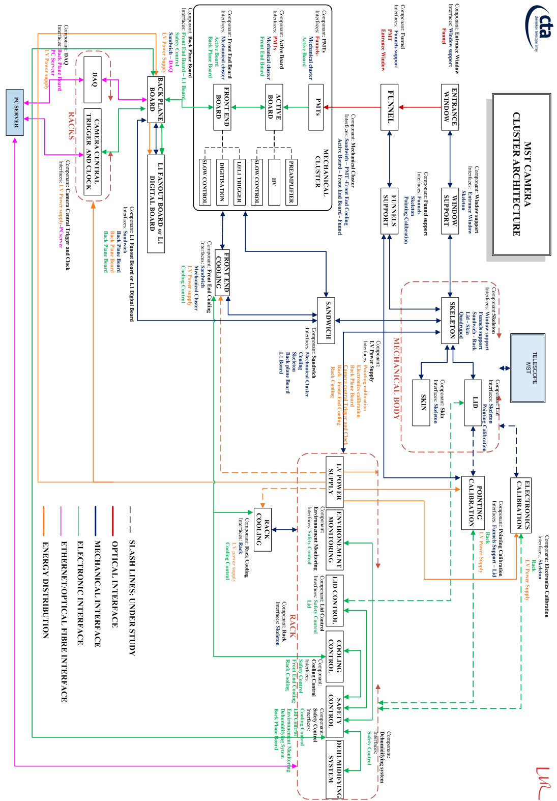

Sketch of interfaces for the Rack architecture
