Storage Management System

Overview
The purpose of the current StorageManagementSystem(SMS) implementation is to provide functionality for staging files from tape to disk storage (frontend cache) at the SEs of the Tier-1 sites. The staged files should be available in the disk cache for a certain pre-defined period of time, until a job needs to access them.
Currently the only client using the SMS is the WorkloadManagementSystem. Namely, when the JobSchedulingAgent detects a job that is assigned to process files only available on tape storage, it builds a dictionary with the SEs as keys and the list of LFNs as values, and sends a request for staging to the SMS along with this dictionary, passing the callback method that should be invoked when the SMS has finished processing the request. This in turn creates new records in the SMS database. The database structure will be explained briefly.
The actual method to be invoked via callback by the SMS is the updateJobFromStager method in the JobStateUpdateHandler service of the WMS.

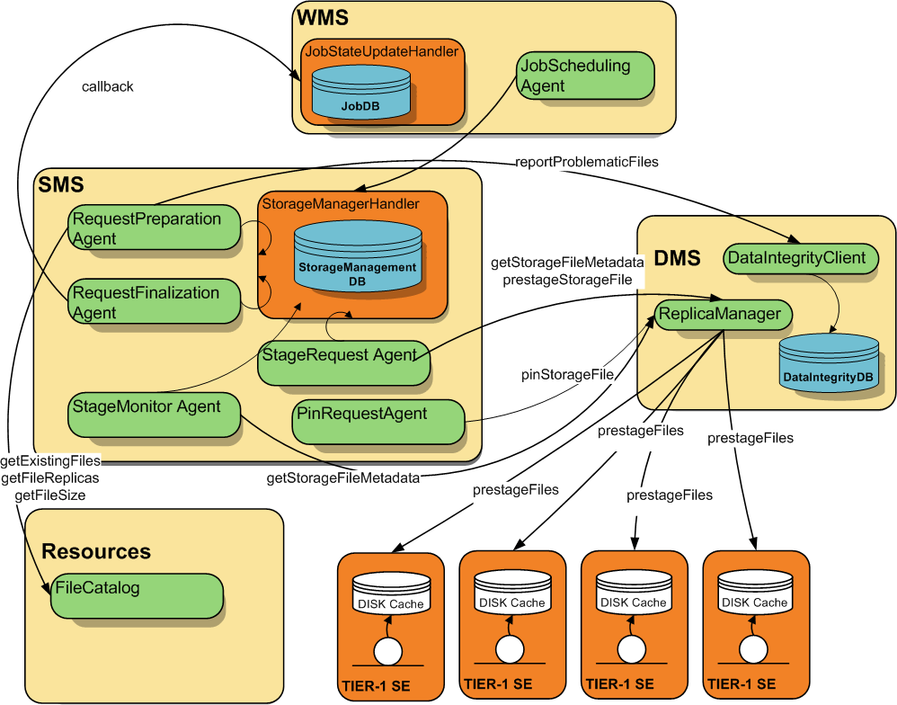
Figure 1 StorageManagementSystem overall design

The SMS (shown in Figure 1) is composed of the following Services, Agents and Database components:
- Service: StorageManagement/StorageManagerHandler
- Agent: StorageManagement/RequestPreparationAgent
- Agent: StorageManagement/RequestFinalizationAgent,
- Agent: StorageManagement/StageRequestAgent
- Agent: StorageManagement/StageMonitorAgent
- Agent: StorageManagement/PinRequestAgent
- Database: StorageManagement/StorageManagementDB

The StorageManagerHandler, like all of Dirac’s services, is implemented as a DISET (Dirac’s secure protocol) RPCServer that responds to requests coming from RPCClients. It directly manipulates the StorageManagementDB database. The E-R model of the StorageManagementDB is shown below (Figure 2).
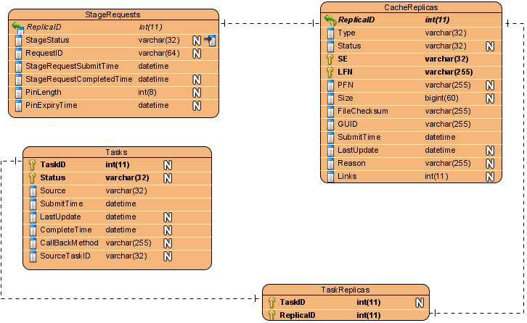
Figure 2 E-R model of StorageManagementDB
The database consists of 4 tables.
- The Tasks table contains records for all the tasks that have requested files to be staged from tape. Information is kept on the source (the actual component) of the request as well as the callback method that should be invoked once the task is marked as ‘Done’.
- The CacheReplicas stores information on all the replicas that are scheduled to be pre-staged on the SE disk cache. This includes file information on the actual SE where the file resides, the LFN, PFN, GUID, Checksum as well as Size of that file, mapped to an assigned ReplicaID.
- The TaskReplicas table maps the TaskIDs from the Tasks table to the ReplicaID from the CacheReplicas table. Two triggers are responsible for incrementing/decrementing the CacheReplicas Links field for the corresponding ReplicaID, whenever there is an insertion/deletion on this table.
- The StageRequests table contains the pre-stage RequestIDs for each of the replicas, along with information on the pin length, pin expiry time, as well as the staging status.
Below are explained the roles of the agents involved in the preparation, pre-staging of files, updating the relevant database tables, and informing the interested clients in the outcome of the process.

RequestPreparationAgent:
It obtains the replicas with a status=’New’ from the CacheReplicas table. Subsequently it checks whether the obtained LFNs are properly registered in the FileCatalog and reports on the missing files (if any). It also performs additional checks on the file size of the obtained LFNs, as well as the number of registered physical replicas, and reports the problematic files to the DataIntegrityClient for further inspection and correction. For the non-problematic files, the CacheReplicas table is updated with information on the PFN, Size and Status (=’Waiting’) for each record of a replica that is ‘New’. In other words, this agent is responsible for managing the New->Waiting transition of the CacheReplicas entries.

StageRequestAgent:
Before attempting to submit staging requests, this agent checks the SE space usage by obtaining a list of the Replicas which have already been submitted for staging (therefore already “pinned”). Currently the space usage is calculated by simple addition of the file sizes of these submitted replicas, without taking into account their expiry time. In case there is not enough space to stage all the necessary files, only a subset is chosen, and the integrity of the eligible files is checked. Integrity checks cover:
- reporting per file if the PFN SE size does not match the FileCatalog one
- reporting per file if the PFN has been Lost by the SE
- reporting per file if the PFN is declared Unavailable by the SE
- reporting per file if the PFN does not exist (returns status Failed when queried) in the SE
For such pathologies as above, the Status of the replicas in CacheReplicas is updated to ‘Failed’, along with the stated reason.

The remaining “sane” list of replicas with Status=’Waiting’ is grouped by SEs and pre-stage requests are submitted for every SE separately. The ReplicaManager is contacted for the actual submission of the pre-staging. It implements a simple wrapper around the SE functionality for pre-staging. The default (pin) lifetime of the files is 7 days. The CacheReplicas table’s records are updated accordingly for the eligible replicas, with a Status change: Waiting->StageSubmitted.

StageMonitorAgent
This agent monitors the status of all replicas with Status=’StageSubmitted’ in the CacheReplicas table. It does so by interrogating the ReplicaManager for metadata on the monitored files. In case of ‘Failed’ reply, the status of the failed replicas is updated in the CacheReplicas table. In case of ‘Successful’ reply, the StageRequests as well as the CacheReplicas records are updated with Status=’Staged’ for the appropriate records related to the successful replicas.

RequestFinalizationAgent
This agent checks for the tasks with Status=’Failed’ and performs callback to the appropriate requesters. Subsequently, it removes such tasks from the Tasks table. It selects all the tasks with ‘StageCompleting’ status and checks whether all the associated files are staged.

Side note: the updateStageCompletingTasks of StorageManagementDB.py is a bit fishy to me. It looks for ‘StageCompleting’ tasks before updating their status to ‘Staged’. However, I don’t see such a Status (‘StageCompleting’) anywhere else in the workflow. This might be the cause of some problems with tasks remaining in ‘StageSubmitted’ state indefinitely.

Callbacks are invoked back to the sources for all the ‘Staged’ tasks. Only for the successful callbacks, the Tasks table is cleaned-up for the respective tasks. If there are no more associated Tasks for a particular replica (links), the respective replica entries are removed from CacheReplicas and StageRequests tables.

Side note: clearReleasedTasks method is not used at all. It queries for tasks with Status=’Released’(?) and removes them from the table.

PinRequestAgent
This agent retrieves all replicas with ‘Staged’ status and issues pinning of all corresponding PFNs at the appropriate SE. The SRM interface is used to directly issue a .pinFile request.

Side note: The insertPinRequest is still not implemented, probably a separate table is planned to be developed for such requests.

It is crucial to follow the state transitions of the Replicas, Requests, and Tasks that are part of the SMS. Below are given their state machines respectfully.

State Machine: CacheReplicas.Status

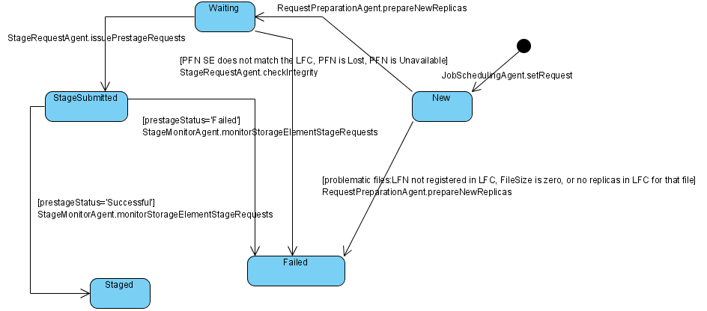

State Machine: StageRequests.StageStatus
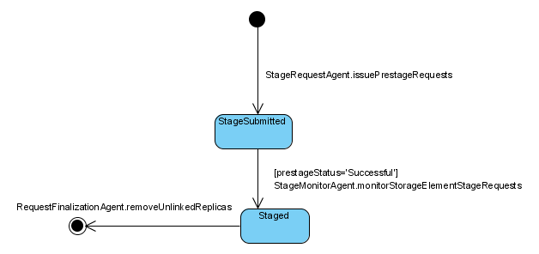
The removal of records from the StageRequests table occurs for those records where the associated replicas (ReplicaID) have Links=0 in the CacheReplicas table.

State Machine: Tasks.Status
The Tasks Status records should be intact with the CacheReplicas Status fields accordingly. However, there seems to be a problem with the state transition StageSubmitted->Staged. (See Side noteSide note in RequestFinalizationAgent section) In the current implementation, a task can get into a Staged state only if the corresponding replicas for that task are already in a state Staged, at the moment that the setRequest method is called by the JobSchedulingAgent (the only “client” for the SMS so far, as stated above). This is probably why manually resetting the Status to ‘New’ solves the problem temporary.

