Jamboree LHCB – Dinner information
On Monday 7th March at 20:00

Restaurant « Le Baronn »
2, rue des Trois Maries,
69005 Lyon
Tel : +33 (0)4 78 37 95 93

Localisation
The restaurant is localized in “Vieux Lyon” area, near “Saint Jean” Cathedral.

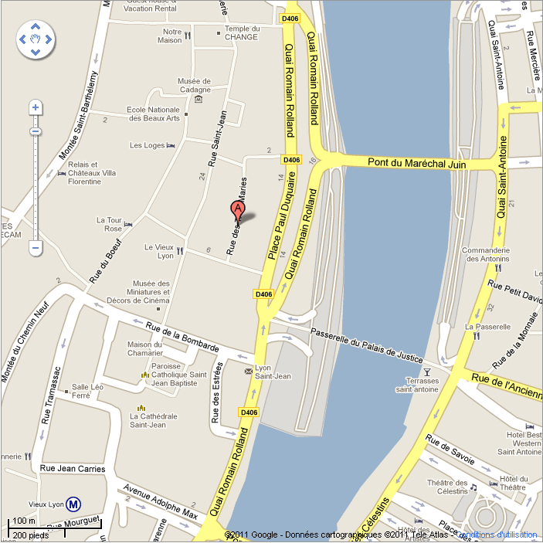

How to reach the restaurant
By public transport, you must reach the “Lyon 5ième – Vieux Lyon” stop from Metro D and then go to the restaurant by foot by taking “Saint Jean” street.

According to your localization, you can easily obtain a detailed route to Vieux Lyon from TCL web page: http://www.tcl.fr/index.asp?page=travel

From CC-IN2P3
Take first the Tramway T1 (from University at 200m of CCIN2P3) to “Guillotière” stop and then take the Metro D.

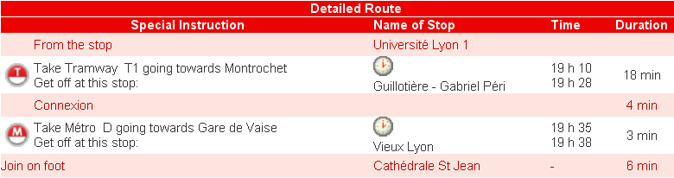

Public transport map

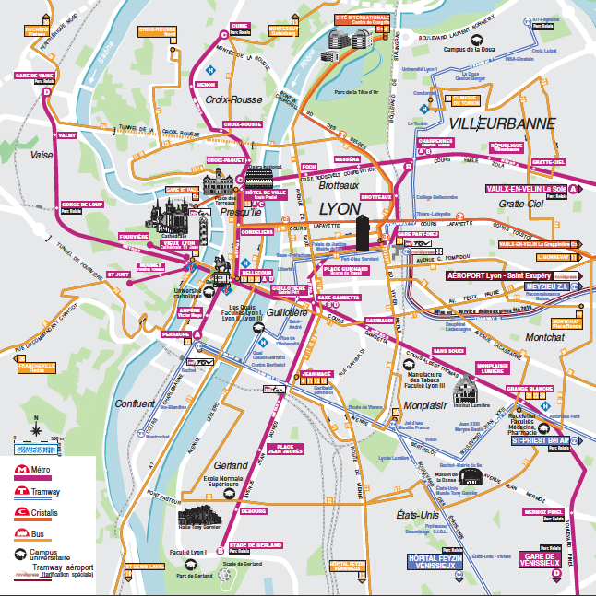
CCIN2P3
Vieux Lyon

