Hexagonal SiGe alloy on Si substrate for Laser
Aamir Ejaz a, Joséphine Pelenc a, P. Regreny a, S. Walia b N. Chauvin a & J. Penuelas a
a ECL Lyon, CNRS, INSA Lyon, UCB Lyon 1, CPE Lyon, INL
b Royal Melbourne Institute of Technology, Australia
Silicon is considered the backbone of the modern telecommunications industry; however, it cannot be used directly as an efficient light source due to its indirect bandgap [1]. Recent studies have shown that Si/SiGe alloys can potentially exhibit direct-bandgap behaviour when their crystal structure is transformed from the conventional cubic phase to the hexagonal phase [2]. This development opens exciting prospects for the realization of silicon-compatible light emitters and lasers, which are highly desirable for future integrated optoelectronic technologies and high-speed data transfer.
In this project, we aim to realize hexagonal SiGe (Hex-SiGe) through the epitaxial growth of III-V nanowires, which act as crystal templates, followed by the growth of a hex-SiGe shell using the crystal phase transfer method. A major objective of the work is to investigate how quantum confinement, strain, and doping influence the optical properties of the alloy, with the goal of tuning its bandgap toward the telecommunication wavelength range (1.2 to 1.6 μm). These effects are particularly important because hex-SiGe may revert to indirect-bandgap behaviour at higher Si compositions (typically for Si ≥ 35%) [2], making band structure engineering a key challenge.
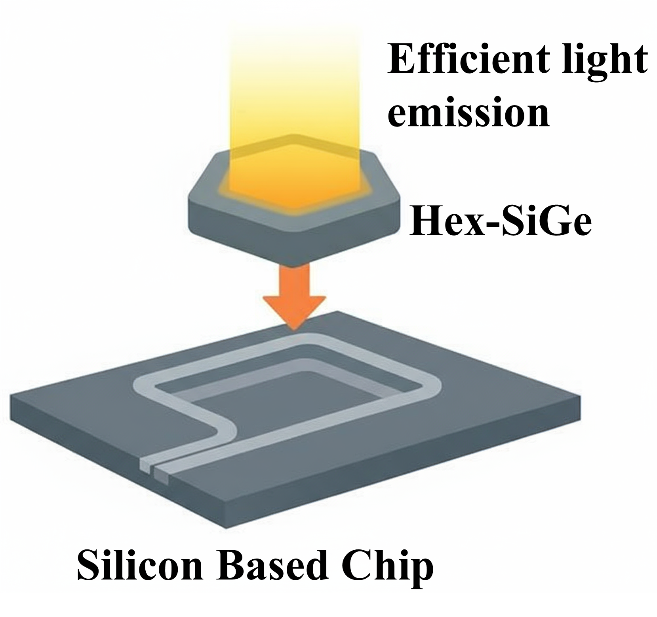
In addition to material synthesis, the project also aims to explore the morphological design of nanowires so that they can function as optical cavities for laser operation, for example through suitable etching and geometry control. The produced nanowires will be investigated using a combination of structural, morphological, optical, and electronic characterization techniques.
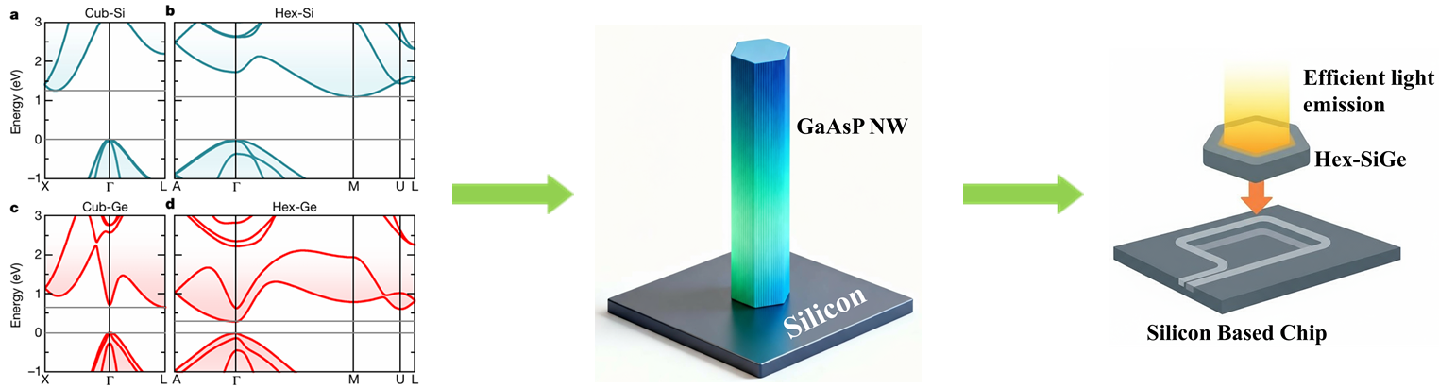
- Noskov. (2025). arXiv preprint arXiv:2507.19001.
- Fadaly et al. Nature 580, 205 (2020)

