Experimental study of the optical response of gold nanobipyramids used as photoelectrochemical electrodes
Youn NOH¹, Christophe BONNET¹, Emmanuel COTTANCIN¹, Michel PELLARIN¹, Elie BOU-RAHHAL², Frédéric LEROUGE², Christophe BUCHER²
¹ Institut Lumière Matière (iLM), Université Claude Bernard Lyon I, Villeurbanne (France)
² Laboratoire de Chimie de l’École Normale Supérieure de Lyon (LCENSL), Lyon (France)

Keywords: plasmonics / nanobipyramids / electrochemistry / nanosensing
Gold nanoparticles are a versatile tool for probing and monitoring their local environment. On the one hand, they exhibit optical extinction dominated by Localised Surface Plasmon Resonance (LSPR) whose spectral maxima and width are sensitive to their local environment. On the other hand, selective electrochemical reactions can be driven on electrodes with gold nanoparticles deposited on their surface, allowing, for example, the detection of heavy metal pollutants in water.
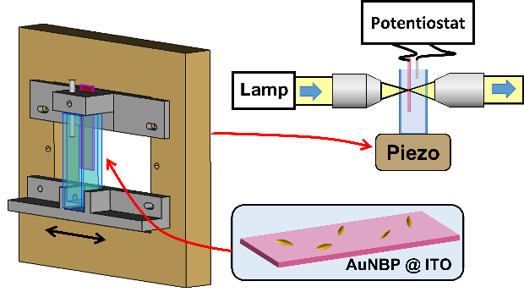
In this work, we have developed a setup combining Spatial Modulation Spectroscopy (SMS), which allows optical measurements on single nano-objects, and voltamperometric measurements (figure (a)). Synthesised Au bipyramids (100 nm in length) have been grafted by silanisation onto an ITO-coated glass substrate. This sample is used as the working electrode in a 0.1 M KNO3 electrolyte (counter electrode: Pt wire) in a 2 cm thick glass cell. The cell is mounted on an open vibrating piezoelectric stage and inserted into a home-built confocal microscope. Light from a collimated white lamp is focused onto the sample and collected in a spectrophotometer (wavelength range: 450-950 nm). Signals from the spectrophotometer are processed with a lock-in amplifier system to extract the extinction signal of individual nanoparticles. SEM images of the samples were also taken.
(a)
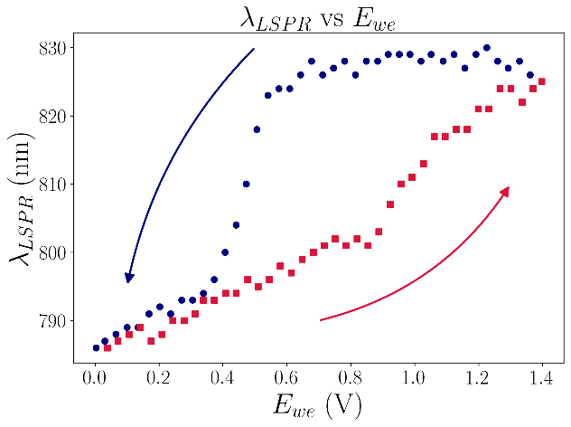
We performed potential cycling and recorded the optical response of Au bipyramids. The plasmonic responses to the stepwise applied potential show a redshift up to 40 nm (typical result in figure (b)) and a decrease in intensity as the potential is increased from 0 to 1.4 V/Ag-AgCl (KCL sat.), which is consistent with the formation of a gold oxide layer on the surface of the nanoparticle. Analysis of the relationship between the potentials at which the gold oxidation reaction occurs and the associated change in the spectral characteristics of individual gold nanoparticles could enable the detection of deposited metallic contaminants.
(b)
[1] J.-M. Rye, C. Bonnet, F. Lerouge, M. Pellarin, J. Lermé, S. Parola, E. Cottancin, Single gold bipyramids on a silanized substrate as robust plasmonic sensors for liquid environments. Nanoscale 2018, 10, 16094 -16101.
[2] V. Wieczny, Study of plasmonic and photoelectrocatalytic properties of gold nanoparticle modified electrodes, PhD Thesis in Chemistry, 2022, ENS Lyon.
Contact e-mail: youn.noh@univ-lyon1.fr

