GIF Ecole 2025 : Stratégie Européenne : Plan A et Plan B


The European Strategy for Particle Physics (ESPP) defines the research and investment priorities for the coming decades, balancing scientific ambition, technological innovation, societal impact, and geopolitical realities. This survey, conducted among 14 participants at the Gif 2025 School (IPHC Strasbourg 17-21 November 2025) https://indico.in2p3.fr/event/36304/ ., explores preferences, strengths, and weaknesses of two main approaches: Plan A, focused on mature, large-scale projects with broad physics programs, and Plan B, which prioritizes innovative, alternative technologies and aggressive R&D.
https://qruiz.net/Q/?ehojnr

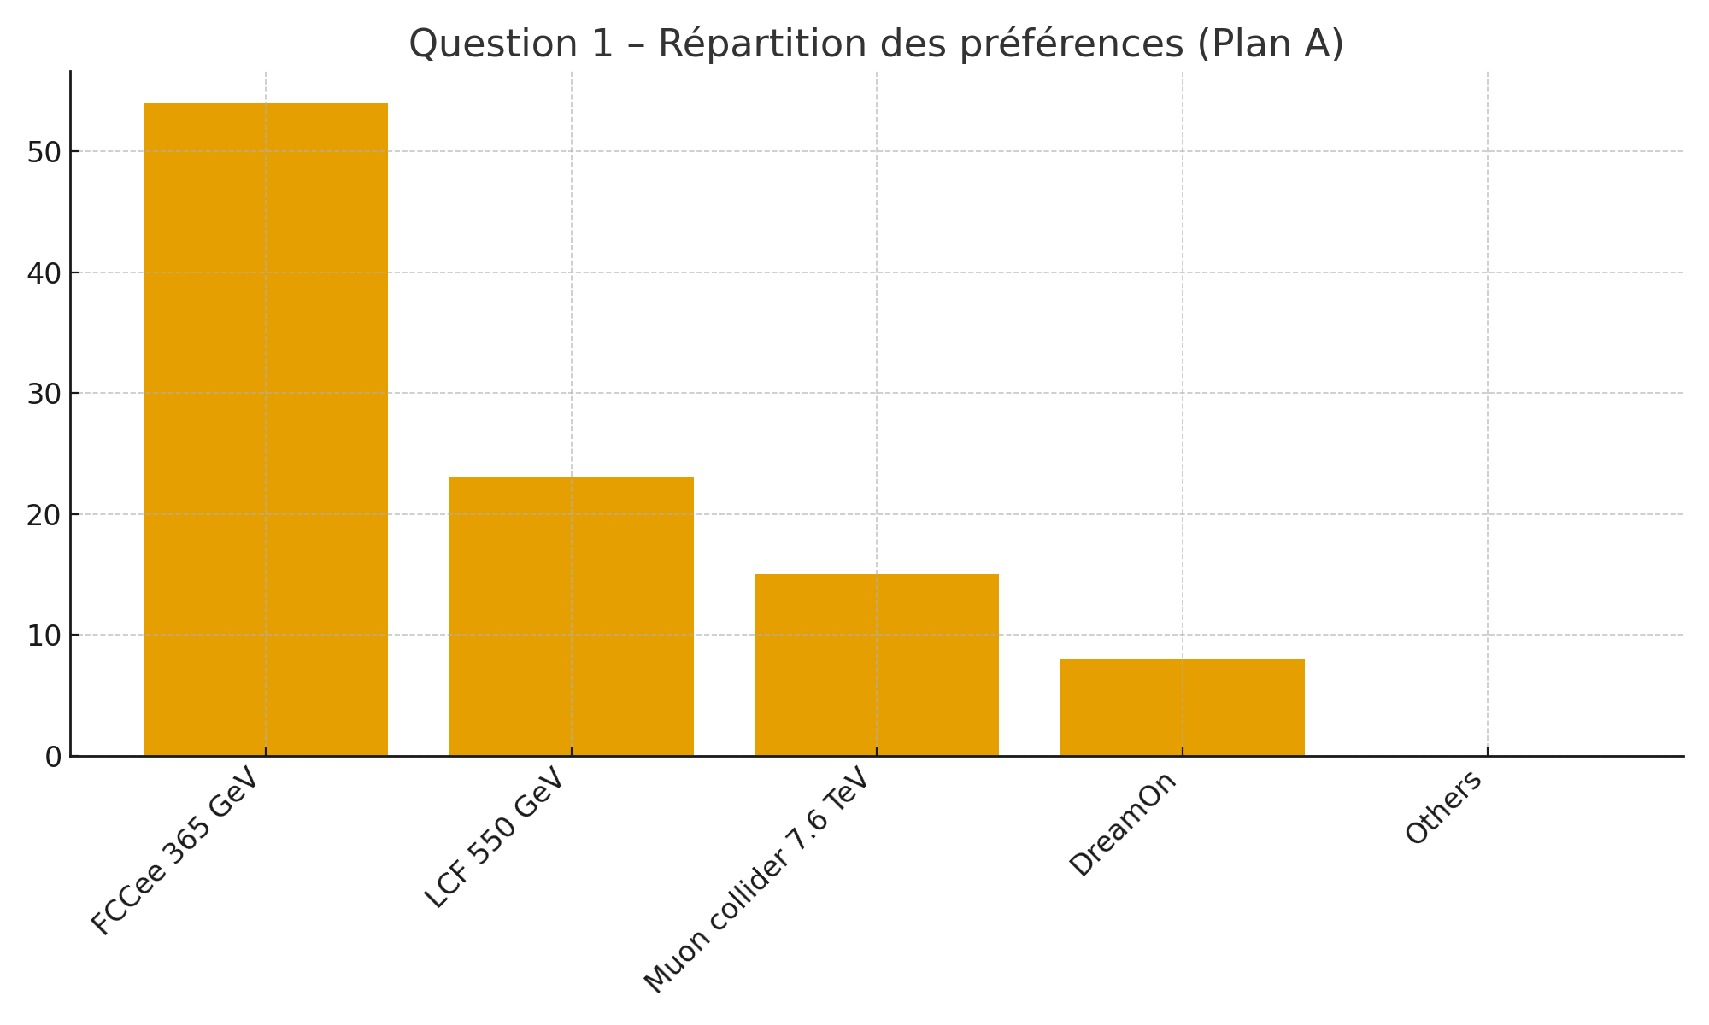
1. Plan A – Preferred main priority
Option | Votes | %
FCCee 365 GeV | 7 | 53.8%
LCF e+e- 550 GeV | 3 | 23.1%
muCollider 7.6 TeV | 2 | 15.4%
DreamOn (R&D) | 1 | 7.7%
CLIC/LHeC/FCChh/LEP3 | 0 | 0.0%

The results show a clear preference for the Plan A scenario based on FCCee 365 GeV, supported by more than half of the participants (54%).
LCF e⁺e⁻ 550 GeV comes next (23%), while the 7.6 TeV muon collider garners minority support (15%) .
No other major project (CLIC, LHeC, FCChh, LEP3) attracted significant votes.
A small fraction (8%) favoured an aggressive R&D strategy (‘DreamOn’).Overall, the community represented in this survey therefore strongly converges towards a circular e⁺e⁻ project as the first option for Plan A.
In conclusion: The results show a clear preference for FCCee 365 GeV (54%). LCF 550 GeV follows with 23%, then the muon collider 7.6 TeV (15%). DreamOn obtains 8%, with the rest being negligible.

2.Perceived strengths of Plan A
The strengths focus on: (1) a rich physics programme, (2) solid technological maturity, (3) significant societal benefits.
The responses highlight several major strengths attributed to Plan A, broadly converging on three dominant themes:
- the quality of the physics programme, described as the richest and most mature, offering high-precision measurements and exceptional potential for FCChh preparation;
- technological maturity and infrastructure, with a project considered to be consolidated, extensible, technically well-known, and supported by a large community;
- societal and industrial benefits, including jobs, greater visibility of feasibility, and transferable technological know-how.
Some answers also highlight more individually the advantage of low e⁺e⁻ collision noise, the potential linearity of certain options, or broader societal benefits

3. Perceived weaknesses of Plan A
The main weaknesses are cost, long time scale, technical risks, and the political/environmental context. The weaknesses mentioned fall into four main categories.
- The cost, which is regularly mentioned, is perceived as high, potentially difficult to defend politically, and associated with considerable uncertainty.
- The timescale, which is described as long, uncertain, and likely to create a gap between scientific ambition and the political or environmental context.
- Technological feasibility, perceived as not fully achieved for certain options, or presenting technical risks.
- External issues, such as environmental impact, geopolitical crises, or difficulties in convincing a wider scientific audience of the programme's relevance.
Finally, some respondents mention the potentially limiting effect on R&D innovation if Plan A absorbs too many resources.

4. Plan B – fall-back solution
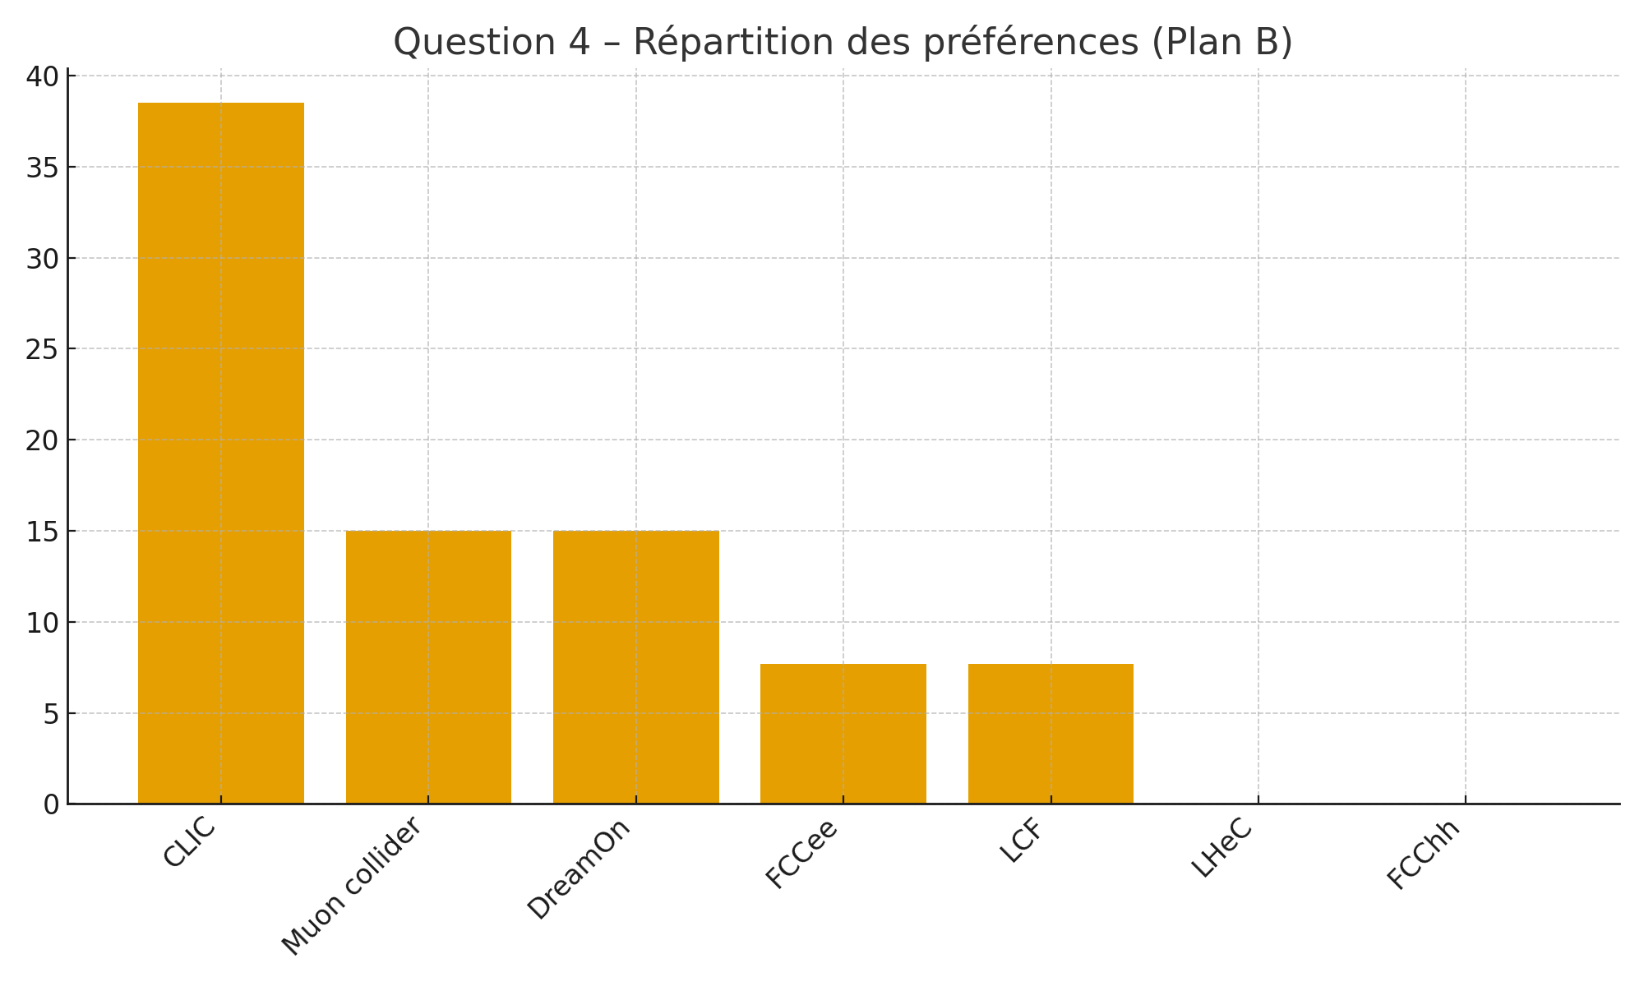
Option | Votes | %
CLIC (high energy e+e-) | 5 | 38.5%
muCollider 7.6 TeV | 2 | 15.4%
DreamOn (R&D) | 2 | 15.4%
LHeC 1.2 TeV | 1 | 7.7%
FCCee 365 GeV | 1 | 7.7%
LCF e+e- 550 GeV | 1 | 7.7%

The responses show a greater dispersion of preferences for Plan B, but with a clear trend:
- CLIC (high-energy e⁺e⁻) dominates the alternatives, with 38.5% of the votes, making it the preferred fallback project.
- The muon collider and DreamOn (aggressive R&D) options each obtained 15% of the votes, highlighting significant interest in emerging technologies.
- FCCee and LCF obtained only marginal support (7.7% each).
- The LHeC and FCChh options attracted very little support.
Plan B response is therefore structured around a compromise between a high-energy linear collider and innovative R&D programmes.

5. Plan B perceived strengths
Participants attribute several distinctive strengths to Plan B, they should be attributed to various projects, but a general synthesis is also worth contemplating.
- A physics programme that remains robust, although less extensive than that of Plan A, but still scientifically relevant.
- The possibility of promoting emerging technologies, particularly for muon colliders, plasma accelerators and innovative superconductors.
- Better potential control of costs and energy consumption, especially for certain linear or more compact designs.
- Perceived simpler or faster feasibility for certain projects, as well as an attractive innovation dimension for the community.
The strengths include: a still robust programme, the opportunity to support emerging technologies, and better potential control of costs and energy consumption. The ‘technological bridge’ dimension and the potential for R&D exploration are also highlighted.

6. Faiblesses perçues de Plan B
Several reservations have been expressed regarding Plan B.
- Lower energy levels or less competitiveness compared to FCC scenarios, reducing certain scientific ambitions.
- The limited maturity of the associated technologies, particularly for emerging options (muon collider, plasma), which are perceived as risky or too far removed from concrete implementation.
- A risk to the dynamics of the field, in the absence of a clear flagship project after HL-LHC, which could lead to weariness or fragmentation within the community.
- The perception of costs that are still high or poorly controlled, depending on the options.
- A scientific scope perceived as less flexible or less broad, limiting the diversity of topics that can be explored.
In conclusion, the weaknesses mentioned are: lower energy achieved, immature technologies, risk to the dynamics of the field, and costs that are sometimes still high. Some individual comments point to a lack of scientific narrative for certain projects (e.g. QCD/LHeC) and a difficulty in convincing the public or decision-makers.

Annex: raw answers
=== Résultats du sondage ===
Titre: Quizz on ESPP projects : Plan A / B
Code: lYSxCpvBUF
Date export: 21/11/2025 08:39
Nombre de participants: 14

Question #7237: Plan A Favourite Main Priority
Type: radio
Statistiques:
- FCCee 365 GeV: 7 (53.8%)
- LCF e+e- 550 GeV: 3 (23.1%)
- CLIC (high energy e+e-): 0 (0.0%)
- LHeC 1.2 TeV: 0 (0.0%)
- FCChh 85 TeV: 0 (0.0%)
- LEP3 230 GeV: 0 (0.0%)
- muCollider 7.6 TeV: 2 (15.4%)
- DreamOn invest in aggressive R&D: 1 (7.7%)

Réponses individuelles:
- : FCCee 365 GeV (18/11/2025 17:19)
- : FCCee 365 GeV (18/11/2025 17:21)
- : LCF e+e- 550 GeV (18/11/2025 17:36)
- : muCollider 7.6 TeV (18/11/2025 17:38)
- : muCollider 7.6 TeV (18/11/2025 17:41)
- : FCCee 365 GeV (18/11/2025 17:41)
- : FCCee 365 GeV (18/11/2025 17:42)
- : DreamOn invest in aggressive R&D (18/11/2025 17:43)
- : LCF e+e- 550 GeV (18/11/2025 17:49)
- : FCCee 365 GeV (18/11/2025 17:54)
- : LCF e+e- 550 GeV (19/11/2025 12:07)
- : FCCee 365 GeV (19/11/2025 12:37)
- : FCCee 365 GeV (21/11/2025 08:27)

==================================================

Question #7238: The strengths of plan A (can give several, up to 3)
Type: text
Réponses individuelles:
- : (18/11/2025 17:13)
- : Best physics programme and measurements useful for FCChh (ultimate physics programme imo) (18/11/2025 17:19)
- : Mature; extensible; rich physics programme (18/11/2025 17:21)
- : lower power, cost and tunnel length and high energy compare with fcc (18/11/2025 17:36)
- : Search of New physics with know energy (18/11/2025 17:38)
- : Largest community, R&D almost done (18/11/2025 17:41)
- : Broad physics program, paving infrastructure for hh, well known technology (18/11/2025 17:41)
- : Large physics opportunities (18/11/2025 17:42)
- : Increase knowledge on technics, possible outcomes for society, better visibility for feasibility (18/11/2025 17:43)
- : Clearner signal due to ee collision and high energy (18/11/2025 17:49)
- : , Ambitious, Best Physics programm (most important criteria), create jobs, (18/11/2025 17:54)
- : Linear, step-by-step (19/11/2025 12:07)
- : Broad physics program and well consolidated project (19/11/2025 12:37)
- : physics program (21/11/2025 08:27)

==================================================

Question #7239: The weaknesses of plan A
Type: text
Réponses individuelles:
- : (18/11/2025 17:13)
- : Expensive (18/11/2025 17:19)
- : Hinders agressive R&D for muon collider/plasma wakefield/room-temperature superconductors/etc (18/11/2025 17:21)
- : the technology is not mature (18/11/2025 17:36)
- : Feasability (18/11/2025 17:38)
- : Long Time unexpectation (18/11/2025 17:41)
- : Large timescale (18/11/2025 17:41)
- : Cost, difficulty to convince people and politics, small experiments should still have funding (18/11/2025 17:42)
- : Time scale limit that is needed is hard to define (18/11/2025 17:43)
- : Environnemental cost (18/11/2025 17:49)
- : Geopolitical crisis, wars, global warming for the installation (18/11/2025 17:54)
- : Cost uncertainty, linear (19/11/2025 12:07)
- : Phyiscs goals not sufficiently contextualised for other scientists, governements and larger audience (19/11/2025 12:37)
- : cost (21/11/2025 08:27)

==================================================

Question #7240: Plan B Alternative choice of a major project
Type: radio
Statistiques:
- FCCee 365 GeV: 1 (7.7%)
- LCF e+e- 550 GeV: 1 (7.7%)
- CLIC (high energy e+e-): 5 (38.5%)
- LHeC 1.2 TeV: 1 (7.7%)
- FCChh 85 TeV: 0 (0.0%)
- LEP3 230 GeV: 0 (0.0%)
- muCollider 7.6 TeV: 2 (15.4%)
- DreamOn invest in aggressive R&D: 2 (15.4%)

Réponses individuelles:
- : CLIC (high energy e+e-) (18/11/2025 17:19)
- : DreamOn invest in aggressive R&D (18/11/2025 17:21)
- : muCollider 7.6 TeV (18/11/2025 17:36)
- : CLIC (high energy e+e-) (18/11/2025 17:38)
- : CLIC (high energy e+e-) (18/11/2025 17:41)
- : CLIC (high energy e+e-) (18/11/2025 17:41)
- : FCChh 65 TeV (18/11/2025 17:42)
- : FCCee 365 GeV (18/11/2025 17:43)
- : CLIC (high energy e+e-) (18/11/2025 17:49)
- : DreamOn invest in aggressive R&D (18/11/2025 17:54)
- : muCollider 7.6 TeV (19/11/2025 12:07)
- : LHeC 1.2 TeV (19/11/2025 12:37)
- : LCF e+e- 550 GeV (21/11/2025 08:27)

==================================================

Question #7241: The strengths of plan B
Type: text
Réponses individuelles:
- : (18/11/2025 17:13)
- : Still a good physics programme (18/11/2025 17:19)
- : Give a chance to emerging techs (muon collider/plasma wakefield/room-temperature superconductor/etc) (18/11/2025 17:21)
- : Lowest power and cost consumption and tunnel length (18/11/2025 17:36)
- : Precision measurement (18/11/2025 17:38)
- : Easy to build (18/11/2025 17:41)
- : New technologies to develop (18/11/2025 17:41)
- : Physics opportunities, challenge (18/11/2025 17:42)
- : Green lights (18/11/2025 17:43)
- : High energy (18/11/2025 17:49)
- : Push R&D until we can build something big (18/11/2025 17:54)
- : Muons, R&D (19/11/2025 12:07)
- : Feasible, interesting, bridge, innovative (19/11/2025 12:37)
- : physics program (21/11/2025 08:27)

==================================================

Question #7242: The weaknesses of plan B
Type: text
Réponses individuelles:
- : (18/11/2025 17:13)
- : Lower energies achieved than FCC (18/11/2025 17:19)
- : Risky: no clear plan for post-HL-LHC flagship collider (18/11/2025 17:21)
- : the technology is far away from mature (18/11/2025 17:36)
- : Lower flexibility in physics subjects (18/11/2025 17:38)
- : Expensive (18/11/2025 17:41)
- : Less large energy scale (18/11/2025 17:41)
- : Technology does not exist yet, cost (18/11/2025 17:42)
- : Hard to define (18/11/2025 17:43)
- : Less matured (18/11/2025 17:49)
- : Lassitude of the field if no new experiences happen (18/11/2025 17:54)
- : R&D (19/11/2025 12:07)
- : The narrative on QCD/LHeC suffers of a global ignorance on what strong matter/interactions are. (19/11/2025 12:37)
- : cost (21/11/2025 08:27)

- https://qruiz.net/Q/?ehojnr

The synthesis has been processed with the help of ChatGPT/MistralAI, but the journey Strasbourg-Marseille in TGV was long, so it is not only counting and IA.

