**Akira Comments:**

...In Fig.2 and Fig.4, the relative difference in high mass data is one order of magnitude smaller. What makes this difference? Béla was wondering the same thing.

* Much better agreement now (Result of rescaling the grand spectrum, a slightly different frequency values, and discarding some raw spectra based on the magnetic field values).

.1) Motivation of this work: "reproduce axion analysis and then analyse the same data for dark photons" needs to be clarified in "Introduction". Now, it is written separately in Sec 3 and 5.

- Implemented.

2) Why not showing the DP analysis result exactly in the same way as axions, before converting to the format of existing DP paper?

- Implemented

3) l.46, modelled by the dielectric loss parameter --> effectively included (?)

- Yes (Reworded)

4) Short description of DAQ (100 us FTT + averaging or summing up over 15 minutes) for one raw power spectrum would be educative, which could be a FAQ in conferences. This is related to l.74-75, "integration time of the spectra", because integration time over FFT linearly decrease the noise while the averaging and rebinning does it in sqrt, which is the one written here.

- Implemented

5) In Eq. (2), what is |g_{a\gamma}|^{\ref}? Also, I spent 30 seconds to recall 1.645 as the one-side 95% CL value...a description next to 95% CL?

- Technically the anomaly ratio E/N = 0.92 is fixed for calculating a reference signal power, and g_{a\gamma}|^{\ref} is the coupling related to the fixed value of C_a_gamma. Now there is a short text to explain the connection of 95% with 1.645 sigma.

6) l.171, E_{R} is the field excited by the receiver system --> accepted by? Because CB200 booster body itself can excite all the polarisation of TE11, only the one having Ey is transferred to the rectangular waveguide and the coaxial cable and the others are reflected back to the booster (resonating inside)

- The description is updated on the note.

For the dark photon analysis, what matters is only that the boost factor (that is calculated for the axion case) is also applicable to the dark photons without any modifications.

If we assume that the ADS process is not relevant for us, as we would get the same boost factor using the reciprocity bead pull method for CB200 (if it was possible). The reciprocity approach is equally valid for dark photons, as it relates two arbitrary sources existing inside a volume. This is also written in section 12.3 of Jacob's thesis. In this section, he shows that the unknown polarization of the dark photon is taken into account by the 1/3 factor (averaging across all possible directions for the dot product of dark photon induced field and reflection induced field). In equation 12.20, both fields are now scalar quantities, so it is irrelevent if ER is in the y-direction or not. Jacob also discusses the potential problem of dark photons having infinite conversion volume in the open setup, but for CB200 it is not relevant. So basically, the argument is that reciprocity approach works the same way for dark photons, and we can use the same boost factor as ALPs. This has been done already for OB300 paper.

7) In Fig.7, what makes the different bandwidth in CB200 and OB300? Is it an intrinsic difference in |beta|^2 of CB/OB or different filters, DAQ, analysis, etc?

- The boost factor bandwidth is mostly determined by the disk configuration. The receiver bandwidth for CB200 was 250 MHz, while for OB300, it was close to 1 GHz.

8) Is it written with LaTeX? The double quotation marks are wrong...: ``*****''

- Implemented.

**Bela comments:**

The text is of course just an internal note. It is clear that like this it is far away from publication standard. I will hence not go into detail of the text itself, however, rather state some general comments/questions

1) from the text it is not clear which data has ben used. As we are talking about dark photon measurement, we do not rely on B-field There were also data taken with MRPURGO off. Are these data considered? If not, why?

* They were not considered previously. New limit uses all time stamps now.

2) lines 68-72: Very confusing. Not clear to me whether baseline removal process is done for each measurement individually or after adding of individual spectra?

* It is done individually for each spectra, like in CB200 analysis. Reworded in the report.

3) steps 1.-6. (lines 79 to 103) miss a lot of information and seems to be mixed up a bit.

Just to mention a few points

- not specified on what SG filter is done --> frequ domain data

- Processed spectra do are NOT described bz Gaussian. Fluctuations of it may though...

- expected axions signal power FOR an arbitrarily fixed C_ay!

- SG filter us used to DETERMINE the baseline,not o remove it.SG filtered spectrum is though

- Y-factor calibration?

- point 6. "After correction": how is this corrected?

- line 104 (and line 153/154) " g_ay is the grand spectrum: ???

"sigma_f is the standard deviation OF WHAT?

* Implemented.

4) Reproduction of analysis result:

This is the most important comment:

I disagree to the statement that the obtained differences are small. 20% is quite a lot

Why is there an order of magnitude difference in deviation for the two configurations?

Where is this coming from? This should not be! Maybe shift in frequency domain by a few bins?

* The agreement is much better now (Result of rescaling the grand spectrum, a slightly different frequency values, and discarding some raw spectra based on the magnetic field values).

5) By smearing the limits the sensitivity is artificially worsened by factor sqrt(2). We should avoid this!

- To be consistent with the earlier dark photon publication, the smearing is left in for now.

Plots that are significantly changed in v2:

Old plot (Grand spectrum low freq):

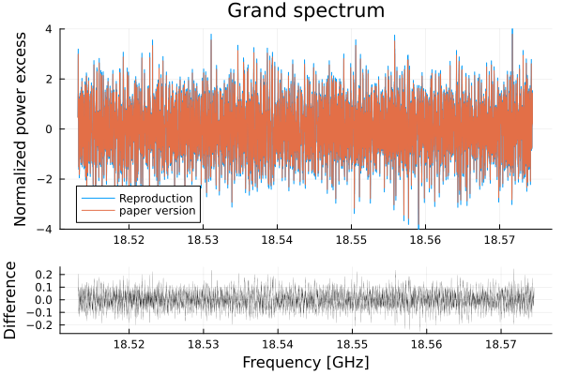

New Plot (Grand spectrum low freq)::

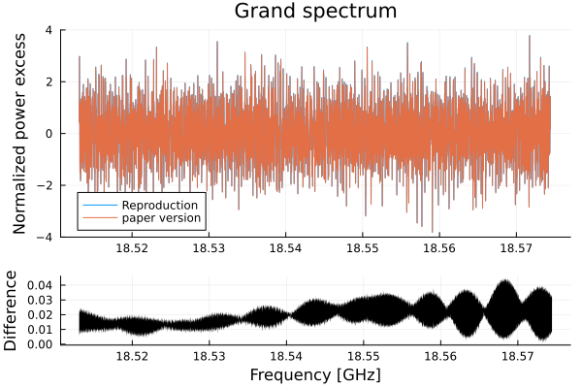

Old plot (Grand spectrum high freq):

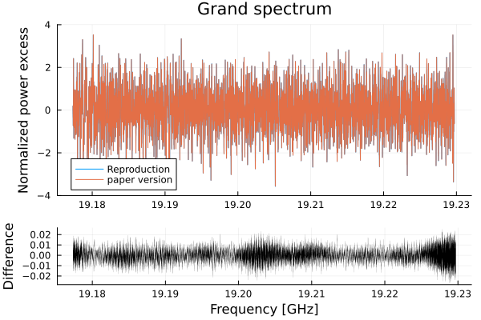

New plot (Grand spectrum high freq):

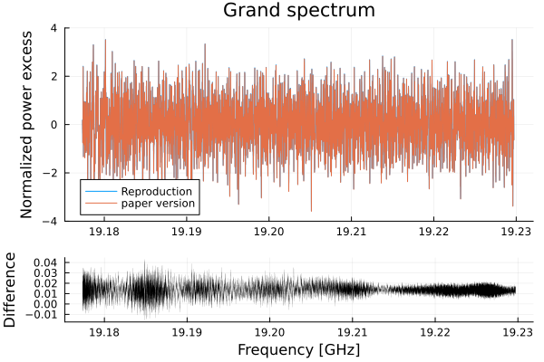

Old limit Low freq:

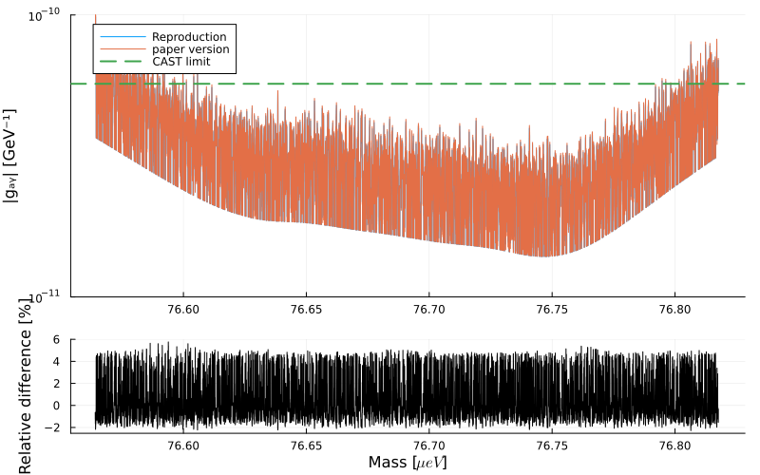

New limit Low freq:

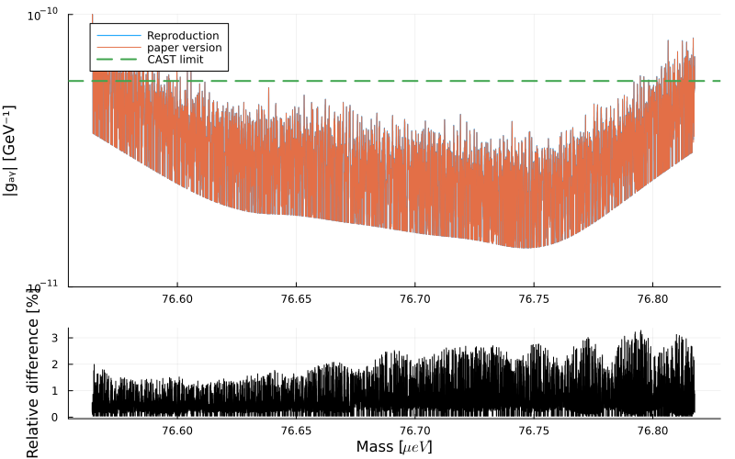

Old Limit High freq:

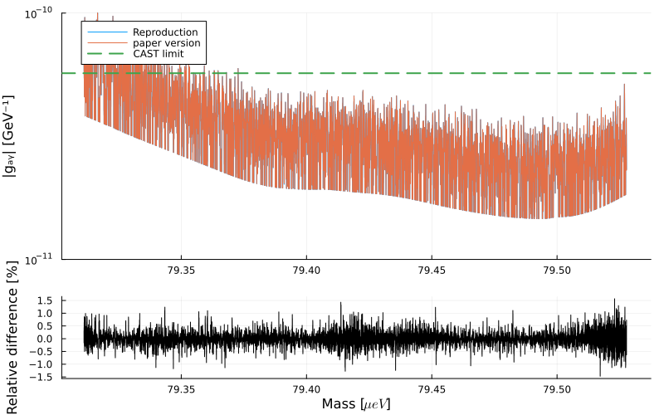

New limit High freq:

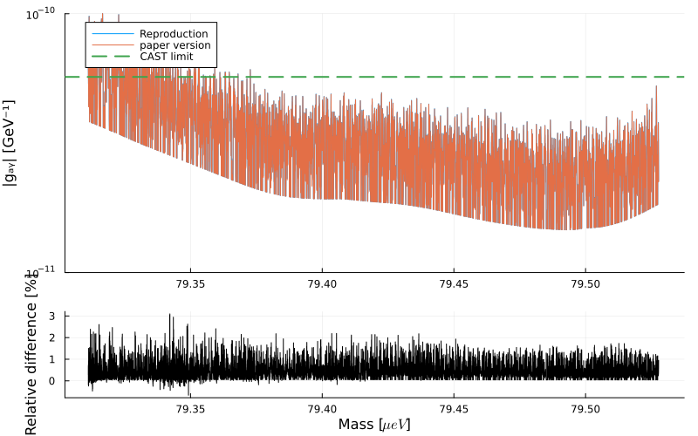

Old dark photon rebinned limit low freq:

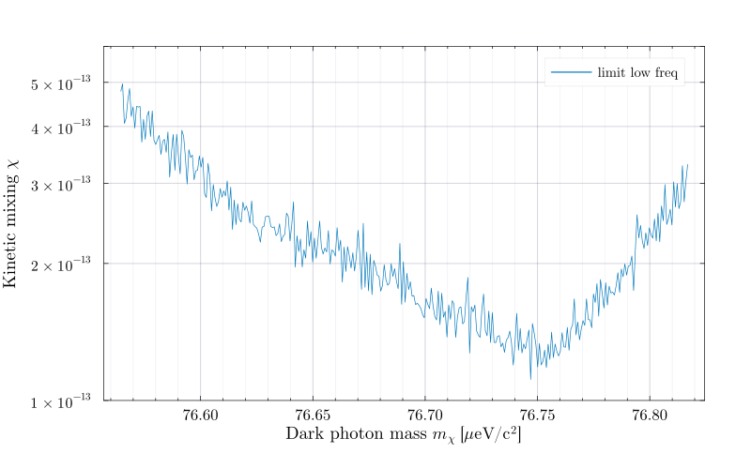

New dark photon rebinned limit low freq:

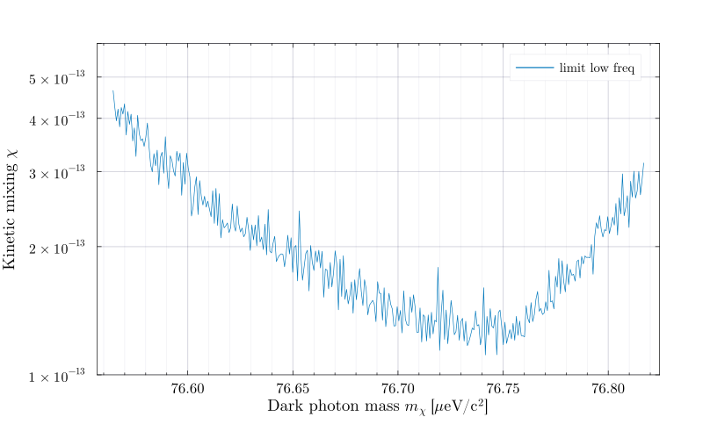

Old dark photon rebinned limit high freq:

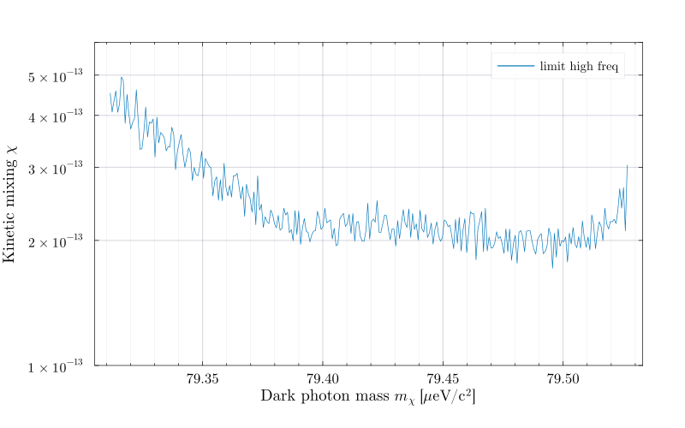

New dark photon rebinned limit high freq:

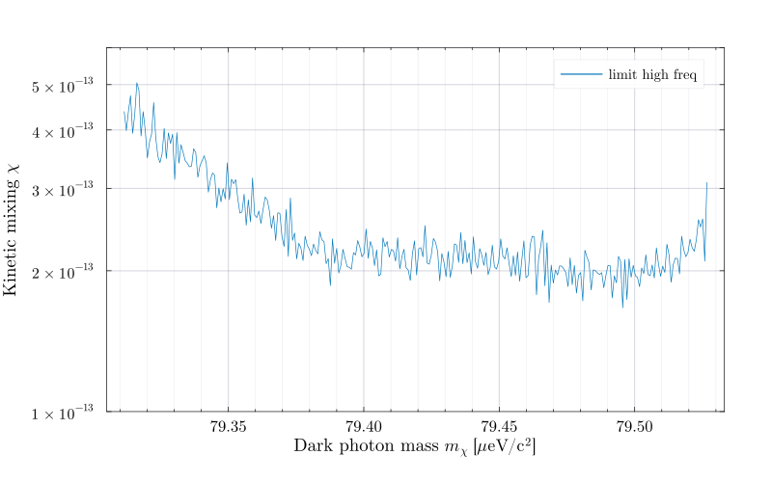

New plots showing the dark photon limit in the ALPs limit style (Akira’s comment)

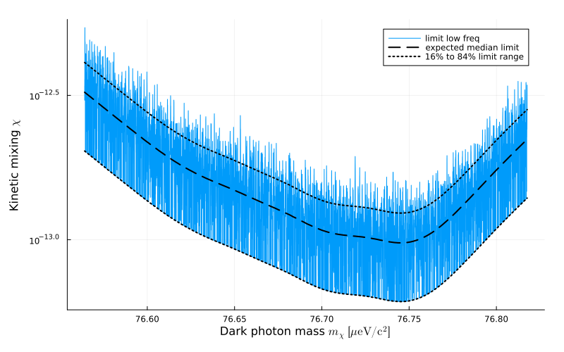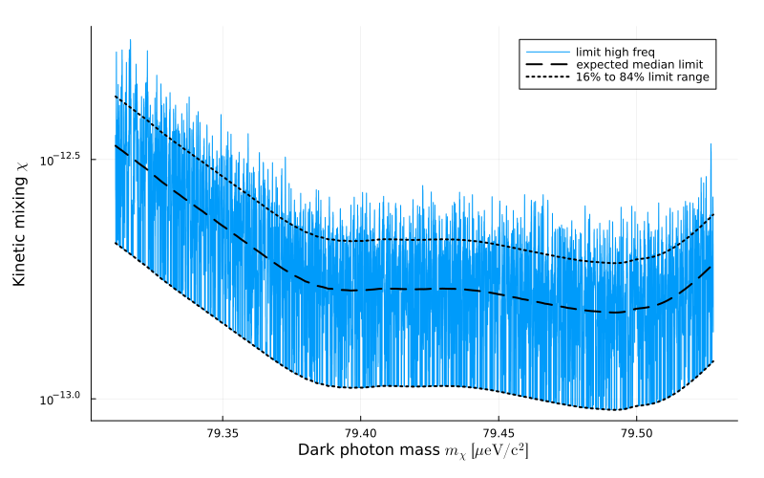

Old dark photon limit plot:

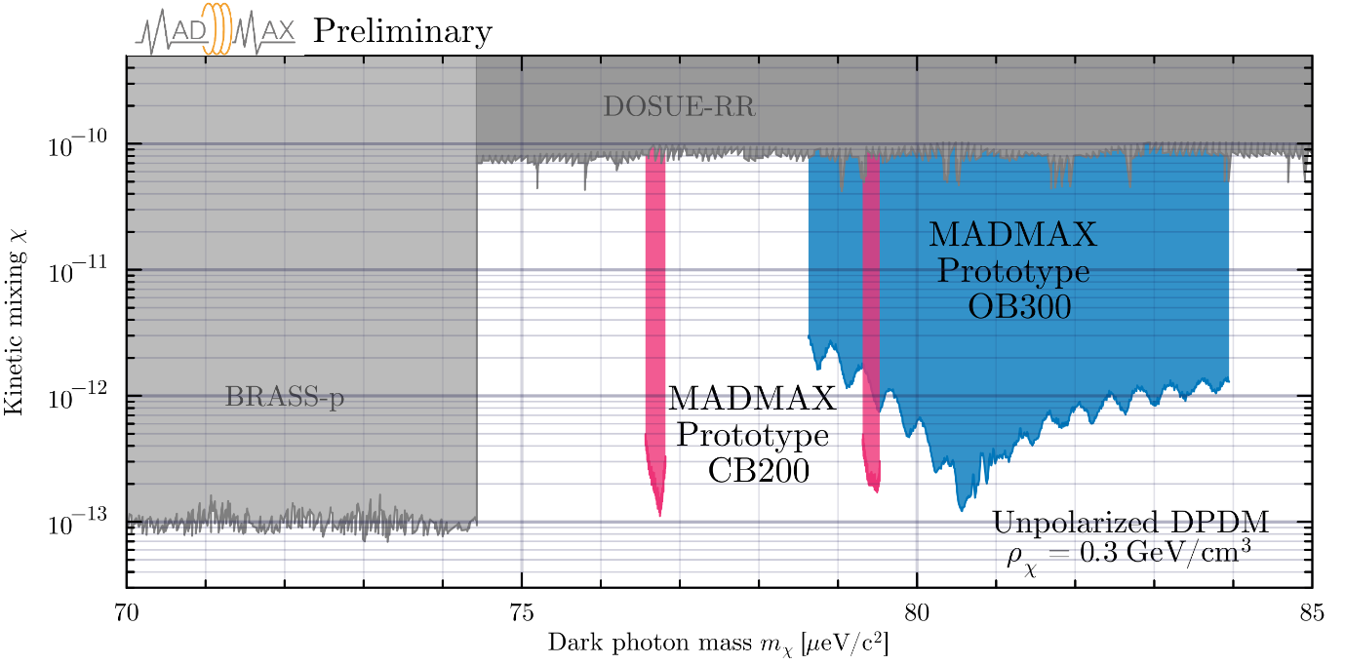

New dark photon limit plot:

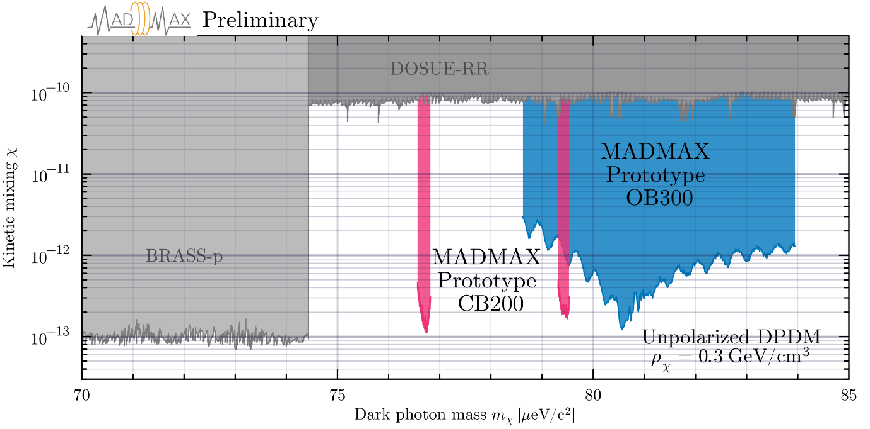

Impact of including extra timestamps in the new limit:

A few things have changed in the analysis compared to the version v1 of the note, so the comparison here considers only the impact of including or not some timestamps in the new (slightly modified) analysis.

Low frequency dataset: (old method, selecting timestamps with B field > 0.1)

1. Total timestamps in 21_overnight: 55
2. Total timestamps in 29_overnight: 405
   1. Further cutting 108 timestamps from this run in old analysis
3. Total timestamps in 05_overnight: 637
4. Total = 989

Low frequency dataset: (New method, selecting all timestamps)

1. Total timestamps in 21_overnight: 60
2. Total timestamps in 29_overnight = 0: 470
3. Total timestamps in 05_overnight = 0: 637
4. Total = 1167
5. Expected increase in sensitivity: 4%

High frequency dataset: (old method, selecting timestamps with B field > 0.1)

1. Total timestamps in 23_weekend, min_B = 0.1: 246
2. Total timestamps in 27_magnettest, min_B = 0.1: 164
3. Total = 410

High frequency dataset: (New method, selecting all timestamps)

1. Total timestamps in 23_weekend, min_B = 0: 263
2. Total timestamps in 27_magnettest, min_B = 0: 172
3. Total = 435
4. Expected increase in sensitivity: 1.5%

Comparison plots: The label All data shows the new limit with all timestamps used, Cut data shows the limit with lesser timestamps used

