**Template JRA**

|  |  |  |  |
| --- | --- | --- | --- |
| **Work package number** | WP29 | **Start date** | 01/06/2019 |
| **Activity Type** | Joint Research Activity | | |
| **Work package acronym** | JRA11-CRYOJET | | |
| **Work package title** | Cryogenically cooled particle streams from nano- to micrometer size for internal targets at accelerators | | |

1. Work carried out and overview of progress
   1. **Project objectives**

*[Please give an overview of the project objectives for the third reporting period (June 2022 – July 2024), with regard to the overall objectives as described in the Annex 1 of the Grant Agreement and summarized below.]*

The objective of this JRA is to significantly develop the science and technology of cryogenically cooled target beam sources for applications in present and planned complex internal-target experiments, which require target beams of highest quality, such as PANDA@FAIR. In addition to hadron physics experiments, cryogenically cooled cluster/pellet/microjet beams have recently been discovered to be perfectly suited as targets for laser-particle interaction.

The comparably small cluster sizes of, e.g., 1-100 nm, of cluster beams make them ideally suited for internal storage ring experiments, targets at electron accelerators, or laser-driven hadron accelerators. Nozzle production techniques will be improved and extended with the aim to achieve higher target beam thicknesses and higher nozzle production yield. Key issue for laser-induced particle acceleration to multi-MeV kinetic energies is to build targets that can make use of the high laser repetition rate (up to kHz), targets that contain only those elements to be accelerated (e.g. hydrogen),and that have a limited density (to assure a high acceleration efficiency. An additional goal of this JRA is to develop cryogenic droplet beam sources, both for hadron physics experiments at storage rings, electron accelerators, and the exciting novel possibility to use them for intense laser-driven proton acceleration. Within this JRA it is planned to prepare a prototype for a real-time pellet tracking system which can predict the time dependent position of an individual pellet in the target region.

* 1. **Progress made during the reporting period towards the objectives**

*[Please describe the progress made during the third reporting period in line with your Gantt chart and the project overall tasks as described in the Annex 1 of the Grant Agreement and summarized below.]*

***Table 1.2 Progress made during the reporting period for each task***

|  |
| --- |
| ***Task 1: Cluster-jet beams*** |
| Based on the former results on the production of high-quality cluster-jet beams, a significantly improved cluster generator has been built and installed at the prototype target in Münster. This device allows for a much easier exchange of cluster nozzles, better vacuum sealing between different vacuum stages, and a temperature readout at the warm stage of the coldhead. The latter improvement is especially important for the target operation with gases heavier than hydrogen.  Further studies on diagnostic tools for cluster-jets using MCP detection systems were performed. Since commonly used phosphor screens were found to be very sensitive to ionized hydrogen clusters, a more robust YAG:Ce screen is now in use. This chemically more robust device provides also sufficiently good images of ionized cluster jets.  Improved cluster nozzle productions techniques were developed which lead to a more reliable production of nozzles with minimum inner diameters down to 30 µm. |
| ***Task 2: Cryogenic droplet beam target*** |
| A new droplet generator has been set into operation and allows for the generation of hydrogen droplets and 10 µm thick frozen hydrogen filaments. Especially the frozen hydrogen filaments with their high local areal target thickness might be of high interest for new hadron physics experiments, such as MAGIX at MESA. The long-term stability of the apparatus was demonstrated in a hundred-hour long-term measurement. A new method to align the cryogenic target particles in vacuum by using deflection jet beams could be shown. |
| ***Task 3: Real-time pellet tracking system*** |
| The pellet tracking system has been re-deployed from the The Svedberg Laboratory to the Ångström laboratory. Individual components have been thoroughly tested and refurbished as needed. The detection modules have been assembled. The readout system is in operation and provides trigger outputs on detected pellets for testing purposes. New components, e.g. lasers, have been tuned for the setup. Furthermore, the alignment of the reassembled modules is nearly complete and a comprehensive documentation of the procedure is in preparation. |
| ***Task 4: Pellet beams*** |
| New droplet/pellet nozzle production techniques have been established. Precise nozzle openings of, e.g., 10 µm diameter are routinely available. In addition, a system to influence the droplet production using a laser has been developed. |

**1.3 Highlights of significant results**

*[Include an overview of the project results towards the objectives in line with the structure of the Annex 1 to the Grant Agreement*.*]*

Numerical simulations on the evaporation of microspheres, i.e. clusters, droplets and pellets, in vacuum have been further developed and compared with data from experiment. These studies led to a good understanding of the vacuum situation for experiments using hydrogen cluster beams. Moreover, these calculations give important information about the freeze-out time of the droplets in vacuum and by this with the known particle velocity about the freeze-out position in the target device. The obtained results could be compared to measurements using droplets produced in a 10 µm droplet nozzle.

Diagnostic tools to investigate the properties and quality of cluster-jet beams have been improved significantly. In detail, a new MCP detection system with a phosphor screen has been tested at COSY. It was found that ionized hydrogen clusters can lead to long-term damage of the phosphor layer. According to this, a chemically more robust scintillating YAG:Ce screen has been used instead.

A new droplet generator has been built and set into operation. The properties of the produced droplet streams were studied by using a new laser diagnostic system. It could be shown that by switching off the piezo transducer a stable frozen hydrogen filament can be produced. Such filaments are of high interest for future hadron physics experiments, such as MAGIX at MESA. A long-term measurement showed that such filaments can be produced for more than 100 hours without interruption.

An implementation and proof of concept of a real-time pellet tracking system have been done. A pellet tracking section with four detection modules has been completely equipped with line scan cameras and lasers. The fine adjustment and alignment are almost finished. A collimator system with 0.16 mm hole diameter is being prepared. The system allows the prediction of when a pellet will be present in the nominal interaction region with high accuracy. This information can be provided to a pulsed laser as a trigger signal.

Furthermore, a system to study the influence of laser light pulses on the droplet production has been prepared and tested at the pellet generator at Uppsala University. The system consists of a point focused, pulsed laser, a CCD camera monitoring the droplet formation chamber, and a line scan camera monitoring the pellet stream after vacuum injection. The studies included different droplet production frequencies and laser power setting. During these runs, no significant effects from applying the laser pulses could be observed in the droplet formation chamber. The offline analysis of the data from the line scan cameras confirmed these results. To achieve an effect a further increase in laser power or additional laser is required.

1. Critical Implementation risks and mitigation actions

**2.1 Risk materialization**

*[Provide the information on the project risks described in Annex 1 to the Grant Agreement*.*]*

1. Delay of systematic studies on cluster/pellet/droplet beams due to not fully optimized cluster/pellet/droplet nozzle production techniques, i.e. process reliability (low)

Whether the risk has materialized? No

1. Pellet diagnostic studies delayed due to not foreseen problems in the operation of the pellet tracking system in combination with a running pellet target experiment (low)

Whether the risk has materialized? Yes

**2.2 Risk-mitigation measures applied**

*[Please indicate whether the risk-mitigation plan described in Annex 1 to the Grant Agreement and corresponding to the risk number was applied in the reporting period*.*]*

1. Start of target beam studies using self-made nozzles of not optimized geometry, which will lead to important information on the required nozzle designs and will have a significant impact on the production techniques.

Whether the risk-mitigation plan was applied? No

1. Test of pellet tracking subsystems in an early phase under realistic conditions, e.g., in combination with mechanical vibrations caused by vacuum pumps.

Whether the risk-mitigation plan was applied? Yes

**2.3 Comments/new risk-mitigation measures proposed**

*[Provide any significant comments on the risks encountered and the mitigation plan applied. Give any unforeseen risks encountered during the reporting period and not mentioned above*.*]*

Risk 2) materialized since the test facility could not be operated due to Covid-19 related restrictions to access by personnel, not because of technical issues that had been thought of at the time of the Grant Agreement. The mitigation plan was applied to an extent limited for the same reason. After restrictions were lifted, we tried to realize as much of the project objectives as possible. However, the phaseout of the host laboratory (The Svedberg Laboratory) meant that extended diagnostic studies beyond the original time foreseen in the Grant Agreement were not possible. The pellet tracking system eventually had to be moved to a new host facility, i.e. Ångström Laboratory, where reassembly, fine adjustment, and alignment allow now for a continued operation of the system at the cost of additional delays.

3. Deviations from Annex 1 (Description of Action) and Annex 2 (Estimated budget for Action) (if applicable)

**3.1 Deviations from planned objectives and tasks, and their impact on the progress of the work package**

*[Explain the reasons for deviations, the consequences and the proposed corrective actions.]*

Delays due to Covid-19 and a redeployment of the pellet tracking system, especially since further studies at the Uppsala Pellet Test station are no longer possible. We have continuously adapted the work plan to the given possibilities to achieve the project objectives despite these difficulties. The planned studies on hydrogen fibers, which were part of the task 4, will not be possible at Uppsala University. However, first exciting results with other shapes of solid target beams were achieved at the University of Münster. All other tasks in the work package are foreseen to catch up with the delays.

**3.2 Deviations between actual and planned person months**

*[Explain deviations between actual and planned person-months. If applicable, propose corrective actions.]*

At Uppsala University, personnel resources were used at a lower level for a long time due to Covid-19 restrictions, which were lifted in February 2022. Until then, on-site work of expert participants from other divisions at the University has only been possible at a reduced level. We adapted the work flow by prioritizing parts which did not involve restricted on-site access to minimize the effect on the project. The redeployment of the pellet tracking system has created an additional need for personnel resources. A reallocation of funds to the staff costs has been necessary to achieve as much of the objectives as possible.

1. Deliverables and milestones tables

**4.1 Deliverables**

*[Please list all the deliverables due in this reporting period, as indicated in Annex I.*

*Deliverables must also be accompanied by a short report (deliverable description and technical documentation, such as photo, list of publications, etc.), so that the European Commission has a record of their existence.]*

***Table 4.1 List of deliverables***

| **Deliverable No.** | **Deliverable name** | **Lead Beneficiary** | **Nature** | **Dissemination level[1]** | **Delivery month from Annex I** | **Delivered**  **(yes/no)** | **Actual delivery month** | **Comments** |
| --- | --- | --- | --- | --- | --- | --- | --- | --- |
| D29.1 | Report on new nozzle and beam production  techniques for high performance cluster-jet, droplet, and pellet targets | 16 - WWU | Report | PU | 62 | Yes | 62 |  |
| D29.2 | Report on measurements  of ion acceleration using laser-induced production | 16 - WWU | Report | PU | 62 | Yes | 62 |  |
| D29.3 | Report on a pellet  tracking system | 41 - UU | Report | PU | 62 | Yes | 62 |  |

*In case a deliverable has been delivered in the reporting period and a report exists in the Participant Portal, you can indicate “uploaded report” in correspondence of a deliverable*

**4.2 Milestones**

*[Please complete the table if milestones are specified in Annex I.*

*Milestones will be assessed against specific criteria and performance indicators as defined in Annex I.]*

***Table 4.2 List of milestones***

| **Milestone number** | **Milestone name** | **Lead beneficiary** | **Delivery month from Annex I** | **Delivered**  **(yes/no)** | **Actual delivery month** | **Comments** |
| --- | --- | --- | --- | --- | --- | --- |
|  |  |  |  |  |  |  |

**No Milestones in the RP3 (months 37-62)**

* 1. **Deliverable Reports**
     1. **D29.1: Report on new nozzle and beam production techniques for high performance cluster-jet, droplet, and pellet targets**

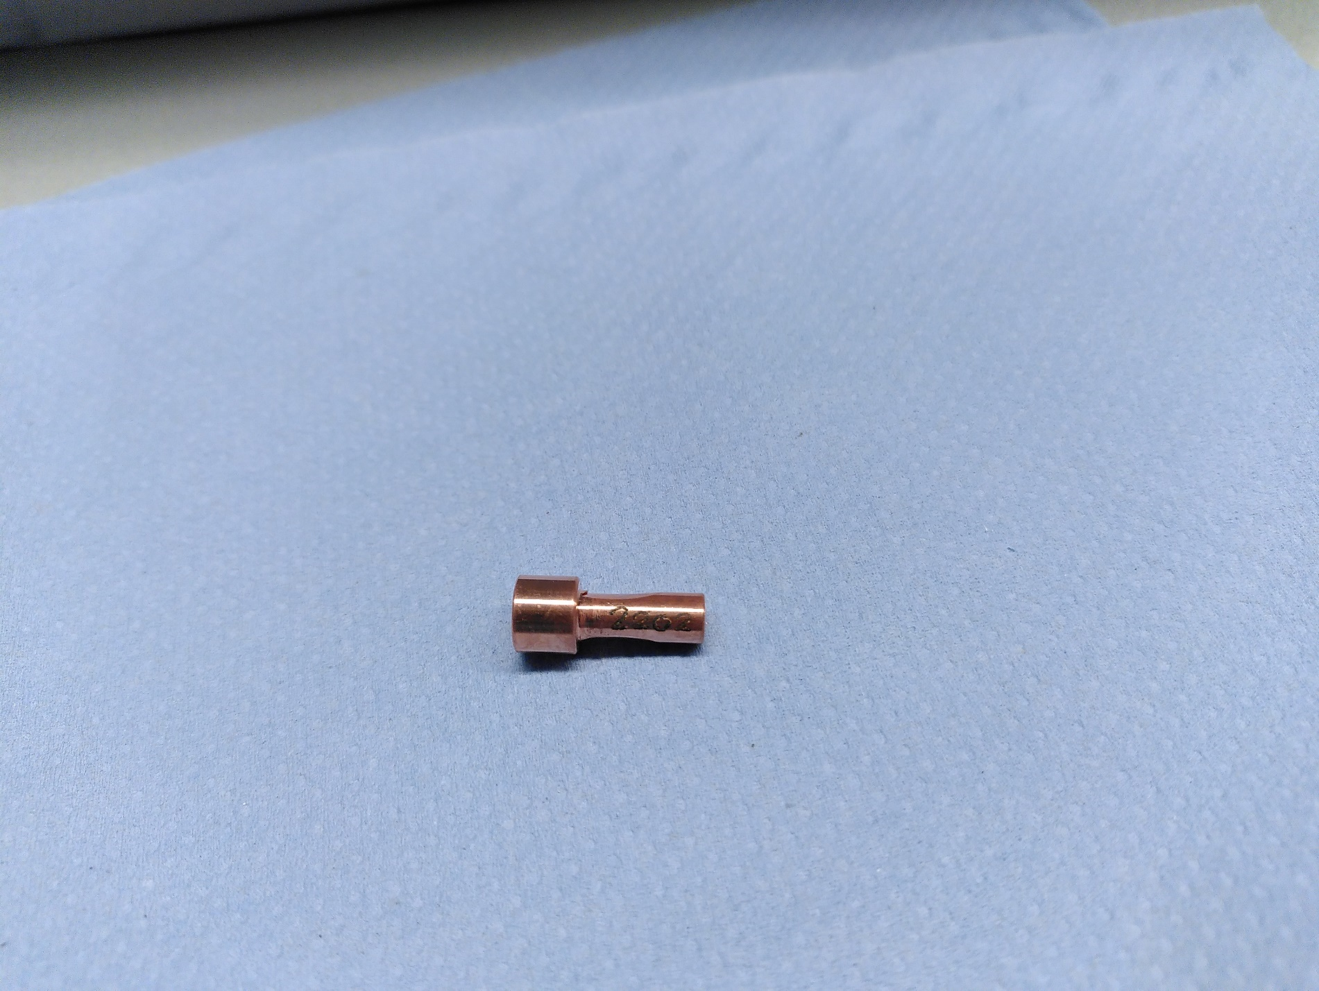 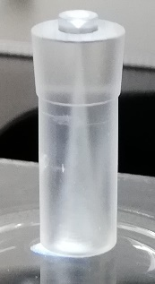 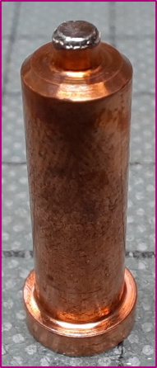

From left to right: newly, totally in-house produced de Laval nozzle “2202”, glass nozzle produced according to our CAD drawings, and newly produced droplet nozzle

For cluster-jet, droplet, and pellet targets the same basic principle holds: cryogenic fluids, in many cases hydrogen is pressed through a dedicated nozzle (system) expanding into vacuum to form ultra-pure targets for a variety of experiments. Due to different requirements on the operation parameters (temperature and pressure) and on the sphere size, different nozzles are necessary. In the report, the production of cluster-jet and droplet/pellet nozzles are presented with their resulting impact on the target performance.

Important for the operation principle of cluster-jet targets is a special nozzle geometry. A convergent inlet leads to the narrowest diameter of 30µm. Afterwards a divergent outlet follows, leading to the total nozzle length of 18mm. The extreme difference between narrowest inner diameter and nozzle length raises the challenge in producing such fine nozzles. As production methods for these nozzles two possibilities are tested.

An external company can produce nozzles according to our CAD drawings out of glass. For gaseous hydrogen being upstream to the nozzle the resulting cluster-jet is similar to cluster-jets emerging from the well-established copper nozzles, but as soon as the vapor pressure curve is crossed the resulting cluster-jet breaks down and ice fragments form inside the nozzle which are then chaotically ejected into the skimmer chamber. Two possible remedies have been tested but were not found to be working. This leads to the omission of these glass nozzles for cluster-jet targets operating with fluids.

As a second production method galvanization in a sulfuric acid copper bath is performed whereas for the first time the production is achieved totally within the Institute of Nuclear Physics of the University of Münster and its mechanical workshop. In total, from nine galvanized workpieces, eight resulted in nozzles from which five have a diameter close to the desired one. Compared to the rejection rate of 60% to 80% of previous (not totally in-house) batches, a huge step forward was taken. The three most promising nozzles were chosen to be inserted in the cluster-jet target. Resulting cluster-jets show similar behavior in density and velocity as well-established nozzles.

Additionally, for the operation with argon a larger nozzle with a narrowest inner diameter of 120µm was galvanized which is significantly easier than the galvanization of 30µm nozzles. The resulting argon cluster-jet was used for experiments in Mainz.

Also, for droplet/pellet nozzles a new production method was established. A platinum iridium orifice with a pinhole of 10µm is welded onto a copper tube with the desired outer geometry. Furthermore, new analysis methods on nozzle clogging were conducted. Raman spectroscopy and electron microscopy can be used to determine the material causing the clogging where insights were gained. As soon as a droplet nozzle functions properly and without clogging, investigations on the jet stability of the droplet target can be performed. It was possible to operate the droplet target stably for 100 hours. During the measurement the beam position deviations are in the order of tens of microns indicating a stable beam behavior.

* + 1. **D29.2: Report on measurements of ion acceleration using laser-induced production**

Owing to their extreme field strengths of over 100 GeV/m, plasmas are of high interest for use as compact particle accelerators. In our work, we irradiate a cryogenic hydrogen cluster-jet beam with a high-powered laser beam, thereby accelerating protons to multi-MeV energies.

The cluster-jet beam was generated by the MCT-D (Münster cluster-jet target Düsseldorf). It injects cryogenic hydrogen (e.g. 28 K) through a de Laval nozzle (e.g. 42 µm smallest inner diameter) into vacuum, thus producing an atomized jet of clusters up to around 5 µm in diameter. The laser beam was provided by the Arcturus laser of the HHU Düsseldorf, capable of delivering pulses with energies of up to 7 J at a pulse length of 30 fs, reaching intensities up to 1 x 1020 W/cm2.

For the experiments, the Arcturus laser beam was focused perpendicularly onto the cluster-jet beam, generating accelerated protons via a Coulomb explosion-like mechanism. Two Thomson parabolas were used to record them and determine their energies, one under 0° respective to the laser propagation direction and one under 135°.

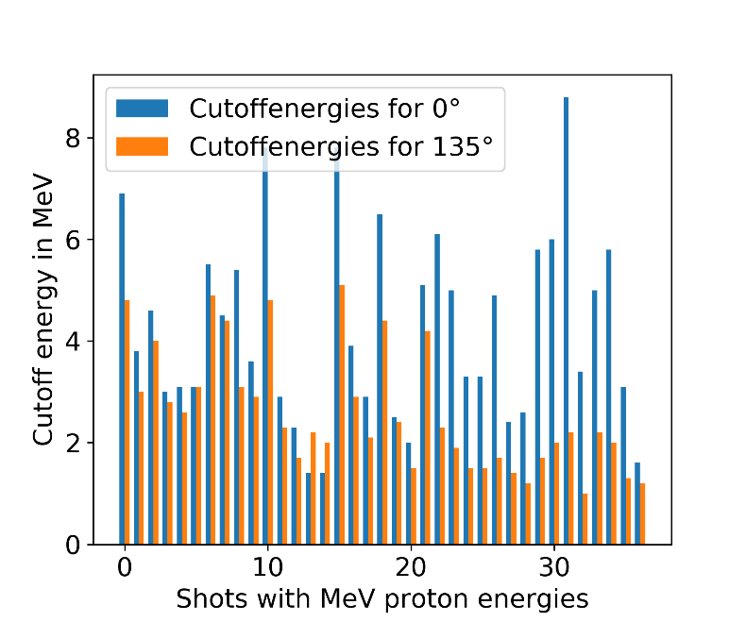

Figure 1: Maximum energies under 0° and 135° grouped per shot.

The results of over 30 individual laser shots are depicted in Figure 1, revealing the production of protons with energies up to the multi-MeV level. However, unlike for a pure Coulomb explosion, the proton acceleration is evidently anisotropic. Additionally, further studies revealed the achieved energies to be laser contrast dependent, with multi-MeV protons only appearing for contrasts better than 10-7. This behaviour can be interpreted together with the anisotropy: The laser’s pre-pulse ionises the cluster which begins to expand before the arrival of the main pulse. At low contrasts, the resulting density is so low that no significant acceleration is achieved. At better contrasts the cluster remains dense enough to achieve multi-MeV energies, however, the expanded cluster no longer performs a pure, isotropic Coulomb explosion. Instead, the interaction becomes anisotropic, which will necessitate simulations to be understood completely.

Through interaction of a cluster-jet beam and a high powered ultra-short pulse laser, multi-MeV protons could be achieved, albeit with a low shot-to-shot stability. There are two possible approaches to improve it. One could enlarge the size of the laser focus, increasing the number of clusters hit per shot and thus improving the shot-to-shot stability, as well as increasing the probability of hitting larger clusters, potentially increasing maximum energies to the multi-GeV range. The other approach is to use a hydrogen pellet target instead of a cluster-jet target. Such a target delivers individual, well separated frozen pellets with an identical diameter of around 20 µm at a constant rate. Since the laser would be guaranteed to always interact with an identical target, the shot-to-shot stability would greatly improve while the large pellet size would lead to, potentially, maximum energies in the multi-GeV range.

* + 1. **D29.3: Report on a pellet tracking system**

As outlined in section 4.3.2 using small pellets of frozen gases as targets for pulsed micro-focus lasers is appealing. Given that there is always a certain amount of divergence and velocity spread in a cryogenic pellet stream, its effective use depends on the ability to predict when a pellet will be in the focus of the laser beam.

In this project, the pellets have a diameter of 30-70 µm, velocities around 80 m/s (0.5% spread), and a flux below 3000 pellets/s/mm2. The pellet stream itself has a diameter of 0.2 mm. The goal is to develop a tracking system that can predict a few milliseconds in advance when a pellet will be inside a nominal target volume of about the same size as the pellets themselves.

The design of the new system is based on adapting a system originally designed for the PANDA experiment at FAIR. Studies have been carried out with Uppsala Pellet Test Station (UPTS). The system is designed to consist of several levels of detector modules, consisting of lasers illuminating the pellets and two synchronized LineScan cameras picking up the reflected light. It was found that pellets passing the narrow line of sight of the cameras can be measured with an accuracy of 20 µm and a time resolution of about 5 µs.

An FPGA processes the data from the multi-camera system in real-time. It contains all the necessary peripheral interfaces and computation resources to realize the trigger function. As part of the processing, the data from the cameras are first de-serialized and parsed, after which the different sensitivity and bias in the pixels is equalized. This is followed by a pellet recognition algorithm and pellet tagging. Having the horizontal pellet coordinates from two levels of detector modules, the trigger output data is prepared, based on which the FPGA can send out timed triggers for the laser.

Most of the components of this real-time pellet tracking system have been successfully tested at the UPTS with pellets. This includes the mechanical components to mount and align cameras and lasers and the electronics to control and read the cameras. A trigger on detected pellets has been implemented in the read-out boards and the performance has been verified using signals from pulsed lasers illuminating a dummy target. A pellet tracking section with four detector modules has been completely assembled.

1. PU = Public

   PP = Restricted to other programme participants (including the Commission Services).

   RE = Restricted to a group specified by the consortium (including the Commission Services).

   CO = Confidential, only for members of the consortium (including the Commission Services).