Template JRA
Work package number | WP26 | Start date | 01/06/2019
Activity Type | Joint Research Activity
Work package acronym | JRA8-ASTRA
Work package title | Advanced ultra-fast solid STate detectors for high precision RAdiation spectroscopy

- Work carried out and overview of progress
  - Project objectives
[Please give an overview of the project objectives for the third reporting period (June 2022 – July 2024), with regard to the overall objectives as described in the Annex 1 of the Grant Agreement and summarized below.]

ASTRA will develop a versatile advanced detector system, from sensors and read-out electronics, to DAQ and controls, namely compact large-area CdTe and CdZnTe detectors to perform high precision photon energy measurements from 10-100 keV and up to the MeV range, respectively. It will also be possible to design pixelated readout for imaging measurements.

  - Progress made during the reporting period towards the objectives
[Please describe the progress made during the third reporting period in line with your Gantt chart and the project overall tasks as described in the Annex 1 of the Grant Agreement and summarized below.]

Table 1.2 Progress made during the reporting period for each task
Task 1: Development of CdTe detectors for an energy range from about 10 – 100 keV
As underlined in the first reporting period, CNR-IMEM performed several simulations in order to identify the best detector shape and electrodes configuration, and commercial available CdTe material with characteristics matching the simulations’ outcomes has been purchased.The preliminary tests carried out at CNR-IMEM on these detectors revealed that 1 mm custom CZT detectors realized in Redlen material show the same or even better performance than CdTe.
So, for all the future activities CZT (or CdZnTe) detectors have been developed and used.

Task 2: Development of CdZnTe detectors for an energy range from a few 10 keV to MeV
After the tests and characterization performed in laboratory, several crucial tests have been carried on testing the performances of the developed devices in an accelerator environment.
In June 2022, the first ever measurement of the energy resolution and timing performances of a CdZnTe device in a collider were performed at the DAFNE accelerating complex of the INFN Laboratories of Frascati. In this first test, one 1x1x0,5 mm3 CZT detector developed at IMEM-CNR was employed.
Then, based on the very promising results, several additional tests have been carried on with a 4-channel system, first, and with an 8-channel one in the latest phase.
These measurements have proven the great capabilities of such devices when operated in a high background environment such as an e+e- collider; in particular, the background rejection capabilities, the linearity and stabilization of the system, the possible arising of radiation damage, the timing and energy resolutions as well as the possibility to operate the detectors with an external trigger have been extensively studied.
Finally, thanks to the good performances reached, the first ever spectra of kaonic atoms measured with CdZnTe detectors have been obtained.

The tests and characterization of the CdZnTe detectors at DAFNE already produced 4 publications in peer-reviewed journals:

L. Abbene et al., Eur. Phys. J. ST 232 (2023) 10, 1487-1492
A. Scordo et al., Nucl.Instrum.Meth.A 1060 (2024) 169060
L. Abbene et al., Sensors 23 (2023) 17, 7328
C. Curceanu et al., Front. Phys. 11 (2023), 1240250.

1.3 Highlights of significant results
[Include an overview of the project results towards the objectives in line with the structure of the Annex 1 to the Grant Agreement.]

As a summary, we report here the list of the positive outcomes of the preliminary tests on the CZT detectors:
1) Good energy resolution, in the range of a few percent, have been obtained in the first laboratory tests with typical Cs, Am, and Co sources.
2) The good energy resolutions, as well as a linearity below a few permille, have been also confirmed in the DAFNE accelerator environment.
3) Tests performed in the laboratory, after the first data taking in DAFNE, confirmed that no radiation damage was observed.
4) Two electronics modules, a Time to Analog Converter and a Mean Timer, have been implemented in the CdZnTe DAQ chain to detect Kaons and MIPs, exploiting the Luminosity Monitor system of the SIDDHARTA-2 experiment hosting the CdZnTe tests in parasitic mode. This test allowed to assess the background rejection factor to be of the order of 10⁵⁻⁶, depending on the timing performances of the detectors, matching that of the SIDDHARTA-2 experiment.
5) The energy calibration fitting function has been optimized, resulting in residuals (deviation of the nominal value of a calibration peak with respect to the one obtained from the calibration function) below 0,4%.
6) “In-situ” detector calibration procedure has been successfully established, allowing for an efficient alternative calibration method with respect to the employment of radioactive sources.
7) Thanks to the fast readout of the CdZnTe detectors, a timing coincidence of a few tens of ns between the external trigger and the detectors have been optimized.
8) This coincidence window has been then used in a data taking run with a Cu target, from which the first ever signals of kaonic atoms measured with such devices were obtained.

- Critical Implementation risks and mitigation actions

2.1 Risk materialization
[Provide the information on the project risks described in Annex 1 to the Grant Agreement.]

- The growing of CdTe crystals does not involve high risk (low)
Whether the risk has materialized? (Yes/No)
No, but better suited crystal material made of CdZnTe was available and therefore selected.
- The growing of CdZnTe crystals does not involve high risk (low)
Whether the risk has materialized? (Yes/No)
No
- The realization of strip and pixel structures might involve some critical steps which need attention (low)
Whether the risk has materialized? (Yes/No)
No

2.2 Risk-mitigation measures applied
[Please indicate whether the risk-mitigation plan described in Annex 1 to the Grant Agreement and corresponding to the risk number was applied in the reporting period.]

- V-I measurements
Whether the risk-mitigation plan was applied? (Yes/No)
Not in this reporting period
- Test measurements
Whether the risk-mitigation plan was applied? (Yes/No)
Not in this reporting period

2.3 Comments/new risk-mitigation measures proposed
[Provide any significant comments on the risks encountered and the mitigation plan applied. Give any unforeseen risks encountered during the reporting period and not mentioned above.]

3. Deviations from Annex 1 (Description of Action) and Annex 2 (Estimated budget for Action) (if applicable)

3.1 Deviations from planned objectives and tasks, and their impact on the progress of the work package
[Explain the reasons for deviations, the consequences and the proposed corrective actions.]

No deviations to be reported

3.2 Deviations between actual and planned person months
[Explain deviations between actual and planned person-months. If applicable, propose corrective actions.]

- Deliverables and milestones tables

4.1 Deliverables
[Please list all the deliverables due in this reporting period, as indicated in Annex I.
Deliverables must also be accompanied by a short report (deliverable description and technical documentation, such as photo, list of publications, etc.), so that the European Commission has a record of their existence.]

Table 4.1 List of deliverables
Deliverable No. | Deliverable name | Lead Beneficiary | Nature | Dissemination level | Delivery month from Annex I | Delivered  (yes/no) | Actual delivery month | Comments
D26.2 | Report on the  characterization of the  final CdTe detector  device | 30 - INFN | Report | PU | 62 | yes | 62
D26.4 | Report on the  characterization of the  final CdZnTe detector | 30 - INFN | Report | PU | 62 | yes | 62
In case a deliverable has been delivered in the reporting period and a report exists in the Participant Portal, you can indicate “uploaded report” in correspondence of a deliverable

4.2 Milestones
[Please complete the table if milestones are specified in Annex I.
Milestones will be assessed against specific criteria and performance indicators as defined in Annex I.]
Table 4.2 List of milestones
Milestone number | Milestone name | Lead beneficiary | Delivery month from Annex I | Delivered  (yes/no) | Actual delivery month | Comments

No Milestones in the RP3 (months 37-62)

4.3 Deliverable Reports
[Please provide, per each deliverable listed in Table 4.1, a brief description, including if possible some technical documentation (photos, list of publications, etc.). Use as many pages as needed per each report.]

Report on the Deliverable D26.2
The deliverable D26.2 contains and describes all the results obtained with the characterization of the CdTe crystals. This characterization consisted in performing the following measurements:
• Evaluation of Te-inclusion density and sizes
• Electric Characterization
• Spectroscopic characterization
The first test already revealed how the CdTe crystals include more large inclusions with respect to the CdZnTe ones, resulting in a degradation of the spectroscopic performances. From the second test, on the contrary, a smaller leakage current of CdTe devices has been observed. Finally, spectroscopic characterization, the most important test, revealed how CdZnTe crystals produced by Redlen show superior performances to CdTe, even in the low-energy range.
The outcome of this characterization funneled all the next phases of the project to be focused on the development of CdZnTe based detectors.
In the following, the figures included in the D26.2 are reported.

Fig. 1: Compared inclusion distribution of the CdTe (Acrorad) and CZT (Redlen) detectors.

Fig.2: I-V characteristics of the functioning pixels of the CdTe samples.
Fig. 3: Spectrum from the best-performing pixel of the CdTe detector

Report on the Deliverable D26.4
The deliverable D26.4 contains and describes all the positive results summarized in the 1.3 section of this document.
In the following, the figures included in the D26.4, as well as the three published papers used as references are reported. For the clarity and the completeness of the deliverable, also a paper on the Luminosity Monitor of the SIDDHARTA-2 experiment has been included.

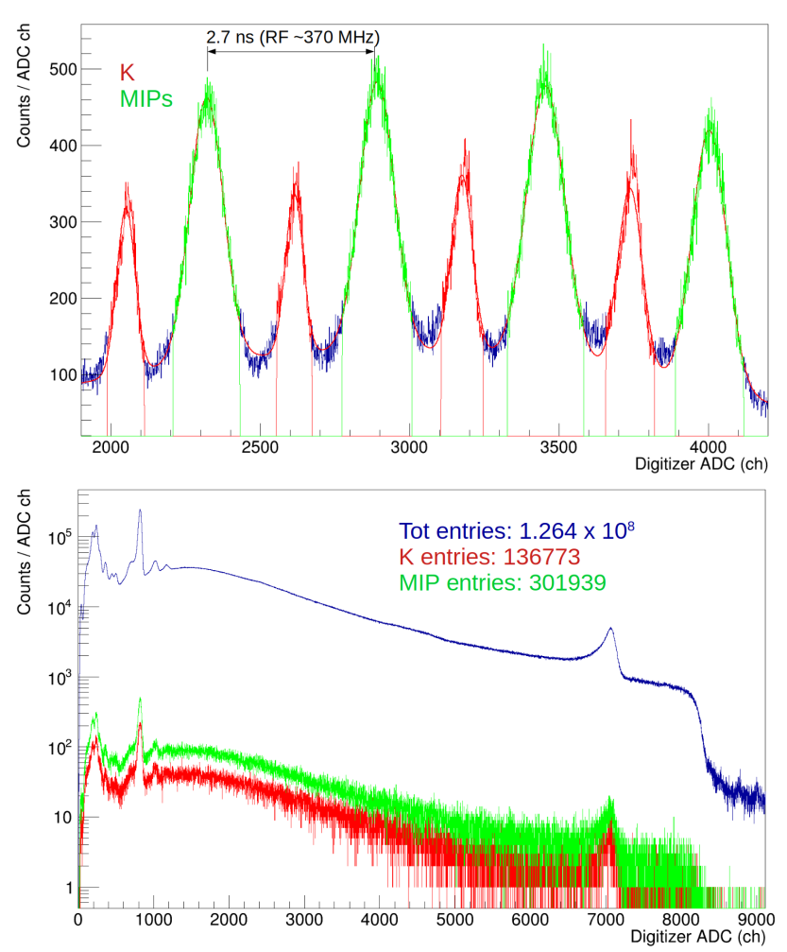
Fig. 1. Top: TAC spectrum from the SIDDHARTA-2 LM; red and green peaks correspond to kaons and MIPs, respectively. Bottom: CZT spectrum with no time selection from the TAC (blue) over imposed on the spectra obtained in coincidence with kaons (red) or MIPs (green) events [2].

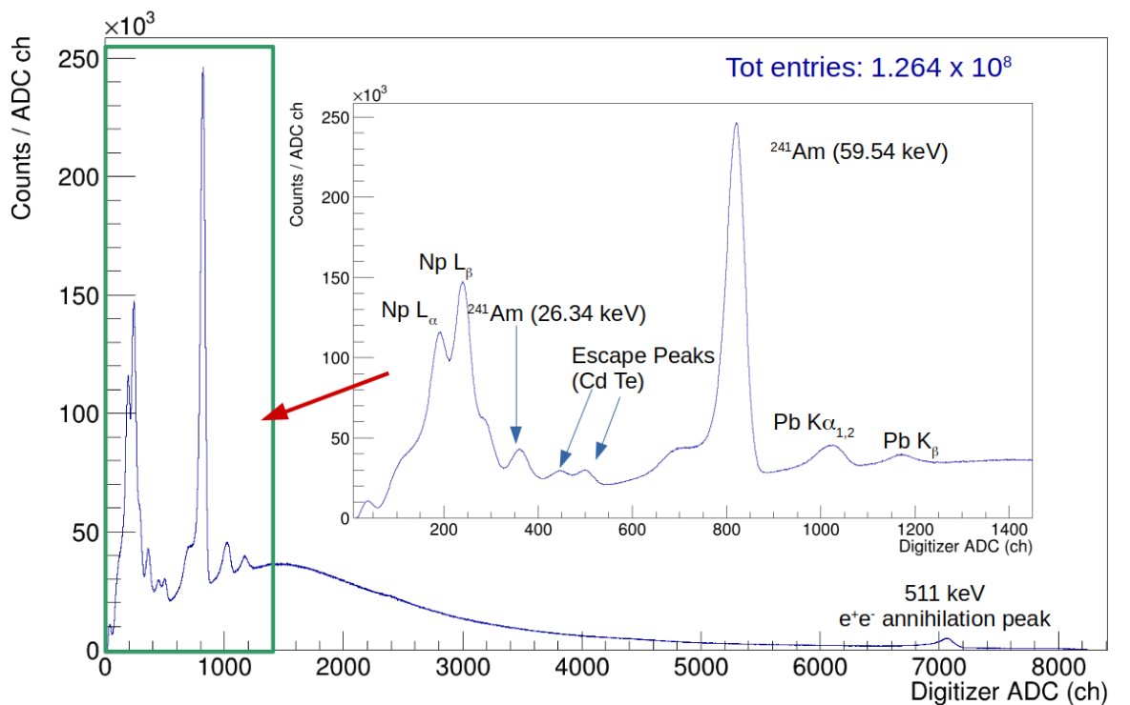

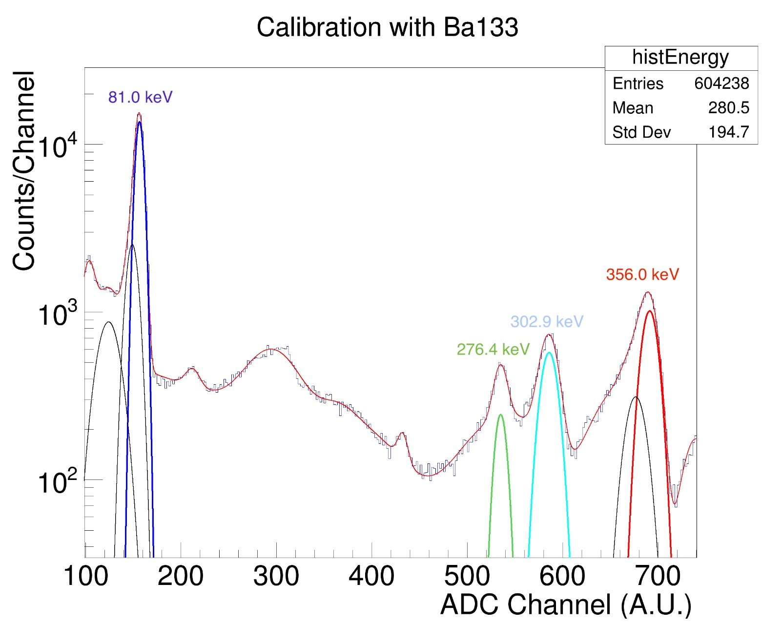

Fig. 2: CZT spectra obtained with the ²⁴¹Am and ¹³³Ba sources in DAFNE [2-3].

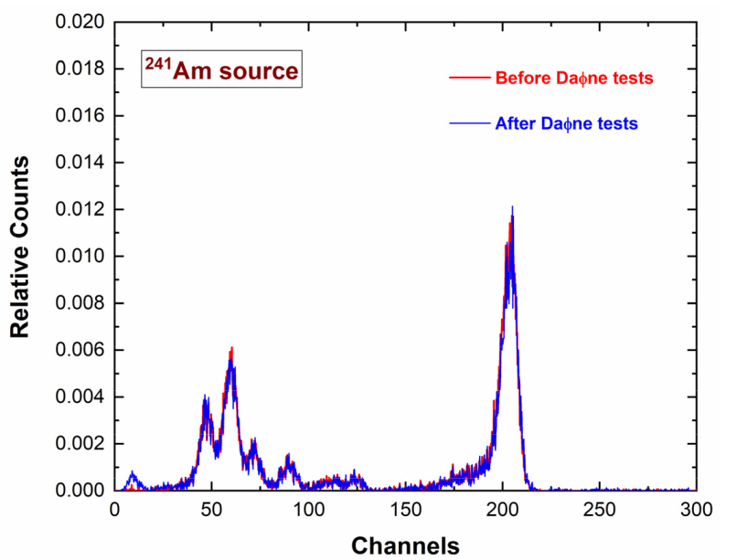

Fig. 3: ²⁴¹Am energy spectrum measured before (red line) and after (blue line) the tests at the DAFNE collider [4].
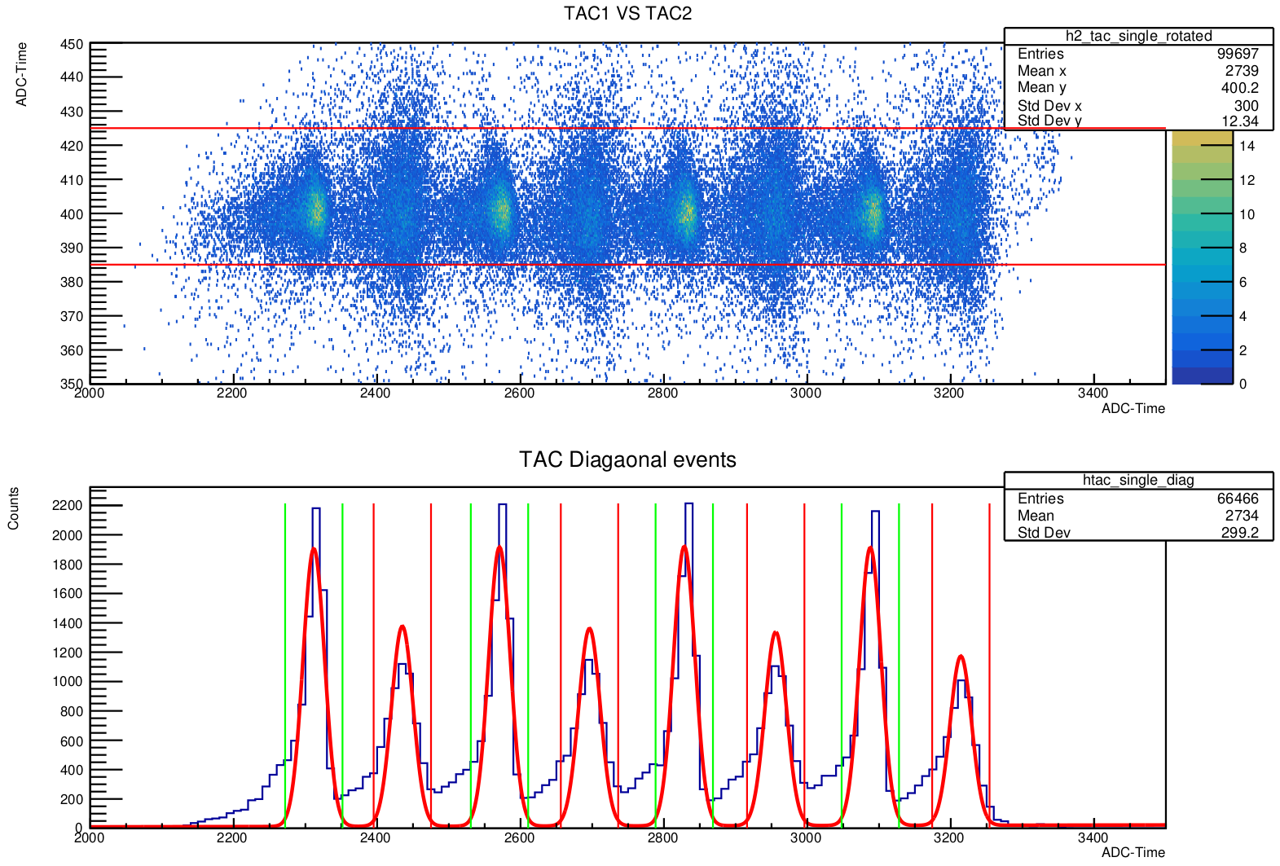

Fig. 4: new K/MIP selection based on the two dimensional (45° rotated) selection of the two TAC modules (up) and the resulting projection on the diagonal.

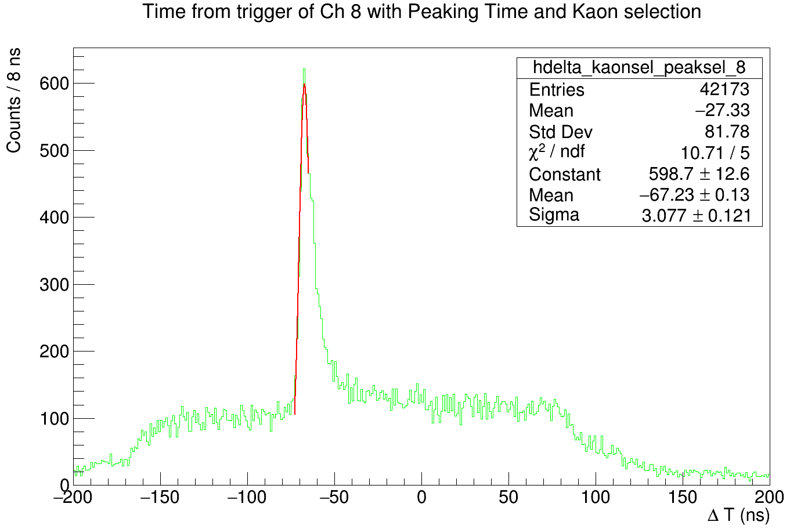

Fig. 5: Triple coincidence timing spectrum between the two SIDDHARTA-2 LM scintillators and one of the CZT detectors; a FWHM < 10 ns is found.
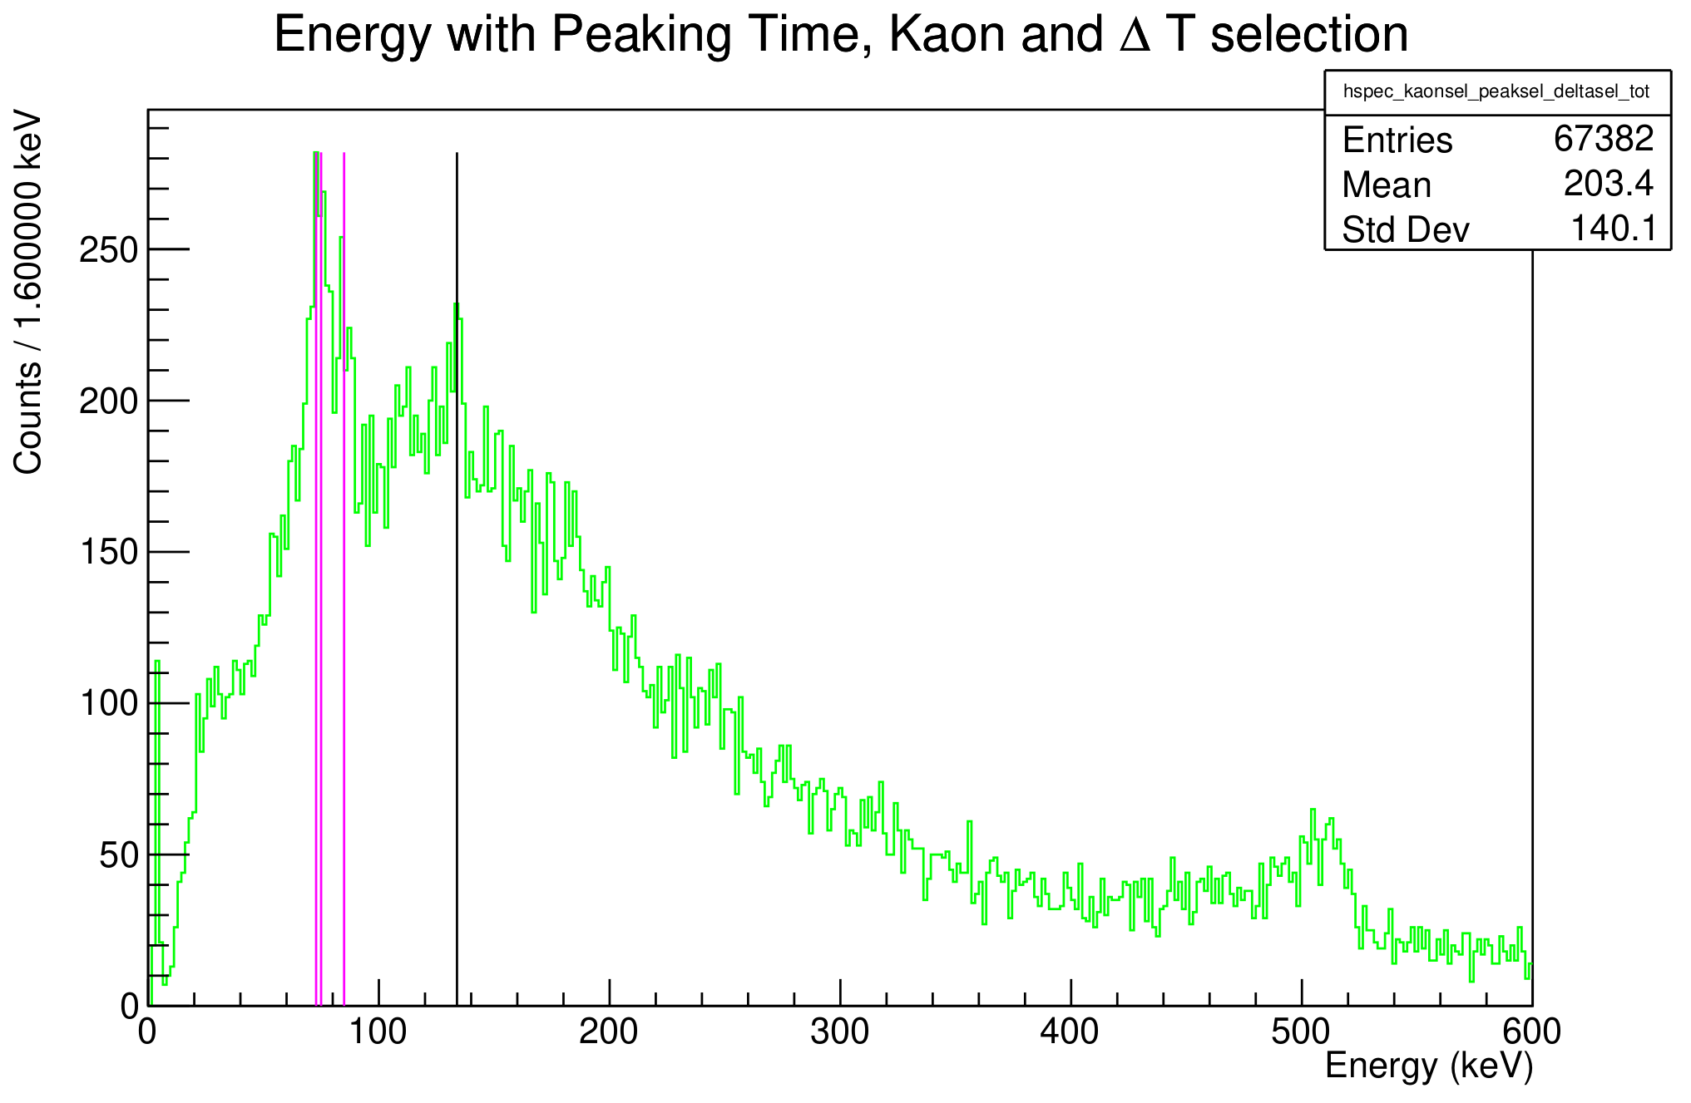

Fig.6: First KCu(6→5) transition spectrum obtained with the CZT detectors; the black line shows the position of the expected peak, while the two pink ones show the positions of the Pb fluorescence peaks due to the shielding activation by the MIPs. The 511 keV e+e- annihilation peak is also clearly visible.

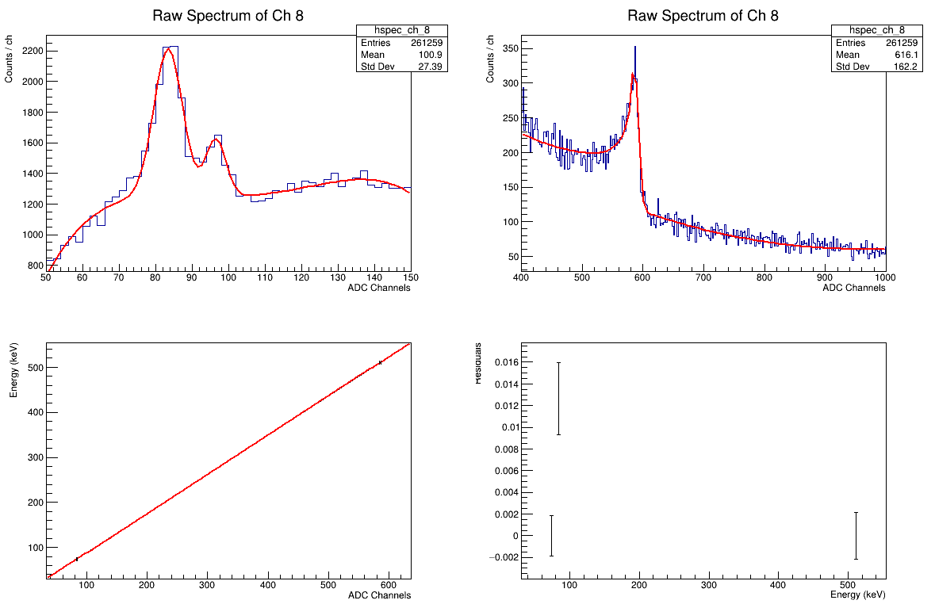
Fig. 7: “in-situ” calibration procedure; the raw spectrum, with no Kaon/MIPs selection cut, has been used for the in-beam calibration with the Pb Kα and Kβ fluorescence lines (up left) and the 511 keV peak (up right). Very good linearity (down left) and residuals below 1% (down right) have been obtained.

References
[1] M. Skurzok et al., JINST 15 (2020) 10, P10010
[2] L. Abbene et al., Eur. Phys. J. ST 232 (2023) 10, 1487-1492
[3] A. Scordo et al., Nucl.Instrum.Meth.A 1060 (2024) 169060
[4] L. Abbene et al., Sensors 23 (2023) 17, 7328

PU = Public PP = Restricted to other programme participants (including the Commission Services). RE = Restricted to a group specified by the consortium (including the Commission Services). CO = Confidential, only for members of the consortium (including the Commission Services).

