**Template NA**

|  |  |  |  |
| --- | --- | --- | --- |
| **Work package number** | WP12 | **Start date** | 01/06/2019 |
| **Activity Type** | Networking activity | | |
| **Work package acronym** | NA1-FAIRnet | | |
| **Work package title** | QCD physics at GSI/FAIR | | |

1. Work carried out and overview of progress
   1. **Project objectives**

*[Please give an overview of the project objectives for the third reporting period (June 2022 – July 2024), with regard to the overall objectives as described in the Annex 1 of the Grant Agreement and summarized below.]*

The FAIRnet networking activity will foster the interchange of ideas and methods on dead time free front end electronics, FPGA based feature extraction, hard- and software for online event selection on heterogeneous multi-core systems (CPU+GPU), and data acquisition networks as well as physics analysis methods.

* 1. **Progress made during the reporting period towards the objectives**

*[Please describe the progress made during the third reporting period in line with your Gantt chart and the project overall tasks as described in the Annex 1 of the Grant Agreement and summarized below.]*

***Table 1.2 Progress made during the reporting period for each task***

|  |
| --- |
| ***Task 1: Front-end, DAQ and On-line*** |
| The ToASt ASIC is a 64-channel integrated circuit developed for the readout of the Silicon strip detector project designed to be placed in the Micro-Vertex Detector of the PANDA experiment. The ASIC has been developed in the framework of this work package. ToASt is implemented in a commercial 110 nm CMOS technology and can provide information on the position, time, and deposited energy of the particle passing through the detector. Its time resolution is given by its 160 MHz master clock. During the reporting period the chip has been characterized electrically both standalone and coupled with sensors, with focus on its noise performances. It has also been tested for radiation tolerance, both in terms of total ionizing dose and single event upset. The results are published (G. Mazza et al., JINST 18, C01020, 2023; F. Lenta et al., JINST 19, C04047, 2024).  The ToASt ASIC was tested successfully with beam (cf. Task 2, and section 1.3 Highlights).  The Aurora Protocol, which is a link layer communications protocol for use on point-to-point serial links was successfully evaluated for time synchronization purposes. Data transport is performed in 8b/10b encoding. The AMC data concentrator board, which was produced during the last reporting period, was combined with 64 channel, 14 bits, 80 MSPS sampling ADCs of the PANDA experiment. An excellent timing synchronization of 160 ps between two SADC modules was achieved.  In June 2024 a front electronics and data acquisition workshop took place within the PANDA collaboration meeting. It was dedicated to the FAIR experiments with emphasis on the PANDA experiment and also the CBM experiment. Further options for future common projects were identified. |
| ***Task 2: Demonstrator*** |
| As planned a demonstrator for the PANDA experiment was set up at the COSY accelerator at the FZK, Jülich, Germany. In a combined test beam in August and September 2023 the forward endcap electromagnetic calorimeter, a prototype of the luminosity detector and of the Micro Vertex Detec­tor were operated together. At the COSY-TOF hall stable running with a high intensity (108/s) beam of 2.74 GeV/c protons on a plastic target was achieved. The silicon vertex detector was read out with the ToASt front end (cf. task 1). For the luminosity detector two sensors of the HV-MAPS MuPix sensors were read out together. The forward endcap lead tungstate electromagnetic calorime­ter was for the first time put into operation as common system under the temperature of -25ºC as planned for its usage at the PANDA experiment. The detector modules were read-out via VPTTs and pertly with APD-readout, connected through pre-amplifiers to the SADC modules. The operation of the data acquisition system went smooth and in total 220 TB of data were recorded, including full waveform information for further analysis. The data reconstruction showed in the two photon invariant mass a clear neutral pion signal. A great success of the beam time. A PANDA EMC meeting was held in Februray 2024 dedicated to the forward endcap, data analysis of the beam time and related issues. Further analysis of the valuable data is ongoing to improve the simulation and analysis software as well as the feature extraction methods. First results were presented at the Calor 2024 conference in Tsukuba, Japan in May 2024 by T. Held.  The second demonstrator was operated at GSI/FAIR. With a full-system sandbox with detector prototypes and pre-series components the free-streaming CBM data transport was developed and tested in the framework of the mCBM experiment. It allows realistic set ups with high rate studies up to 10 MHz collision rate in nucleus-nucleus collisions. During the runs in 2021 and 2022 all data was written to disk and no online-processing was performed. During the reporting period, the online processing chain was successfully developed, and the online processing chain was first tested with a re-play of archived raw data. In March 2024 the online procession was applied for the first time during data taking with a minimum bias trigger. Finally, the full online reconstruction and trigger on displaced vertices for the selection of lambda particles was applied during the Ni on Ni beam time in May 2024. See also section 1.3 Highlights. |
| ***Task 3: Data analysis challenge*** |
| The vast amount of data requires high-level data analysis tools and sophisticated partial wave analysis tools (PWA). During the reporting period the PAWIAN (PArtial Wave Interactive ANalysis Software) was further developed and applied to data analysis. The package supports different reactions from antiproton-proton annihilation (PANDA experiment), pion-proton scattering, pi-pi scattering data, central production, positron-electron annihilation, and two-photon fusion. Its special feature is the coupled channel PWA, were several reaction channels are combined, to put constraints on the resonances. In particular, searching and investigating exotic states, e.g. glueballs, hybrids and tetraquarks is a challenge among the many broad and overlapping resonances. Sophisticated dynamical models are applied respecting unitarity and analyticity. Results of a coupled channel analysis with PAWIAN were discussed in a workshop about “The present and future of heavy flavour and exotic hadron spectroscopy (Munich, May 2023) by M. Küßner and B. Kopf and presented at the HADRON 2023 conference, Genua, Italy by M. Küßner in June 2023.  Progress on the track reconstruction and identification of Λ candidates is depicted in the highlights sections. |
| ***Task 4: Education and outreach*** |
| During the third reporting period the teaching activities and lab visits for school children were ramped up. As Covid-19 restrictions were released, larger events for the public could again take place. For example in the framework of the German year of the universe 2023, a special event for the general public named “big bang in the city” took place at the center of the city of Bochum, Germany. |

**1.3 Highlights of significant results**

*[Include an overview of the project results towards the objectives in line with the structure of the Annex 1 to the Grant Agreement*.*]*

Two successful beam tests of the ToASt AISC were performed at COSY (see also Task 2: Demonstrator) and showed excellent performance. Preliminary results were presented at several conferences (G. Mazza, TREDI workshop on Advanced Silicon Radiation Detectors, Torino, Italy, February 2024; G. Mazza, Pisa Meeting on Advanced Detectors, May 2024, La Biodola, Italy).

The CBM mCBM setup was upgraded for the runs in 2024/25 with detector hardware and Frontend Electronics but in particular with an improved STS, TRD and TOF hit reconstruction for the CA track reconstruction, which is essential for the online selection of events with a Λ candidate.

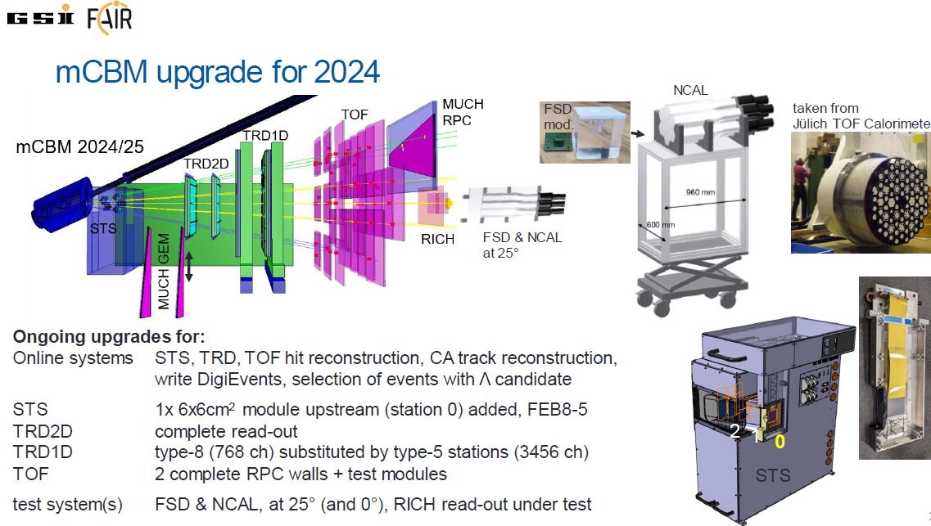

The CBM CA track reconstruction could be improved and is the input for the CBM KFParticle package, which identifies Λ candidates. The reconstruction of Λs could be nicely demonstrated offline with the 2022 Ni+Ni data.

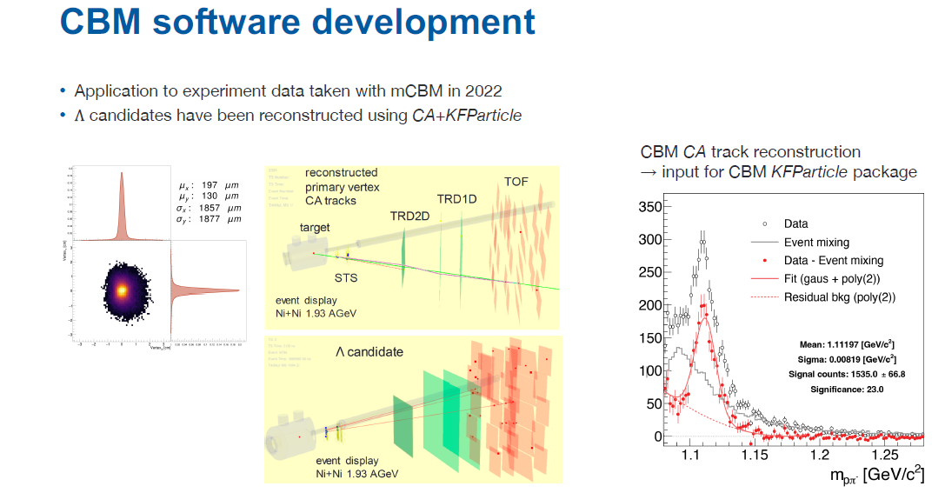

Based on the results of the work package the prototype of CBM online reconstruction and selection is under further development. Everything is under well preparation to reach the objective for the upcoming runs, the successful online reconstruction of events with a Λ candidate.

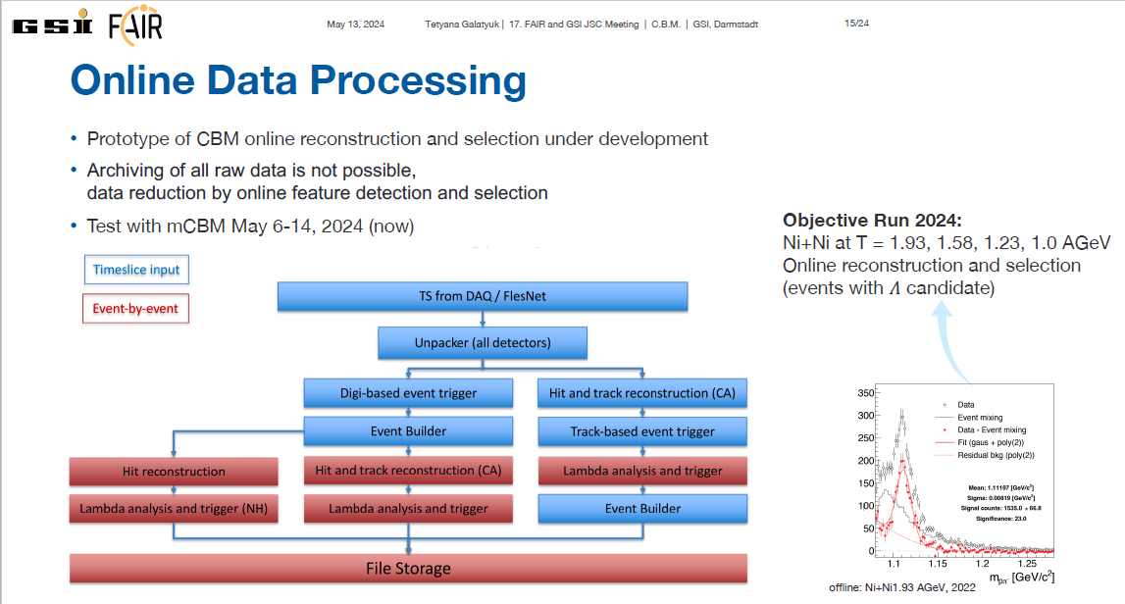

1. Critical Implementation risks and mitigation actions

**2.1 Risk materialization**

*[Provide the information on the project risks described in Annex 1 to the Grant Agreement*.*]*

1. The participating groups have large experience in international collaborations and in the fields of this networking activity. The projects to achieve the high data reduction are ambitious and require innovative concepts beyond state of the art. In view of the high success rate achieved by the groups. (low)

Whether the risk has materialized? No

**2.2 Risk-mitigation measures applied**

*[Please indicate whether the risk-mitigation plan described in Annex 1 to the Grant Agreement and corresponding to the risk number was applied in the reporting period*.*]*

1. The experts of the different participating groups will connect by virtual meetings to detect risks early. In case of failure of certain planned concepts, alternative solution will be worked out.

Whether the risk-mitigation plan was applied? No

**2.3 Comments/new risk-mitigation measures proposed**

*[Provide any significant comments on the risks encountered and the mitigation plan applied. Give any unforeseen risks encountered during the reporting period and not mentioned above*.*]*

No.

3. Deviations from Annex 1 (Description of Action) and Annex 2 (Estimated budget for Action) (if applicable)

**3.1 Deviations from planned objectives and tasks, and their impact on the progress of the work package**

*[Explain the reasons for deviations, the consequences and the proposed corrective actions.]*

No deviations from the planned objectives and tasks.

**3.2 Deviations between actual and planned person months**

*[Explain deviations between actual and planned person-months. If applicable, propose corrective actions.]*

No deviations for the planned person months.

1. Deliverables and milestones tables

**4.1 Deliverables**

*[Please list all the deliverables due in this reporting period, as indicated in Annex I.*

*Deliverables must also be accompanied by a short report (deliverable description and technical documentation, such as photo, list of publications, etc.), so that the European Commission has a record of their existence.]*

***Table 4.1 List of deliverables***

| **Deliverable No.** | **Deliverable name** | **Lead Beneficiary** | **Nature** | **Dissemination level[1]** | **Delivery month from Annex I** | **Delivered**  **(yes/no)** | **Actual delivery month** | **Comments** |
| --- | --- | --- | --- | --- | --- | --- | --- | --- |
| D12.1 | Report on detector tests, FEE, DAQ and data analysis; user manuals on  FEE and DAQ software | 11 - RUB | Report | PU | 62 | yes | 62 |  |
| D12.2 | Repository of software components | 11 - RUB | Other | PU | 62 | yes | 62 |  |

*In case a deliverable has been delivered in the reporting period and a report exists in the Participant Portal, you can indicate “uploaded report” in correspondence of a deliverable*

**4.2 Milestones**

*[Please complete the table if milestones are specified in Annex I.*

*Milestones will be assessed against specific criteria and performance indicators as defined in Annex I.]*

***Table 4.2 List of milestones***

| **Milestone number** | **Milestone name** | **Lead beneficiary** | **Delivery month from Annex I** | **Delivered**  **(yes/no)** | **Actual delivery month** | **Comments** |
| --- | --- | --- | --- | --- | --- | --- |
|  |  |  |  |  |  |  |

**No Milestones in the RP3 (months 37-62)**

**4.3 Deliverable Reports**

*[Please provide, per each deliverable listed in Table 4.1, a brief description, including if possible some technical documentation (photos, list of publications, etc.). Use as many pages as needed per each report.]*

***Deliverable D12.1****: Report on detector tests, FEE, DAQ and data analysis; user manuals on FEE and DAQ software - Achieved*

The document of deliverable D12.1 consists of the following publications, reports and user manuals:

1. G. Mazza, “ToASt v1 User’s Guide*”,* 2024.
2. Francesca Lenta et al., “Characterization of the radiation tolerant ToASt ASIC for the readout of the PANDA MVD strip detector”, 2024, JINST 19 C04047.
3. P.Marcinieweski, T. Johansson, “PANDA Forward EMC Sampling ADC”, Uppsala University, 2023.
4. M. Preston a, S. Bukreeva b, S. Diehl, P. Marciniewski, R.W. Novotny, S. Ryzhikov, P.A. Semenov P.-E. Tegnér on behalf of the PANDA Collaboration, “A feature-extraction and pile-up reconstruction algorithm for the forward-spectrometer EMC of the PANDA experiment”, Nuclear Inst. and Methods in Physics Research, A 1011 (2021) 165601.
5. Radim Dvořák and Lukáš Chlad for the CBM collaboration, “Performance studies for the mCBM experiment campaigns in 2022”, PoS(FAIRness2022)013.
6. V. Sidorenko et al, “Time error accumulation in a hierarchical time and clock distribution network with deterministic optical links”, 2024 JINST 19 C03014.
7. V. Sidorenko et al, “Evaluation of GBT-FPGA for timing and fast control in CBM experiment”, 2023 JINST 18 C02052.
8. V. Sidorenko et al, “Prototype design of a timing and fast control system in the CBM experiment” 2022 JINST 17 C05008.
9. CBM Progress Report 2023, Contributions on DAQ/FLES and Computing.
10. G. Barucca et al,”Feasibility studies for the measurement of time-like proton electromagnetic form factors from***p*** ̄ ***p***→ μ+μ− at PANDA at FAIR”, Eur. Phys. J. A (2021) 57:30.
11. G. Barucca et al (PANDA collaboration), “PANDA Phase One”, Eur. Phys. J. A (2021) 57:184.
12. G. Barucca et al, “Study of excitedΞ baryons with the PANDA detector”, Eur. Phys. J. A (2021) 57:149.

***Deliverable D12.2:*** *Repository of software components - Achieved*

The repository, accessible via the web site <https://strong-2020.ep1.rub.de/category/repository/> contains a collection of software developed in the framework of the experiments at FAIR/GSI, especially CBM and PANDA. The following software package are available not only for experiments at FAIR/GSI, but also provide valuable algorithms for future hadron physics experiments and beyond.

FAIRroot: The FairRoot framework is an object oriented simulation, reconstruction and data analysis framework. It includes core services for detector simulation and offline analysis of particle physics data. FairRoot is the standard simulation, reconstruction and data analysis framework for the FAIR experiments at GSI Darmstadt. The framework enables the users to design and/or construct their detectors and /or analysis tasks in a simple way, it also delivers some general functionality like track visualization. The basic idea of FairRoot is to provide a unified package with generic mechanisms to deal with most commonly used tasks in HEP. FairRoot allow the physicist to:

* Focus on physics deliverables while reusing pre-tested software components.
* Do not submerge into low-level details, use pre-built and well-tested code for common tasks.
* Allows physicists to concentrate on detector performance details, avoiding purely software engineering issues like storage, retrieval, code organization etc.

CbmRoot: CbmRoot is the software package for simulation, reconstruction, and data analysis for the CBM experiment.

PandaRoot: PandaRoot is the software package for simulation, reconstruction, and data analysis for the PANDA experiment.

TRB3: The TRB-family contains a versatile FPGA-platform, TDC-in-FPGA technology with 10ps precision, front-end electronics and a complete set of data acquisition and control software.

PAWIAN PArtial Wave Interactive Analysis: PAWIAN is a powerful, user-friendly and highly modular partial wave analysis software package with the aim to support analyses for a multitude of different physics cases at hadron physics experiments. Real data originating from the pbar p annihilation process and from e+ e- reactions are currently under investigation with PAWIAN. It is possible to define complicated decay trees, to choose different spin formalisms and resonance dynamics as well as to set up numerous other parameters via a simple plain text configuration file without modifying and compiling any code.

Parameters that can be set in the configuration file include, among many more:

* The amplitudes can be described with different formalisms.
* The widely used helicity, canonical and the Lorentz-invariant Rarita-Schwinger formalisms are supported so far
* A couple of different descriptions for the dynamics of resonances can be chosen, e.g. the Breit-Wigner parametrization with or without barrier factors, the Flatté-formalism and the K-matrix formalism
* The minimization is realized with an event-based maximum likelihood fit. It makes use of the MINUIT2 minimization package. In addition, one can start with a pre-fitter based on a genetic algorithm
* To improve the performance for the very time-consuming fit procedure the applications can be run in parallel on multi-core CPUs (multi-threading) and/or on computer clusters (networking)
* Coupled channel analyses are supported
* The analyst can generate events based on the user-defined decay model or on the fit result obtained with real data
* Tools for quality assurance, histogramming and for extracting values of different goodness-of-fit criteria are also available

PAWIAN is written in C++ and follows an object-oriented approach with a wide range of flexibility. The code therefore allows to be easily extended for further decay models, complete amplitudes and also other descriptions for the dynamics.

1. PU = Public

   PP = Restricted to other programme participants (including the Commission Services).

   RE = Restricted to a group specified by the consortium (including the Commission Services).

   CO = Confidential, only for members of the consortium (including the Commission Services).