**Template TA**

|  |  |  |  |
| --- | --- | --- | --- |
| **Work package number** | WP5 | **Start date** | 01/06/2019 |
| **Activity Type** | Transnational Access | | |
| **Work package acronym** | TA3-LNF | | |
| **Work package title** | Transnational Access to LNF | | |
| **Lead beneficiary** | 30 - INFN | | |

# Publicity concerning the new opportunities for access

*[Please describe the measures taken to publicise the opportunities for access during the third reporting period (June 2022 – July 2024)].*

The web-page dedicated to the Transnational Access to LNF-INFN has been active.

This page has been widely publicized and spread within the hadron physics community.

The web-page address is:

http://www.lnf.infn.it/cee/STRONG2020/

All necessary information could be found in this web-page, including a description of the LNF facilities (in particular the DAFNE complex, including the collider, the LINAC and relative Beam Test Facility – BTF), how to apply, the selection procedure, infos for users, etc.

Moreover, a large scientific community, including both existent users and potential users of the DAFNE complex at Laboratori Nazionali di Frascati dell'INFN, was capillary informed via mail.

# Selection procedure

## 2.1 Organization of the Users Selection Panel (USP)

Eligible researchers wishing to have transnational access to LNF (TARI-LNF), taking advantage of the support of the European Grant Agreement 824093 STRONG-2020, were requested to submit to the secretariat of TARI-LNF written proposals.

A User Selection Panel (USP) for the selection of the submitted proposals and the monitoring of the progress of the approved projects was implemented. The USP was formed by 4 members: 3 external members and 1 internal member, chosen on the basis of their internationally recognized expertise and appointed by the LNF Director. For all selected projects a short report was prepared by the USP, including the results of the assignement, and sent to the applicants.

## 2.2 Selection criteria

The USP based its selection criteria on scientific merit and following the statements contained in the Chapter 4 Article 16.1, Section 1, of the Grant Agreement 824093 — STRONG-2020.

## 2.3 Users Selection Panel members

The USP members were:

Frank Maas (chairperson) Helmholtz Institute, Mainz (Germany)             external member   
Josef Pochodzalla    Johannes Gutenberg University, Mainz (Germany)   external member   
Edoardo Milotti            Trieste University (Italy)                     external member   
Antonella Antonelli    Laboratori Nazionali di Frascati (Italy)     internal member

## 2.4 Users Selection Panel meetings

A second Call of TARI-LNF within STRONG-2020 was launched on 15/07/2020 and closed on 10/09/2020. Given the impossibility for the users to reach Frascati due to the restrictions for pandemic, the USP decided to postpone the selection of the received proposals.   
In the mean time, a relevant number of man*days already assigned in the first Call could not be utilized.

At the light of the fact that the restrictions lasted until fall 2021, it was decided to reset the second Call and to launch a new Call, with dead line 14 November 2021.   
The USP met on 7th December 2021, giving a new assignment of days and trips for 2022, to be added to the days/trips already assigned in the first Call and that could not be utilized. Additional to the pandemic, the international crisis added to the difficulty in users travelling, which made so that the use of man*days was less intensive than (initially) planned; The TA providers and USP monitored constantly the situation in 2022 and in the first half 2023; in summer 2023 all projects were still having consistent man*days assigned and not yet used. The USP monitored the situation and discussed it in June 2023 to verify the status of TA, and decided to extend the use of the assigned days to the projects until the end of STRONG-2020; moreover, for the few projects which required more man*days to achieve their goals the USP decided to supplement the requests from the remaining funding.

Note: since not all money could be spent, together with the STRONG-2020 management (EB) it was decided to setup a task force of 2 Postdocs to guarantee the successful completion of the INFN-LNF TNA by 07/24 (included in the amendment and approved).

The goal of the task force which was fundamental in achieving the full success was as follows:

1) One post doc who acted as technical support for the INFN-LNF TNA related projects, including the technical support for: a) the High Purity Germanium Detector (HPGe detector system), related to Zagreb Univ. TA project, for measurements of heavy kaonic atoms (kaonic lead), as test measurements for the very important kaon mass measurement and kaon-nuclei potential; b) the veto-2 and the luminosity monitor, related to Vienna univ. and Jagiellonian Univ. TA projects, aiming to the measurement of kaonic deuterium and light kaonic atoms measurements during the 2024 run on the DAFNE collider. In particular the post doc assisted in the installation and optimization of the detectors; in the shifts for the run on DAFNE collider and also as a link between experiments/ TA projects and the DAFNE collider. In this last context, the post doc contributed to the information exchange between the projects and the accelerator team for the optimization of machine parameters for the kaonic atoms runs, including: background optimization, luminosity (kaons) optimizations for the better use of the delivered beams and kaons. The post doc was fundamental to fulfil at best all the goals of the project(s), which also contribute towards various publications (which include acknowledgements to the STRONG-2020 project);

2) One post doc who acted as data analyses and Monte Carlo support for the TNA projects which aimed for data taking on kaonic deuterium (Vienna Univ., Jagiellonian Univ.) and other kaonic atoms (Zagreb Univ.), with SDD also HPGe detector systems, integrating veto-2 system and luminometer. The Monte Carlo and data analyses using advanced statistical methods, is fundamental to achieve the physics outcome aimed by the TNA projects. In particular, the post doc applied newly developed analyses methods implementing Machine Learning algorithms both for the detector calibration as well as for the signal extraction by using the veto systems. Monte Carlo advanced simulations of the various setups and their components, in parallel with the data taking, in the realistic run conditions of the 2024 runs, both for the kaonic deuterium as well as for kaonic lead (this last one with HPGe detector) are fundamental to extract the yields of kaonic atoms transitions, and for a better understanding of the physics processes at the basis of exotic (and kaonic) atoms cascade. The post doc was fundamental in last months of the project to fulfil at best all the goals of the project(s), which also contributed towards various publications (which include acknowledgements to the STRONG-2020 project);

# 3. Transnational Access activity during the reporting period

## 3.1 Detailed description of the activity

*[Please describe the activity during the reporting period as reported in Annex I to the Grant Agreement]*

The following activity was carried on during the reporting period:

Facility PADME:

Project n.2 (Venelin Kozhuharov, Sofia University, Bulgaria): Searching for new light particles with PADME at BTF (Dark And Rare). The aim of this application was: participation in the preparation of the PADME experiment, improved calibration and monitoring of the charged particles veto system, control system preparation.

Project n.9 (Venelin Kozhuharov, Sofia University, Bulgaria): Searching for new light particles with PADME at BTF (Dark And Rare). The aim of this application was: continuation of the search with the PADME experiment of Dark Matter, in particular of the Dark Photon at 17 MeV; the activity was focused on calibration of the detector and data analyses.

Facility SIDDHARTA:

Project n. 3 SIDDHARTA-2 "Studying kaonic deuterium atoms with SIDDHARTA-2" (Johann Zmeskal, SMI, Vienna, Austria), with the following activities:

• Participation in beam time shifts

• Data analysis

• MC simulations

• Calibration of Veto-2 system and its use

Project n. 4 KRAKOW@SIDDHARTA-2 "Investigation of kaonic deuterium atoms with SIDDHARTA-2" (Szymon Niedzwiecki, Jagiellonian University, Cracow, Poland), with the flowing activities:   
• Participation in beam time shifts   
• Optimization of data analysis for luminosity detector   
• Optimization of programs for fast on-line data analysis   
• Participation in data analysis   
• MC simulations   
  
Project n. 6 EARS-2 "Exotic atoms research with SIDDHARTA-2" (Alexandru Mario Bragadireanu, IFIN-HH, Magurele (Bucharest),Romania) with the following activities:   
• Participation in beam time shifts for kaonic atoms measurements  
• Data analysis of data collected   
• Optimization of the degrader   
• Calibration and optimization 1 mm thick SDD   
• Development of new interface in LabView software for DCS   
• Integration of new DCS in DAQ and Slow Control systems.   
  
Project n. 7  SIDDHARTA-2 & HPGetest   "SIDDHARTA-2 data taking and HPGe tests measurements" (Damir Bosnar, University of Zagreb, Zagreb, Croatia), with the following activities:  
• Test measurements with HPGe in parallel with SIDDHARTA-2 data taking   
• Determination of background level, position and shielding of HPGe, for the precision measurement of the charged kaon mass   
• Participation in data taking   
• Participation in data analysis and MC simulations.

Project n. 8 IGFAE-Kd “Kaonic Atoms at SIDDHARTA-2” (Antonio Romero Vidal, Santiago di Compostella, Spain), with the following activities:

• Participation in beam time shifts

• Data analysis for kaonic deuterium using Machine Learning

Project n. 10 SIDDHARTA-2 " Studying kaonic deuterium atoms with SIDDHARTA-2 " (Johann Zmeskal, SMI, Vienna, Austria), with the following activities:

• Participation in beam time shifts for kaonic deuterium at various densities

• Data analysis

• MC simulations

• Continuous maintenance and calibration of Veto-2 system during run

Project n. 11 Project n. 4 KRAKOW@SIDDHARTA-2 "Investigation of kaonic deuterium atoms with SIDDHARTA-2" (Magdalena Skurzok, Jagiellonian University, Cracow, Poland), with the flowing activities:

• Participation in beam time shifts for Kd

• Continuous data analysis for luminosity detector and extraction of luminosity during runs

• Participation in data analysis

• MC simulations

Project n. 12 Project n. 5 MeKaSD " Measurements of Kaonic atoms with SIDDHARTA-2 at Dafne" (Laura Fabbietti, TUM, Munich, Germany) with the following activities:

• Data analysis of SIDDHARTa-2 Kd run

• Participation in beam time shifts

• SDD calibration in loco during data taking

• Development of advanced data analyses using ML

Project n. 13 SIDDHARTA&HPGetest "SIDDHARTA-2 data taking and HPGe tests measurements" (Damir Bosnar, University of Zagreb, Zagreb, Croatia), with the following activities:

• Continuous optimization of HPGe detector in the DAFNE Hall

• Test measurements with HPGe in parallel with SIDDHARTA-2 data taking continued

• Determination of background level, position and shielding of HPGe, for the precision measurement of the charged kaon mass

• Participation in data taking for Kd

• Participation in data analysis and MC simulations.

Project n. 14 EARS-2 "Exotic atoms research with SIDDHARTA-2" (Alexandru Mario Bragadireanu, IFIN-HH, Magurele (Bucharest),Romania) with the following activities:

• Participation in beam time shifts for SIDDHARTA_2 full setup

• Data analysis of data collected

• Optimization of the degrader for Kd measurements

• Calibration and optimization 1 mm thick SDD

• Optimization of DAQ and Slow Control systems

Project n. 9 and 15 IGFAE-Kd “Kaonic Atoms at SIDDHARTA-2” (Antonio Romero Vidal, Santiago di Compostella, Spain), with the following activities:

• Participation in beam time shifts for final Kd run

• Data analysis for kaonic deuterium using Machine Learning

***Table 3.1 Access to the facility during the reporting period supported by the project***

|  |  |  |  |
| --- | --- | --- | --- |
| **Project No.** | **User-project acronym** | **Number of users** | **Number of days spent at the infrastructure** |
| **2** | **DarkAndRare** | **4** | **38** |
| **3** | **SIDDHARTA-2** | **1** | **24** |
| **4** | **KRAKOW@SIDDHARTA-2** | **6** | **16** |
| **6** | **EARS-2** | **1** | **10** |
| **7** | **SIDDHARTA-2 & HPGe** | **1** | **10** |
| **8** | **IGFAE-Kd** | **1** | **10** |
| **9** | **DarkAndRare** | **5** | **134** |
| **10** | **SIDDHARTA-2** | **4** | **223** |
| **11** | **KRAKOW@SIDDHARTA-2** | **10** | **178** |
| **12** | **MeKaSD** | **1** | **10** |
| **13** | **SIDDHARTA&HPGetest** | **2** | **123** |
| **14** | **EARS-2** | **2** | **43** |
|  | TOTAL | **38** | **819** |

## 3.2 Scientific output of the transnational access activity in the reporting period

## Follows a description of the scientific outputs followed by articles resulting from TA3-LNF.

## Facility PADME: projects 2 and 9

Data analyses for the X17 run is ongoing, with results expected by autumn 2024. The new eTagger has been installed (2021-2022) and a new gaseous tracking detector is under construction to better measure X17 decay products in a run to take place in 2025. This system was tested and will be used to separate gg from ee clusters; also a new gaseous tracking detector is under construction to better measure X17 decay products

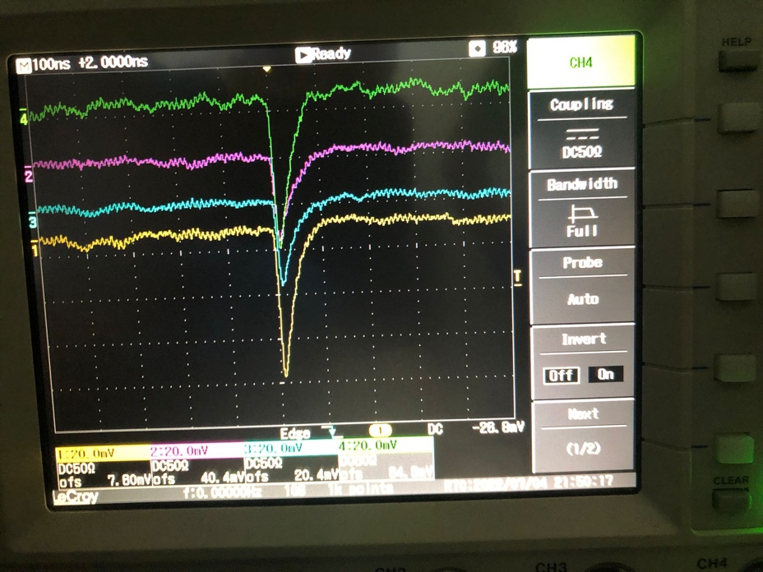Gamma-gamma tagger test:

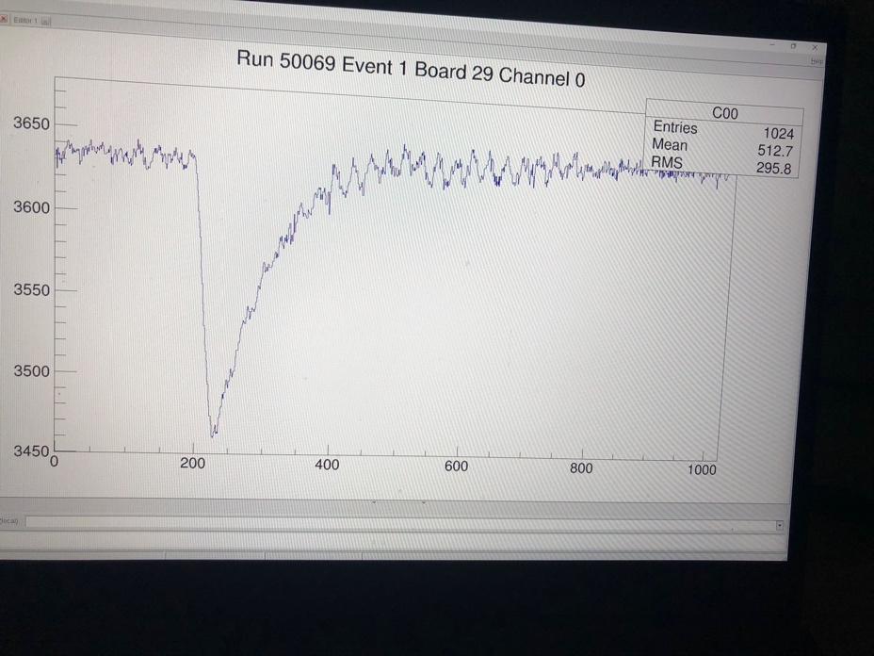

## Facility SIDDHARTA Project n. 4  KRAKOW@SIDDHARTA-2: the activity consisted in the installation of the luminometer and its calibration with the kaon monitor and the DAFNE calculated luminosity; participation in the beam time shifts; data analysis.

## Project n. 5 ANTIKD: the activity consisted in the participation in the beam time shifts with SIDDHARTA-2 and in the participation in data analysis for extraction of kaonic helium.

## Project n. 6  EARS-2: the activity consisted in the participation in the beam time shifts of SIDDHARTINO and in the development of a new interface in the software LabView for DCS. Project n. 7  SIDDHARTA-2 & HPGetest: the users installed the HPGe detector in the DAFNE hall, and performed first tests measurements, in parallel with the SIDDHARTA-2 data taking.

## Project n. 3  SIDDHARTA-2: the Vienna group participated in the final SIDDHARTA-2 detector assembly; participated in the calibration of the Veto-2 system and in its installation; participated in the beam time shifts and in the data analyses and Monte Carlo simulations.

Project n. 3  AntiKD: the Munich group participated in the beam time shifts for calibration of the SIDDHARTA-2 setup with various kaonic atoms measurements for degrader optimization; in the data analyses and Monte Carlo simulations.

## Project n. 10  SIDDHARTA-2: the Vienna group participated in the maintenance and optimization of SIDDHARTA-2 setup, in particular of veto-2 detector, during Kd run; participated in the calibration of the Veto-2 system and extraction of the veto signal; participated in the beam time shifts and in the data analyses and Monte Carlo simulations.

Project n. 11  KRAKOW@SIDDHARTA-2: the activity consisted in monitoring the luminometer and calculating the luminosity during the Kd run; participation in the run shifts and in the data analysis to extract the Kd and other kaonic atoms signals.

Project n. 12  MeKaSD: the Munich group participated in the beam time shifts for kaonic deuterium run to extract shift and width of kaonic deuterium fundamental level; in the data analyses and theoretical interpretations.

Project n. 13  SIDDHARTA-2 & HPGetest: the Zagreb group optimizaed the data taking of the kaonic heavy atoms with the HPGe detector in the DAFNE hall, by performing test measurements for kaonic lead; data were analysed and submitted for publication, in parallel the group took part to the SIDDHARTA-2 data taking.

Project n. 14  EARS-2: the activity consisted in the participation in the beam time shifts of SIDDHARTa-2 for kaonic deuterium and other kaonic atoms and in the optimization of in the software LabView for DCS

Project n. 15 IGFAE-Kd: the Spanish team participated in the shifts for Kd measurement, in data analyses and MCarlo simulations by also applying ML method.

The most precise measurement of the kaonic helium transitions to the 2p level in gas, obtained with the SIDDHARTINO setup (reduced SIDDHARTA-2 setup) in which all Projects were involved; the obtained kaonic helium spectrum is shown in Fig. 1, and published in J. Phys. G: Nucl. Part. Phys. 49 0551

06

*Figure 1: the kaonic helium spectrum obtained with support of transnational access in SIDDHARTA facility (from paper J. Phys. G: Nucl. Part. Phys. 49 055106)*

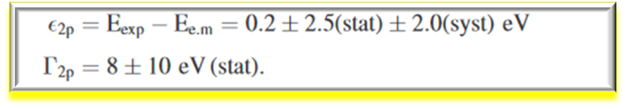

* Optimization of the degrader for stopping kaons in a gaseous target – with application to the helium target – Figure 2 (taken from J. Phys. G: Nucl. Part. Phys. 49 055106)
* 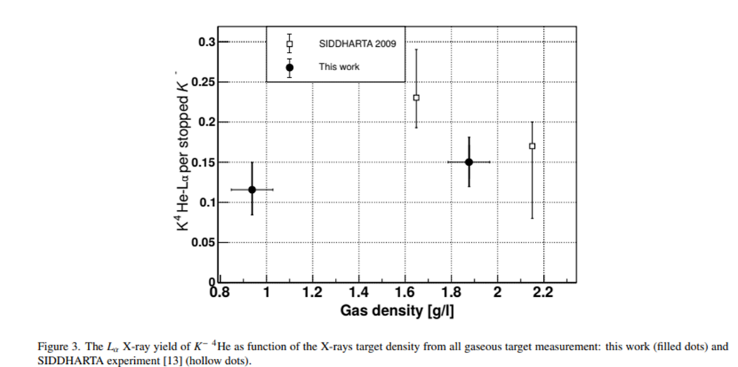

*Figure 2: Optimization of the degrader for gaseous helium target with SIDDHARTINO setup*

* The yields of kaonic helium transitions on 2p level for 2 different gas target densities (0.7 and 1.5% Liquid density)
* The installation of the final SIDDHARTA-2 setup with all key-elements (SDD, veto1, veto2 , trigger, luminometer, slow control, DAQ…) on the DAFNE Collider, Figure 3 test and debug and first characterization with kaonic helium

*Figure 3: The final SIDDHARTA-2 setup installed on DAFNE Collider*

* The first measurement of kaonic neon (data taken for optimization of final SIDDHARTA-2 setup) with measurement precision below 1 eV which proves that this measurement could in the future provide the kaon mass with best precision up to date, Fig. 4

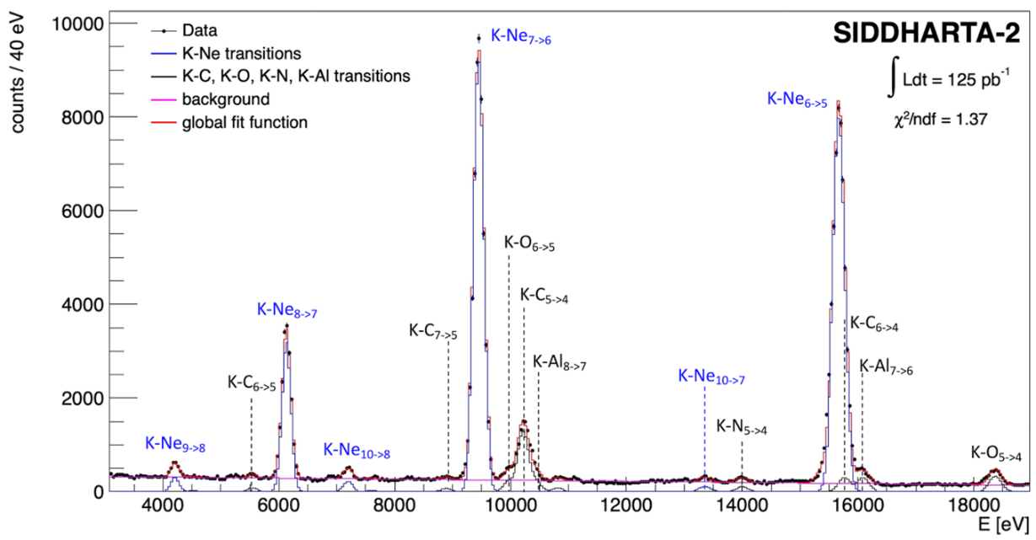

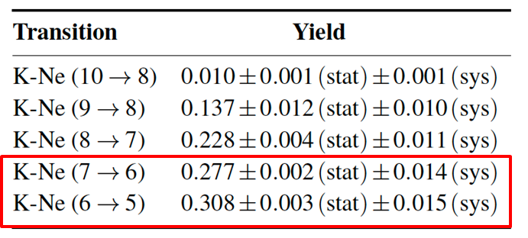

*Figure 4: The kaonic neon spectrum obtained by SIDDHARTA-2 and the precision of the measurement*

* The first kaonic deuterium run in April 2022 – June 2024 – data analyses is ongoing and looks very promising
* Installation and characterization of the High Purity Germanium detector on DAFNE in parallel with SIDDHARTA-2 setup, Figure 5; first measurement of kaonic lead with HPGe at DAFNE, Fig 6

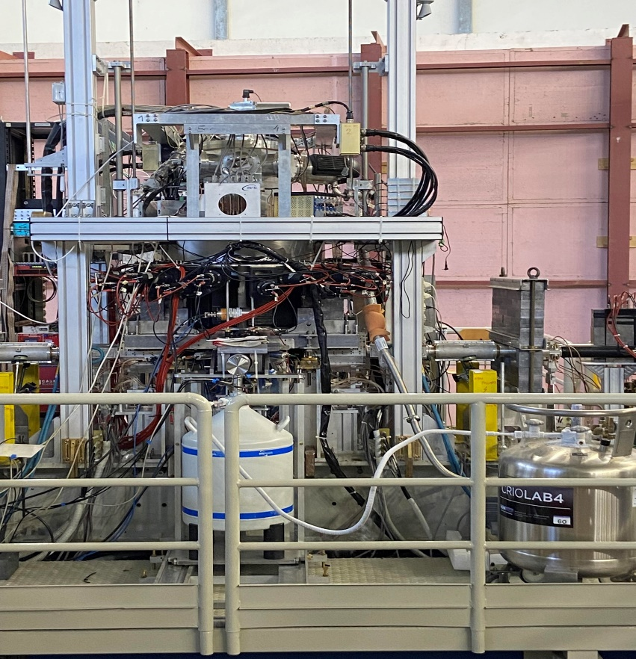

*Figure 5: The HPGe detector installed on DAFNE collider*

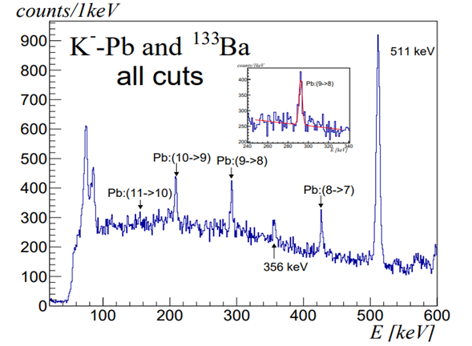

*Figure 6: Kaonic Lead spectrum – results submitted for publication*

## Publications as results of the activities at LNF within TA3-LNF Facility SIDDHARTA:

Kaonic lead feasibility measurement at DAΦNE to solve the charged kaon mass discrepancy, e-Print: 2405.12942, submitted to NIM

Characterization of the SIDDHARTA-2 Setup via the Kaonic Helium Measurement, Condens.Mat. 9 (2024) 1, 16

Kaonic atoms with SIDDHARTA-2 at the DAϕϕNE collider, EPJ Web Conf. 291 (2024) 01008

Kaonic Helium-4 L-series Yield Measurement at 2.25 g/l Density by SIDDHARTA-2 at DAΦΦNE, Acta Phys.Polon.Supp. 17 (2024) 1, 1-A8

The Odyssey of Kaonic Atoms Studies at the DAΦΦNE Collider: From DEAR to SIDDHARTA-2, Acta Phys.Polon.B 55 (2024) 5, 5-A

The SIDDHARTA-2 Veto-2 system for X-ray spectroscopy of kaonic atoms at DAΦNE, JINST 18 (2023) 11, P11026

First measurement of kaonic helium-4 M-series transitions, J.Phys.G 51 (2024) 5, 055103

Kaonic atoms at the DAϕNE collider: a strangeness adventure, Front.in Phys. 11 (2023) 1240250

Potentialities of CdZnTe Quasi-Hemispherical Detectors for Hard X-ray Spectroscopy of Kaonic Atoms at the DAΦΦNE Collider, Sensors 23 (2023) 17, 7328

Measurements of high-n transitions in intermediate mass kaonic atoms by SIDDHARTA-2 at DAΦNE, Eur.Phys.J.A 59 (2023) 3, 56

New opportunities for kaonic atoms measurements from CdZnTe detectors, Eur.Phys.J.ST 232 (2023) 10, 1487-1492

New measurements of kaonic helium-4 L-series X-rays yields in gas with the SIDDHARTINO setup, Nucl.Phys.A 1029 (2023) 122567

Kaonic atoms measurements with SIDDHARTA-2, J.Phys.Conf.Ser. 2446 (2023) 1, 012023

SIDDHARTA-2 veto system design and performance for kaonic atoms studies at DAΦNE, EPJ Web Conf. 290 (2023) 06005

Towards the first kaonic deuterium measurement with the SIDDHARTA-2 experiment at DAΘNE, Nuovo Cim.C 45 (2022) 6, 205

Studies of the Linearity and Stability of Silicon Drift Detectors for Kaonic Atoms X-ray Spectroscopy, Acta Phys.Polon.Supp. 15 (2022) 4, 1

First Tests of the Full SIDDHARTA-2 Experimental Apparatus with a 4He Gaseous Target, Acta Phys.Polon.A 142 (2022) 3, 373-37

Large area silicon drift detectors system for high precision timed x-ray spectroscopy, Measur.Sci.Tech. 33 (2022) 9, 095502

Status and perspectives for low energy kaon-nucleon interaction studies at DAΦΦNE: from SIDDHARTA to SIDDHARTA-2, PoS PANIC2021 (2022) 200

The SIDDHARTA-2 calibration method for high precision kaonic atoms x-ray spectroscopy measurements, Phys.Scripta 97 (2022) 11, 114002

Kaonic atoms at the DAΦNE collider with the SIDDHARTA-2 experiment, Phys.Scripta 97 (2022) 8, 084006

## Facility PADME

Investigating the dark sector with the PADME experiment, Nuovo Cim.C 47 (2024) 4, 241

Characterization of the PADME positron beam for the X17 measurement, JHEP 08 (2024) 121

Design and performance of the front-end electronics of the charged particle detectors of PADME experiment, JINST 19 (2024) 01, C01051

Beam diagnostics with silicon pixel detector array at PADME experiment, JINST 19 (2024) 01, C01016

Dark sector studies with the PADME experiment, ,PoS ICHEP2022 (2023) 145

The study of the X17 anomaly with the PADME experiment, J.Phys.Conf.Ser. 2586 (2023) 1, 012140

Searching for light dark matter with the PADME experiment, PoS CORFU2021 (2022) 040

Cross-section measurement of two-photon in-flight annihilation of positrons at s=20  MeV with the PADME detector, Phys.Rev.D 107 (2023) 1, 012008

***Table 3.2 List of user meetings***

No users meetings have been held during the reporting period

# 4. Tables to be filled in the IT tool in Part A of the Periodic Report

|  |  |  |  |  |  |  |  |  |  |  |
| --- | --- | --- | --- | --- | --- | --- | --- | --- | --- | --- |
| **Researcher** | | | **Employing organisation/Home institution** | | | **User-project acronym** | **Activity Domain (Discipline)** | **Installations used by the researcher (*)** | | |
| **Name** | **Gender** | **Nationality** | **Name** | **Legal Status** | **Country** | **Infrastructure Short Name** | **Installation ID** | **Installation Short Name** |
| *Radoslav Simeonov* | *M* | *Bulgarian* | *Sofia Univ.* | Uni | *Bulgaria* | *DarkAndRare* | *Physics* | *LNF* | *1* | *DAFNE* |
| *Svetoslav Plamenov Ivanov* | *M* | *Bulgarian* | *Sofia Univ.* | Uni | *Bulgaria* | *DarkAndRare* | *Physics* | *LNF* | *1* | *DAFNE* |
| *Kalina Dimitrova* | *F* | *Bulgarian* | *Sofia Univ.* | Uni | *Bulgaria* | *DarkAndRare* | *Physics* | *LNF* | *1* | *DAFNE* |
| *Momchil Nydenov* | *M* | *Bulgarian* | *Sofia Univ.* | Uni | *Bulgaria* | *DarkAndRare* | *Physics* | *LNF* | *1* | *DAFNE* |
| *Venelin Kozhuharov* | *M* | *Bulgarian* | *Sofia Univ.* | Uni | *Bulgaria* | *DarkAndRare* | *Physics* | *LNF* | *1* | *DAFNE* |
| *Sterenberg Frankenthal André* | *M* | *Brazilian* | *Princeton Univ.* | Uni | *USA* | *DarkAndRare* | *Physics* | *LNF* | *1* | *DAFNE* |
| *Radi Malaj* | *M* | *Albanian* | *SMI Vienna* | RES | *Austria* | *SIDDHARTA-2* | *Physics* | *LNF* | *1* | *DAFNE* |
| *Hexi Shi* | *M* | *Chinese* | *SMI-Vienna* | RES | *Austria* | *SIDDHARTA-2* | *Physics* | *LNF* | *1* | *DAFNE* |
| *Francesco Clozza* | *M* | *Italian* | *SMI-Vienna* | RES | *Austria* | *SIDDHARTA-2* | *Physics* | *LNF* | *1* | *DAFNE* |
| *Kairo Toho* | *M* | *Japanese* | *Tohoku Univ.* | Uni | *Japan* | *SIDDHARTA-2* | *Physics* | *LNF* | *1* | *DAFNE* |
| *Diana Sirghi* | *F* | *Romanian* | *SMI-Vienna* | RES | *Austria* | *SIDDHARTA-2* | *Physics* | *LNF* | *1* | *DAFNE* |
| *Magdalena. Skurzok* | *F* | *Polish* | *Jagiellonian University* | UNI | *Poland* | *KRAKOW@ SIDDHARTA-2* | *Physics* | *LNF* | *1* | *DAFNE* |
| *Ksymena Poradzisz* | *F* | *Polish* | *Jagiellonian University* | *UNI* | *Poland* | *KRAKOW@ SIDDHARTA-2* | *Physics* | *LNF* | *1* | *DAFNE* |
| *Pawel Arthur Moskal* | *M* | *Polish* | *Jagiellonian Univ.* | *UNI* | *Poland* | *KRAKOW@ SIDDHARTA-2* | *Physics* | *LNF* | *1* | *DAFNE* |
| *Karolina Klimek* | *F* | *Polish* | *Jagiellonian Univ.* | *UNI* | *Poland* | *KRAKOW@ SIDDHARTA-2* | *Physics* | *LNF* | *1* | *DAFNE* |
| *Monika Rasz* | *F* | *Polish* | *Jagiellonian Univ.* | *UNI* | *Poland* | *KRAKOW@ SIDDHARTA-2* | *Physics* | *LNF* | *1* | *DAFNE* |
| *Katarzyna Dziedzic-Kocurek* | *F* | *Polish* | *Jagiellonian Univ.* | *UNI* | *Poland* | *KRAKOW@ SIDDHARTA-2* | *Physics* | *LNF* | *1* | *DAFNE* |
| *Kamila Kasperska* | *F* | *Polish* | *Jagiellonian Univ.* | *UNI* | *Poland* | *KRAKOW@ SIDDHARTA-2* | *Physics* | *LNF* | *1* | *DAFNE* |
| *Sushil Sharma* | *M* | *Indian* | *Jagiellonian Univ.* | *UNI* | *Poland* | *KRAKOW@ SIDDHARTA-2* | *Physics* | *LNF* | *1* | *DAFNE* |
| *Katarzyna Dziedzic-Kocure* | *F* | *Polish* | *Jagiellonian Univ.* | *UNI* | *Poland* | *KRAKOW@ SIDDHARTA-2* | *Physics* | *LNF* | *1* | *DAFNE* |
| *Gabiel Moskal* | *M* | *Polish* | *Jagiellonian Univ.* | *UNI* | *Poland* | *KRAKOW@ SIDDHARTA-2* | *Physics* | *LNF* | *1* | *DAFNE* |
| *Michal Z. Silarsk* | *M* | *Polish* | *Jagiellonian Univ.* |  | *Poland* | *KRAKOW@ SIDDHARTA-2* | *Physics* | *LNF* | *1* | *DAFNE* |
| *Adam Strach* | *M* | *Polish* | *Jagiellonian Univ.* | *UNI* | *Poland* | *KRAKOW@ SIDDHARTA-2* | *Physics* | *LNF* | *1* | *DAFNE* |
| *Karolina Klimek* | *F* | *Polish* | *Jagiellonian Univ.* | *UNI* | *Poland* | *KRAKOW@ SIDDHARTA-2* | *Physics* | *LNF* | *1* | *DAFNE* |
| *Monika Rasz* | *F* | *Polish* | *Jagiellonian Univ.* | *UNI* | *Poland* | *KRAKOW@ SIDDHARTA-2* | *Physics* | *LNF* | *1* | *DAFNE* |
| *Alessio Porcelli* | *M* | *Italian* | *Jagiellonian Univ.* | *UNI* | *Poland* | *KRAKOW@ SIDDHARTA-2* | *Physics* | *LNF* | *1* | *DAFNE* |
| *Raffaele Del Grande* | *M* | *Italian* | *TUM* | *RES* | *Germany* | *MeKaSD* | *Physics* | *LNF* | *1* | *DAFNE* |
| *Raffaele Del Grande* | *M* | *Italian* | *TUM* | *RES* | *Germany* | *AntiKD* | *Physics* | *LNF* | *1* | *DAFNE* |
| *Alexandru Mario Bragadireanu* | *M* | *Romanian* | *Horia Hulubei* | *RES* | *Romania* | *EARS-2* | *Physics* | *LNF* | *1* | *DAFNE* |
| *Diana Sirghi* | *F* | *Romanian* | *Horia Hulubei* | *RES* | *Romania* | *EEARS-2* | *Physics* | *LNF* | *1* | *DAFNE* |
| *Antonio Romero Vidal* | *M* | *Spanish* | *Stantiago di Compostella* | *UNI* | *Spain* | *IGFAE-Kd* | *Physics* | *LNF* | *1* | *DAFNE* |
| *Damir Bosnar* | *M* | *Croatian* | *University of Zagreb* | *UNI* | *Croatia* | *SIDDHARTA&HPGetest* | *Physics* | *LNF* | *1* | *DAFNE* |
| *Ivica Friščić* | *M* | *Croatian* | *University of Zagreb* | *UNI* | *Croatia* | *SIDDHARTA&HPGetest* | *Physics* | *LNF* | *1* | *DAFNE* |
| **(*) add as many rows as you need** | | | | | | | | | | |

***4.2 Research infrastructures made accessible to all researchers in Europe and beyond through EU support and summary of trans-national access provision per installation per reporting period (RP)***

|  |  |  |  |  |  |  |  |
| --- | --- | --- | --- | --- | --- | --- | --- |
| **Participant number** | **Organisation short name** | **Short name of infrastructure** | **Installation** | | **Unit of access** | **Min. quantity of access to be provided in Annex I (A)** | **Access provided in RP2** |
| **Number** | **Short name** |
| *30* | *INFN* | *LNF* | *1* | *DAFNE* | *beam-hour* |  | *1440* |