**I ) Introduction**

Experimentaly the main causes of constant term in ECAL energy resolution have been observed to be:

Fluctuation in “escape energy” This has been simulated in Denys shower simulation for our planned 16.8cmx16.8cm x 24.4X0=40cm test module and found to be < 1% even when scan in a sizeable part of the ECAL +-6cm in X or Y (0.25% in the back <0.4% from the sides)

Another cause of constant term is caused by the local x y light yield non uniformity , this was simulated by Denys for (1+ 0.07 cos (2pi x/7mm)) x (1+ 0.07 cos (2pi y/7mm)) and found to be about 1% an update will have to be done when the results of the CERN test will give information to replace the 0.07 fluctuation used in Denys simulation

Finally the 3rd cause of constant term often observed even in crystal ECAL (CSI BGO…) is the non uniformity of the scintillation light collection as function of Z for example due to light absorption in the bulk crystal or in the WLS fibers before reaching the light detectors (PMT or SiPM)

**II) Shower Z fluctuation**

There is an important effect due to the position of the first interaction: In the case of electrons the probability of brem is about x/x0 * ln(Emax/Emin) and therefore 4-5 x (X/X0) However the probability of high energy gamma pair creation is smaller (as can be found in PDG formula 34.31) the probability is (7/9)(X/X0)

Hence the average value of the first interaction <x> = integral from 0 to 25X0 of (x exp(-7x**/**9x0)) dx =9X0**/**7 => about 3.5 cm and the rms (if I do the integral correctly!) is (9X0/7)**/** sqrt(2) about 2.5cm

In : <https://indico.cern.ch/event/294651/contributions/671929/attachments/552041/760669/Delmastro_ESIPAP2014_3.pdf>

One can find example of typical longitudinal shower development

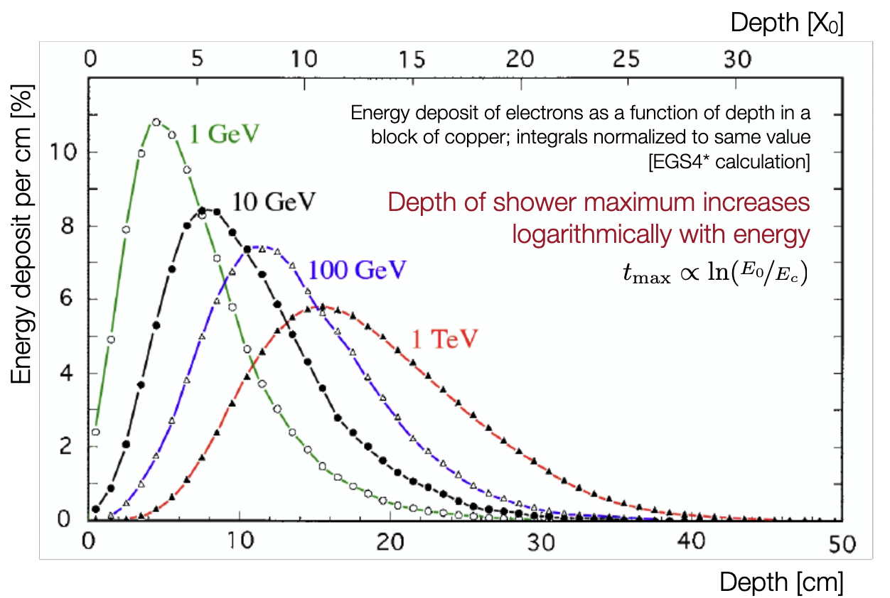 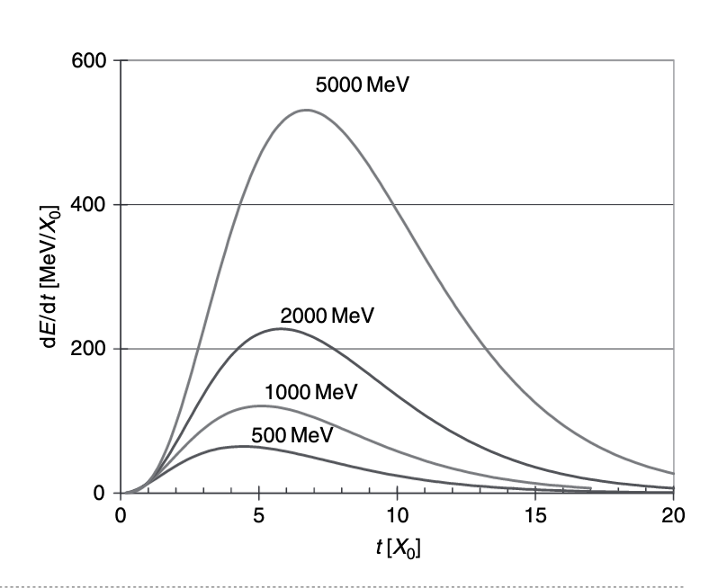

The big assumption **which should be tested by shower simulation** Is that the rms variation in the average position of the shower development in Z from event to event for a given energy is essentially due to the variation of the shower start point calculated above .This seems reasonable because after you have more and more particles and the fluctuation should decrease as 1/sqrt(N particles)

**III) Light attenuation in WLS fiber**

In the fiber tests done with the UVLED scintillators and WLS fibers we have measurements done with 20cm or 40 cm between the fiber excitation and the SiPM. I have taken the numbers from a Ianina pptx of March 10th

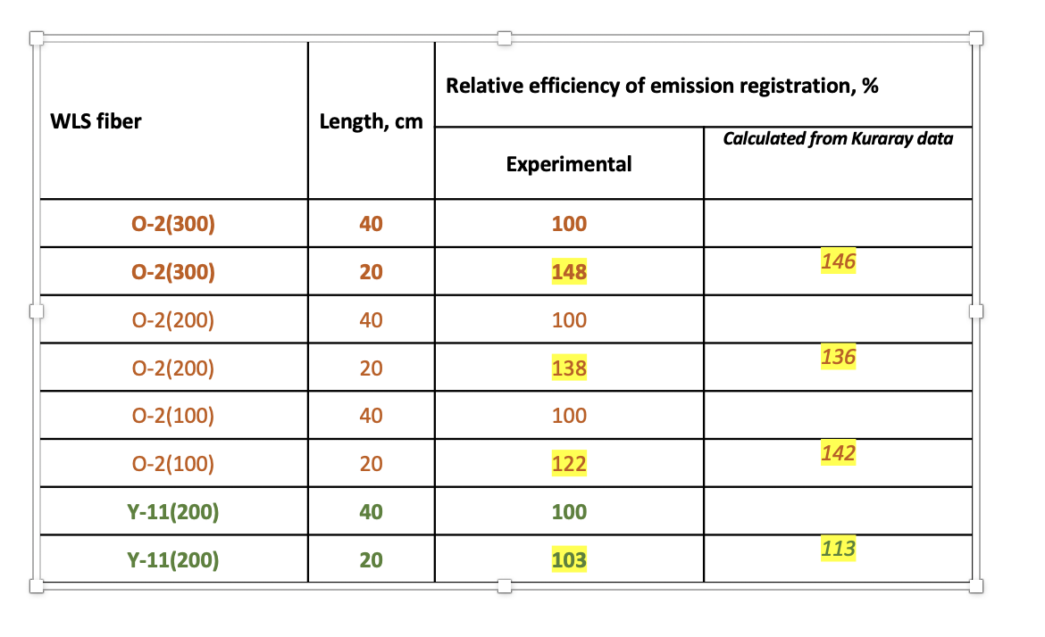

For O(200) a factor 1/ 1.36 for 20cm absorption => 1.5%/cm => 2.5cm from above => 3.7% WOW!

For Y11(200) (which would have less light but perhaps possible?) the measurements are optimist but if we use the Kuraray numbers =13% for 20cm => 0.65%/cm => 2.5cm from above => 1.6%

**IV) Improvements**

1. The first obvious improvement compared to these worrying results is the fact that “in a certain way” one can read the fibers from “both sides” and therefore decrease the variation with Z… Of course “doubling the SiPM and acquisition” would be expensive (and cumbersome for a final FCCee detector) and therefore unrealistic (?) but one can put an VM2000 reflector (as in liquid O I believe) or a vaporized Al reflector at the end of fibers as tried in LHCb… or as done in LHCb do a loop to connect two fibers (but this is not easy since the minimum radius of curvature of fibers is not small ) Of course when Z of light generation increases the direct light increases while the reflected light decreases and therefore the total effect is decreased However because of attenuation in the fiber (and imperfect mirror) the cancelation is not perfect.

The distance between the average shower position in Z and the entrance is about 7X0 (from plots above) => about 11cm so the light which travels to the mirror and comes travels about 22 cm about a factor 1.4 attenuation from Ianina’s tables if the mirror of VM2000 (?) has a reflection efficiency of 70% the over all attenuation is 50% Nevertheless this for an increase of the light because of shower displacement of 3.7% one adds -0.5 x 3.7% with the opposite sign and a total increase of light by 1.5 => (3.7% -1.85%)/ 1.5 = 1.23% ( not ideal but better!) but a 70% mirror is not trivial!

If the fiber used would be Y11(200) the situation is clearly better the attenuation over the 22cm is only 14.5% and with a mirror of 70% one gets 0.6 fraction of light which varies in the opposite direction the 1.6% of the Y11 without mirror gets reduced by 1.6% (1-0.6)/1.6 => 0.4% constant term.

**V) Use of Preshower**

Very often before ECAL at collider apparatus there was a Preshower of about 4X0 This improves significantly the electron identification. However there could be another use to the preshower if there is fluctuation of the first gamma conversion by 0.9 X0 the effect on a preshower of 4X0 should be much more important than compared to the full 25X0 and therefore it should be possible from the ratio preshower/total to correct for the effect of the fluctuation of the position of the first conversion… This seems highly plausible but a shower simulation would be needed to be sure.

How to obtain a Preshower readout on the Granita 25X0 module should be studied: For initial test of the module with gamma it would be possible the build a small 4X0 preshower (CSI or BGO) the lateral side does not need to be large and read by a PMT

But one could imagine a solution more applicable to the future: imagine that each of the 576 fiber is built of 2 fibers 4X0 long and 21 X0 long aluminised at one end and you glue these fiber to each other on their aluminised surface then you read the PS in front and the rest of ECAL in back… can these 576 fibers aluminisation and gluing be done by a “machine”?

Ianina has produced a picture of the idea

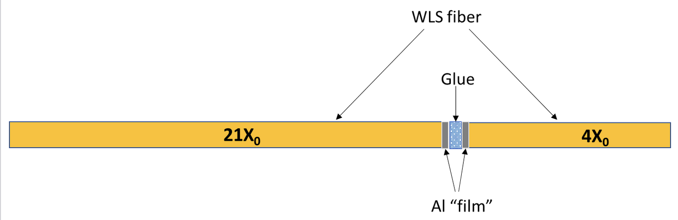

VI) Conclusion

Since the referees did not discuss these problems it is not obvious to me we should raise them in our future ANR document?

However we should foresee further test of fiber attenuation and fiber aluminisation before starting the module construction