Liste de materiel:

Box 1)

- PMT + scintillator

- 2 HV cables + 2 signal cables + 2 short HV cables

- 4 T connectros + 4 BNC-lemo + 4 50Ohms + 4 I connectors SHV

- Green LED + Blacck connector for fiber + lemo-lemo

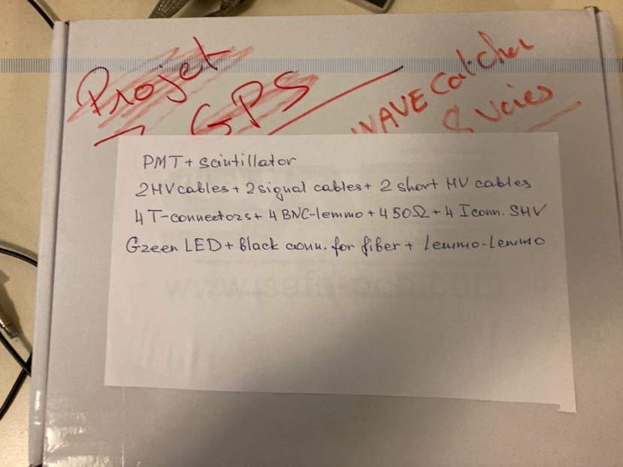

Box2)

- SiBB + 16 SiC + 16 collectors

- SiBB LV cable

- USB cable

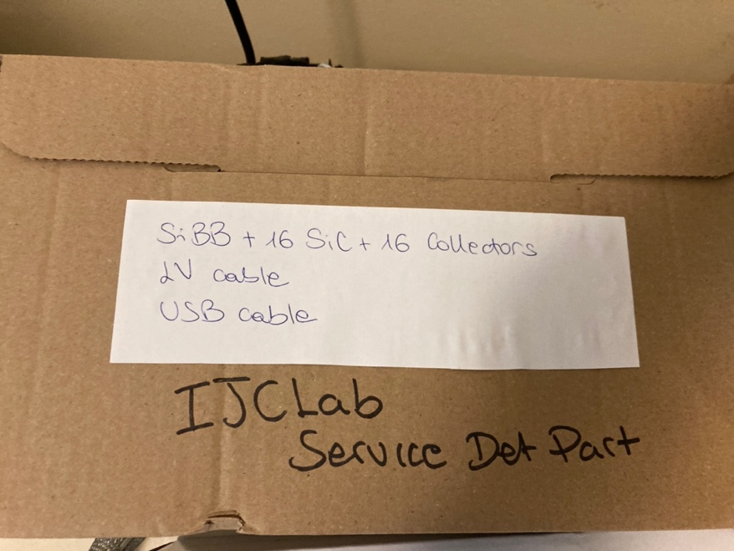

Box 3)

- Signal generator + 220V cable

- Multimeter

- Multi-socket

- 3 long HV cables

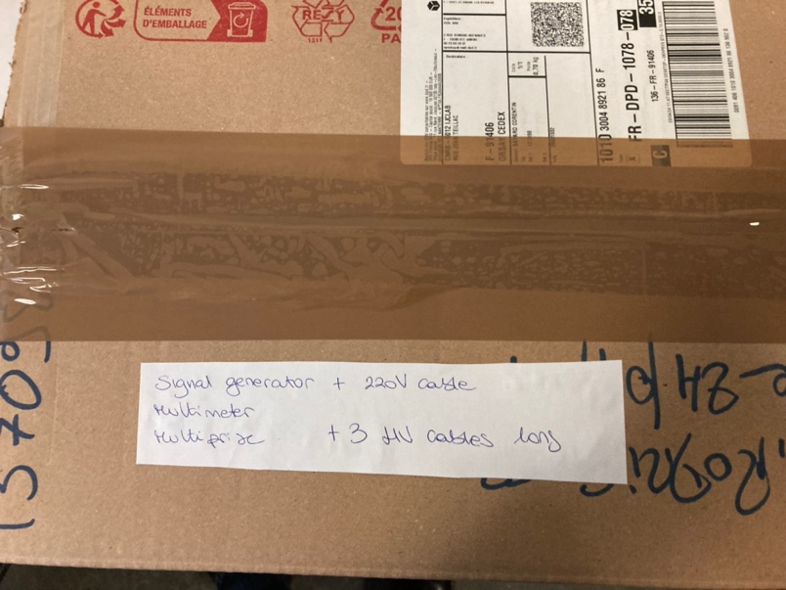

Box 4)

- BNC and lemo cables

- 4 cables MCX-lemo

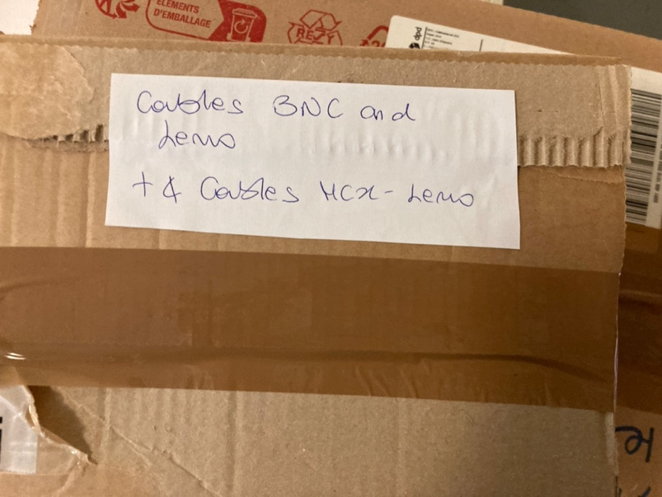

Box 5)

- H2O2 weak

- Heavy liquid

- Stuff for troll filling and grains’ washing

- Demineralized water

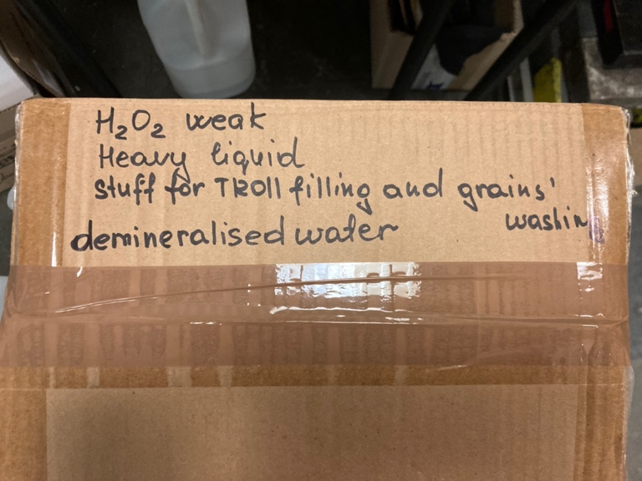

Box 6)

- Troll 2

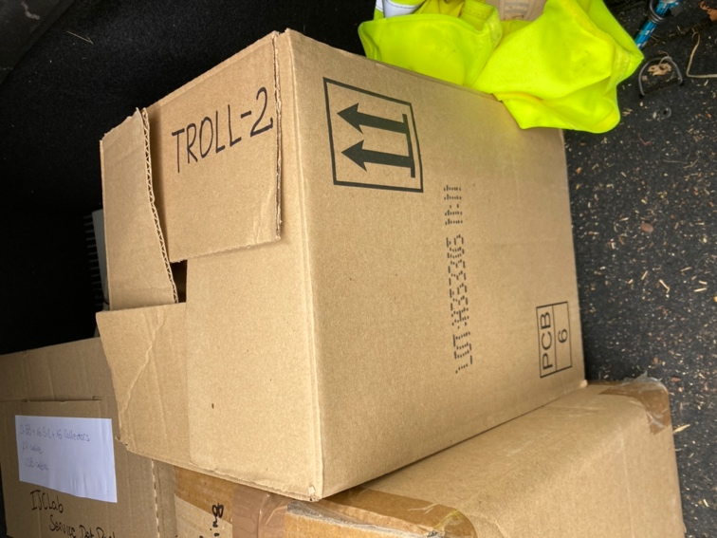

- LV module + 220V cable

- Acquisition GRAiNITA PC + 220V cable + mouse

-Full crate with modules (amplifier x5, discriminator, dual timer, TTL-NIM converter, coincidence unit, logic fan in/ fan out, linear fan in/fan out, HV power supply), cables.

