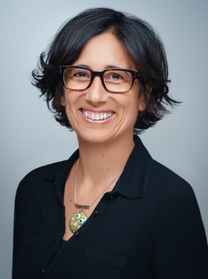

**Louise Zelia Carvalho**

Louise was born in Liverpool and grew up on Vancouver Island. She is of Anglo-Irish and Goan descent, has dual nationality, speaks several languages, and lived in six countries.

A lawyer by profession, Louise has practiced in Canada, in England, within the United Nations and European Union institutions in post-conflict Kosovo, and at the Organisation for the Prohibition of Chemical Weapons (*Nobel Peace Prize,* 2013) in The Hague.

Louise joined CERN in October 2014 as a Legal Adviser and was appointed Diversity & Inclusion Programme Leader in 2018. After carrying both functions at 50% for a time, she now devotes 100% of her working time to D&I.

“*Each of us possess a unique set of characteristics and traits, both visible and invisible. Some persons or communities require additional support, greater visibility, or workplace adjustments. While every one of us benefits from inclusive processes, policies, and infrastructure.*

- L Carvalho, D&I Programme Leader