A test bench for the qualification of the GRAiNITA prototype

Magali Magne* on behalf of

H. Chanal∗, S. Barsuk†, O. Bezshyyko§, I. Boyarintseva†‡, A. Boyarintsev‡, D. Breton†, A. M. Dubovik‡,Y. Hou∗, G. Hull†, D. Klekots§, J. Lefranc，ois†, J. Maalmi†, S. Monteil∗, D. Picard∗,M.-H. Schune†, I. Tupitsyna‡ and M. Yeresko∗

∗Universit´e Clermont Auvergne, CNRS/IN2P3, LPCA, F-63000 Clermont-Ferrand, France

†Universit´e Paris-Saclay, CNRS/IN2P3, IJCLab, Orsay, France

‡Institute for Scintillation Materials of the National Academy of Sciences of Ukraine,

60 Nauki Ave., Kharkiv 61072, Ukraine

§Kyiv National Taras Shevchenko University, 01033 Kyiv, Ukraine

**Abstracts** :

The GRAiNITA prototype has been developed as a first step toward the development of a next-generation calorimeter for FCC-ee. To evaluate GRAiNITA performance, a special test bench was built. The principle consists in tracking the cosmic ray muons that pass through the prototype to check the response of the prototype as a function of the region traversed. Wavelength-shifting fibers capture the light emitted when muon particles travel through the crystal and transmit it to silicon photomultiplier (SiPM) detectors. A fast acquisition system is used to count the individual photoelectron. An offline analysis allows one to correlate the tracks with the deposited energy.

**Summaries** :

GRAiNITA is a new type of calorimeter that uses small grains of a high-Z scintillating material in a high-density transparent liquid. The latter acts as an absorber. Its development aims at improving the energy resolution of the existing and cost-effective shashlik calorimeter architecture to meet the needs of the Future Circular Collider (FCC-ee).

This poster presents the architecture of the test bench dedicated to evaluate the performance of the GRAiNITA prototype. It uses the accurate reconstruction of the muon tracks to study the light generation in the detector volume. As such, the electronics part of the test bench must deal with:

* The determination of the energy deposited in the GRAiNITA prototype.
* The muon track reconstruction.

The GRAiNITA prototype is a 16x2.4x2.4 cm light-tight box with wavelength shifting (WLS) fibers regularly spaced every 7 mm in the detection volume. For initial studies, it has been filled with ZnWO4 or BGO grains mixed with air, water, or ethylene glycol. The light is converted using silicon photomultiplier (SiPM). Two equivalent systems are used to readout the SiPMs: a dedicated board using the DRS4 chip (called the ASM board[2]), and the Wavecatcher[1] acquisition. Both can perform the digitization of each SiPM signal with a 1 ns sampling time. It allows one to accurately count and time every single photoelectron during the 25 μs scintillation time of the ZnWO4.

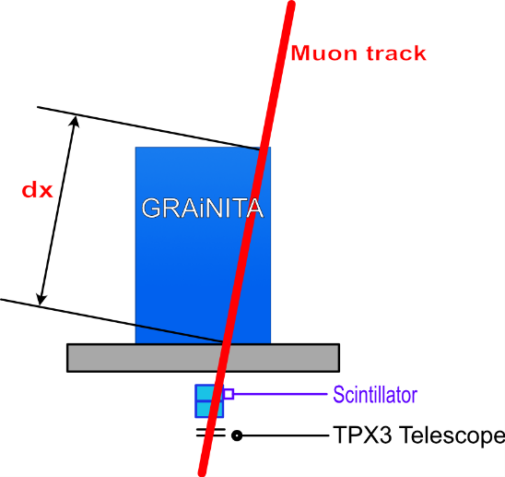

Figure 1The cosmic muon test bench.

On the other hand, a TimePix tracker consisting of two individual chips separated by 4.5 mm allows one to accurately reconstruct the muon tracks. Each chip is made up of a 256x256 matrix of 55 μm side pixels leading to a 1 mm resolution on the track position at 10 cm at the GRAiNITA level. Its time resolution is set at 1.56 ns. A trigger is generated by the combination of 3 scintillators. Two (2x2cm2) are located below GRAiNITA and one at the top (15x15 cm2). These scintillators are also readout by the ASM Board which add an accurate time stamp with a nanosecond resolution. The data of all these detectors are merged into an offline analysis tool.

The poster will present the development of these electronics and the calibration of the detector. A focus will be placed on the fast acquisition system and its characterization. Finally, some results about the performance of GRAiNITA prototype with cosmic muons will be shown.

Reference :

[1] D. Breton et al., ”The WaveCatcher family of SCA-based 12-bit 3.2-GS/s fast digitizers”, 2014 19th IEEE-NPSS Real Time Conference, 1-8

[2] M. Magne, ”An application of the DRS4 chip : the ASM Board”, Workshop on picosecond photon sensors for physics and medical applications,Clermont-Ferrand, March 2014