|  |  |  |
| --- | --- | --- |
| Project management document | | |
| **Project Office IT Tools Requirements description**  **Abstract**  This document describes the needs of the Einstein Telescope Project Office IT tools. | | |
| Author | Verified | Approved |
| L.Latronico | A.Rocchi  A.Variola  A.Falone | R.Saban  R.Flaminio  A.Freise |
| Distribution list: tbd | | |

|  |  |  |  |
| --- | --- | --- | --- |
| **Revisions history** | | | |
| Rev. | Date | Modifications description | Author/Editor |
| 0.1 | 17/10/2022 | First draft | L. Latronico |
| 0.2 | 2/11/2022 | First complete draft including comments from internal review | L. Latronico |
| 0.3 | 3/11/2022 | Distribution for review by INFRADEV group | L. Latronico |
|  |  |  |  |
|  |  |  |  |
|  |  |  |  |
|  |  |  |  |
|  |  |  |  |
|  |  |  |  |
|  |  |  |  |

1. Summary

1 List of Acronyms 2

2 Project Office working goals 3

3 General requirements 4

4 The Project Office List of tools 5

1. Project management 6

2. Documents repository 6

3. Configuration management 7

4. Project reporting 7

5. Interfaces management 8

6. Users Communication management 8

7. Project workflow management 9

8. Finance & resource monitoring 9

5 Conclusions 10

6 Bibliography 10

# List of Acronyms

|  |  |
| --- | --- |
| ET | Einstein Telescope |
| ET-PO  ET-PB | Einstein Telescope Project Office  Einstein Telescope Project Board |
| ET-PP | Einstein Telescope Preparatory Phase |
| INFN | Istituto Italiano di Fisica Nucleare |
| IT | Information Technology |
| LHC | Large Hadron Collider |
| OBS | Organization Breakdown Structure |
| ORAMS | Operability, Reliability, Availability, Maintainability and Safety |
| PBS | Product Breakdown Structure |
| PM | Project Management |
| PMP  RACI | Project Management Plan  Responsible, Accountable, Consulted, Informed |
| RMP | Requirements Management Plan |
| RR | Requirements Register |
| SEP  SLA | System Engineering Plan  Service Level Agreement |
| SMP | Schedule Management Plan |
| TDR | Technical Design report |
| TRL | Technical Readiness Level |
| WBS | Work Breakdown Structure |
| WG  WYSIWG | Working Group  What You See Is What You Get |

# Project Office working goals

The Einstein Telescope Project Office (ET-PO) will set up the project management environment for the construction of the ET Research Infrastructure (RI). The ET-PO will define processes and tools for planning, implementing, monitoring, control and reporting the entire project development.

In particular, the ET-PO will provide executive support for key project objectives, such as:

* establish agreed and efficient decision-making processes;
* define and maintain science and technical requirements;
* flow-down requirements and their dependencies at all levels;
* identify expectations and resources constraints from the stakeholders;
* capture requirements, constraints, and interfaces into a technical baseline;
* provide a schedule and budget management framework
* kick-off and control the project baseline implementation;
* introduce and monitor the processes of technical and processes change requests
* report the progress to the stakeholders.

All these activities shall be developed in line with the main ET-PO mandate [1].

The ET-PO will need to select and adopt suitable IT tools to support this work.

This document defines the requirements for this task and a list of specific functions required to the tools that will be selected by the PO in consultation with ET project executive boards.

This document is the D5.2 deliverable of the WP5 of the ET-PP HORIZON-INFRA-2021-DEV-02 proposal.

# General requirements

With reference to the ET-PO Mandate and Structure document, the PO will complete several activities through the action of twelve Work Packages (1).

Each WP will need to rely on IT tools to develop, share and deliver its outputs.

As significant data, which evolve with the project, are shared across many WPs (eg PBS, WBS, schedule), a general requirement is that **the tools used in different WPs reference to the same database of project deliverables and therefore have an I/O function towards external data**.

However, there is no single software that implements all the necessary functions needed by the PO WPs, although some integrated frameworks do exist on the market, which offer a bundle of tools that come under the same license and environment.

Moreover, some flexibility in the choice of tools may be motivated by the existence of multiple stakeholders and collaborators, with specific constraints in the choice of tools and/or formats (eg open-source vs licensed tools, procurement practices across different administrations ...).

We shall therefore first list general requirements.

Each IT tool to be adopted by the ET-PO shall (2):

1. Be cloud based with server-side backend for data storage and backup;
2. Allow concurrent usage from multiple users, via desktop applications and/or cross-platform web-based interfaces;
3. Implement secure user identification for data checkout and check in;
4. Implement version control and comparison (track history of an object or product);
5. Offer the ability to securely share data real time with internal and external stakeholders;
6. Allow integration with other databases or legacy systems and with other tools in use by the ET-PO;
7. Be compatible with required support contractors and/or suppliers (i.e., can accept data from a third party as required);
8. Be available for the entire duration of the project (note this means at least two decades for ET);
9. Allow updates.

# The Project Office List of tools

While the work of the ET-PO is organized in WPs with specific deliverables, there will be significant overlap of data and software tools across different WPs and identifying specific tools with single WPs is not necessarily the best choice.

We shall instead ensure the full coverage of the PO IT needs by matching the PO activities to a list of functions, as typically administered by commercially available PM software tools, which will be exercised in the PO working units. The table below reports such activities in each row, and their main correlation with functions of standard project management tools which are reported in the columns.

We shall identify these functions in the specific classes of IT tools and define requirements for all of them in the remainder of this document.

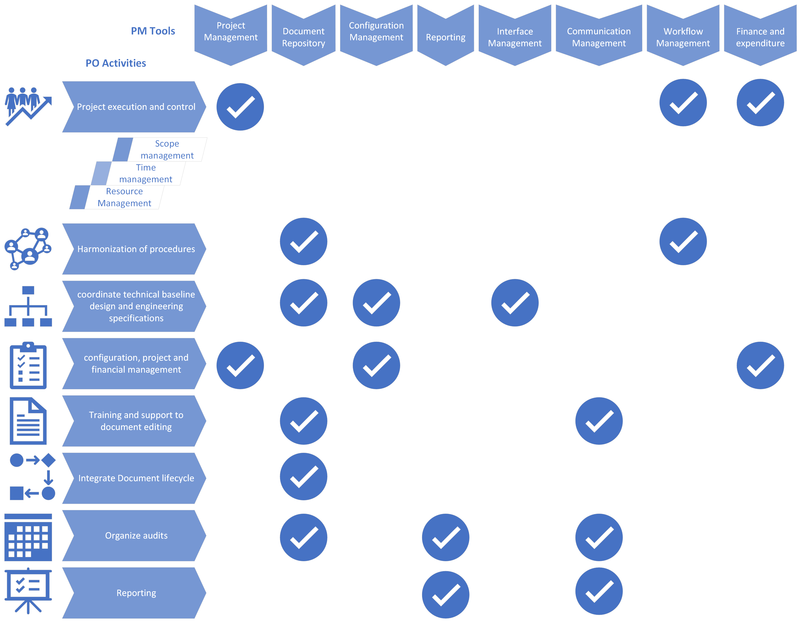

## Project management

As generic as this definition might sound, the ordinary functions offered in this area by commercial software cover time and resource management, with a solid anchor to the project WBS.

The PM tool to be adopted by the ET-PO shall therefore (3):

1. Allow time planning trough definition of blocks of activities with well-defined temporal relationships, identification of milestones and verification points;
2. Offer multiple visualizations of the time sequence (table, Gantt chart, Kanban dashboard);
3. Manage costs, with separation of actual vs planned costs;
4. Refer to the project resource pools (org. chart and general human resources);
5. Offer interface to a portfolio manager to allow a project tailoring decomposition (e.g. for structuring the various ET-PO WP as separate projects within the same portfolio);
6. Allow export of time, budget and resource summary data at specified dates and for specific periods of activity.

## Documents repository

The document management system is a general underlying service common to all functional areas of a project. Besides the general requirements listed above, any content management solution shall:

1. Allow multiple level of access and data segregations in response to specific permissions associated to single or groups of users;
2. implement version control;
3. Allow concurrent editing from multiple users with revision tracking and comments management;
4. Implement document lifecycle management and approval workflow including notifications processes;
5. Offer dedicated storage options for classified documents, possibly by interfacing remote, proprietary backend servers;
6. Offer a user-friendly, complete, powerful search engine, ideally with full text search capability extended to the entire document and not limited to the document metadata (title, file name, originator …);
7. Allow easy ingestion and further management of documents generated with the document system currently in use within the ET Collaboration (TDS).
8. Allow storage and handling (directly or interfacing with another platform) of CAD files.

## Configuration management

Configuration Management is the pulsating heart of the project engineering and execution, firmly linked to the actual project deliverables. Dedicated *software solutions must support the five high-level tenets of CM: configuration planning, configuration identification, configuration status accounting, configuration change management, and configuration traceability,* *verification, and audit (**4**)*.

The selected CM software shall:

1. Enable management of configuration items (CI) and configuration data (CD);
2. Implement configuration rules for baseline identification;
3. Manage bill of materials (BOM);
4. Manage change process, including notifications and reporting;
5. Track as-designed and as-built configurations;
6. Export configuration changes for audits and periodic reports;
7. Report delivered configuration for certification and warranty.
8. Manage CI identification and visualization in CAD environment.

## Project reporting

Thorough project reporting address multiple stakeholders and hence involve various classes of data, such as overall project advancement (eg progress of individual tasks and Work Packages), time tracking (eg schedule and milestone), resources monitoring (eg finance and team progress accounting), risk register updates, configuration changes and non-conformance reporting.

The effectiveness of the reports is enhanced by providing the right level of aggregate data, clear and attractive visual representations of the data, easy-to read and navigate written reports which include an effective summary of the interactions between the project and the relevant stakeholder at the report session (6).

Starting from these considerations, the project reporting tool for the ET-PO shall:

1. Generate both written reports and summary presentations;
2. Apply project templates;
3. Accept data from various sources both in static format (tables, graphs, pictures) and in dynamical format from a linked data source (spreadsheet extracted from the relevant tool for reporting purposes, webserver, or directly from the actual PM or CM tool);
4. Generate archival copies of the reports that can be managed by the project document lifecycle and be stored in the project document repository.

## Interfaces management

Effective interface management goes beyond keeping track of relationships in periodic static tables, whether they are physical connections between sub-systems or hierarchical representations of requirements.

It instead follows the evolution of the interfaces with the system configuration as tracked by the CM service and through its proper authorization flow (7).

Consequently, the IM management tool for the EP-TO shall:

1. Tag and release a reference interface table and/or diagram;
2. Tag and release the hierarchy of requirements;
3. Keep track of the history of the changes to the interface matrix;
4. Integrate a change request system which shall highlight all the elements (physical and requirements) connected to the requested change and force cascaded updates to all related objects (documents, procedures, design and drawings), in compliance with the role-based permissions set by the organization.

## Users Communication management

The PO will organize frequent online meetings and point-to-point working sessions and shall rely on a communication tool that:

1. Is delivered by cross-platform, web-based applications, accessible from portable devices (smartphones and tablets);
2. Allow access of separate groups of registered users as well as external guests from outside the organization;
3. Include calendar of events and notifications of planned events;
4. Allow real-time group meetings without prior scheduling;
5. Includes public group and private chat services;
6. Enables meetings recording and playback.

## Project workflow management

Definition and control of the project workflows will be managed using a dedicated tool that allows establishing decisional and executive processes, monitor the status of all active flows, and provide feedback to the stakeholders involved.

The tool implementing the ET-PO workflow management shall (5):

1. Represent workflows with WYSIWIG, user-friendly, code-free graphical representation;
2. Feature a role-based user accessibility;
3. Implement a dynamical user assignment and e-mail notification system;
4. Offer a control dashboard on the status of the active workflows with increasingly complex information on the advancement of the flow and its level of completion (eg simple done/not-done indicators, semaphores, full color-coded SLA indicators);
5. Include reporting capabilities.

## Finance & resource monitoring

The breadth of these functions spans a vast variety of scales, both in the area of finances, eg from top-level monitoring of the funding agencies contributions to single research unit specific parts procurement, and in the area of human resources, eg from generic allocation of professional resources down to the tracking of individuals’ timesheet.

As of now, it will suffice to state general considerations to be considered when evaluating tools that implement functions in these areas (8).

1. Security: both storage and access to sensitive financial information shall require secure and controlled access;
2. Cost: tools for managing finances and purchase orders can have significantly different costs depending and the level of integration and scale they offer, and should therefore be tailored to size of the organization and fit a pre-allocated budget;
3. Remote versul local storage and operations: while a general requirement for the ET-PO tools is to rely on cloud-based applications, both security and practical considerations (eg use in case of limited internet access) might relax this requirement. It should be noted that on-premise installations are in general more expensive;
4. Compatibility with partner institutions financial department tools: while a full inter-operability may not be possible or even desirable, a very close link to accounting and financial management at participating institutions through tools and budget code structures is highly recommended; the possibility to extract and import relevant data for reporting purposes should be granted as a minimum.

# Conclusions

The choice of the right IT tools to support the ET-PO activity descends from the analysis of the PO mandate and the deliverables assigned to its Work Packages.

Availability of commercial, licensed or proprietary software, as well as heritage tools will help but not drive the selection.

This document provides a general, complete list of requirements generated by reviewing the WP tasks and will support the evaluation and choice of the tools to be adopted to complete them.

# Bibliography

1. ET Project Office Mandate and Structure, ETPMP004
2. [https](https://www.nasa.gov/seh/6-5-configuration-management)://www.nasa.gov/seh/6-5-configuration-management
3. [https](https://comparisons.financesonline.com/microsoft-project-vs-merlin)://comparisons.financesonline.com/microsoft-project-vs-merlin
4. [https](https://cmstat.com/solutions/hardware-configuration-management)://cmstat.com/solutions/hardware-configuration-management
5. [https](https://kissflow.com/workflow/workflow-management-system-10-must-have-features/)://kissflow.com/workflow/workflow-management-system-10-must-have-features/
6. [https](https://kissflow.com/project/project-management-report/)://kissflow.com/project/project-management-report/
7. [https](https://www.interfacemanagement.com/im/resources/about-interface-management)://www.interfacemanagement.com/im/resources/about-interface-management
8. [https](https://planergy.com/blog/financial-management-tools/)://planergy.com/blog/financial-management-tools/