Integration of loaded cells onto Local Supports

Document change record
Version | Date | Modified pages | Changes
V-00 | 22/04/21 | All | Creation of the document
V-00-01 | 20/05/22 | All | Update of the document

Distribution
Entities | Names
LAPP

Prepared by (Name + Visa) : | Controlled by (Nom + Visa) : | Approved by (Nom + Visa) :
A.JEREMIE

Table of contents

1. INTRODUCTION 3
2. DOCUMENTS 3

2.1. Applicable and reference documents 3

2.2. List of abbreviations 3
3. PROCEDURE 3

3.1. Preparation of the DUT 3

3.2. Setup establishment 4

3.3. Test procedure (As run) 6
4. Safety instructions 8
5. Acceptance criteria 8
This test is compliant if the value of the leak current is in the range of the dozen of nA by the end of the timer. 8

INTRODUCTION
This document is the procedure for the Integration of loaded cells onto Local Supports.

DOCUMENTS

Applicable and reference documents

- High Voltage Testing and Validation Procedures (reference AT2-IP-GP-0003)
- High Voltage Power Supply SHQ HIGH PRECISION series manual: https://www.fastcomtec.com/ftp/manuals/shqrs232.pdf
- Design qualification document (reference)

List of abbreviations

List of abbreviations
LS | Local Support | Ln (n=2, 3 or 4) | Detector Layer
IHR | Inner Half Ring | TIM | Thermal Interface Material
Base block | On the LS | Cooling Block | On loaded cell
PP0 | Patch-Panel for Type 0 services | Type 0 services | First On detector services
PP0 M6 | PP0 designed for 6 modules | PP0 M12 | Designed for 12 modules

PROCEDURE
For this test, you must work in an environment at 19 to 23°C, dust free and with gloves, and hair net in a clean room on an ESD mat. For some steps, it is mandatory to be 2 people (shown in red I text below).

Loaded cell reception
For this step, you will need
Clean room clothes (gloves, hair net, blouse…)
Cutting materiel for opening transport boxes
Camera

Procedure
- Reception of cells in carrier boxes outside clean room.
- Open package by cutting tape or cardboard box and make visual inspection, take picture and write information in database
- Enter cells in carrier boxes into clean room sas
- Get dressed for clean room environment: gloves, mask, hair net, blouse.
- Open secondary package in sas
- Enter carrier boxes into clean room
- Store carrier boxes in clean room until needed for reception tests.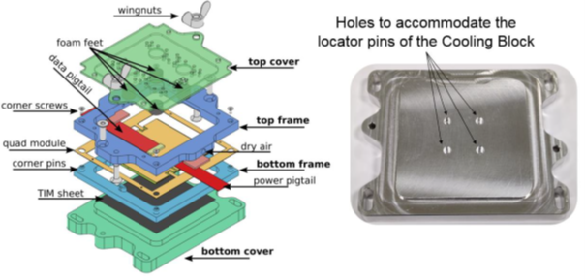

Loaded cell reception test
For this step, you will need
Clean room clothes (gloves, hair net, blouse…)
Camera
A flat screwdriver (is this the screwdriver needed to open carrier box? What size?):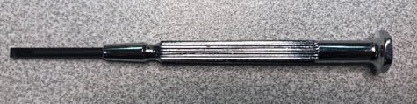
A cell pick-up tool or suction tool (either one with 4 suction cups, or the one needed later with 3 suction cups). The suction cups have to be clean and ESD.
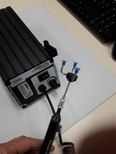
Refrigerated test set-up ? 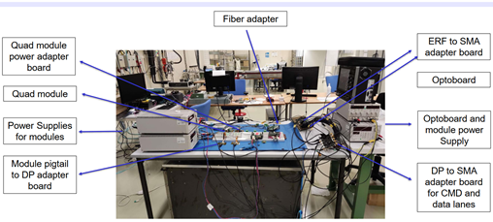

Procedure
- Remove cells in carrier boxes from storage area.
- Open carrier box cover with flat screwdriver
- Take picture of cell in carrier box with camera on stable stand
- Inspect cell, note any comment and write information and photo into database.
- Take cell out of carrier box with pick-up tool and put cell on refrigerated test set up
- Make sure test bench is running and functional
- Electrical reception test (see reference… ? who is writing this procedure?)
- What do we do with a damaged cell?
- Fill database with reception test results and note on carrier box where the cell goes (flat/incl)
- Put cell back into carrier box with pick-up tool for storage in clean room until needed for integration on LS

Local support reception
For this step, you will need
Clean room clothes (gloves, hair net, blouse…)
Hexagonal screwdriver 3mm (final sizes?) 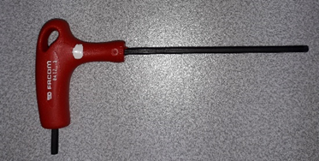
Hexagonal screwdriver 4mm (final sizes?) 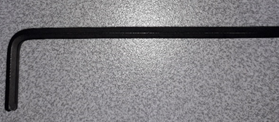

Procedure
- Get dressed with clean room equipment.
- Bring transport box into clean room (2 people, without rolling wheels)
- Open LS transport box
- Check integrity of dry air bag and choc indicator and fill database
- Pick up LS/handling frame and protection box (2 people) and set on dedicated table with ESD mat (needed if carbon base?).
- Remove protection box by unscrewing the fixation screws with the two screwdrivers (hexagonal 3 and 4mm). There are 3 parts to remove. Remove the 2 extremities first, then the central part by lifting with the handles
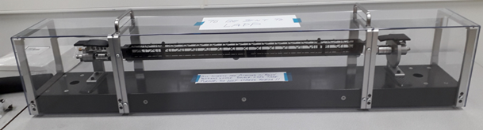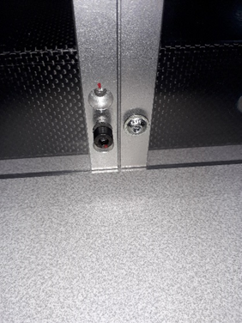
- Mechanical inspection (basic checks)
- Set handling frame from shipping to integration mode, using the 3mm hexagonal screwdriver
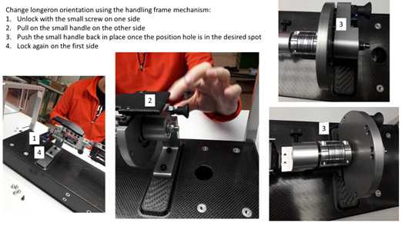

PP0, pigtails, Z-ray, inserts and screw reception

For this step, you will need
Clean room clothes (gloves, hair net, blouse…)
Cutting materiel for opening transport boxes

Procedure
- Get dressed with clean room equipment.
- Bring transport box into clean room.
- Open transport box with cutting tool.
- Check Type 0 PP0 and pigtails have not been damaged during shipping
- Check correct number of Z-rays, interposers and screws have been shipped.
- Fill database.

Connection of pigtails to cells
For this step, you will need
Clean room clothes (gloves, hair net, blouse…)
Pliers to remove pigtail from transport box
A flat screwdriver (is this the screwdriver needed to open carrier box? What size?):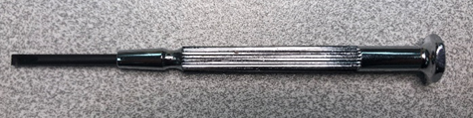
A cell pick-up tool or suction tool (either one with 4 suction cups, or the one needed later with 3 suction cups). The suction cups have to be clean and ESD.
Cell integration 3D support attached to a vacuum/venturi system
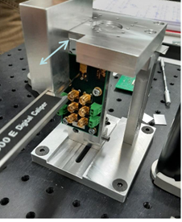
ZIF insertion tool
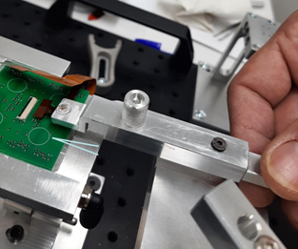
ZIF locking Q-tip tool
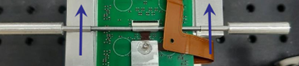
A torque screwdriver (already set on 28 mN.m) with hexagonal 0.9mm head: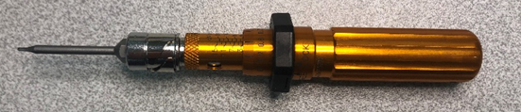
Strain relief glue (reference?Araldit 2011?)

Procedure
- Get dressed with clean room equipment.
- Make sure you have the total amount of loaded cells to complete the whole integration process of one LS (36 for a longeron and 16 for L2, 22 for L3, or 28 for L4 for IHR)
- Open carrier box cover with flat screwdriver
- Disconnect temporary pigtails (data and power) with your gloved fingers. (what happens to the temporary pigtails, do they need to be sent back to cell loading sites?)
- Remove cell from carrier box with pick-up tool
- Put on 3D support
- Store empty carrier box to be shipped back to cell loading sites
- Turn on 3D support vacuum system for stability
- Pick-up 3D pigtail from transport tray (with pliers)
- Insert pigtail into zif connector with insertion tool holding the data pigtail
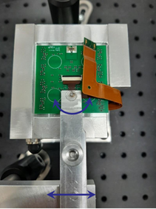
- Lock zif connector with Q-tip tool
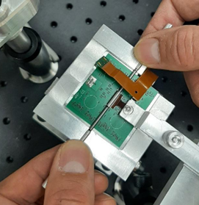
- Remove ZIF insertion tool
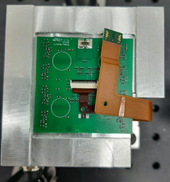
- Connect Power connector (CLM/FTM) by hand with a delicate pressure
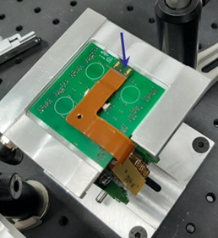
- Connect Z-ray end onto test board using the torque screwdriver, 2 Ti screws and an interposer (already installed?). Could also be with just a pressure peg. This ensures correct pigtail geometry.
- Perform quick connectivity tests (which ones?). Last chance to correct system before gluing strain relief.
- Disconnect ZIF using Q-tip and CLM disconnecting tool to separate pigtail from module. Repeat steps 10-15. (need specific disconnection tools?)
- Strain Relief should already be on the module during cell loading process (or earlier)
- Align power and date pigtails by putting pliers through the dedicated holes in the pigtails and strain relief.
- Install Strain relief fork to stabilize the system.
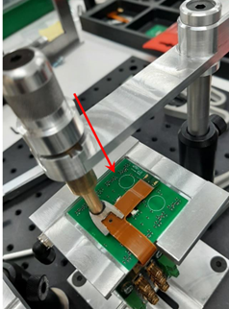
- Prepare glue by mixing components (if needed) then pour into glue dispenser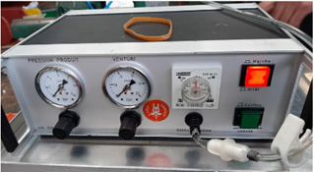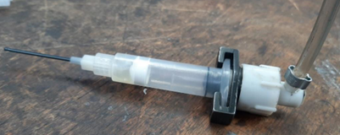
- Pour a very small amount of glue into strain relief so that a small dome comes out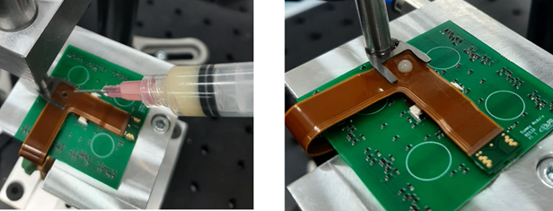
- Wait 24h at room temperature for the glue to set
- Turn off vacuum system on 3D support
- Pick-up cell with pigtail using the 3 feet pick-up tool and install into a dedicated 3D support for storage before cell integration onto LS
- Fill database

Cell integration on local support

For this step, you will need
Clean room clothes (gloves, hair net, blouse…)
Total amount of loaded cells to complete the whole integration process of one LS (36 for a longeron and 16 for L2, 22 for L3, or 28 for L4 for IHR) all equipped with their pigtail
LS is accessible and prepared as in section ?
All 1mm screws for all cells
TIM (either paste or pads)
Long torque screwdriver already set to 12mN.m with hexagonal 0.9mm tip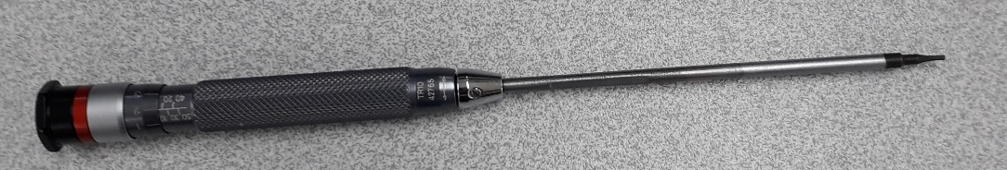
A cell pick-up tool or suction tool (either one with 4 suction cups, or the one needed later with 3 suction cups). The suction cups have to be clean and ESD.
Big mirror

Procedure (pictures)
 | - Get dressed with clean room equipment.
 | - The LS must be in a position where the loaded cells are presented vertically to the LS so that both operators have access to the front and back of cell (2 people)
 | - Install TIM onto Base blocks (if paste, just a few cells in advance with gluing tools, if pads, install all pads with pliers)
 | - Install a large mirror on the LS base to have a better view from all sides.
 | - Pick-up cell with 3D pigtails from support with 3-feet suction tool (2 people)
 | - Install cell with cooling block on TIM (2 people) on base block. Make sure you aim at the precision hole on the base block with the precise pin on the cooling block. 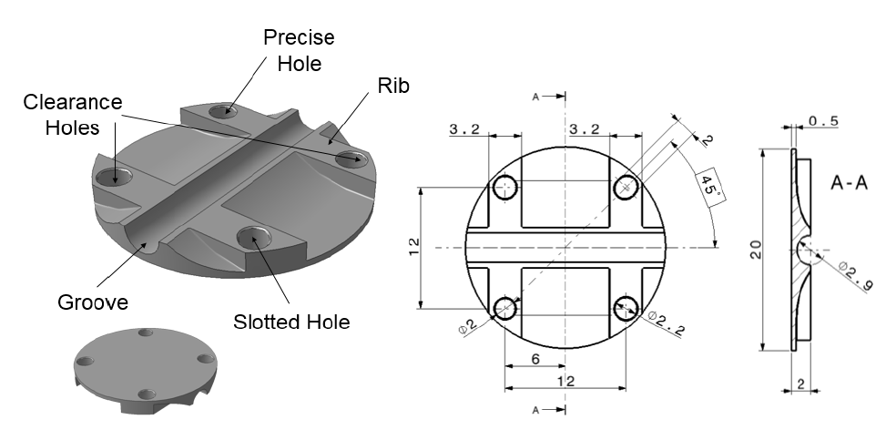
 | - The second person at the back of the cell is equipped with the torque screwdriver and 4 screws each cell. Tighten screws through the LS to fix the cells. (2 people)
 | - For the longeron, start with the X_{bottom} cells, then continue with the X_{top} cells. Attach the cells starting from an extremity and continuing along the LS. This leaves some extra space on one side of the cell. Once cells on one row are finished, turn the LS on the other side for better access to the front and back of cells. | For the IHR, start with the Front (or Back cells)?
 | - Fill database.

Install PP0 on LS

For this step, you will need
Clean room clothes (gloves, hair net, blouse…)
All PP0 to complete LS integration: 2 M12 and 2 M6 PP0 for longeron, specific PP0 for IHR
PP0 fixation screws
A torque screwdriver (already set on 28 mN.m) with hexagonal 0.9mm head: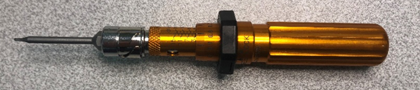
Pigtail opening tool (?)

Procedure (pictures)
 | - Get dressed with clean room equipment.
 | - Install pigtail opening tool (or is it already on the LS?)
 | - LS should be in the correct position after installing loaded cells, but if not, turn it so that the cells are vertical.
 | - Open pigtails slightly, but enough to install PP0 with bent wings | (for IHR ?)
 | - Pick up PP0 by hand
 | - Install both PP0 M6 at the centre of the LS and the M12 at the extremities. They are positioned so that the power connection is to the right when looking from the end of the LS. | (IHR?)
 | - With torque screwdriver, fix the PP0 onto the LS
 | - Fill database.

Connect pigtail to PP0

For this step, you will need
Clean room clothes (gloves, hair net, blouse…)
All Z-ray interposers to complete LS integration: 36 for the longeron and 16 for L2, 22 for L3, or 28 for L4 for IHR)
All Z-ray Ti screws (2 per loaded cell)
A torque screwdriver (already set on 28 mN.m) with hexagonal 0.9mm head:
Z-ray connection pliers
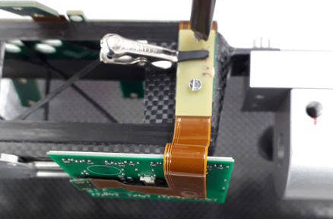
Bent pliers for interposers
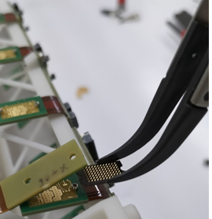

Procedure
 | - Get dressed with clean room equipment.
 | - Turn LS to have the wings on top. For the X_{top} cells, you need to turn the whole handling frame instead of the LS in its Handling frame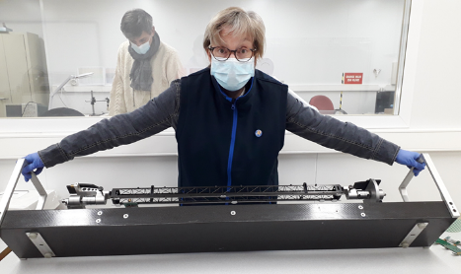 | IHR?
 | - Install interposer in between inserts in order to have the red triangle mark on the interposer facing the wing away from the PP0
 | - Bring pigtail to wing
- Pinch Z-ray sandwich with pinching tool
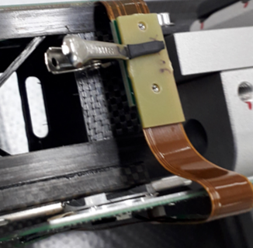
 | - Pick-up small M1 screw with pliers and install onto Z-ray.
- Holding the screw in place, screw Z-ray screws with torque screwdriver
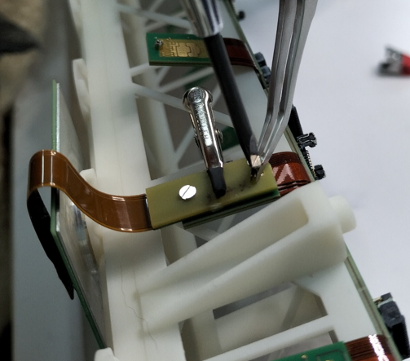
 | - Repeat steps 3-7 until all pigtails have been attached by Z-rays
 | - Reposition the protection cover of the handling frame as in section ? until LS is ready to be tested electrically in the cooling station.

