Equilibrium Configuration of LiH and Li₂

Pant, Amba Datt*
Central Department of Physics, Kirtipur, Kathmandu, Nepal

The present work describes the equilibrium configuration of the lithium hydride (LiH) and lithium dimer (Li₂) calculated using the Hartree-Fock procedure implemented by the Gaussian 03 set of programs. We have also calculated the ground state energy of the lithium atom and ions using the single-center expansion method with the Gaussian shell orbitals. The ground state energies for the lithium atom and ions calculated using the single-center expansion method and the HF procedure agree to each other within 3%. The ground state energy for the lithium atom has been estimated to be -7.432 a.u. and that for Li⁺ and Li⁺⁺ ions to be -7.236 a.u. and -4.494 a.u., respectively. With these HF values of energy for the lithium atom and ions, we have estimated the first and second ionization potentials for the lithium atom to be 5.34 eV and 79.95 eV, respectively, which are in close agreement to the previously reported experimental values within 1%. We have also performed calculations using configurations interaction (CI) method and the density functional theory (DFT) to study the equilibrium configurations of LiH and Li2. The ground state energies for LiH and Li₂ obtained using the DFT calculation are lower than that obtained with the CI method, which, in turn, are lower than that obtained with the HF approximation. With the DFT calculation we have estimated the binding energy of LiH to be 242.81 kJ/mol, which is in close agreement with the previously reported experimental value of 238.049 kJ/mol within 2%. However, in case of Li₂ the DFT value of binding energy is less than the corresponding CI value by around 9%. The binding energy of Li₂ using the CI calculation has been estimated to be 94.99 kJ/mol, which is close to the previously reported experimental value of 98.98 kJ/mol within 4%. We have also studied the variation of energy with distance between the constituent atoms of LiH and Li₂. From the energy versus distance curves we have estimated the bond lengths for Li-H and Li-Li to be 1.59 Å and 2.70Å, respectively, which are in close agreement with the previously reported experimental values within 1%.

Key words: HF approximation, CI, DFT, binding energy, bond length.

- Introduction
The first-principles approaches are being widely used to study the electronic structure and to determine the various physical properties (e.g., ground state energy, dipole moment, ionization potential, polarizability, nuclear quadruple moment etc) of many-electron systems [1]. These approaches can be classified into three main categories: Hartree-Fock (HF) approximation, density functional theory (DFT) and quantum Monte Carlo method. Here the calculations are carried out using only HF and DFT methods. Since Hartree-Fock approximation can not calculate the correlation between electrons of opposite spin, the correlation methods like Møller-Plesset perturbation (MP₂) and configuration interaction (CI) considers the mixing of wave function from the ground state configuration are taken. The CI method, in principle, has many of the desirable features being well defined, size-consistant and variational [2]. Møller-Plesset perturbation theory adds higher excitations to HF theory as a non-iterative correction and are variational. So there is a possibility of overcorrecting the energy values [3].
In another first-principles approach- DFT, in which the electronic orbitals are solution to a Schrodinger equation which depends on the electron density rather than on individual electron orbitals, the exchange-correlation potential not only includes exchange effects arising from the antisymmetric of the wave functions but also correlation effects due to the motions of the individual electrons (dynamic correlation effects). In this method exchange and dynamic correlation effects are in practice treated approximately [1]. HF, MP₂, CI and DFT methods can be used to study the electronic structure and to calculate the various physical properties of many electron systems with the aid of the Gaussian 03 set of programs [3].
*E-mail:pant_amba@yahoo.com

II. Ground state energy of Li atom using Gaussian shell orbitals (GSO)
In order to determine ground state energy of many-electron system like Li atom, the Gaussian Shell orbitals (GSO) which are hybrid of Gaussian type and Slater type orbitals [4] are used to optimize the variational parameters of GSO minimizing the following energy expression
$E=\frac{\left\langle φ\left|H\right|φ\right\rangle }{\left\langle φ|φ\right\rangle }$ (1)

Using non-relativistic Hamiltonian of the lithium atom (Z=3) within the Born-Oppenheimer approximation in atomic units (i.e., e=1, ħ=1,m=1) can be expressed as
$\begin{aligned}H=−\frac{1}{2}\left(∇_{1}^{2}+∇_{2}^{2}+∇_{3}^{2}\right) \\ −\left(r_{1}^{−1}+r_{2}^{−1}+r_{3}^{−1}\right)+\left(r_{\text{12}}^{−1}+r_{\text{13}}^{−1}+r_{\text{23}}^{−1}\right)\end{aligned}$ and choosing proper wave function for different terms of H so that the Pauli principle should be satisfied, we have calculated ground state energy of Li atom, Li⁺ and Li⁺⁺ ion and ionization potentials of Li atom.

- Hatrtree-Fock Approximation
Hartree-Fock theory is well established approach to obtain an approximate solution of the many-electron Schrodinger equation by writing the total (electronic) wave function of the system as a single Slater determinant containing one-electron orbitals [5]. In Hartree-Fock self-consistent method for calculating the electronic states of many-electron systems, we have also explained the Hartree-Fock Roothaan variational procedure and the Møller-Plesset perturbation theory (MP₂). Taking the wave function of many-electron system as Slater determinant, the missing term in Hartree’s SCF model (i.e., exchange interaction) can be taken into account in the Hartree-Fock approximation. Application of the variational principle to a Slater determinant leads to a set of N coupled equations, known as Hartree-Fock equations [6]. Then a basis set is introduced and it converts the spatial integro-differential closed-shell Hartree-Fock equations to a set of algebraic equations, known as Roothaan equations [2].
In order to fulfil the antisymmetic principle, the wave function for N-electron system is taken in the form of Slater determinant [7] and using the Born-Oppenheimer approximation, the Hamiltonian of the many-electron system is given to be
$H=−\sum_{i=1}^{N}{\frac{1}{2}}∇_{i}^{2}−\sum_{i=1}^{N}{−\sum_{A=1}^{M}{\frac{Z_{A}}{r_{iA}}+}}\sum_{i=1}^{N}{−\sum_{j>i}^{N}{\frac{1}{r_{\text{ij}}}}}$ (2)
Hartee-Fock method looks for those orbitals $χ_{i}$ that minimize the variational energy integaal Eq. (1) and each orbital is taken to be normalized i.e., $\left\langle φ|φ\right\rangle =1$. Then using Eq. (1) and Eq. (2), we get
$E=\left\langle Ψ\left|H\right|Ψ\right\rangle$=$\sum_{a=1}^{N}{h_{\text{aa}}}+\frac{1}{2}\sum_{a=1}^{N}{\sum_{b>a}^{N}{{(J}_{\text{ab}}}−K_{\text{ab}})}$ (3)
where, h_{aa} is the average kinetic and nuclear attraction energy of the electron described by the wave function$Ψ_{a}\left(r_{1}\right)$, $J_{\text{ab}}$ is the classical repulsion between the charge clouds${\left|Ψ_{a}(r_{{}_{1}})\right|}^{2}$and ${\left|Ψ_{b}(r_{{}_{2}})\right|}^{2}$, and is called the Coulomb integral or the electrostatic repulsion potential which arises due to electron b when its position is averaged over the space and $K_{\text{ab}}$ is called the exchange integral, which arises due to the asymmetry of the total wave function, and requires the spin of electrons a and b to be parallel.
For atoms and molecules with the closed shell configuration, the energy expression Eq. (3) can be written as
$E=2\sum_{a}{h_{\text{aa}}}+\sum_{a=1}{\sum_{b=1}{{(\text{2J}}_{\text{ab}}}−K_{\text{ab}})}$
Minimizing $E[\left\{χ_{a}\right\}]$ with respect the spin orbitals, subject to the constraint that the spin orbitals remain orthogonal.
$F(1)|χ_{a}(1)⟩=\sum_{b=1}^{N}{ε_{\text{ba}}}|χ_{a}(1)⟩$ (4)
where, $F\left(1\right)=h(1)+\sum_{b=1}^{N}{\left\{J_{b}(1)−K_{b}(1)\right\}}$ is known as the Fock operator. Eq. (4) are known as the Hartree-Fock equations. Using Hartree-Fock orbitals $ψ_{i}=\sum_{μ}{C_{μi}}φ_{μ}$ where $i=1,2,\text{.}\text{.}\text{.}k$ and spatial integro-differential equation, we get
$\sum_{μ}{F_{\text{νμ}}C_{μi}=ε_{i}\sum_{μ}{S_{\text{νμ}}}}C_{μi}$: i=1, 2, … k (5)
where,
$S_{\text{νμ}}=\int{{\text{dr}}_{{}_{1}}}φ_{ν}^{}(1)φ_{μ}(1)$, & $F_{\text{νμ}}=\int{{\text{dr}}_{{}_{1}}}φ_{ν}^{}(1)F(1)φ_{μ}(1)$
Eq. (5) are known as Roothan equations.

- Correlation methods
The Møller-Plesset (MP) perturbation theory adds higher excitations to the Hartree-Fock theory as a non-iterative correction. It deals with the dividing the Hamiltonian (H) of the system into two different parts: unperturbed and perturbed Hamiltonian [3, 8] suggesting that the wave function and energy can be expressed as a power series in terms of the parameter$λ$, due to the addition of the small correction terms, i.e.,
$Ψ=Ψ^{(0)}+λ^{1}Ψ^{(1)}+λ^{2}Ψ^{(2)}+λ^{3}Ψ^{(3)}+…$ (6)
$E=E^{(0)}+λ^{1}E^{(1)}+λ^{2}E^{(2)}+λ^{3}E^{(3)}+…$ (7)
Substituting the perturbed wave function and energy into the time independent Schröndinger wave equation $\hat{H}Ψ=EΨ$, we get,$E^{\left(0\right)}=\left\langle Ψ^{\left(0\right)}\left|{\hat{H}}_{0}\right|Ψ^{\left(0\right)}\right\rangle$,
$E^{(1)}=\left\langle Ψ^{(0)}\left|{\hat{H}}^{\left(1\right)}\right|Ψ^{(0)}\right\rangle$ and $E^{(2)}=−−\sum_{t}{\frac{{\left|\left\langle Ψ^{(0)}\left|{\hat{H}}^{\left(1\right)}\right|Ψ_{t}\right\rangle \right|}^{2}}{\left(E_{t}{\text{-E}}^{(0)}\right)}}$ (8)
Eq. (8) shows that the second order perturbation to the Hartree-Fock energy is negative. Lowering the energy is what the exact correction should do. Howerer, it should be noted that the Moller-Plesst perturbation theory is not variational and it is possible that the ground state energy of many-electron system could be overcorrected using the Møller-Plesset perturbation theory.

- Results and Discussion
The ground state energy of Li atom, Li⁺ and Li⁺⁺ ions have been calculated using Gaussian 03 set of programs shown in Table 1. and have been estimated the first and second ionization potentials shown in Table 2. below.
Table 1.Ground state energy of Li atom, Li⁺ and Li⁺⁺ ions using Gaussian 03 set of programs
Levels of calculations | Basis sets | Ground state energy (a.u.)
Levels of calculations | Basis sets | Li atom | Li+ ion | Li++ ion
HF | 6-31G | -7.43124 | -7.23548 | -4.44954
HF | 6-31G* | -7.43137 | -7.23554 | -4.45499
HF | 6-311G | -7.43203 | -7.23584 | -4.49370
HF | 6-311G* | -7.43203 | -7.23584 | -4.49370
HF+MP2 | 6-31G | -7.43214 | -7.23548 | -4.44954
HF+MP2 | 6-31G* | -7.43137 | -7.23554 | -4.45499
HF+MP2 | 6-311G | -7.43203 | -7.23584 | -4.49370
HF+MP2 | 6-311G* | -7.43203 | -7.23584 | -4.49370

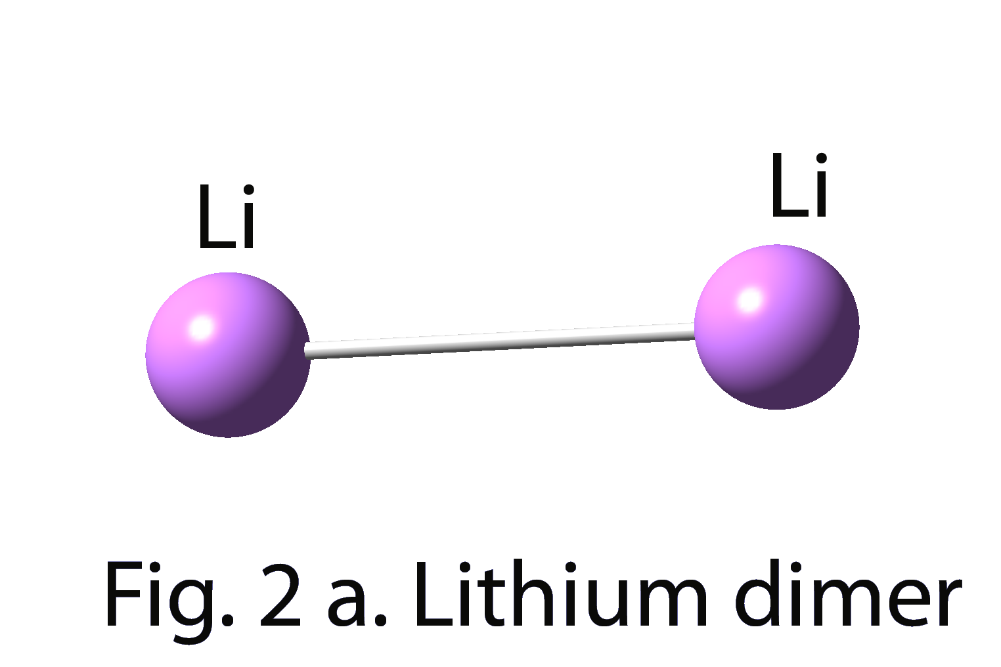
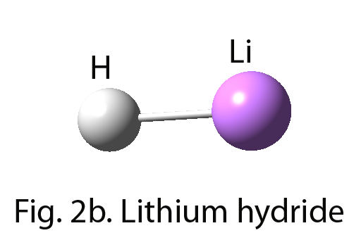

Fig. 2a. and Fig. 2b. are the equilibrium state of Lithium dimer (Li₂) and Lithium hydride (LiH) in ball and stick form using Gaussian 03 set of programs, respecrively.
Table 2. Ionization potentials of Lithium atom
Source | First ionization potential(eV) | Second ionization potential(eV)
Previously reported [9] | 5.39 | 81.01
Present work | 5.34 | 79.95

Table 3. Binding energy (B.E.) and bond length (d) of LiH
Levels of calculations | Basis sets | Ground state energy (a.u.) of |  |  | B.E.  (a.u.) | B.E.  (kJ/mol) | d (Å)
Levels of calculations | Basis sets | H | Li | LiH | B.E.  (a.u.) | B.E.  (kJ/mol)
HF | 6-31G | -0.4982 | -7.4312 | -7.9795 | 0.0500 | 131.41 | 1.64
HF | 6-31G* | -0.4982 | -7.4314 | -7.9809 | 0.0513 | 134.58 | 1.63
HF | 6-311G | -0.4998 | -7.4320 | -7.9847 | 0.0528 | 138.68 | 1.61
HF | 6-311G* | -0.4998 | -7.4320 | -7.9854 | 0.0536 | 140.75 | 1.61
HF+MP2 | 6-31G | -0.4982 | -7.4312 | -7.9920 | 0.0625 | 164.15 | 1.65
HF+MP2 | 6-31G* | -0.4982 | -7.4314 | -7.9960 | 0.0664 | 174.23 | 1.64
HF+MP2 | 6-311G | -0.4998 | -7.4320 | -7.9978 | 0.0659 | 173.13 | 1.61
HF+MP2 | 6-311G* | -0.4998 | -7.4320 | -8.0013 | 0.0685 | 182.42 | 1.61
CI | 6-31G | -0.4982 | -7.4312 | -7.9986 | 0.0692 | 181.61 | 1.67
CI | 6-31G* | -0.4982 | -7.4314 | -8.0029 | 0.0733 | 192.55 | 1.65
CI | 6-311G | -0.4998 | -7.4320 | -8.0046 | 0.0727 | 190.95 | 1.63
CI | 6-311G* | -0.4998 | -7.4320 | -8.0085 | 0.0767 | 201.38 | 1.62
DFT | 6-31G | -0.5003 | -7.4909 | -8.0809 | 0.0897 | 235.59 | 1.62
DFT | 6-31G* | -0.5003 | -7.4910 | -8.0819 | 0.0907 | 238.05 | 1.62
DFT | 6-311G | -0.5022 | -7.4913 | -8.0854 | 0.0916 | 241.49 | 1.59
DFT | 6-311G* | -0.5022 | -7.4913 | -8.0859 | 0.0925 | 242.81 | 1.59
Table 4. Binding energy (B.E.) and bond length (d) of Li₂
Levels of calculations | Basis sets | Ground state energy (a.u.) of |  | B.E.  (a.u.) | B.E.  (kJ/mol) | d (Å)
Levels of calculations | Basis sets | Li | Li2 | B.E.  (a.u.) | B.E.  (kJ/mol)
HF | 6-31G | -7.4312 | -14.8663 | 0.0039 | 10.11 | 2.82
HF | 6-31G* | -7.4314 | -14.8669 | 0.0042 | 10.97 | 2.81
HF | 6-311G | -7.4320 | -14.8702 | 0.0061 | 16.02 | 2.78
HF | 6-311G* | -7.4320 | -14.8703 | 0.0063 | 16.49 | 2.78
HF+MP2 | 6-31G | -7.4312 | -14.8818 | 0.0193 | 50.78 | 2.81
HF+MP2 | 6-31G* | -7.4314 | -14.8854 | 0.0227 | 59.60 | 2.78
HF+MP2 | 6-311G | -7.4320 | -14.8857 | 0.0216 | 56.71 | 2.77
HF+MP2 | 6-311G* | -7.4320 | -14.8889 | 0.0249 | 65.30 | 2.75
CI | 6-31G | -7.4312 | -14.8930 | 0.0306 | 80.29 | 2.77
CI | 6-31G* | -7.4314 | -14.8966 | 0.0339 | 88.90 | 2.73
CI | 6-311G | -7.4320 | -14.8969 | 0.0328 | 86.09 | 2.72
CI | 6-311G* | -7.4320 | -149002 | 0.0362 | 94.99 | 2.69
DFT | 6-31G | -7.4909 | -15.0139 | 0.0321 | 84.23 | 2.73
DFT | 6-31G* | -7.4910 | -15.0143 | 0.0323 | 84.78 | 2.72
DFT | 6-311G | -7.4913 | -15.0156 | 0.0330 | 86.64 | 2.71
DFT | 6-311G* | -7.4913 | -150158 | 0.0332 | 87.19 | 2.70
Table 5. Comparison of binding energy (B.E.) and bond length (d) of LiH and Li₂ with previously reported experimental values.
System | Quantity | Previoulsy reported value | Present work
LiH | B.E.(kJ/mol) | 238.049 [10] | 242.81
LiH | D (Å) | 1.595 [7] | 1.59
Li₂ | B.E.(kJ/mol) | 98.98 [11] | 94.99
Li₂ | D (Å) | 2.67 [8] | 2.70

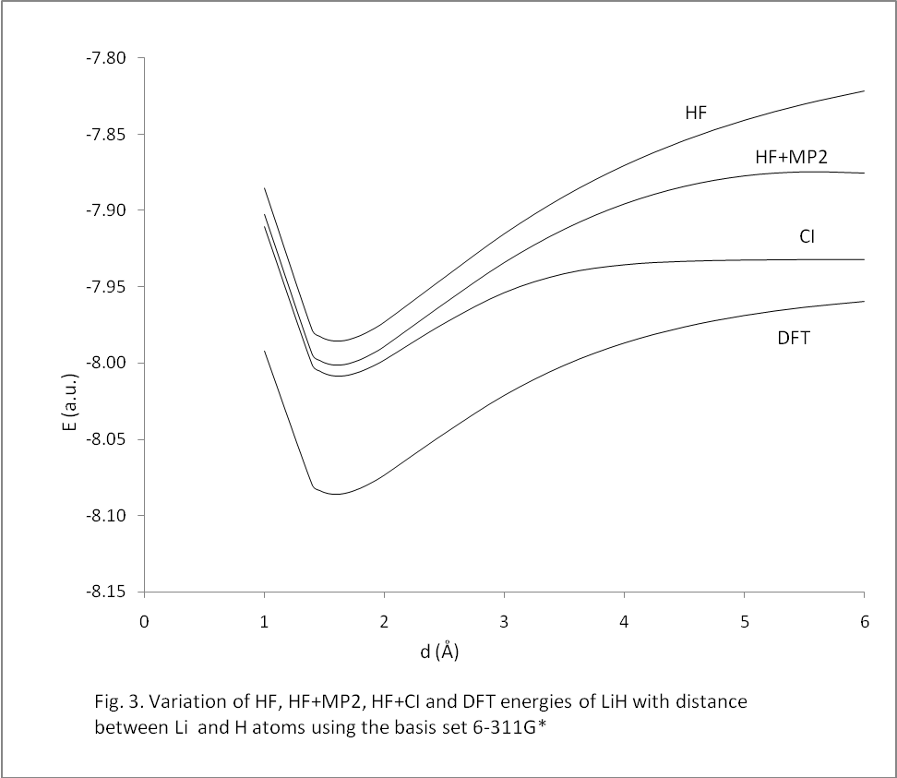
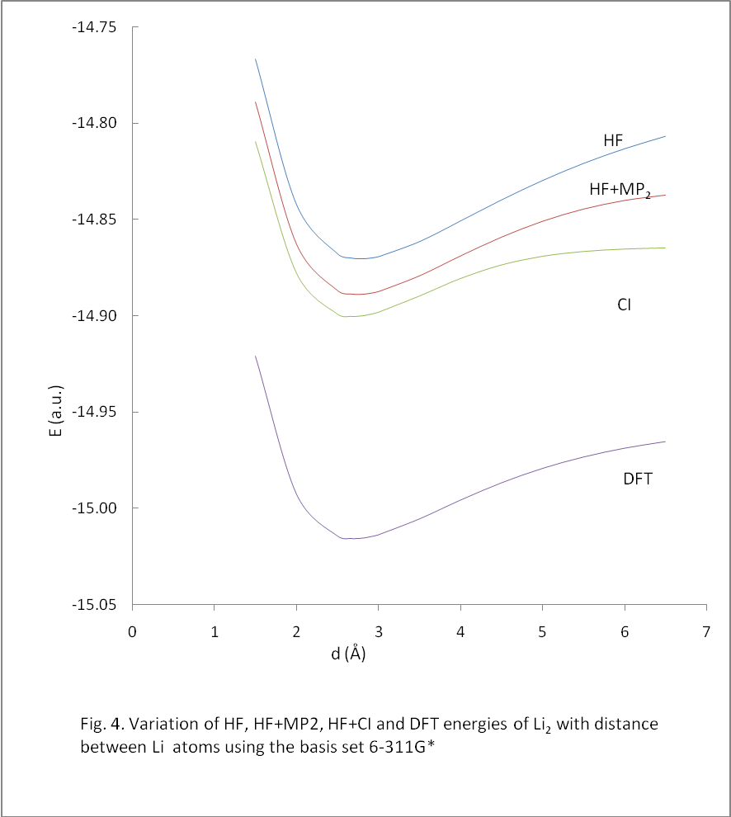

We can use the first principles(ab initio) approaches to study the aqueous hydration of metal cations that plays an important role in biology and medicine that are related to the ion channel of cell membranes [12] and structural properties of molecules having large numbers of atoms like DNA [5].

REFERENCES
[1] J.M. Thijssen, Computational Physics, Cambridge University Press, Cambridge, first edition. 1999.
[2] Attila Szabo and Neil S. Ostlund, Modern Quantum Chemistry, Introduction to Advanced Electronic Structure Thoery, Dover Publications Inc, New York, second edition, 1996.
[3] J. B. Foresman and E. Frish, Exploring Chemistry with electronic Structure Methods, Guassian, Inc., Pittsburgh, Second edition, 1996.
[4] Poshusta, R. D., V. P. Agrawal and W. D. Moseley, 1975, Intrenational Journal of Quantum Chemistry, 9, 635-647.
[5] R.H. Scheicher, The Role of the Impurities in the Molecular solids and the Biological Materials, 2004, Ph. D. thesis submitted to the Department of Physics, University at Albany, State University of New York.
[6] S.M. Blinder, Am. J. Phys., 33, 431(1965).
[7] F.L. Pilar, Elementary Quantum Chemistry, Mc Graw-Hill Book Company, New York, 1968.
[8] D. A. McQuarrie, Quantum Chemistry, University Science Books, Sausalito, 1983.
[9] C. Kittel. Introduction to Solid State Physics. John Wiley & Sons, Inc., Singapore, seventh edition, 1996.
[10] Lide, R. D., 1996, Handbook of Chemistry and Physics, 76th Ed. (CRC Press, Enc. New York).
[11] Velasco, R., Ch. Ottinger and R. N. Zare, 1969, J. Chem. Phys. 51, 5522.
[12] Shoji, Morita and Shogo, Sakai, 2006, Bull.Chem. Soc., Jpn. 79, No. 3, 397-405.

