PERIODIC REPORT TEMPLATE

FRONT PAGE

PROJECT PERIODIC REPORT

Grant Agreement number: 212372
Project acronym: EUROnu
Project title: A High Intensity Neutrino Oscillation Facility in Europe
Funding Scheme: FP7-Infrastructures-2007-1
Date of latest version of Annex I against which the assessment will be made: 23rd May 2008
Periodic report: 1st ■ 2nd □ 3rd □ 4th □
Period covered: from 1st September 2008 to 31st August 2009

Name, title and organisation of the scientific representative of the project's coordinator:
Dr. T.R.Edgecock, STFC Rutherford Appleton Laboratory
Tel: +44 1235 445089
Fax: + 44 1235 446733
E-mail: rob.edgecock@rl.ac.uk
Project website address:
http://euronu.org

Declaration by the scientific representative of the project coordinatorError: Reference source not found

I, as scientific representative of the coordinatorError: Reference source not found of this project and in line with the obligations as stated in Article II.2.3 of the Grant Agreement declare that:

- The attached periodic report represents an accurate description of the work carried out in this project for this reporting period;
- The project (tick as appropriate):
□ has fully achieved its objectives and technical goals for the period;
  - has achieved most of its objectives and technical goals for the period with relatively minor deviations;
  - has failed to achieve critical objectives and/or is not at all on schedule.

- The public website is up to date, if applicable.
- To my best knowledge, the financial statements which are being submitted as part of this report are in line with the actual work carried out and are consistent with the report on the resources used for the project (section 6) and if applicable with the certificate on financial statement.
- All beneficiaries, in particular non-profit public bodies, secondary and higher education establishments, research organisations and SMEs, have declared to have verified their legal status. Any changes have been reported under section 5 (Project Management) in accordance with Article II.3.f of the Grant Agreement.

Name of scientific representative of the CoordinatorError: Reference source not found: ....................................................................

Date: ............/ ............/ ............

Signature of scientific representative of the CoordinatorError: Reference source not found: ................................................................

Publishable summary


EUROnu FP7 Design Study

The recent discovery that a neutrino changes type (or flavour) as it travels through space, a phenomenon referred to as neutrino oscillations, means that neutrinos have a tiny, but non-zero mass. This implies that the Standard Model of particle physics is incomplete and has far reaching implications. For example, neutrino interactions may be responsible for the removal of all the anti-matter created in the Big Bang from the early Universe, thus enabling our existence, and neutrinos may have played a crucial role in the birth of the Universe itself.
Knowledge of the contribution of neutrinos in these areas needs precise measurements of the parameters governing neutrino oscillations. This will require a new high intensity beam-based neutrino oscillation facility in which neutrino beams are generated using new and highly challenging concepts. This Design Study will review all three currently accepted methods of realizing this facility (the so-called neutrino Super-Beams, Beta Beams and Neutrino Factories). It includes a detailed study of the key technical challenges of the accelerator facilities and of the detector options necessary to measure the neutrino oscillation parameters and a comparison of the physics reach of these facilities.
The objectives of the Design Study follow the recommendations of the European Strategy for Particle Physics approved by CERN Council in Lisbon the 14th July 2006 and which is the reference for Particle Physics Research Infrastructures in the ESFRI Roadmap (the neutrino facility being an Emerging Proposal). Further, EUROnu will be a significant step towards solving a problem noted by the OECD: the lack of a formal framework for global collaboration in this area.
The design study will also perform a cost assessment that, coupled with the physics performance, will permit the European research authorities to make a timely decision on the lay-out and construction of the future European neutrino oscillation facility. Doing this work now will enable Europe to secure the lead in this field.
The study gathers some of the foremost specialists in the field, working at some of the leading institutes in European high energy physics, to assure these results are delivered within the given time and cost framework. The work of the project is described on the website at http://euronu.org, much of which is publically accessible. More information can be obtained by contacting rob.edgecock@rl.ac.uk.
Objectives of the project
The three facilities included in the Design Study are as follows. The first is a so-called neutrino Superbeam. This uses the same technique as existing facilities for the creation of the neutrino beam: a proton beam is fired into a target to make pions and the pions are focussed in the direction of a far neutrino detector. The neutrino beam is produced by the decay of the pions. The two main differences to the existing facilities are a much more powerful proton beam is used and the neutrino detector is much larger. These features will give a much better sensitivity to the neutrino oscillation parameters. The particular project being studied in EUROnu is a CERN to Fréjus Superbeam, where the neutrino beam is created at the CERN laboratory close to Geneva and measured using a detector 130km away in the Fréjus tunnel under the Alps.

The second facility, the Neutrino Factory (see figure 1), goes a stage further than the Superbeam. It produces pions and lets them decay, but this time the muons from the decay are captured. The muons are formed into bunches and their energy spread is reduced, before they are accelerated to 25GeV. Once at this energy, they are injected into one or more storage rings and the neutrino beams produced from the muon decays in the straight sections of these rings. These will be pointed at neutrino detectors up to 7000km away.

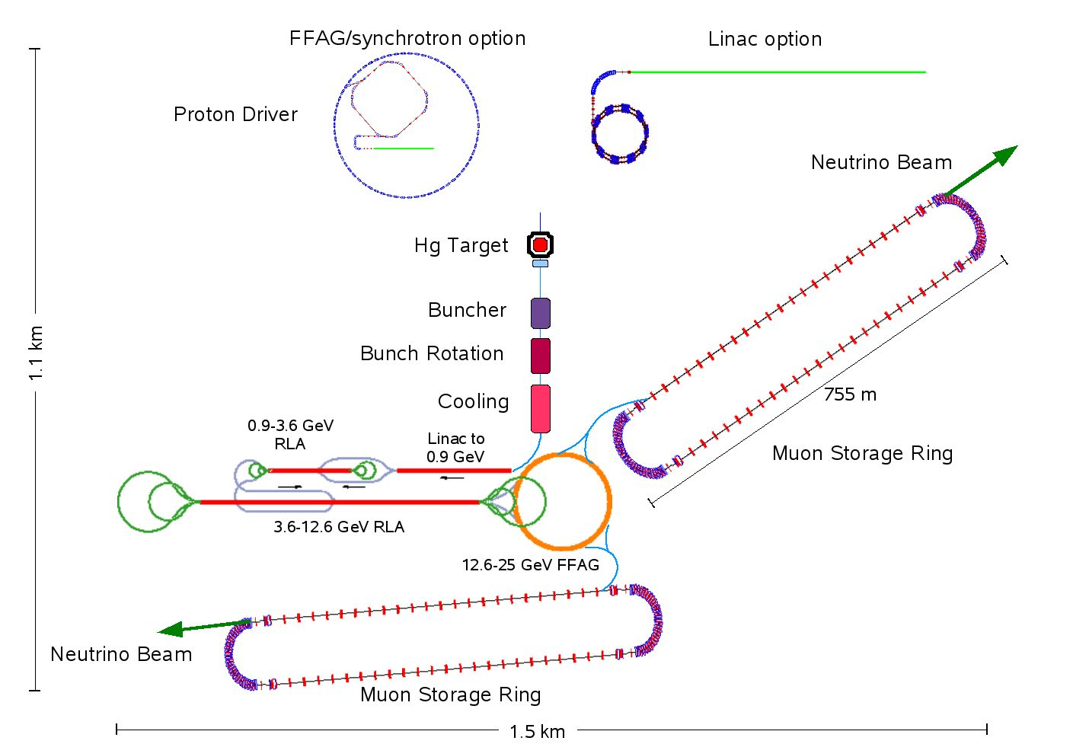
Figure 1: Layout of a Neutrino Factory.

The Beta-beam, the last facility, will use a different technique (see figure 2). In this, beta-emitting radioactive ions are created, accelerated and stored in a storage ring. As in a Neutrino Factory, the neutrino beams are produced by the decay of the ions in the straight sections of the ring. The main issue with this facility is producing a sufficient flux of radioactive ions and EUROnu is particularly investigating novel methods of doing this, in particular using an ion production ring. In this case, the accelerator would be located at CERN and the detector about 730km away in the Gran Sasso laboratory, not far from Rome.
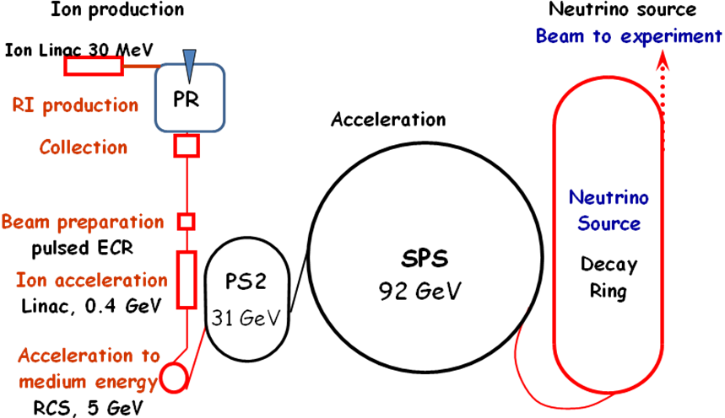
Figure 2: Layout of a Beta-beam facility using an ion production ring.
EUROnu is undertaking design studies of the most likely show-stoppers for each of the three candidate facilities. The aim of this is determine realistic parameters for the performance of each. In addition, will also investigate the performance of the specific neutrino detectors to be used. This will then allow a determination of the physics reach of each facility. To enable a complete comparison between them EUROnu will also estimate the cost of construction, look at the most important safety features of each, in case there are any stop-stoppers there, and assess any outstanding major risks.

Main achievements so far

EUROnu started on 1st September 2008 and has therefore been running for one year. The main achievements so far are.........

This section should be of suitable quality to enable direct publication by the Commission. Please ensure that it is set out and formatted so that it can be printed as a stand-alone paper document not exceeding four pages. It shall also reflect the website of the project (if applicable).

Please include a summary description of the project objectives, a description of the work performed since the beginning of the project, a description of the main results achieved so far, the expected final results and their potential impact and use (including the socio-economic impact and the wider societal implications of the project so far). You should update this publishable summary at the end of each reporting period.

Please include also, as appropriate, diagrams or photographs illustrating and promoting the work of the project, the project logo and relevant contact details.

The address of the project public website should also be indicated, if applicable.

Project objectives for the period

The objectives of EUROnu over the course of the Design Study are shown in table 1, taken directly from Annex I of the Grant Agreement, and this shows that there are no explicit objectives for this period. Nevertheless, there were two main aims for each work package. The first was to undertake a review of the relevant state-of-the-art to determine more precisely the work programme for each. The second was to start this work. The milestones and deliverables for the period reflected these aims. The progress made for each work package is described in section 3.

Objective | Delivery date
Define facility comparison criteria | 18
Undertake interim facility performance for Project Review | 36
Produce a reference design of each facility | 42
Undertake a physics and cost comparison | 46
Write a design report for each facility and publish outcome | 48
Table 1: Objectives of the EUROnu Design Study.

Please provide an overview of the project objectives for the reporting period in question, as included in Annex I of the Grant Agreement. These objectives are required so that this report is a stand-alone document.

Please include a summary of the recommendations from the previous reviews (if any) and indicate how these have been taken into account.

Work progress and achievements during the period

Please provide a concise overview of the progress of the work in line with the structure of Annex I of the Grant Agreement.

For each work package -- except project management, which will be reported in section 3.5--please provide the following information:

- A summary of progress towards objectives and details for each task;

- Highlight clearly significant results;

- If applicable, explain the reasons for deviations from Annex I and their impact on other tasks as well as on available resources and planning;

- If applicable, explain the reasons for failing to achieve critical objectives and/or not being on schedule and explain the impact on other tasks as well as on available resources and planning (the explanations should be coherent with the declaration by the project coordinator) ;

- a statement on the use of resources, in particular highlighting and explaining deviations between actual and planned person-months per work package and per beneficiary in Annex 1 (Description of Work)

- If applicable, propose corrective actions.

Deliverables and milestones tables

Deliverables (excluding the periodic and final reports)

Please list all the deliverables due in this reporting period, as indicated in Annex I of the Grant Agreement.
Deliverables that are of a nature other than written "reports", such as "prototypes", "demonstrators" or "others", should also be accompanied by a short report, so that the European Commission has a record of their existence.
If a deliverable has been cancelled or regrouped with another one, please indicate this in the column "Comments".
If a new deliverable is proposed, please indicate this in the column "Comments".

This table is cumulative, that is, it should always show all deliverables from the beginning of the project.

Table 1. Deliverables

Del. no. | Deliverable name | WP no. | Lead beneficiary | Nature | Dissemination  level | Delivery date from Annex I (proj month) | Delivered  Yes/No | Actual / Forecast delivery date | Comments
D1 | Requirements for proton driver | 2 | 2 | R | PU | 6 | Yes | 9
D3 | Review detector performance of baseline scenarios | 5 | 4 | R | PU | 12 | ?? | ??
D4 | Review physics of baseline scenarios and optimisation | 6 | 6 | R | PU | 12 | ?? | ??

Milestones

Please complete this table if milestones are specified in Annex I of the Grant Agreement.
Milestones will be assessed against the specific criteria and performance indicators as defined in Annex I.

Table 2. Milestones

Milestone  no. | Milestone name | Work package no | Lead beneficiary | Delivery date from Annex I | Achieved  Yes/No | Actual / Forecast achievement date | Comments
1.1 | Review of 1st year milestones, deliverables & costs | All | 1 | 12 | ?? | ??
2.1 | Proton driver report | 2 | 2 | 12 | ?? | ??
4.1 | Baseline Beta-Beam scenario | 4 | 3 | 12 | ?? | ??
5.1 | Review detector performance for Neutrino Factory | 5 | 6 | 12 | ?? | ??
6.1 | Update physics potential | 6,5,2 | 6 | 12 | ?? | ??

Project management

The following Consortium management tasks have been undertaken during this period:

- Distribution of the Commission financial contribution. This was done in accordance with the GA and after each beneficiary had acceded to the GA and signed the Consortium Agreement. The sum distributed to each beneficiary was the total pre-financing for that beneficiary, so that all funds received were distributed and each beneficiary received what was expected. A record has been kept of the dates of transfer and the sums transferred.
- The project website was created and can be found at http://euronu.org . Please note that much of the information is available only to registered people and the project coordinator should be contacted to register. The website contains information about EUROnu, a calendar of project meetings and all the documents produced.
- Email lists have been created for the Consortium as a whole, for each work package and for each Board. The lists are configured so that all emails sent to them are stored in archives and can be retrieved at a later date. A member of each list can also see who else is on the same list.
- Meetings of the EUROnu management structure have been arranged in accordance with the GA, to maintain the smooth running of the Design Study and compliance with our obligations.
- An International Advisory Panel (IAP) has been created, consisting of 5 renowned experts in the field. All the members of this panel attended the first Annual EUROnu meeting (see below) and produced a comprehensive review of their findings. Their report is available on the website. Although the IAP made a number of valuable suggestions that will improve collaboration with other international activities and improve the running of the Study and identified some areas that need additional attention, they did not identify any problems with the work being done. The external view they bring to EUROnu is proving to be very helpful and their recommendations are currently being implemented.
- As stated above, all the documents produced by EUROnu are kept on the website. However, before being made available publically, they are assessed and verified by the Dissemination Board to check their accuracy, quality and observance of the GA requirements.
- EUROnu has been publicised via presentations at a range of important meetings, workshops and conferences. Examples include the European Physical Society High Energy Physics Conference 2009, the 11th International Workshop on Neutrino Factories, Superbeams and Beta Beams in 2009, the Neutrino 2008 Conference and the Neutrino Oscillation Workshop in 2008. Presentations have also been made to international bodies working on this area, including the International Design Study for a Neutrino Factory, a number of Superbeam projects, the Muon Collider Technical Advisory Panel in North America and the European Committee for Future Accelerators. A presentation was made to the CERN Scientific Policy Committee, which has led to EUROnu becoming an official part of the CERN Council Strategy for Particle Physics. This means that is recognised by the CERN Council that the results from the Study will be important in determining the future direction of neutrino oscillation studies in Europe.
- EUROnu has provided input to a committee created by CERN Council to investigate a possible increase in CERN staff working on R&D for future accelerator driven neutrino oscillation facilities. If this is successful, these staff would work in the CERN EUROnu group and add to what the Study can achieve.
- EUROnu has collaborated other relevant FP7 projects, in particular the NEU2012 NA of the EuCARD IA and the LAGUNA DS.
- Project planning and status;
- Impact of possible deviations from the planned milestones and deliverables, if any;
- List of project meetings.

The section should also provide short comments and information on co-ordination activities during the period in question, such as communication between beneficiaries, possible co-operation with other projects/programmes etc.

For Grant Agreements related to infrastructures (Annex III of the Grant Agreement), the access provider shall include a section in the periodic reports on the access activity, indicating the membership of the selection panel as well as the amount of access provided to the user groups, with the description of their work, and the names and home institutions of users.

Explanation of the use of the resources

Please provide an explanation of personnel costs, subcontracting and any major direct costs incurred by each beneficiary, such as the purchase of important equipment, travel costs, large consumable items, etc. linking them to work packages.

There is no standard definition of "major direct cost items". Beneficiaries may specify these, according to the relative importance of the item compared to the total budget of the beneficiary, or as regards the individual value of the item.

These can be listed in the following tables (one table by participant):

Table 3.1 Personnel, subcontracting and other major Direct cost items for Beneficiary 1 for the period
Work Package | Item description | Amount | Explanations
Ex: 2,5, 8, 11, 17 | Personnel costs | 235000 €* | Salaries of 2 postdoctoral students and one lab technician for 18 months each*
5 | Subcontracting | 11000 €* | Maintenance of the web site and printing of brochure*
8, 17 | Major cost item 'X' | 75000 €* | NMR spectrometer*
11 | Major cost item 'Y' ……….. | 27000€* | Expensive chemicals xyz for experiment abc*
 | Remaining direct costs | 15000€*
TOTAL DIRECT COSTS |  | 363000€*
* The entries in italics are examples and purely for illustration

Table 3.2 Personnel, subcontracting and other major Direct cost items for Beneficiary 2 for the period

Work Package | Item description | Amount | Explanations
 | Personnel costs
 | Subcontracting
 | Major cost item 'X'
 | Major cost item 'Y' ………..
 | Remaining direct costs
TOTAL DIRECT COSTSError: Reference source not found

The following table is required only for the funding schemes for Research for the benefit of SMEs

THE TRANSACTION
Please provide a list of the actual cost incurred by the RTD performers during the performance of the work subcontracted to them. These costs refer only to the agreed 'Transaction'.

Name of RTD Performer | Number of person months | Personnel Costs | Durable equipment | Consumables | Computing | Overhead Costs | Other Costs | Total by RTD performer
TOTAL

Financial statements – Form C and Summary financial report

Please submit a separate financial statement from each beneficiary (if Special Clause 10 applies to your Grant Agreement, please include a separate financial statement from each third party as well) together with a summary financial report which consolidates the claimed Community contribution of all the beneficiaries in an aggregate form, based on the information provided in Form C (Annex VI) by each beneficiary.

When applicable, certificates on financial statements shall be submitted by the concerned beneficiaries according to Article II.4.4 of the Grant Agreement.

IMPORTANT:

Form C varies with the funding scheme used. Please make sure that you use the correct form corresponding to your project. Templates for Form C are provided in Annex VI of the Grant Agreement. An example for collaborative projects is enclosed hereafter. A Web-based online tool for completing and submitting the forms C is under preparation. If you have to submit forms C before the tool becomes available, please ask your Commission project officer for an Excel version of the form.

If some beneficiaries in security research have two different rates of funding (part of the funding may reach 75% in reference with Article 33.1 of the EC rules for participation - REGULATION (EC) No 1906/2006) then two separate financial statements should be filled by the concerned beneficiaries and two lines should be entered for these beneficiaries in the summary financial report.

Certificates

List of Certificates which are due for this period, in accordance with Article II.4.4 of the Grant Agreement.

Beneficiary | Organisation short name | Certificate on the financial statements  provided?  yes / no | Any useful comment, in particular if a certificate is not provided
1 |  | Yes
2 |  | no
 |  | no | Expenditure threshold not reached
Etc.

A copy of each duly signed certificate on the financial statements (Form C) or on the methodology should be included in this section, according to the table above (signed originals to be sent in parallel by post).

Usually the contact person of the coordinator as specified in Art. 8.1. of the grant agreement
The home page of the website should contain the generic European flag and the FP7 logo which are available in electronic format at the Europa website (logo of the European flag: http://europa.eu/abc/symbols/emblem/index_en.htm ; logo of the 7th FP: http://ec.europa.eu/research/fp7/index_en.cfm?pg=logos). The area of activity of the project should also be mentioned.
If either of these boxes is ticked, the report should reflect these and any remedial actions taken.
If either of these boxes is ticked, the report should reflect these and any remedial actions taken.
For Security Projects the template for the deliverables list in Annex A1 has to be used.
Total direct costs have to be coherent with the directs costs claimed in Form C

