ACGRID-II Grid School
last update: Nov, 2009

Indico Agenda: http://indico.in2p3.fr/conferenceDisplay.py?confId=2116
Practical Wiki: http://www.euasiagrid.org/wiki/index.php/Training_materials_and_other_resources

Participant ID: __ __

How to access the computer lab @ UM
For WINDOWS machines
Username: Makmal Komputer
Account Password: fizikdpt

For LINUX machines
Username: usl__ __a or usl__ __b
Account Password: grid09

How to access the GILDA gLite User Interface and Central Services
User Interface: glite-tutor.ct.infn.it Top BDII: bdii-gilda.ct.infn.it
Username: kualalumpur __ __ LFC: gilda-lfc.ct.infn.it
Account Password: GridKUA__ __ WMS: gilda-wms-01.ct.infn.it
Certificate Password: KUALALUMPUR CE: grid010.ct.infn.it
DPM: aliserv6.ct.infn.it
AMGA: amga.ct.infn.it

Participant Grid Server Information
First Virtual Server Name: vm __ __.thinkgrid.org
Second Virtual Server Name: vm __ __. thinkgrid.org
Root Password: klacgrid
Connect to your server via ssh. E.g.: ssh –X root@vm__ __.thinkgrid.org

Local GILDA infrastructure @ UM
UI: ui.thinkgrid.org Top BDII: wms.thinkgrid.org
WMS+LB: wms.thinkgrid.org
CE: ce.thinkgrid.org SE: se.thinkgrid.org

How to access to the local infrastructure in UM
User Interface: ui.thinkgrid.org
Username: kualalumpur __ __
Account Password: GridKUA__ __
Certificate Password: KUALALUMPUR

Connect to the local UI via ssh. E.g.: ssh –X kualalumpur__ __@ui.thinkgrid.org

Command with Example | Use

Access to Grid
voms-proxy-init –voms <VO_NAME> | Create proxy with additional credentials as a member of gilda VO
voms-proxy-destroy | Destroy proxy
voms-proxy-info --all | See proxy information

Information System
lcg-infosites --vo <VO_NAME> ce | List CEs
lcg-infosites --vo <VO_NAME> se | List SEs
lcg-infosites --vo <VO_NAME> closeSE | List CE’s with “close SEs”

Workload Management
glite-wms-job-submit -o fileForId.txt hostname.jdl | Submit a job, save its id in a file
glite-wms-job-status <job id>  glite-wms-job-status -i fileForId.txt | Check status
glite-wms-job-output <job id>  glite-wms-job-output --dir <outputdir in your UI> \  -i <file>  glite-wms-job-output --help | Retrieve output
glite-wms-job-cancel <job id> | Cancel a job
glite-wms-job-logging-info <jobid> | See the log for a job

Data Management
Catalogue access LCG File Catalogue (LFC)and  file management (lcg-utils)  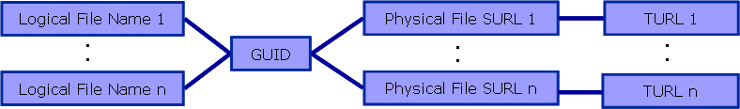 | You do need to specify the VO in the lcg-* commands  lfn: logical file name  GUID: global unique identifier  SE: Storage element
lfc-ls -l /grid/gilda/training/ | List a directory in the LFC
lfc-mkdir \  /grid/gilda/training/kualalumpur/kualalumpur__ __ | Create new directory in LFC  /grid/<voname>/….
lfc-ln -s <existing lfn name> <new name> | New lfn
export LFC_HOME=/grid/<VO_NAME>/tutorials/kualalumpur/ | Set LFC home directory  Avoids repeatedly typing /grid/….
lcg-cr -v --vo <VO_NAME> file://$PWD/text_file.txt -l \  lfn:/grid/<VO_NAME>/tutorials/kualalumpur/myfile.txt \  -d <SE_HOSTNAME>  lcg-cr -v --vo <VO_NAME> -d <SE_HOSTNAME> \  -l lfn:mydata.txt \  file://$PWD/mydata.txt | Copy a file to a SE and register it into the catalog  Equivalent if $LFC_HOME is set and I’m in the local directory that holds mydata.txt.
lcg-cp --vo <VO_NAME> \  lfn:<FILE_2_DOWNLOAD> \  file://`pwd`/kc_1.tar.gz | Copy a file from SE to your local directory - uses the LFC to locate the file. (uses $LFC_HOME)
lcg-rep --vo <VO_NAME> -d <SE_HOSTNAME> \ lfn:/grid/<VO_NAME>/tutorials/kualalumpur/ex3.tar | Create a replica on named SE for a specified lfn
lcg-lr --vo <VO_NAME> lfn:/grid/<VO_NAME>/data.txt | List replicas (by lfn or GUID)

Installation and Configuration
yaim –c –s <site-info.def> -n <node type name> | Configure already installed services
yaim –r –s <site-info.def> -f <function name> | Execute a configuration function
Other options:
-v | --verify checks for required variables
-d | --debug define logging level
-e | --explain describe what will be done but
don’t do it.
-a | --available print out configuration targets
-h | --help print command help
<VO_NAME> = gilda

Acronyms
Components:
UI User Interface
RB Resource Broker
CE Computing Element
WN Worker Node
SE Storage Element
LFC LCG File Catalogue
VOMS Virtual Organization Management Service
WMS Workload Management System

Information System (IS):
BDII Berkeley DataBase Information Index
GIIS Grid Index Information Server
GRIS Grid Resource Information Server
MDS Monitoring and Discovery Service
LDAP Light Weight Directory Access Protocol
DN Distinguished Name
GLUE Grid Laboratory for a Uniform Environment

Grid Security:
CA Certification Authority
VOMS Virtual Organization Management System

Data Management:
DPM Disk Pool Manager (Storage Element)
SRM Storage Resource Manager
LFC LCG File Catalog
GFAL Grid File Access Layer (POSIX file access API)
LFN Logical File Name
GUID Global Unique Identifier
SURL Storage URL
TURL Transport URL

Reference Links:

EGEE: http://www.eu-egee.org
gLite User Guide https://edms.cern.ch/file/722398/1.1/gLite-3-UserGuide.html
gLite Documentation: http://glite.web.cern.ch/glite/documentation/default.asp

GILDA Wiki: https://grid.ct.infn.it/twiki/bin/view/GILDA/WebHome

EGEE Digital Library: http://egee.lib.ed.ac.uk/

Requirement for applying user certificate from ASGCCA

ASGCCA: http://ca.grid.sinica.edu.tw/index.html
ASGCCA FAQ: http://ca.grid.sinica.edu.tw/general/faq.html
ASGCCA RA Contact List: http://ca.grid.sinica.edu.tw/contact.html

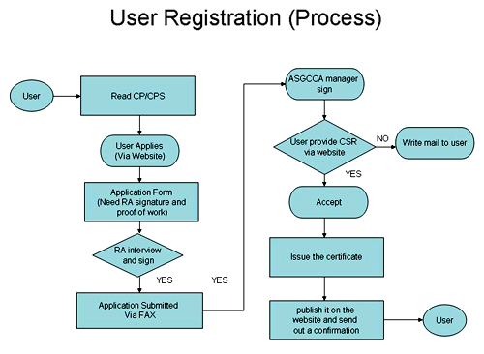
OS and Browser requirement
- Windows XP
(v) IE
(v) Mozilla Firefox
2. Wndows Vista
(x) IE
(v) Mozilla Firefox
3. MAC
(v) Safari
(v) Mozilla Firefox

