R-COD/C-COD dashboard HOWTO

- Overview and principle

  - General overview

We use the word “Operational dashboard” to refer to the set of tools and interfaces dedicated to R-COD/C-COD daily work, available at https://cic.gridops.org/index.php?section=cod&page=coddashboard
It consists of different parts:
- GGUS Tickets interface (see 1.2)
- monitoring alarms interface (see 1.3)
- weekly handover (see 2.8)
- other useful tools including list of Scheduled Downtimes, SAMAP (SAM admin’s page), etc.

  - About the interface with GGUS

Tickets created by R-CODs are part of the GGUS System. There is in GGUS a dedicated Helpdesk for COD tickets (CIC_Helpdesk). This is the one which is interfaced with the dashboard.
This dedicated Helpdesk is connected with the global GGUS helpdesk and tickets information transits from one to another (see schema below).
Having such a dedicated helpdesk ensures to cover specific R-COD/C-COD needs (fields for site and node, specific escalation procedure…).
Interface is done using SOAP web services.

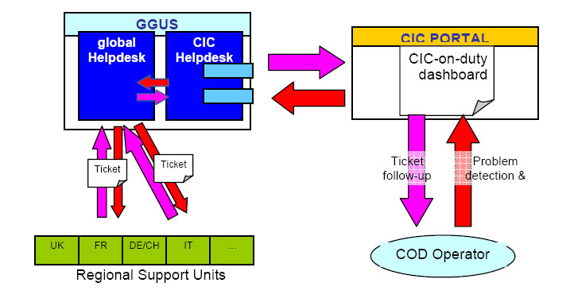

  - About SAM alarms

Problem detection is done by SAM framework.
Different sensors have been implemented (CE, BDII…). Each time an error is detected by one of these sensors, an alarm is generated.
Alarms are stored in a dedicated DB in the SAM framework, and are interfaced with the dashboard using a XSQL based service.
There are 4 different alarm statuses:
- new (the alarm has not been handled)
- assigned (the alarm has been handled, a ticket has been created to report the problem)
- masked (the alarm is to be ignored until the parent alarm is off)
- off (the problem has been solved or deliberately ignored)

When a test is failing, a new alarm appears in the dashboard. Next failures for the same test on the same node won’t trigger other alarms unless the existing one is set to off
When an alarm masking other alarms is set to off , masked alarms are “unmasked”: if the current status of the test is OK, alarm is set to off . If not, alarm is set to new .
For each alarm, a set of information is available:
- test that failed
- date of the failure
- impacted node
- corresponding site
- current status of the test
For masked alarm, ID of the parent alarm is provided. For assigned alarms, ID of the corresponding GGUS ticket is provided.
- HOW TO

  - Access to dashboard

The R-COD/C-COD dashboard is available from the CIC Operations Portal (http://cic.gridops.org ), in the “RC” or “ROC” management section (top tabs in left menu), “Regional dashboard” page (left menu), or directly at this URL: https://cic.gridops.org/index.php?section=roc&page=dashboard

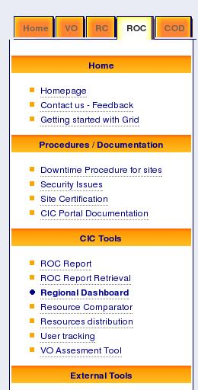

All subsections presented after in this document (tickets, alarms, dashboard, SAM Admin’s page, Scheduled Downtimes, Hand over, view, metrics and preferences) are available from here.
To access the dashboard, one need to be registered in GOCDB at least as “site manager”.

First default page is a homepage which displays the list of new alarms and open GGUS tickets in the scope of the role chosen in the preferences.

In the following, we will describe all the tabs available in the dashboard starting by the “Preferences” one.
  - Preferences

Some displayed options are based on user preferences:
- for C-COD: the time frame to view the alarms and tickets
- for other roles: the possibility to choose preferred sites in the sites list of the scope
On top of the page, you can see the role you are currently identified as and the different roles you can use regarding your GOCDB roles.

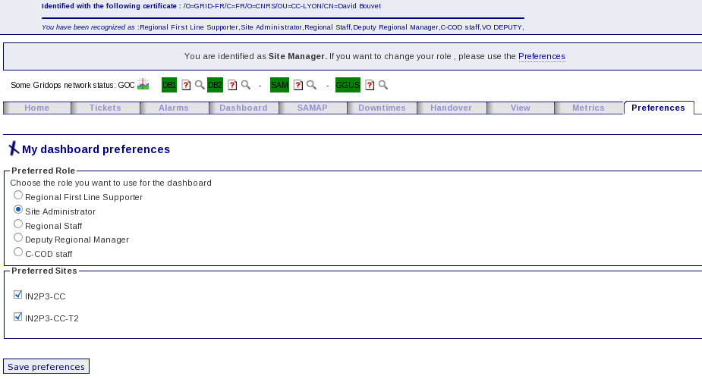
  - Home

This page gives you a summary of current alarms and tickets for the sites in the scope of the role chosen in the preferences.
No action can be performed on this page except viewing of SAM tests history and GGUS tickets.

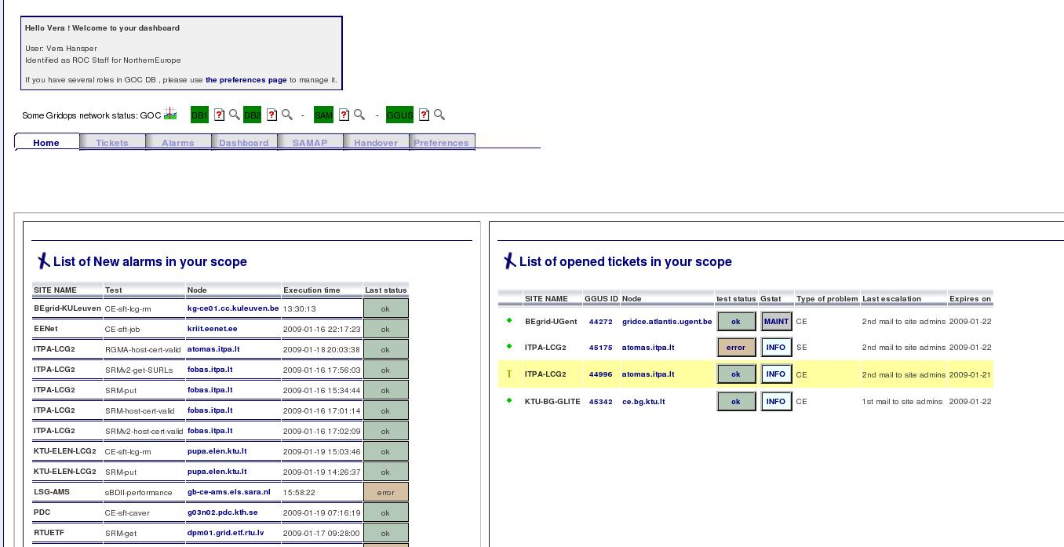
  - Dashboard

The “Dashboard” tab is the most useful page of the dashboard.
It gives a complete view of the status of the site/region in the scope of the role chosen in the preferences.
From this full view, basic informations are available for each site:

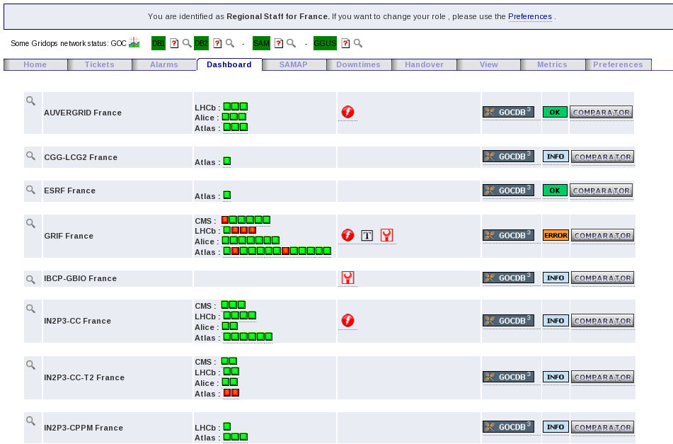
(1) (2) (3) (4) (5) (6) (7)

- magnifying symbol (1) Click on this leads to site details (see below).
- site name and ROC (2)
- VO specific test results with colored squares (3) Rolling the cursor over the squares leads to a drop down summary of the test results.
- a set of symbols in case of alarms (“storm” symbol), GGUS tickets (“T” symbol), declared downtime (“wrench” symbol), network trouble (“antenna” symbol, not on the snapshot) (4) Rolling the cursor over these symbols leads to a drop down summary of the corresponding item.
- GOC-DB icon (5) Click on this leads to site information page in GOC-DB.
- GSTAT status (6) Click on this leads to site status page in GSTAT.
- Comparator icon (7) Click on this leads to the “Comparator” tool for the site which displays the difference between BDII and GOC-DB publications.

Clicking on the magnifying button on the left of site name, a drop down page opens giving all the details about alarms, tickets, downtimes... for the site.

    - Site administrators view

Site administrators cannot act on the alarms of there sites. They can use the notepad to give informations about the site for the R-COD shifter.

    - 1st line support and R-COD view

From the “Dashboard” page, 1st line supporter and R-COD shifter can act on alarms, create tickets, or add notes in the notepad for a site.

    - C-COD view

C-COD shifters have the same privileges as 1st line supporters and R-COD. But they only see:
- new alarms older than 3 days
- non closed tickets older than 30 days
- expired tickets since 3 days
- tickets in the last escalation

  - Alarms

    - View information about current alarms

Alarms are listed per site, not per node.
All the alarm (new, masked, assigned) are displayed.

Basic information is available about each alarm:
- status of alarm: new, masked, assigned
- alarm ID: click on this leads to alarm details (see below).
- test that failed and triggered the alarm
- impacted node: click on this leads to SAM history for this node on the SAM portal.
- execution time (when the test failed)
- last test status of the test that failed and triggered the alarm

A color code is associated to alarm age in the background of “Execution time” cells:
- green: age < 24h
- beige: 24h< age < 3 days
- red: age > 3 days
Depending on that age, alarm can be seen or not by C-COD.

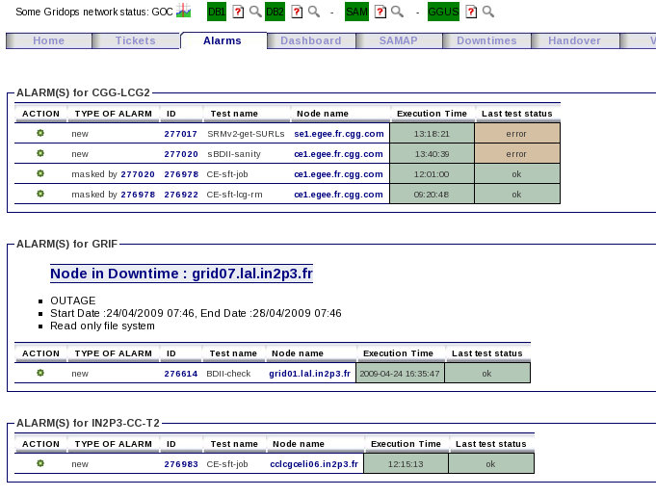
For each site, you can also see the downtimes published:

By clicking on alarm ID, details about a given alarm is given in a frame looking like:

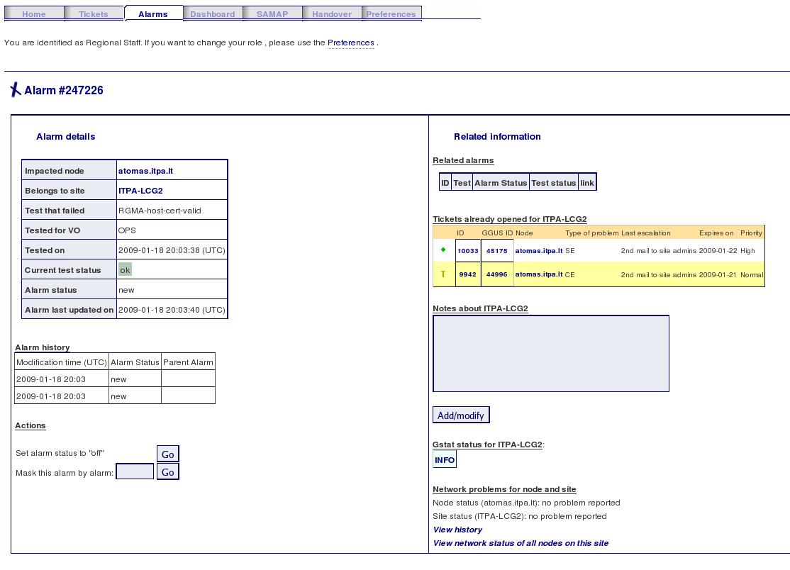

Among these details one can find:
- all information available in the list (alarm ID, node, site, test, execution date, last test status)
- VO used to submit the test
- alarm history and last update date
- related alarms (same site, same node, or masked alarms)
- already open tickets for that site
- notepad for the corresponding site (except for the “Site administrator” role)
- additional informations about site and node (GSTAT, network status)

From this page you can set “off” or mask the alarm. This is not possible if you choose the “Site administrator” role. Site administrators do not have the rights to act on alarms.

    - Actions on alarms without ticket creation

The following actions can not be performed by “Site administrator” role.

      - Close an alarm to ignore
Click on the “Set alarm status to “off” ” button from the alarm details page.

      - Mask a new alarm
From the alarm details page, click on the “Mask alarm” button after having specified by which alarm this one should be masked.
You can copy/paste the alarm ID which will mask the current one from the related alarms table displayed on the same page.

      - Unmask an alarm
Detailed page for a masked alarm is slightly different. Only possible actions are “Set to off” and “Unmask”.
Click on the “Unmask alarm” button to put alarm status back to “new”.

      - Enter notes for a given site
For sites where recurrent problems are known, it is useful to keep notes about this to avoid other
operational shifters to search for a problem which has already been identified. This is the goal of the text area in the alarm details page called “Notes about site XX”.
This notepad is related to the one found in the “Dashboard tab” page.

To enter new notes or update existing notes, just enter your text in the text area and click on the “Add” button.

  - Tickets

Tickets should be escalated following the escalation procedure.
Tickets have a color assigned to assist with easy age identification (see below).

As R-COD, you have to:
- track ticket for responses from sites,
- escalate tickets after 3 days if no response,
- escalate old tickets (> 30 days) to C-COD,
- try to assist site in solving ticket if appropriate. Solved tickets should, ideally, have a well written description of the solution to the problem (not applicable in all cases – use some discretion).

    - Create a new ticket

You can create a ticket from the “Dashboard” tab.

Clicking on the magnifying symbol on the left of the site name presents a summary drop down page, as below:

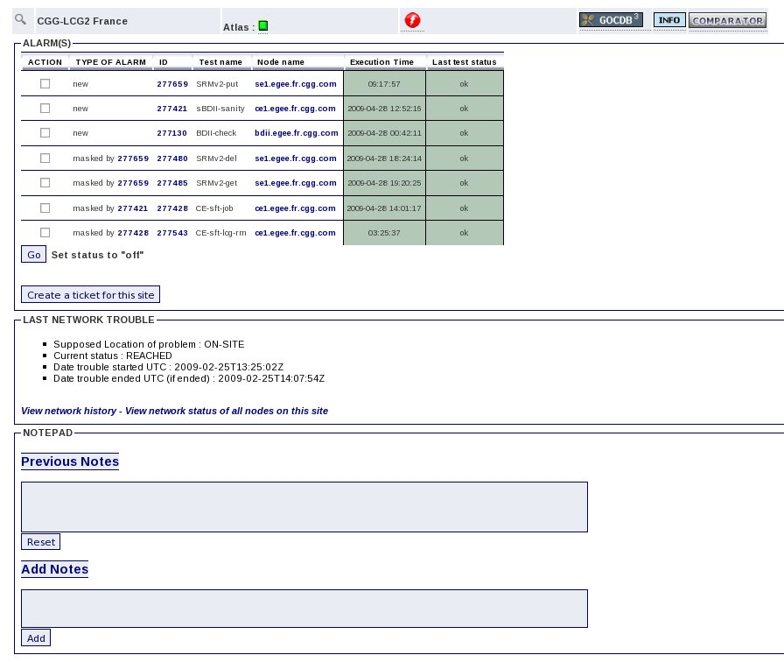
Under the list of current alarm, you will see the “Create a ticket” button.
Creating a ticket brings up to the ticket creation form:

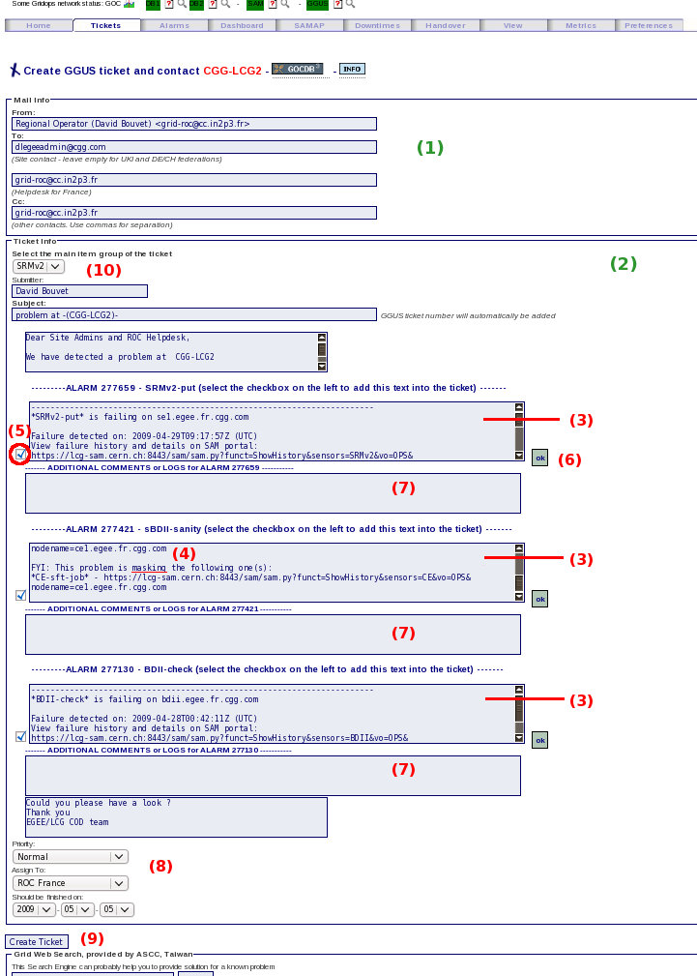
All information is obtained automatically (site and ROC contacts, site name, node, problem summary, ticket submission text and mail body). There is normally no need to change these headers unless you want to explicitly add someone in Cc of the notification mail, or add information about type of problem.

Two frames compose this form ((number) refers to the previous picture):
- “Mail info” (1): only about mail headers,
- “Ticket info” (2): gives all the informations about the problem to create the GGUS ticket.

If ticket was created from a site having alarm(s), alarm(s) details (3-4) will appear for each one in the ticket creation form and will be inserted in the mail body. Masked alarms (4) will also appear in the ticket under the parent one.
You can choose an alarm not to appear in the ticket by unticking the box (5) on the left of the alarm body.
On the right of the alarm, you will find the last status (6) of the test that triggered the alarm. Click on this leads to SAM history for the given node on the SAM portal.

Please review all information before submitting the ticket.
Fill in the appropriate fields (7) if needed. The more information given to the site, the better they will be able to solve the problem.

At the bottom of the “Ticket info” frame, you will find the priority and the expiration date (8). These information are set automatically, but you can change them if needed.

Click on the “Create Ticket” button (9). You will then see a snapshot of the mail sent to the site.

The ticket will be created in CIC_Helpdesk and GGUS Helpdesk. Notification will be sent to site and ROC, Cc to ROD-followup mailing list.
Note: there are special cases (UKI and DE/CH) where sites are not to be contacted directly. In that
cases, the “to” field is left empty, and all mail communication transits through ROC helpdesk.

When the ticket is created, corresponding alarm(s) (if any) is(are) set to “assigned” and linked to this ticket. After a while (time for the caches to refresh, usually less than 2 minutes) you will see the new created ticket in the tickets list.

At the end of the page, you can see the “Grid Web Search engine” you can use to find some useful links to solve the problem. It will open a new window with the results of your request. You can then insert some of these links in the “Additional comments” fields (7).

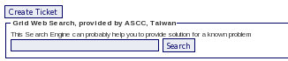

    - View information about existing tickets

Basic informations about each ticket is displayed in the GGUS tickets list under the “Tickets” tab.
Tickets are flagged by a different color and icon following when they expire, and are by default sorted by expiration date (first tickets to expire appear at the top). The icon/color code is shown in the following table:

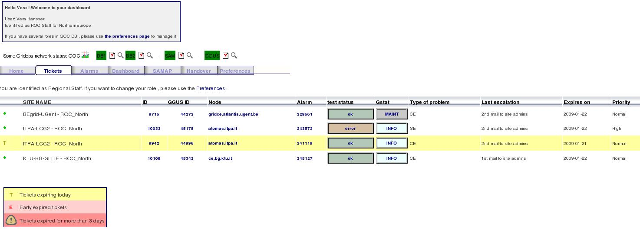

The list gives the following informations:
- impacted site and ROC. Click on this leads to site information in GOC-DB.
- ticket ID (in CIC Helpdesk). Only useful for R/C-CODs. Click on this leads to ticket details and modification page (see below).
- ticket GGUS ID (in GGUS system). This is the ID sites and ROCs need to know. Click on this leads to GGUS ticket details page on GGUS portal.
- impacted node. Click on this leads to SAM history for the given node on SAM portal.
- related alarm and current status of the test that triggered the alarm. Click on this leads to Alarm details page on the dashboard (see below)
- site overall status in GSTAT
- type of problem (corresponds to SAM sensor)
- last escalation, as defined in the escalation procedure
- expiration date
- priority

    - Update/escalate an existing ticket

From the tickets list, you can access the ticket details and modification page by clicking on “Ticket ID” field. You’ll find a page looking like this one:

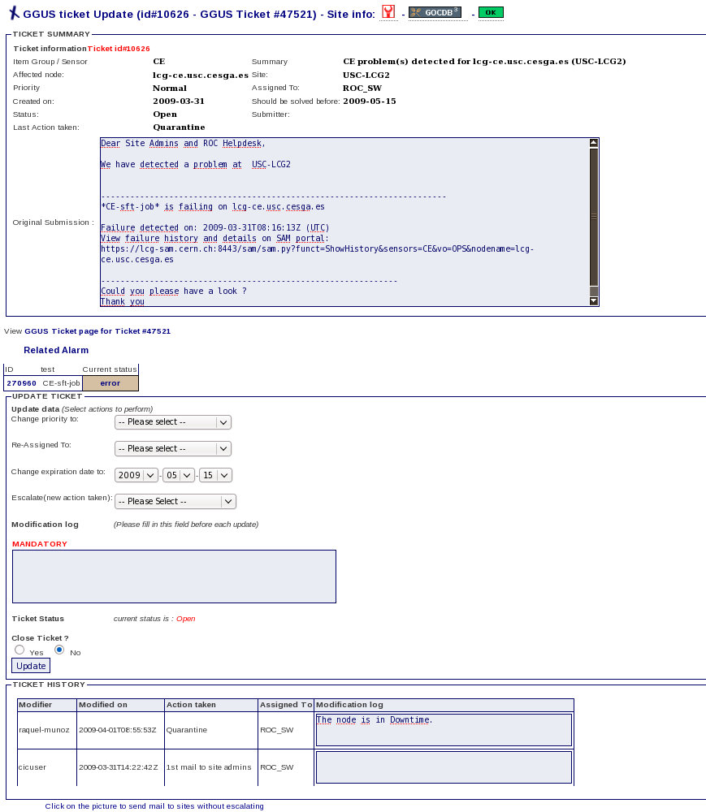
From this page, you can change different fields in the ticket:
- priority
- support unit
- expiration date
- escalate the ticket according to escalation procedure
- close the ticket
For each modification, it is mandatory to enter a comment on which action has been taken and why. The comment will be recorded in the “Ticket history” table below the update ticket section.

At the end of the page, a magnifying symbol will present a drop page when clicking on. This page is a form to send an informative mail without escalating.

    - Ticket creation without an alarm

It is also possible to create a ticket for a site without an alarm.
Use with caution!

From the dashboard tab, clicking on the magnifying symbol of a site without any alarm will show you the drop down page below:

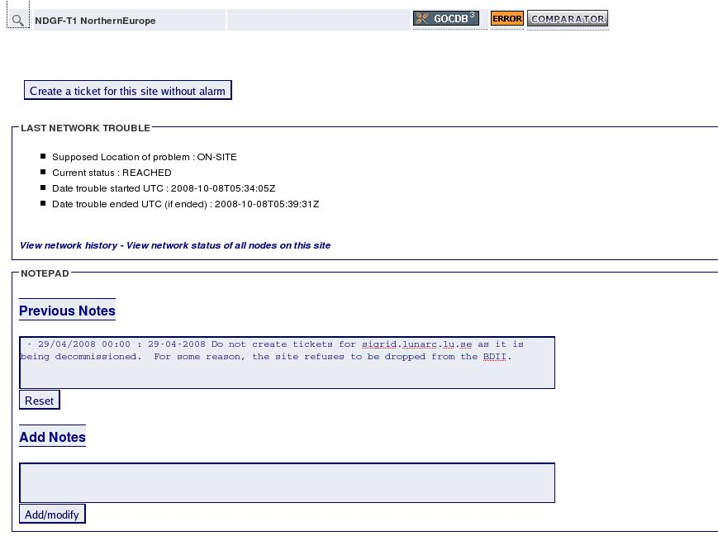

Clicking on the “Create a ticket” button leads to the ticket creation form described in § 2.6.a.

  - SAMAP

This tool allows to submit a SAM test on a given node.

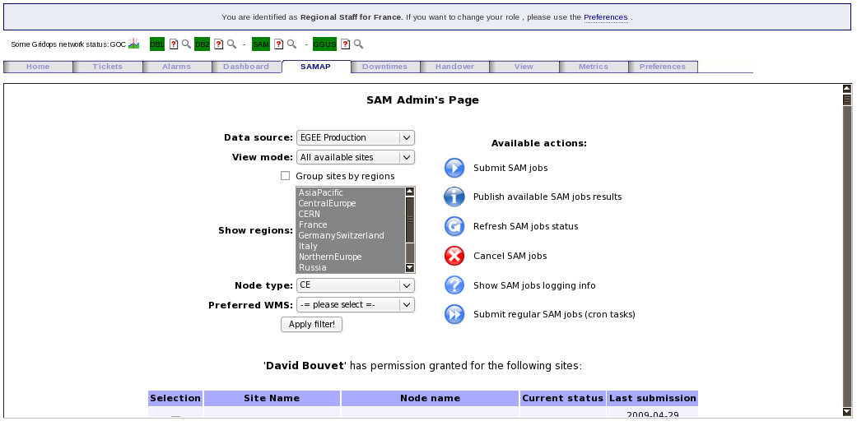
  - Handover

A handover log form is available under the “Handover” tab.
It is useful to make a summary of the past week and to keep information available for the next shifters. This handover is also used by the WLCG meetings.

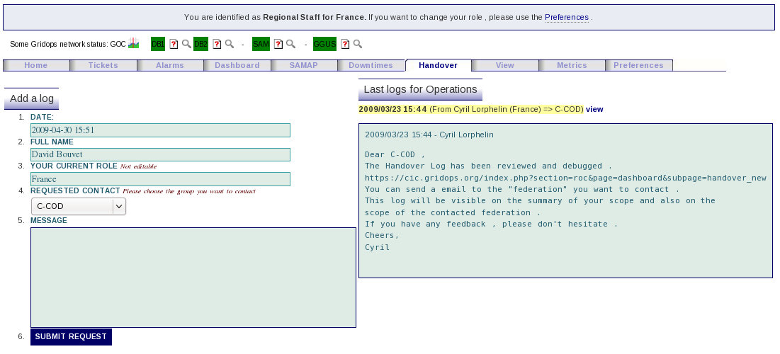
The drop down menu “Requested contact” gives you the choice of the targeted contact to whom you want to send the handover.
You can choose between C-COD or one of the region.

On the right side of the page you can see the last logs clicking on the “view” link.
  - Other tools

    - Downtimes

Under the “downtimes” page you will find the list of downtimes published for the site under the scope of the role chosen in the preferences.
They are displayed depending on the range : site level or node level.

    - View

It allows to see the status of sites in other the regions. No action is possible.

    - Metrics

This page gives some metrics on regional activity.

