**THIS FORM HAS TO BE SUBMITTED BY FINISHED/FINISHING AND ON-GOING PROJECTS**

**FINISHED/FINISHING PROJECTS (with a duration of a year or more) JUST NEED TO FILL IN THE “PROGRESS REPORT” PART (1-5)**

***The annual funding (not including salaries) requested from OCEVU must be ≤ 25 k€.***

***Note that PhD and Postdoc OCEVU grants include a lump sum of 2 k€/yr covering installation and (some) operating expenses.***

**Please *make your financial requests as realistic as possible. Do not inflate them artificially, it is counterproductive for everybody.***

**Note that*:***

***- any human resources (postdoc and/or PhD student) and new equipment money requested for 2015 have to be justified in detail and will be treated on the same footing as the ones of new projects, even if they were discussed in the original, approved proposal.***

***- in case of modifications of the initial scientific perimeter or scientific objectives of the project, make sure to describe in detail these modifications, their cause(s) and their impact on the project***

**Type of project: X** Scientific collaborative project  
  Other:

**Project OCEVU-ID: 95**

**Project title: Probing the nature of Electroweak Symmetry Breaking at the LHC with the ATLAS**

**Detector.**



**Project time frame:**

Start date: October 2013 duration (months): 60

**Project coordination:**

Coordinator’s name: Lorenzo Feligioni

Lab/team: CPPM email: lorenzo@in2p3.fr tel: 04 91 82 76 21

Signature:

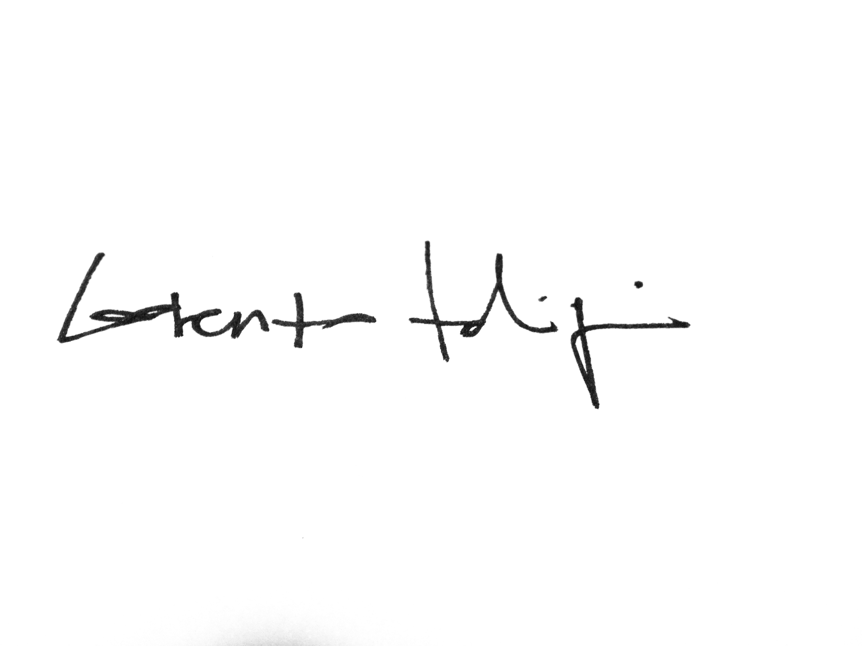

**1. SUMMARY OF THE OBJECTIVES OF THE PROJECT**

The discovery of the Higgs boson at the Large Hadron Collider in particular by the ATLAS experiment, has open new and exciting opportunities for fundamental research in physics. The presence of this new particle having a mass of approximately 125.5 GeV constrains all theoretical models that provide a mechanism for spontaneous Electroweak Symmetry Breaking (EWSB) via a natural extension to the Standard Model (SM). The measurement of the properties of this new particle will shed light on the possibility of new physics at the TeV scale: any deviation from the SM Higgs predictions in terms of spin or couplings to all other SM particles will lead to an indication of new physics which could be produced and directly searched for in the data being collected at the LHC. The ongoing project (PESBLADe) directly addresses this cutting-edge research area.

After an initial phase described later in this report, the project is now structured along three main axes:

* 1. **SUperSYmmetric (SUSY) models with R-parity violation [A1]**

One potential scenario for natural EWSB is low energy SUSY. In this scenario, EWSB can be generated radiatively through perturbative quantum effects in an extended sector of elementary Higgs fields. Motivated by naturalness of the Higgs potential, which would favor light third-generation squarks, and the stringent LHC bounds on spectra in which the gluino or first and second generation squarks are light, we focus on scenarios dominated by the pair production of light stops.

This work has been inspired by a recent publication [27] that considers various possible direct and cascade decays of the stop involving the tri-linear RpV operators. These decay chains consist of multi-jet final state, which are able to constrain the stop mass better than the four-jets final state ones. These later are usually considered to test such processes [32]. Our interest for this channel was also motivated by the fact that despite it well motivated, it has not yet been explored at the LHC experiments and the CPPM group has lead this kind of analysis in Run 1 in the framework of the fully hadronic ttH(H→bb) searches.

* 1. **New physics beyond the SM in multi-boson final states [A2]**

Multi-boson final states can be used as a probe for new physics either by precisely testing any deviation from the SM using model-independent Effective Field Theory approaches [33,34] or by searching for specific signatures of BSM models. In this latter we can list the SM extension by one weak gauge triplet of scalar fields with a very small vacuum expectation value, which is a very promising setting to account for neutrino masses through the so-called type II seesaw mechanism [35].

* 1. **Study of the R-parity conserving SUSY [A3]**

Despite its lack of evidence after LHC run 1, R-paritiy Conserving SUSY remains very well-motivated, in this case the search for chargino and neutralino production in final states with 1 lepton, 2 b-jets compatible with a Higgs boson and missing transverse energy, is still one of the most promising channel where to see it. In parallel the implication on the development of Suspect [10,11], SUSY spectrum calculator developed in Montpellier will allow to be able to extend its usage to RpV scenarios, instrumental to **A1**.

* 1. **Some more words on PESBLADe**

PESBLADe is intended to be a general collaborative framework between the experimental ATLAS-CPPM and the LUPM-L2C phenomenological group. The first one provides, thanks to the already planned commitments for Run 2, the necessary manpower to carry difficult analyses in a competitive environment such as ATLAS. In this case both **A1** and **A2** will be leaving their experimental life within the two ATLAS-CPPM working groups dedicated to, top-Higgs Yukawa coupling analysis and multi-lepton based SUSY analysis. **A3** builds on the expertise acquired during Run 1 where the same topic was the PhD thesis of M. Ughetto.

**2. PROGRESS OF THE PROJECT**

**2.1. Setting up**

The PESBLADe project started in 2013 with a series of meetings between the LUPM-L2C phenomenology group and the ATLAS-CPPM group. The first meetings were devoted to present the work of the different actors of what was going to be the PESBLADe project. The topics discussed in these meetings were as free as we could set them, taking into consideration the specific expertise of the two groups involved on SM top-quark [1,2], vector boson pairs production [3], SM Higgs [4,5,6], SUSY [7], and on 4th generation quark searches in top-like events [8] (ATLAS-CPPM) and the phenomenology of minimal [9,10] and extended [11,12] SUSY models, Higgs physics [13,14,15], as well as composite Higgs models and their implications on Beyond SM (BSM) collider phenomenology and particle dark matter [16,17].

In these first brainstorming sessions (see Table 1) several topics were identified, where a synergy between the two groups could be at least foreseen, for these a bibliographic study was started and some conclusions were drawn based on these studies; what follows is a list of the BSM models considered:

* **Higgs couplings**: in particular how to use top-quark and bottom-quark coupling measurements to constrain SUSY and composite Higgs models.
* **Direct SUSY searches**: stop pair production and associated stop plus Higgs production (proposed by LUPM-L2C collaborators [18, 19])
* **Single heavy quark production** in the framework of several phenomenological model such as *Composite Higgs Models* and *Extra Dimensions*.
* **Dark Matter in composite Higgs models.**
* **Identifying final states that can be reinterpreted simultaneously in terms of different models** (SUSY, composite model, single stop production in SUSY R-parity violating scenarios [24]), as shown in [23].

Table 1: Description of the first series of meetings between ATLAS-CPPM and LUPM-L2C

|  |  |
| --- | --- |
| 7 August 2012 | Marseille: brainstorming around CPPM-ATLAS and LUPM-L2C interest and common points. Discussion on how to develop the application for OCEVU Post-doc in terms of interfacing the two experimental and phenomenological groups. |
| 16-17 May 2013 | Montpellier: bibliographic work aimed at exploring possible research topics at the LHC (SUSY, composite Higgs, DM...) |
| 10-11 July 2013 | Marseille: finalization of the application for the OCEVU Post-doc position |

At the end of this series of discussions the focus was given to the **stop pairs plus Higgs associated production**. The re-actualization of this analysis was the subjects of the first meetings, see Table 2, with Sara Diglio, post-doc OCEVU on the PESBLADe project since January 2014, from October 2013. We looked at different decay stop decay modes and allowed SUSY phase space to determine whether this process could be competitive with direct stop production, or associated stop production with multi-jet. Looking at stop-stop Higgs associated production allowed us to familiarize with the MadGraph [25] Monte Carlo Event generator, which allows a complete NLO description of SUSY final states, and that was used to compare stop-stop-Higgs production cross sections, together with the relevant SM backgrounds, with other SUSY final states which could compete in terms of sensitivity.

Table 2 : first hand-on meetings.

|  |  |
| --- | --- |
| 21-25 October 2013 | Montpellier: including postdoc Sara Diglio. Tutorial MadGraph5 and study of stop-stop-Higgs final state in MSSM. Computer tool issues, interfacing with  SuSpect, embedding loop induced stop → c Neutralino decays**.** |
| 24-25 February 2014 | Marseille: multi-b+light jets R-parity violation final states ; triplet Higgs, limits on H++ → W+ W+ |

After this first round of studies, we concentrated on another scenario based on R-parity violating SUSY, looking at final states with multi-jets and multi-b-jets. Since the beginning of PESBLADe it was decided to dedicate approximately one week per month to meet in person between the ATLAS-CPPM and UM2 people, this monthly meeting happens alternatively in Montpellier and Marseille. We also have weekly telephone meeting to discuss our work, every Wednesday at 10h30 am.

Table 3 : RpV dedicated meetings.

|  |  |
| --- | --- |
| 7-11 April 2014 | Montpellier: R-parity violating multi b-jets final states |
| 19 -23 May 2014 | Marseille: R-parity violating multi b-jets final states |
| 10 - 15 June 2014 | Montpellier: R-parity violating multi b-jets final states |
| 16-17 June 2014 | Montpellier: Labex OCEVU workshop |
| 23-28 June 2014 | Montpellier: defense of M1 stage, progress on R-parity violating |
| 21-23 July 2014 | Marseille: R-parity violating multi b-jets final states |
| 27-28 Oct. 2014 | Marseille: R-parity violating multi b-jets final states |
| 18-21 Nov. 2014 | Marseille: R-parity violating multi b-jets final states |
| 15-17 Dec. 2014 | Montpellier: R-parity violating multi b-jets final states |
| 16-20 Feb. 2015 | Montpellier: R-parity violating multi b-jets final states |
| 1-5 March 2015 | Marseille: R-parity violating multi b-jets final states |
| 24-27 March 2015 | Montpellier: R-parity violating multi b-jets final states |
| 13-15 April 2015 | Marseille: R-parity violating multi b-jets final states |
| 20-23 April 2015 | Montpellier: R-parity violating multi b-jets final states |
| 24-28 May 2015 | Marseille: R-parity violating multi b-jets final states + OCEVU workshop |

**2.2. Results, milestones reached, and significant events and actions performed**

We have finalized our first study on signatures of R-parity violation originating from hadronically decaying light top squarks at the LHC. The main result is that different decay channels characterized by heavy- and light-jet multiplicities can have very different and complementary sensitivities to the R-parity violating couplings, with comparable production and decay cross-sections. In particular, higher jet multiplicities scan typically smaller R-parity violating couplings, down to tiny values where the R-parity conserving experimental bounds set in due to long-lived lightest supersymmetric particles.

This suggests a general search strategy including different final states with heavy- and light-jets or leptons that would allow a more complete interpretation of the signal or of mass versus coupling exclusion limits at LHC RUN2. We illustrated the case with several benchmark points for a compressed spectrum of light stop, chargino, neutralino, within the model independent setting of the low-energy phenomenological MSSM. We identified 10 different types of signal final states with specific b-jet (and light-jet or lepton) multiplicities and studied the sensitivity of the associated cross-sections to the supersymmetric mass spectrum and to the R-parity violating coupling in the third quark generation sector.

The variety of jet content, ranging from 4 up to 12 jets in the signal, requires a dedicated analysis of signal versus background issues of which we provide a preliminary discussion in this first study ; in particular, very small couplings close to the onset of R-parity conservation, enhance final state decays with multi-b (or light) jet that are sufficiently copious to allow a study of the decaying stop, as compared to the QCD background overwhelmed 2-jet decays.We also stressed the fact that most of the final states are similar to the all hadronic ttH(→b b) final states and could actually enhance the latter cross-sections by up to 20 %. We are now finalizing a draft of the first paper.

We recall hereafter some of the intermediate steps and actions performed during the study

(see also last year's report).

The steps performed so far have been driven by the following fundamental question: can we prove the existence of a region of the SUSY parameter space at Grand Unification Theory (GUT) and/or low energy scales where the stop decay in a bottom quark and a chargino is enhanced with respect to other competitive SUSY processes (for example the stop decay into a top quark and a neutralino)?

In order to answer such a question, we firstly generated the Trilinear RpV SUSY model using the SARAH code [28]. SARAH is a Mathematica package to build SUSY and non-SUSY models in the UFO format which is supported by the MadGraph5 events generator (MadGraph5 will be used later to generate the full process starting from a 13 TeV proton-proton collision).

As a second step we calculated several SUSY spectra for the above Trilinear RpV SUSY model using SPheno (Supersymmetric Phenomenology) [29,30]. This code allows calculating the SUSY spectrum using low energy data and a user supplied high scale model as input. More specifically, two different input options are available: the user can either provide GUT scale SUSY parameters (top-botttom approach) or low scale SUSY ones (bottom-bottom approach).

We started with the former approach: we chose different combinations for the values of the particle masses at GUT scales (m0, m1/2), the common coupling term A0, the ratio of the two Higgs doublet vacuum expectation value (vev) tanb and the sign of the Higgs mass term sign(mu). We then looked at the different generated spectra in order to identify/verify which are the conditions that need to be satisfied in order to have the process of our study as the dominant over other SUSY processes. These condition are listed in the following:

* The right handed stop must be the lightest squark;
* Higgsinos must be nearly degenerate and their masses must be smaller than the stop mass;
* Charginos must be mostly Higgsinos-like;
* The difference between the stop mass and the chargino’s one must be smaller than 200 GeV in order to suppress the phase space for the stop decay into a top and a neutralino.

We selected combinations, which verify the above conditions, but indeed we faced the difficulty of linking the GUT scale parameters with the physical mass eingenstates at low energy. Among all, we realized that the combinations selected above are not fitting the current measurement of a Higgs mass of ~125 GeV.

In order to bypass such a difficulty, we explored the bottom-bottom approach. This consists in choosing low energy SUSY scale parameters as an input in SPheno: the Bino, Wino and gluino masses (M1, M2, M3), the mass of the pseudo scalar Higgs (mA), the ratio of the vev of the two Higgs doublet (tanb), the Higgs mass term (mu) and the soft masses coupling terms.

The advantage of using this approach is that it is possible to recover the supersymmetric Lagrangian parameters as direct expressions of appropriate physical masses. This can be realized by inverting the correspondent matrices, which link the low mass SUSY, parameters listed above with the physical mass eigenstates [31]. We developed a Mathematica code to invert such matrices and to retrieve the parameters to be put as an input in SPheno.

More specifically, the Mathematica code still requires the inclusion of loop corrections to the stop and Higgs mass in order to provide a very precise spectrum inversion to be fed into Spheno.

. Meanwhile we determined, through educated guess, several benchmark points where the process of interest is dominant with respect to other SUSY processes and where the lightest neutral Higgs mass fits the measurements of ~ 125 GeV. and performed a wide scan over low energy SUSY parameters listed above.

The A2 theme started with a focus on the experimental side, including the qualification task of VE. The activity was embedded in the electron detection technical working group (“e-gamma” performance group) and addressed more specifically the electron identification optimization for the Run 2 conditions, which are expected to be different and more difficult from Run 1. Indeed a higher pileup (close to 40, while the average was twice less in Run 1) as well as several modifications of the detector (new silicon layer, changes in gas composition of the TRT detector etc.) lead to the need of a general reoptimisation of the electron identification algorithms. VE together with another student (Chao Wang) took the charge of the re-optimisation of the cut-based algorithms in the lower transverse momentum domain.

We addressed more specifically the following topics:

* monitoring of the exiting cut-based identification “menus” at low PT (5-50 GeV)
* re-optimisation of the TRT selection conditions
* optimized the pile-up dependence of the algorithms
* generic monitoring framework for the identification performance.
* Multi-variate optimisation of the electron identification algorithms

An example of study is illustrated in the figure below. Two working points (6.2 and 6.4) are displayed, essentially differing in the choice of the targeted signal efficiencies. The efficiency for signal (top row) and background (bottom row) are shown as a function of the electron pseudo-rapidity for three ET ranges. The efficiencies are shown for the “tight” version of the menus, designed to maximize the background rejection.

In Mai 2015 we delivered the first selection menu for Run 2.

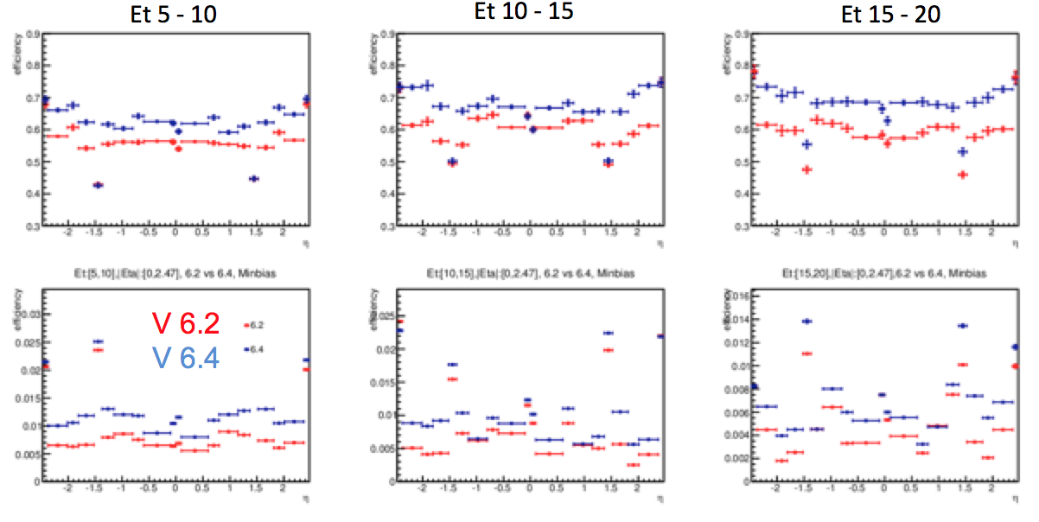

Since beginning of June 2015 the group got involved in the analysis of the first data. VE was amongst the first to show a preliminary study using the new data, he studied the impact of the new detectors, of the re-alignment of the first data and qualified the electron identification variables. As a result of this hard and focused work, the group participates to the production of official figures to illustrate ATLAS performance with the first Run 2 data. One of these figures is shown here and displays the residual energy around a cone of 0.2 around the electron candidates obtained using Z->ee candidates (ATLAS internal since the approval process is ongoing and expected to converge this week).

image28

**2.3. Difficulties encountered**

Objectively the main difficulty we had this year is linked to the fact that Sara Diglio left her post-doc position with OCEVU for personal reasons. While she is still actively working with us, while on another post-doc contract which is not LHC related, having lost her full support had the effect of slowing down both the publication on RpV SUSY signal and the ramp up of the BSM phenomenological study in the multi-boson production.

**2.3.1 [A1]**

The main difficulty we encountered in realizing the project described above is related to the usage of software programs, which do not contain all the features we need in order to find a region of the SUSY parameter space where the process of interest is dominant with respect to other SUSY processes.

In particular, we considered using the LUPM-L2C software **Suspect as a SUSY mass spectrum calculator, but one limit of such a code consists in not having the RpV models implemented**. Given that, we opted for using the SPheno code (which instead does have the RpV models implemented). Indeed we soon faced a non negligible difficulty in using such a code: the SUSY spectrum obtained by running the SPheno code does not account for the most recent low energy constraints coming from the LHC experiments. Given the impossibility of setting the Higgs mass as an input for the SPheno code, we developed a Mathematica code based on matrix inversions, which allows to choose physical masses eigen-states as input and to obtain the corresponding combinations of SUSY parameters at low energy scale as output. Among the several inputs for the Mathematica code, we required the lightest neutral SUSY Higgs mass to be 125 GeV.

As a first approximation we planned to use the output of the just mentioned Mathematica code as an input for SPheno. In principle this would have ensured to select several combinations for SUSY parameters at low energy scale that guarantee an RpV SUSY spectrum which:

* Fulfill the conditions discussed in the previous section to assure the process of interest as being the dominant one over other possible SUSY processes;
* Ensures a lightest neutral SUSY Higgs mass of ~125 GeV.

Another difficulty we encountered this year after was linked to the estimation of cross sections of RpV with many body final states: up to 12 partons. Usually this kind of production are dealt with by factoring out the branching ratios for the resonance produced in order to fasten the computation with MadGraph which consider all possible contributions to the final state. Unfortunately this approximation is not viable for the RpV processes where many decays in the chain come from off-shell particles and therefore the narrow width approximation, used to factor out the BR is not valid anymore. This results on a large computing time spent to generate such processes.

**2.3.2 [A2]**

The A2 task includes a strong synergy between the phenomenology and experimental work. However, the experimental evolutions, very much focused on Run 2 preparation leas to a rearrangement of the agenda such that the group become very visible within the collaboration for Run 2 data preparation. We stress that understanding the detector and contributing to the basic experimental work is necessary in order to be able to install and execute new analyses ideas as the one proposed in this theme. This approach, also adequate for the mandatory “qualification task” of the new PhD student (this procedure is requested from new collaboration members) builds in addition the basis for the future data analysis, since the subject was at the heart of the lepton identification, an essential ingredient of the proposed analysis. We found out that the task, done under time pressure, within a competitive context and including the ramp-up of the student training in the experimental physics (VE has a followed a theoretical master previously), was not compatible with a simultaneous development of the phenomenological part of A2. However, given the strong impact in the performance group that was achieved during these last 9 months, a transition to the phenomenological studies should be possible before September (a group meeting is foreseen for end July to discuss the next steps).

**3. SCIENTIFIC IMPACT**

**3.1. Publications**

1. “R-parity violation in ttH final states”, S. Diglio, L. Feligioni, G. Moultaka.(draft in preparation, to be submitted to Phys Rev D)“

2. The ATLAS Collaboration, “Electron Identification performance for Run 2”.

**3.2. Other internal and external communication actions**

Internal communications have been regularly made in the framework of the collaborations and OCEVU report. For the phenomenological aspects of **A1**, those have been reported during the 2014 and 2015 OCEVU workshops:

* https://indico.in2p3.fr/event/10109/session/66/contribution/5/material/slides/0.pdf
* <https://indico.in2p3.fr/event/11626/session/15/contribution/9/material/slides/0.pdf>

Concerning the experimental aspects of A2, the work on electron identification started by the PhD student Venugopal ELLAJOSYULA has been presented several times within the ATLAS collaboration relevant working group meetings. About 20 presentations were shown in the last 9 months in the “Tag and Probe” subgroup at CERN and VE was designed 3 times to represent the most recent results in the electron identification area (including results from other working teams as well) in the plenary session of the e-gamma working group. He was designed by the e-gamma group to present the first results comparing Run 2 data to simulations in the “ATLAS Data-MC Workshop” on July 3, 2015. VE will also present the preliminary plots release request in the plenary e-gamme meeting on July 15.

Concerning the external communications PESBLADe is actively involved in preparing a candidateship to organize the Higgs Couplings workshop, gathering around 100 physicists mostly from theory and ATLAS, CMS to discuss the status of the experimental analysis and of the theoretical tools supporting them.

**4. FINANCIAL ASPECTS**

**4.1. Consumption of the budget allocated for 2014 and 2015**

In 2014 the nature of the spending of the PESBLADe allocated budget was basically due to the traveling expenses between Marseille and Montpellier of the people actively involved. The second source of spending were to cover the travel to CERN for Venugopal ELLAJOSYULA especially linked to his qualification work to acquire the ATLAS authorship during his first year as an ATLAS collaborator.

**5. HUMAN RESOURCES**

**5.1. Contributions in 2014-2015**

In 2013-2014 we had the possibility to hire Sara Diglio, a post-doc with a strong background on working with phenomenology. We had many fruitful discussions with almost the whole CPPM-ATLAS group and the UM2 group. Everybody participated at the beginning, then there was a phase where less people stayed when the project started – mostly because of previous commitment - now as the project evolve, people are starting to come back. Concerning the work carried out, mostly the interaction between Sara Diglio, Lorenzo Feligioni, Gilbert Moultaka and Jean-Loic Kneur, in 2014, the expertise on SUSY phenomenology in one side, and on experimental analysis in the other was well matched to carry the sensitivity studies foreseen.

**5.1.1. List of people (within and outside OCEVU) involved in the project**

|  |  |  |  |  |
| --- | --- | --- | --- | --- |
| **Name** | **Position1** | **Laboratory** | **#PM2  2014** | **#PM  2015** |
| DIACONU Cristinel | DR | CPPM | 1 | 6 |
| FELIGIONI Lorenzo | CR | CPPM | 2 | 4 |
| MUANZA Steve | CR | CPPM | 0.5 | 0.1 |
| KNEUR Jean-Loïc | DR | L2C | 1 | 0 |
| MOULTAKA Gilbert | CR | L2C | 0.3 | 3 |
| DIGLIO Sara | PD | CPPM | 7 | 4 |
| ELLAJOSYULA Venugopal | PhD | CPPM | 4 | 7 |
| LIU Yanwen | PR | USTC | 2 | 0 |

1 (PR, DR, MCF, CR, PhD, PD=postdoc,…)

**2 #**PM = number of person.months = number of months spent for each year on the project

**5.1.2. Contributions to the project**

|  |  |  |
| --- | --- | --- |
| **Name** | **Nature of the contribution to the project** | |
| DIACONU Cristinel | co-direction of PhD student | |
| FELIGIONI Lorenzo | coordination, co-direction M1 stage, involved on ATLAS analysis that could indirectly spin off on R-parity violating stop searches | |
| MUANZA Steve | Run 1 analysis which will be in the scope of PESBLADe for Run 2 | |
| KNEUR Jean-Loïc | Participation to discussions, expertise on SUSY models | |
| MOULTAKA Gilbert | Coordination, , co-direction of PhD and M1 stage students, expertise on SUSY models, implementation of BSM models into and running of MC generators | |
| DIGLIO Sara | Running MC generators, sensitivity studies, co-direction of M1 stage student | |
| ELLAJOSYULA Venugopal | Phenomenology studies for the multi-boson analysis, qualification task within ATLAS | |
| LIU Yanwen | Sensitivity studies for multi-boson analysis |  | |

**6. EVOLUTION AND PERSPECTIVES OF THE PROJECT FOR THE COMING YEAR**

As already described in Section 1, the general framework of PESBLADe has allowed the emergence of three well-identified research axes, all of which are within the initial scientific perimeter of the project:

-**A1** has now reached a cruising speed. The necessary computational tools for the study of light stop hadronic decays in R-parity violating supersymmetric models have been set up, and are running with proper interfacing of the susy spectrum calculator SPheno code with the parton level event generator MADGRAPH and a 'spectrum-inverter' mathematica code. We have now delineated the phenomenological interesting parts of the parameter space where multi-b (or light)-jet final state decays are sufficiently copious to allow a study of the decaying stop, as compared to the QCD background overwhelmed 2-jet decays. The aim for the coming two years is to exploit, together

with the new postdoc, these first promising results and to push further the study through the computational tools that we have set-up along two complementary directions:

- a more complete ''bottom-bottom'' scan over the so-called “natural susy” scenarios that still escape present exclusion limits with a realistic experimental analysis of multi-jet final states using simulated data

- a « top-bottom » approach starting from high scale R-parity violating models taking into account the full set of R-partiy violating couplings in order to map the forseen experimental constraints onto the fundamental supersymmetric and supersymmetry breaking parameters.

The ambition is to provide a case study for feasibility in ATLAS with the Run 2 data.

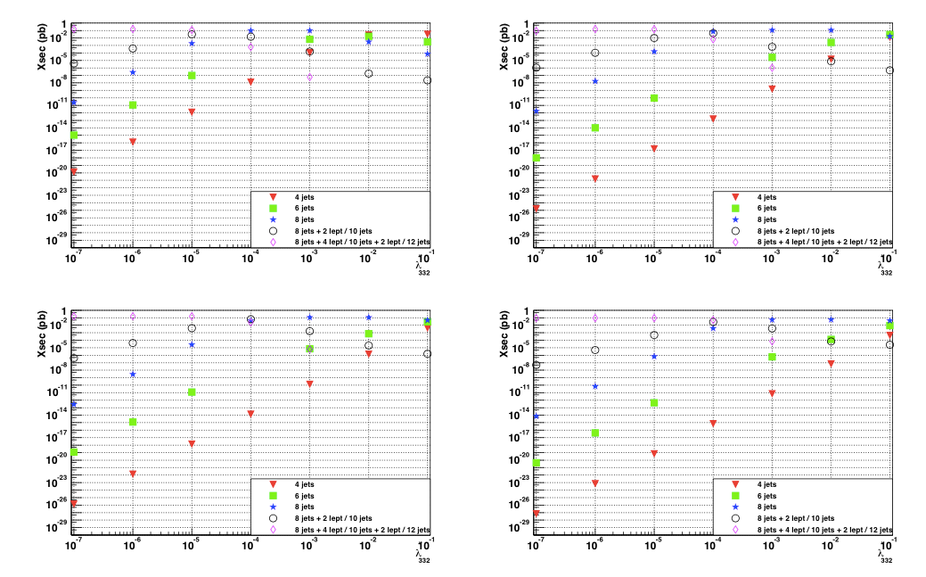

Figure 3. stop-anti-stop production and decay cross-sections at center of mass energy of  14 TeV for 4, 6, 8, 10 and 12 jets final states as a function of the tri-linear RpV coupling.

-**A2** has been built following discussions amongst PESBLADe members and with an OCEVU visiting scientist around two complementary approaches: *(a)* model-independent constraints on effective operators involving weak vector bosons and the Higgs boson, *(b)* model-dependent re-interpretation of the constraints in terms of non-standard neutral or (doubly) charged intermediate Higgs states.

The measurements associated with these research directions will be focused on final states with three leptons and will be based on the Run 2 data. The student (VE) has therefore engaged the preparation for the data taking, which has just started. This is the normal sequence in the experimental work since a qualification task has to be fulfilled within ATLAS. In addition, the imminence of Run 2 required a full focus on the data analysis reparation and enhanced the visibility of the team within ATLAS.

During the next year we expect to ramp up the activity on the one hand along *(a)* in continuation of the first analysis produced by Yan-Wen Liu (and his students) which triggered discussions with the PESBLADe experimentalist and theoretician members, and on the other hand along *(b)* building on existing expertise in extended Higgs sector models as well as on the tools being developed in **A1** to take furthers steps in the studyof a possible re-interpretation of constraints on the effective operators in terms of same-sign W final states from doubly-charged Higgs decays.

Obviously these projected activities will offer a favorable environment for the starting PhD.

**- A3** The priority of the student for the first year of PhD12 will be her ATLAS authorship project. It will be dedicated to the maintenance, the adjustment to the data taking conditions and the performances of current b-tagging algorithms. This is a crucial tool for the analysis since we tag the neutralino2 using the h->bbar decay mode. This work will also be a prime importance for the project A1 where there are two additional b-jets per events for the ttH signal. The two secondary priorities will be the learning of the structure of Suspect v3 so as to prepare for its future developments as well as the first steps into the analysis to improve the modeling of the signal and to prepare new signal regions that will be accessible when sufficiently large integrated luminosity (~5/fb) will be collected at 13 TeV.

* + 1. **Project methodology and justification of resources**

As stated before the PESBLADe is a general framework where LHC experimentalists meet HEP phenomenologist. In practice this is declined in the orientation and reinterpretation of Run 2 analysis where the CPPM-ATLAS group is involved by means of the knowledge on BSM phenomenological models of interest for the LUPM-L2C group.

In this sense A1 projet is a reinterpretation of the multi-jets, multi-b-jets and more generally top-Higgs final states in terms of SUSY RpV searches. The work on this last year and a half consisted on the characterization of such models in light of recent LHC results in terms of direct searches and Higgs mas and couplings. This was mostly a phenomelogy study and was carried out with the help of **Sara Diglio, OCEVU post-doc** from January 2013 to Avril 2014. It will continue with the help of the new post-doc, which will be hired at the end of the current month of July.

A2 started from a phenomelogy work on Higgs triplets and double charged Higgs signatures in final states with two W bosons with the same sign, even though so far the experimental aspects of it, the identification of electrons with ATLAS detector have been taken most of the time. This work is the thesis topic of **ELLAJOSYULA Venugopal, an OCEVU PhD student** from October 2014. For the experimental aspected this work is done in collaboration with the CPPM-ATLAS group of people which works on electron identification and on the ATLAS electro-magnetic calorimeter.

Finally our last student, **Rima El Kosseifi**, which will start on October 2015 will work on RpC SUSY signatures and the development of Suspect in order to include RpV SUSY scenarios.

**6.1.2. Financial resources scheduled in 2015 to be allocated for 2016**

For quite some time we have been foreseeing the organization of two mini-workshops on phenomenological and experimental aspects on RpV SUSY and multi-jet, multi b-jet final .The estimated total cost is 5000 Euros, which includes travel and stay for three guests from outside the OCEVU perimeter. Since the delay on the publication process, also due to the fact that Sara Diglio left her position, we would like to ask to maintain this allocated funds and report it in 2016.

**6.1.3. Justification of the requested additional resources (human and financial) for 2016 *(when applicable)*.**

One potential scenario among these models is SUSY with R-parity violation (RpV) . In this scenario various possible direct and cascade decays of the stop that involve the trilinear RpV operators lead to multi b-jet new physics signals without missing energy or leptons.

This challenging final state new physics signature is very similar to the one produced in the fully hadronic decay channel by the Higgs-Englert-Brout boson in associated production with top quarks (ttH). This decay channel has been searched for and studied by the ATLAS CPPM group in the context of the LHC Run 1 data and proved to be interesting to study during Run 2 data. In Run 2 ATLAS, other than the improved center of mass energy and luminosity provided by the LHC will benefit from the efficient and successfully implemented b-jet trigger in the ATLAS readout trigger chain. For this reason we ask for a PhD student to use the analysis technique developed in Run I data and the experience acquired for the search for the ttH process in the fully hadronic decay channel to build a new analysis framework with improved techniques and methods to search for multi b-jets signature expected in RpV decay processes such as pair-produced stops decays to an on-shell chargino, which subsequently decays via RpV coupling into a virtual stop and a b-quark. The virtual stop subsequently decaying into a light and a b quark, giving rise to eight-jet final state, 6 of which are b-jets.

The goal is to probe new physics scenario that provide a mechanism for spontaneous EWSB via natural extension to the SM and as spin-off of this analysis establish evidence of the ttH production process and possibly provide a first direct measurement of the top-Higgs Yukawa coupling.

The project is built on several techniques that will improve the sensitivity to probing new physics beyond the current state-of-the-art, in particular b-jet trigger which is expected to improve by one order of magnitude of the light multijets background, and the jet-substructure techniques applied to highly boosted hadronically decaying heavy particles, such as H→bb and t→Wb which may potentially greatly improve the resonance mass resolution and the background rejection. All this is based on the cumulated valuable experience acquired during Run I data in the search for the ttH process in the fully hadronic mode, where CPPM lead ATLAS effort, namely:

• Estimation of trigger efficiency and data/Monte Carlo scale factor in order to work in the not-fully efficient region,

• Multijet background modeling in high jet and b-jet multiplicity,

• The use of multivariate techniques, such as Boosted Decision Trees to discriminate signal and background events by use of kinematical variables,

• Identifying control region and use of profiled likelihood techniques to greatly constrain systematic uncertainties common to signal and background.

Besides these proven and mastered techniques, one needs, from the theoretical side, to work on ways to characterizing RpV signal and on the identification of new kinematical variables that may result in enhancing discrimination between signal and background.

* 1. **Expected results, and potential scientific exploitation and technological transfer in 2016.**

In the next year we expect two main results, first the complete characterization of SUSY RpV signals in top-Higgs final states [**A1**], this will be the subject of a follow-up article to the one being presently finalized, second the exploitation by the ATLAS collaboration of the electron identification studies put in place by Venugopal [**A2**]. These two studies will be the first bricks for RpV searches and for the multi-boson analysis in Run 2 in the framework of the analysis carried by the CPPM-ATLAS group. On another side thanks to **A3** it is foreseen the implementation of RpV SUSY model into Suspect.

* 1. **Updated detailed planning of the project including project milestones**

In this next year we foresee the publication of our RpV SUSY work and the extension of it in two possible directions, a more detailed sensitivity study which involves also background studies in order to assess the final reach of LHC in Run 2 for such processes, and a study of kinematical variables that could be used in order to discriminate signal and background, especially exploiting the remarkable signatures due to multi-resonance production. Finally with the help of a new PhD student starting in 2016 we would like to start looking for this kind of signatures in data integrating the CPPM-ATLAS group, which works in similar final state analysis (2 post-docs, 6 permanents, 2 PhD students).

On the multi-boson final states, this analysis also will integrate the CPPM-ATLAS group working on electron-based signatures (2 PhD students, 4 permanents, 1 post-doc, plus a strict collaboration with USTC-China multi-boson group) to start the data analysis. With the help of the post-doc replacing Sara Diglio a detailed phenomenology study of Higgs triplet contribution to multi-boson final state will also start.

As for **A3**, Rima will start working on her qualification task to become an author of ATLAS and will get started on the implementation and development of Suspect.

**7. FINANCIAL ASPECTS**

**7.1. Budget request for 2015**

We request approximately the same amount than for the other years of PESBLADe functioning, i.e. 2200 euros, We think this is enough and would not want to have additional budget associated with the new student that will start in 2016. Even though we understand that the original proposed budget was thought for allow traveling to more people than actually did make regular trips on the road Marseille-Montpellier, we would like to take to organize small colloquia with relevant MC generator developers and BSM phenomenologist to carry out at the best our studies.

Also travel expenses for a total amount of 5 trips to Montpellier and 5 trips to Geneva for Venu, Rima and the post-doc who will replace Sara Diglio starting this fall, on the order of the same amount of travels respectively to Montpellier and Marseille for the researcher from the different labs.

Finally travel expenses for communication linked to the soon to be published RpV phenomenology studies.

|  |  |
| --- | --- |
| **Amounts in €** | **Requested for 2015** |
|  |  |
| **Equipment** |  |
| **Computing** |  |
| **Travel expenses** | 17000 |
| **Colloquia** | 5000 |
| **Operating budget** |  |
| **TOTAL** | 22000 |

**8. HUMAN RESOURCES**

**8.1. Expected contributions in 2015**

**8.1.1. List of people (within and outside OCEVU) involved in the project**

|  |  |  |  |
| --- | --- | --- | --- |
| **Name** | **Position1** | **Laboratory** | **#PM2  2016** |
| DIACONU Cristinel | DR | CPPM | 8 |
| FELIGIONI Lorenzo | CR | CPPM | 8 |
| PESBLADe post-doc | PD | CPPM | 12 |
| EL KOSSEIFI Rima | PhD | CPPM | 12 |
| ELLAJOSYULA Venugopal | PhD | CPPM | 12 |
| NAGY Elemer | PR | CPPM | 4 |
| MUANZA Steve | CR | CPPM | 4 |
| KNEUR Jean-Loïc | DR | L2C | 2 |
| MOULTAKA Gilbert | CR | L2C | 8 |
| TALBY Mossadek | PR | CPPM | 4 |

1 (PR, DR, MCF, CR, PhD, PD=postdoc,…)

**2 #**PM = number of person.months = number of months spent for each year on the project

**8.1.2. Contributions to the project**

|  |  |
| --- | --- |
| **Name** | **Nature of the contribution to the project** |
| DIACONU Cristinel | Coordination, co-direction of PhD student, sensitivities studies, data analysis |
| FELIGIONI Lorenzo | Coordination, co-direction M1 stage, sensitivities studies, pdata analysis |
| NAGY Elemer | multi-b-jets analysis |
| MOULTAKA Gilbert | Coordination, running of MC generators, co-direction of PhD, implementation of BSM models into MC generators |
| PESBLADe post-doc | MC generators, sensitivity studies, data analysis |
| KNEUR Jean-Loïc | Co-direction PhD thesis, work on Suspect development |
| ELLAJOSYULA Venugopal | Sensitivity studies, data analysis, electron identification |
| EL KOSSEIFI Rima | ATLAS qualification task, Suspect development |

**8.2. Requested additional human resources** (including possible co-financing)

1. **PhD grant : yes co-financing: no   
    *source*:**If a grant is requested, fill in and join the form “PhD Grants International Program” which describes the details of the doctoral position.
2. **Postdoc grant: no co-financing: yes/no  
   Duration of the contract** *(years)***: *source*:**If a grant is requested, fill in and join the form “Postdoctoral Grants International Program” which describes the details of the postdoctoral position.
3. **Visiting scientist: no duration of the stay** *(up to 3 months)***:**If yes, fill in and join the corresponding form (visiting scientist project description including the CV of the visitor). *Stays are for up to 3 months; the visitor will receive an up to 150€ per diem, to cover food (up to 94€/day) and lodging expenses (up to 120€/day), and up to 1000€ to cover his/her travel expenses*. *An invoice is required for the lodging and travel expenses but not for the food expenses less than 31€/day.*

**9. Bibliography**

1. ATLAS Collaboration, *Measurements of top quark pair relative differential cross-sections with ATLAS in pp collisions at √s = 7 TeV*, CERN-PH-EP-2012-165, arXiv:1207.5644 [hep-ex] submitted to EPJC
2. ATLAS Collaboration, *Measurement of the ttbar production in the all-hadronic channel in 4.7 fb-1 of pp collisions at √s = 7 TeV with the ATLAS detector*, ATLAS-CONF-2012-031.
3. ATLAS Collaboration, *Measurement of the W+W- cross section in √s = 7 TeV pp collisions with ATLAS*, Phys. Rev. Lett. 107 (2011) 041802.
4. ATLAS Collaboration, *Observation of an excess of events in the search for the Standard Model Higgs boson in the gamma-gamma channel with the ATLAS detector.*
5. ATLAS Collaboration, *Observation of an excess of events in the search for the Standard Model Higgs boson in the H-> ZZ(*)-> 4l channel with the ATLAS detector,* ATLAS-CONF-2012-092.
6. ATLAS Collaboration, *Search for the Standard Model Higgs boson produced in association with a vector boson and decaying to a b-quark pair with the ATLAS detector,* arXiv:1207.0210 [hep-ex], submitted to Phys.Lett. B.
7. ATLAS Collaboration, *Search for Supersymmetry in final states with two same-sign leptons, jets and missing transverse momentum with the ATLAS detector in pp collisions at √s=8 TeV*, ATLAS-CONF-2012-105.
8. ATLAS Collaboration, *Search for pair production of heavy top-like quarks decaying to a high-pT W boson and a b quark in the lepton plus jets final state at √s=7 TeV,* arXiv:1210.5468 [hep-ex], submitted to Phys. Lett. B.
9. ATLAS Collaboration, *Expected performance of the ATLAS Detector, Trigger and Physics,* CERN-OPEN-2008-020 and ArXiv:0901.0512 [hep-ex].
10. SuSpect: *A Fortran code for the supersymmetric and Higgs particle spectrum in the MSSM,* A. Djouadi, J.-L. Kneur, G. Moultaka, Comput.Phys.Commun. 176 (2007) 426-455.
11. SUSPECT3, A.Djouadi, J-L. Kneur, G. Moultaka, M. Ughetto, D. Zerwas, in Les Houches 2011: Physics at TeV Colliders New Physics Working Group Report, G. Brooijmans et al., arXiv:1203.1488.
12. *NMSPEC: A Fortran code for the sparticle and Higgs masses in the NMSSM with GUT scale boundary conditions.* U. Ellwanger and C. Hugonie, Comput.Phys.Commun. 177 (2007) 399-407.
13. *NMHDECAY 2.0: An Updated program for sparticle masses, Higgs masses, couplings and decay widths in the NMSSM*, U. Ellwanger and C. Hugonie, Comput.Phys.Commun. 175 (2006) 290-303.
14. *Higgs bosons near 125 GeV in the NMSSM with constraints at the GUT scale,* U. Ellwanger and C. Hugonie, Adv.High Energy Phys. 2012 (2012) 625389.
15. *Higgs boson decay into 2 photons in the type II seesaw model,* A. Arhrib, R. Benbrik, M. Chabab, G. Moultaka, L. Rahili, JHEP 1204 (2012) 136.
16. *Composite GUTs: models and expectations at the LHC,* M. Frigerio, J. Serra, A. Varagnolo, JHEP 1106 (2011) 029.
17. *Composite Scalar Dark Matter,* M. Frigerio, A. Pomarol, F. Riva, A. Urbano, JHEP 1207 (2012) 015.
18. *Associated Production of Higgs Bosons with Scalar Quarks at Future Hadron and e+e− Colliders,* A. Djouadi, J.-L. Kneur, G. Moultaka, Nucl.Phys. B569 (2000) 53-81.
19. *Higgs Boson Production in Association with Scalar Top Quarks at Proton Colliders,* A. Djouadi, J.-L. Kneur, G. Moultaka, Phys.Rev.Lett. 80 (1998) 1830-1833.
20. *A First Top Partner Hunter's Guide,* A. De Simone, O. Matsedonskyi, R. Rattazzi, A. Wulzer, JHEP 1304:004
21. *LHC signal from Warped Extra Dimensions,* K. Agashe, A. Belyaev, T. Krupovnickas, G. Perez, J. Virzi, Phys. Rev. D77:015003, 2008.
22. *New Higgs Production Mechanism in Composite Higgs Model*, A. Carmona, M. Chala, J. Santiago, arXiv:1205.2378
23. *Top Quark Pair plus Missing Energy at the LHC,* T. Han, R. Mahbubani, D. G. E. Walker, L. Wang, JHEP 0905:117
24. *Single Stop Production at Hadron Colliders,* T. Plehn, Phys.Lett. B488 (2000) 359-366
25. *The automated computation of tree-level and next-to-leading order differential cross sections, and their matching to parton shower simulations,* J. Alwall, R. Frederix, S. Frixione, V. Hirschi, F. Maltoni, O. Mattelaer, H.-S. Shao, T. Stelzer, P. Torrielli, M. Zaro, arXiv:1405.0301
26. The ATLAS collaboration, *Search for pair-produced top squarks decaying into a charm quark and the lightest neutralinos with 20.3 fb−1 of pp collisions at √s=8 TeV with the ATLAS detector at the LHC,* The ATLAS collaboration, ATLAS-CONF-2013-068.
27. *A Swarm of Bs,* Jared A. Evans, arXiv:1402.4481.
28. *Sarah,* F. Staub, arXiv:0806.0538
29. *SPheno, a program for calculating supersymmetric spectra, SUSY particle decays and SUSY particle production at e+ e- colliders,* W. Porod, Comput. Phys. Commun. 153 (2003) 275.
30. *SPheno 3.1: extensions including flavour, CP-phases and models beyond the MSSM,* W. Porod and F. Staub, Comput. Phys. Commun. 183 (2012) 2458
31. *Inverting the Supersymmetric Standard Model Spectrum: from Physical to Lagrangian Ino Parameters,* J.-L. Kneur, G. Moultaka, Phys.Rev. D59 (1999) 015005.
32. CMS Collaboration, Search for pair-produced resonances decaying to jet pairs in proton-proton collisions at *√s=8 TeV,* arXiv:1412.7706v2

For a recent reappraisal see e.g., [Effective Field Theory: A Modern Approach to Anomalous Couplings](http://inspirehep.net/record/1115311), [C. Degrande](http://inspirehep.net/author/Degrande%2C%20Celine?recid=1115311&ln=fr) et al., **Annals Phys. 335 (2013) 21-32**, ,e-Print: [arXiv:1205.4231](http://arXiv.org/abs/arXiv:1205.4231) **[hep-ph]**

[3] See e.g. , [A Bayesian view of the Higgs sector with higher dimensional operators](http://inspirehep.net/record/1227950), [Beranger Dumont](http://inspirehep.net/author/Dumont%2C%20Beranger?recid=1227950&ln=fr) et al., **JHEP 1307 (2013) 065** e-Print: [arXiv:1304.3369](http://arXiv.org/abs/arXiv:1304.3369) **[hep-ph]**

The Higgs Potential in the Type II Seesaw Model A. Arhrib, R. Benbrik, M. Chabab, G. Moultaka, M. C. Peyranère, L. Rahili, J. Ramadan. arXiv:1105.1925v2 [hep-ph].

*These comments can include comments on the project itself, its trajectory and its financial and human resource aspects, or on anything you think could improve the way projects are managed in OCEVU.*

***Your “2013-2014 Progress report and 2015 Requests” form must be submitted***

***together with the forms corresponding to human resource requests, if applicable,***

***by Wednesday July 16th,2014 noon by email***

***at labex-ocevu-aap@cppm.in2p3.fr***