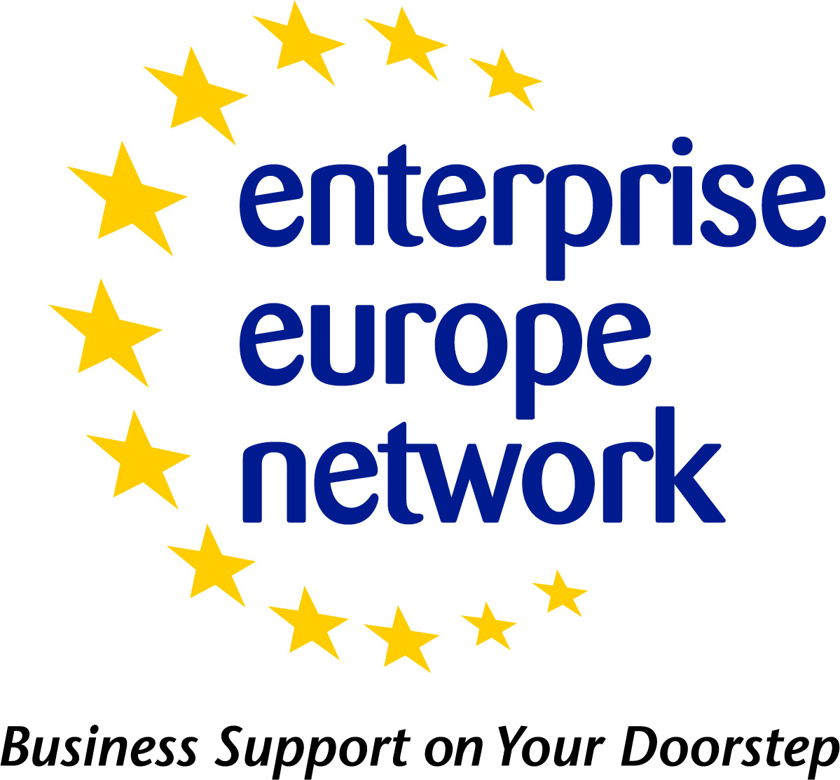 | Technology Offer - Profile Template  Updated - June 2013
 | European Commission
Technology Offer Profile
The following table can be used as a template for drafting a Technology Offer profile. Please be sure to refer to the Technology Offer Profile Guidelines for what information you should include in each field.
Please note:
- Fields that can be ticked should only have one selection when drafting the profile unless specified under the field title.
- Fields marked with asterisk (*) are mandatory
Field Title | Field To be populated
Title*
Internal Reference
Summary*
(1-500 characters)
Advantages and Innovations*
(50-2000 characters)
Stage of Development* | Already on the market  Available for demonstration  Concept Stage  Field Tested / Evaluated  Project Already Started  Project in Negotiations - Urgent  Proposal under development  Prototype available for demonstration  Under development / lab tested
Comments Regarding Stage of Development
Profile Origin* | CIP  Eurostars  FP4  FP5  FP6  FP7  National R&D programme  Other  Other European R&D programme  Private (in-house) research  Regional R&D programme
Description *
(100-4000 characters)
Technical Specification or Expertise Sought
IPR Status*  Note: Multiple fields can be selected. | Copyright  Design Rights  Exclusive Rights  Granted patent or patent application essential  Other (registered design, plant variety, etc.)  Patent(s) applied for but not yet granted  Patents granted  Secret Know-how  Trade Marks
Comments Regarding IPR Status
Technology Keywords*
Market Keywords*
NACE Keywords*
Responsible* | *In Merlin, select who from your organisation will be responsible for this profile*
Sector Group | Agrofood  Automotive, transport and logistics  Bio Chem Tech  Creative Industries  Environment  Healthcare  ICT Industry and Services  Intelligent Energy  Maritime Industry and Services  Materials  Nano – and Microtechnologies  Services and Retail  Space and Aerospace  Sustainable Construction  Textile and Fashion  Tourism and Cultural Heritage  Women entrepreneurship
Restrict Dissemination to specific countries
Type and Size of Client* | Industry SME <= 10  Industry SME 11-49  Industry SME 50 – 249  Industry 250-499  Industry >500  Industry MNE >500  Inventor  Other  R&D institution  University
Year Established
Turnover (Euros – Millions) | <1M  1-10M  10-20M  20-50M  50-100M  100-250M  250-500M  >500M
Already Engaged in Trans - national Cooperation? | Yes (In Merlin tick the check box for yes)  No
Additional Comments
Certification Standards
Language Spoken
Client Country
Type and Role of Partner Sought*
Profile is Opened for Expressions of Interest? | Yes (In Merlin tick the check box for yes)  No
Type and Size of Partner Sought  Note: Multiple fields can be selected. | SME < 10  SME 11-50  SME 51 – 250  251-500  >500  MNE >500  Inventor  R&D institution  University
Type of Partnership Considered*  Note: Multiple fields can be selected. | Acquisition Agreement  Commercial Agency Agreement  Commercial Agency Agreement with technical assistance  Distribution Services Agreement  Financial Agreement  Franchise Agency Agreement  Joint Venture Agreement  License Agreement  Manufacturing Agreement  Outsourcing Agreement  Reciprocal production  Research Cooperation Agreement  Services Agreement  Subcontracting  Technical Cooperation Agreement
Attachments | *Only can be added in Merlin*  File Size max 4Mb. Only jpg, gif and jpeg files allowed.

