“Boards for STAVE FLEX tests”.
Minutes of the meeting for 2015 plans 28/01/2015.
Sebastien Vilalte, 02/02/2015.
- Stave flex rates evaluation.
Goal: estimate the maximum rates over the flex length for the two standard protocols, LVDS and CML. These tests are not limited to the FEI4 that will be used for the demonstrator.
Use of a BERT (bit error rate testing): consists to replace the module and inject a well-known pseudo random pattern via the module wing. Recovering the data at the end of the flex, we will estimate the maximum speed of the transmission.
We will use high speed CTF3 board (PCIe or eval) with HSMC connector.
Needed development: a passive adaptor board for connectors.
Rk: attention must be paid on the drawing because of high data rates.

SIGNAL INTEGRITY BOARD.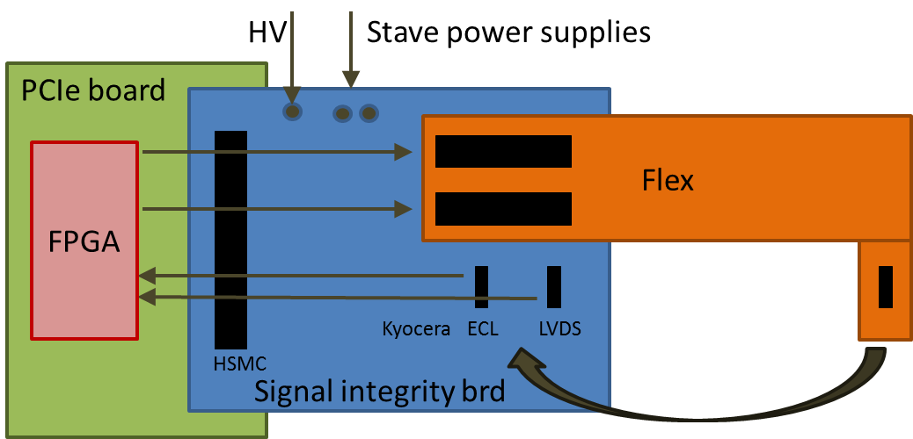

This board injects data through the module connector and recovers them by folding the flex.
As the three flexes connectors are designed to be compatible, a unique “VIP” connectors set is needed.
High voltage and serial power supplies connectors will be added in order to test the isolation and thermal behavior.
Two modules connectors are needed on the signal integrity board: each will be dedicated to a signal type that is routed on a different HSMC bank: CML for high speed and LVDS.
Comparing results with estimations/simulations, we will discuss the possibility of tests with analog network analyzer and mechanical cross-section analysis.
Measuring the rates for the different modules should allow to map rates for modules positions.
Rk: impedance tests will be performed on coupons produced on the same assembly.
- Functional LVDS Stave flex tests.
Goal: tests dedicated to the FEI4 transmissions, ability to transmit LVDS data on a full equipped flex at FEI4 frequency – typically 160Mbps.
Use of an injection board replacing the module: a CPLD can be programmed to act as a module. Developments needed for a full layer2 acquisition test:

→ Acquisition/concentration board. The full layer acquisition needs the acquisition of the three flexes simultaneously. For 56 FE, it represents a huge number of differential links , about 6*56=336 signals (no counting the I²C links).We intend to use the powerful CTF3 PCIe or evaluation boards.
The connection is HSMC based and does not allow such a number of signals. As HSMC connectors can be used at their maximum capabilities on CTF3 boards, 10Gb/s links are available on the central bank. These links have already been tested up to 11Gb/s with success. A serializer can concentrate 160Mb/s links to Gb/s links. The full data rate for reception should be ~9Gb/s while the CTF3 board allows up to 8 links @10Gb/s.
In the other direction, Clocks and Controls should be de-serialized or buffered if identical.
A discussion has already began with LPSC in order to collaborate on another role of the board: serial powering current injection and DCS. A connector (to be defined) can be reserved for a mezzanine dedicated to powering. This modular development should allow the tests of future solutions for serial powering without interfering with data rates tests. For first tests, serial powering is intended to be perform using of-the-shelf generator.
The simultaneous data transmission over the 3 flexes should allow to test the crosstalk between flexes and should allow to conclude on the necessity of using “spacers”.

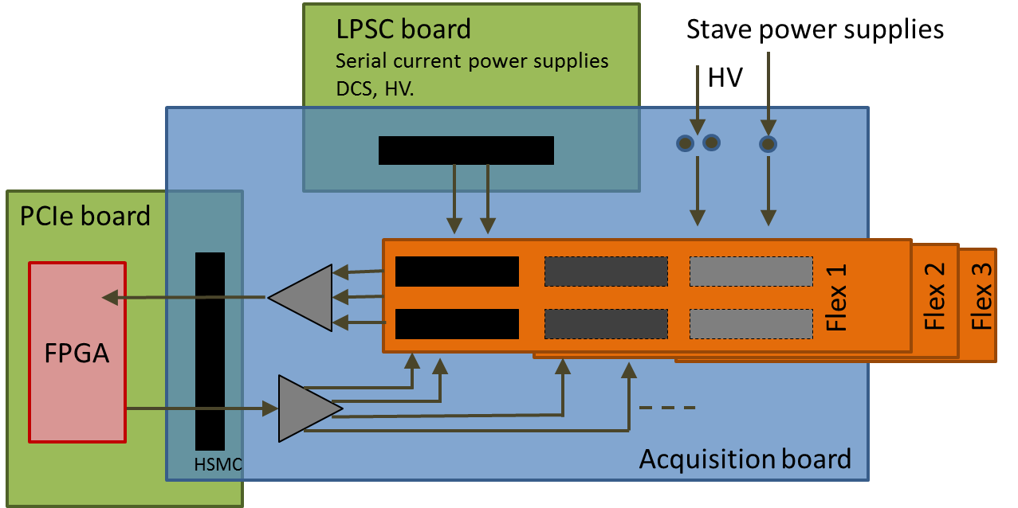

→ CPLD boards. A small board can emulate module behavior using CPLD. Logic will be flashed using simple JTAG protocol. The boards should be powered using the I²C power supply line.

→ Shunt board. Another small board will allow to fake the power consumption and to close the current line for serial powering. This board will be used when CPLD is not needed but also to test the stave flexes with standard module power consumption (thermal, DCS-PSPP…).

To be discussed: integration of next PSPP chips on CPLD or shunt boards for full powering line tests. PSPP boards should be available next spring.

- Individual module tests.
Goal: tests of the modules front-end chips.
We will use the already USBpix system.
USBpix has been designed to fit to previous modules (IBL).
A passive adaptor board will link the Kyocera connector to the USBpix connector.
To be understood: what is the USBpix connector? How many FE can recover USBpix?
If 2, adaptor board should be able to link two USBpix output for M4 modules (4FE).

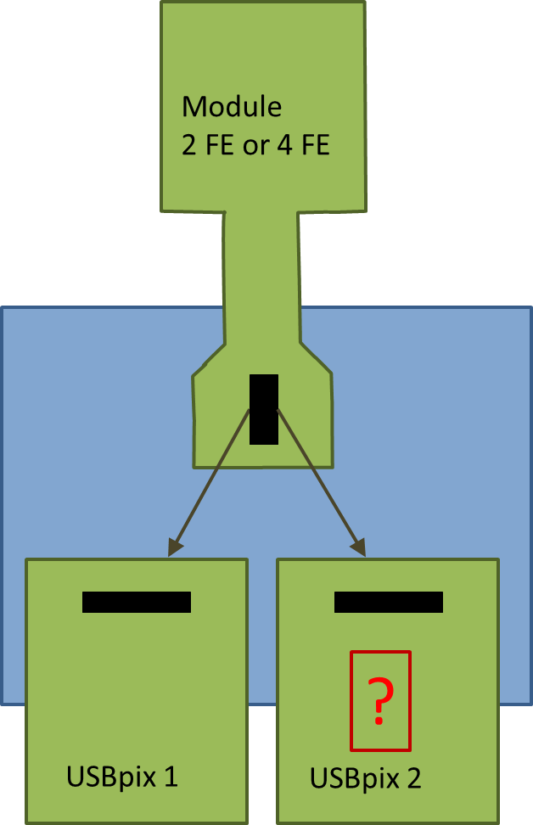

To be discussed: do we need HV for sensor tests?

- Full filled stave with modules flex.
Goal: test the full flex + modules functionalities before loading them on the stave. This “on the table” full filled flexes test is not foreseen to be a step in final process but will allow the full system qualification. The acquisition system will be the same than the final one for full equipped stave tests: connection of the three flexes and acquisition with the standard system.
A “VIP0” board can do the job. Specifications will depend on the used technology as DAQ.
With future HSIOII, 16 FE could be acquired (to confirm). With COB/RCE, this number could be up to 64. The total layer 2 stave will need 56 FE readout.

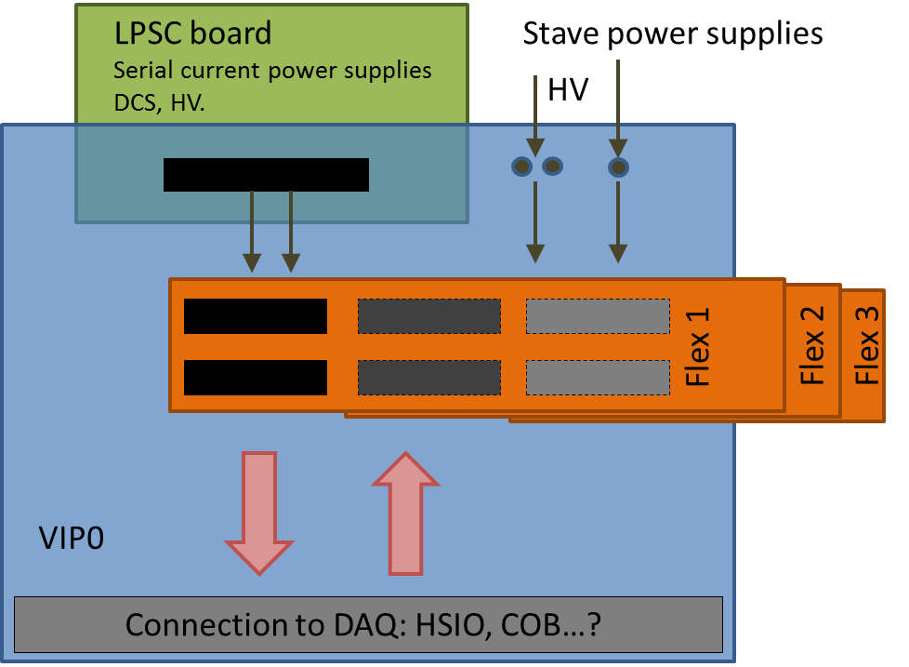

To be discussed: What DAQ system? What standard connection?

2015 Milestones and deliverables: estimations.

Stave flex:
Quotation for two flex sets: mid February.
Deliverables: April.
Price?

Signal integrity board: 2 boards?
Design: March-April.
Deliverables: May.
Price: ~500-800€ for 2.

Acquisition/concentration board: 2 boards?
Design: April-May.
Deliverables: June.
Price: ~1000€ for 2.

CPLD & Shunt boards: depending if we equip one or two sets of flexes, 25-50 boards.
Design: May.
Deliverables: June.
Price: ~500-1000€, ~20€/pce.

Individual module test board: depending on the architecture.
Design: summer.
Deliverables: September.
Price: ~200€/pce.

Total boards estimated budget: ~1500-3000€

